- Search strategies
PubMed: 383 Results, 1.5.2022
"Mediastinum"[MeSH Terms] AND (("Endosonography"[MeSH Terms] OR ("Ultrasonography"[MeSH Terms] OR "Ultrasonics"[MeSH Terms])) AND "Lung Neoplasms"[MeSH Terms])

Cochrane Library: 62 Results, 1.5.2022
MeSH descriptor: [Lung Neoplasms] explode all trees
MeSH descriptor: [Endosonography] explode all trees
MeSH descriptor: [Ultrasonography] explode all trees

Embase: 471 Results, 1.5.2022
'Lung Neoplasms'/exp
'Endosonography'/exp
'Ultrasonography'/exp

Supplementary Figures and Tables
Supplementary Table 1. Quality assessment of included studies by QUADAS-2
Study | Patient Selection (3) | Index Test (2) | Reference Standard (2) | Flow and Timing (4) | Total quality scores
Rintoul et.al. 2005 | 3 | 2 | 2 | 3 | 10
Vilmann et.al.2005 | 3 | 2 | 2 | 4 | 11
Wallace et.al. 2008 | 3 | 2 | 2 | 4 | 11
Herth et.al. 2010 | 2 | 2 | 2 | 3 | 9
Hwangbo et.al. 2010 | 2 | 2 | 2 | 3 | 9
Annema et.al. 2010 | 2 | 2 | 2 | 4 | 10
Szlubowski et.al. 2010 | 2 | 1 | 2 | 2 | 7
Ohnishi et.al. 2011 | 3 | 2 | 2 | 3 | 10
Libermanet.al. 2014 | 3 | 2 | 2 | 4 | 11
Szlubowskiet.al. 2015 | 3 | 2 | 2 | 3 | 10
Kanget.al. 2014 | 2 | 2 | 2 | 2 | 8
Okiet.al. 2014 | 3 | 2 | 2 | 3 | 10
Haueret.al. 2015 | 2 | 1 | 1 | 3 | 7
Jhunet.al. 2012 | 2 | 2 | 2 | 3 | 9
Leeet.al. 2014 | 3 | 2 | 2 | 3 | 10
Doomset.al. 2015 | 3 | 2 | 2 | 4 | 11
Umet.al. 2015 | 3 | 2 | 2 | 3 | 10
Vialet.al. 2018 | 2 | 2 | 2 | 3 | 9
Crombaget.al. 2019 | 3 | 2 | 2 | 4 | 10
Tutaret.al. 2018 | 3 | 2 | 2 | 3 | 10

Supplementary Table 2. Publication bias and heterogeneity of summarized outcomes
Outcomes | Publication bias
Outcomes | Begg (P value) | Egger (P value)
Summarized staging accuracy of EBUS | 0.19 | 0.15
Summarized staging accuracy of EUS | 0.41 | 0.39
Summarized staging accuracy of EBUS+EUS | 0.71 | 0.84

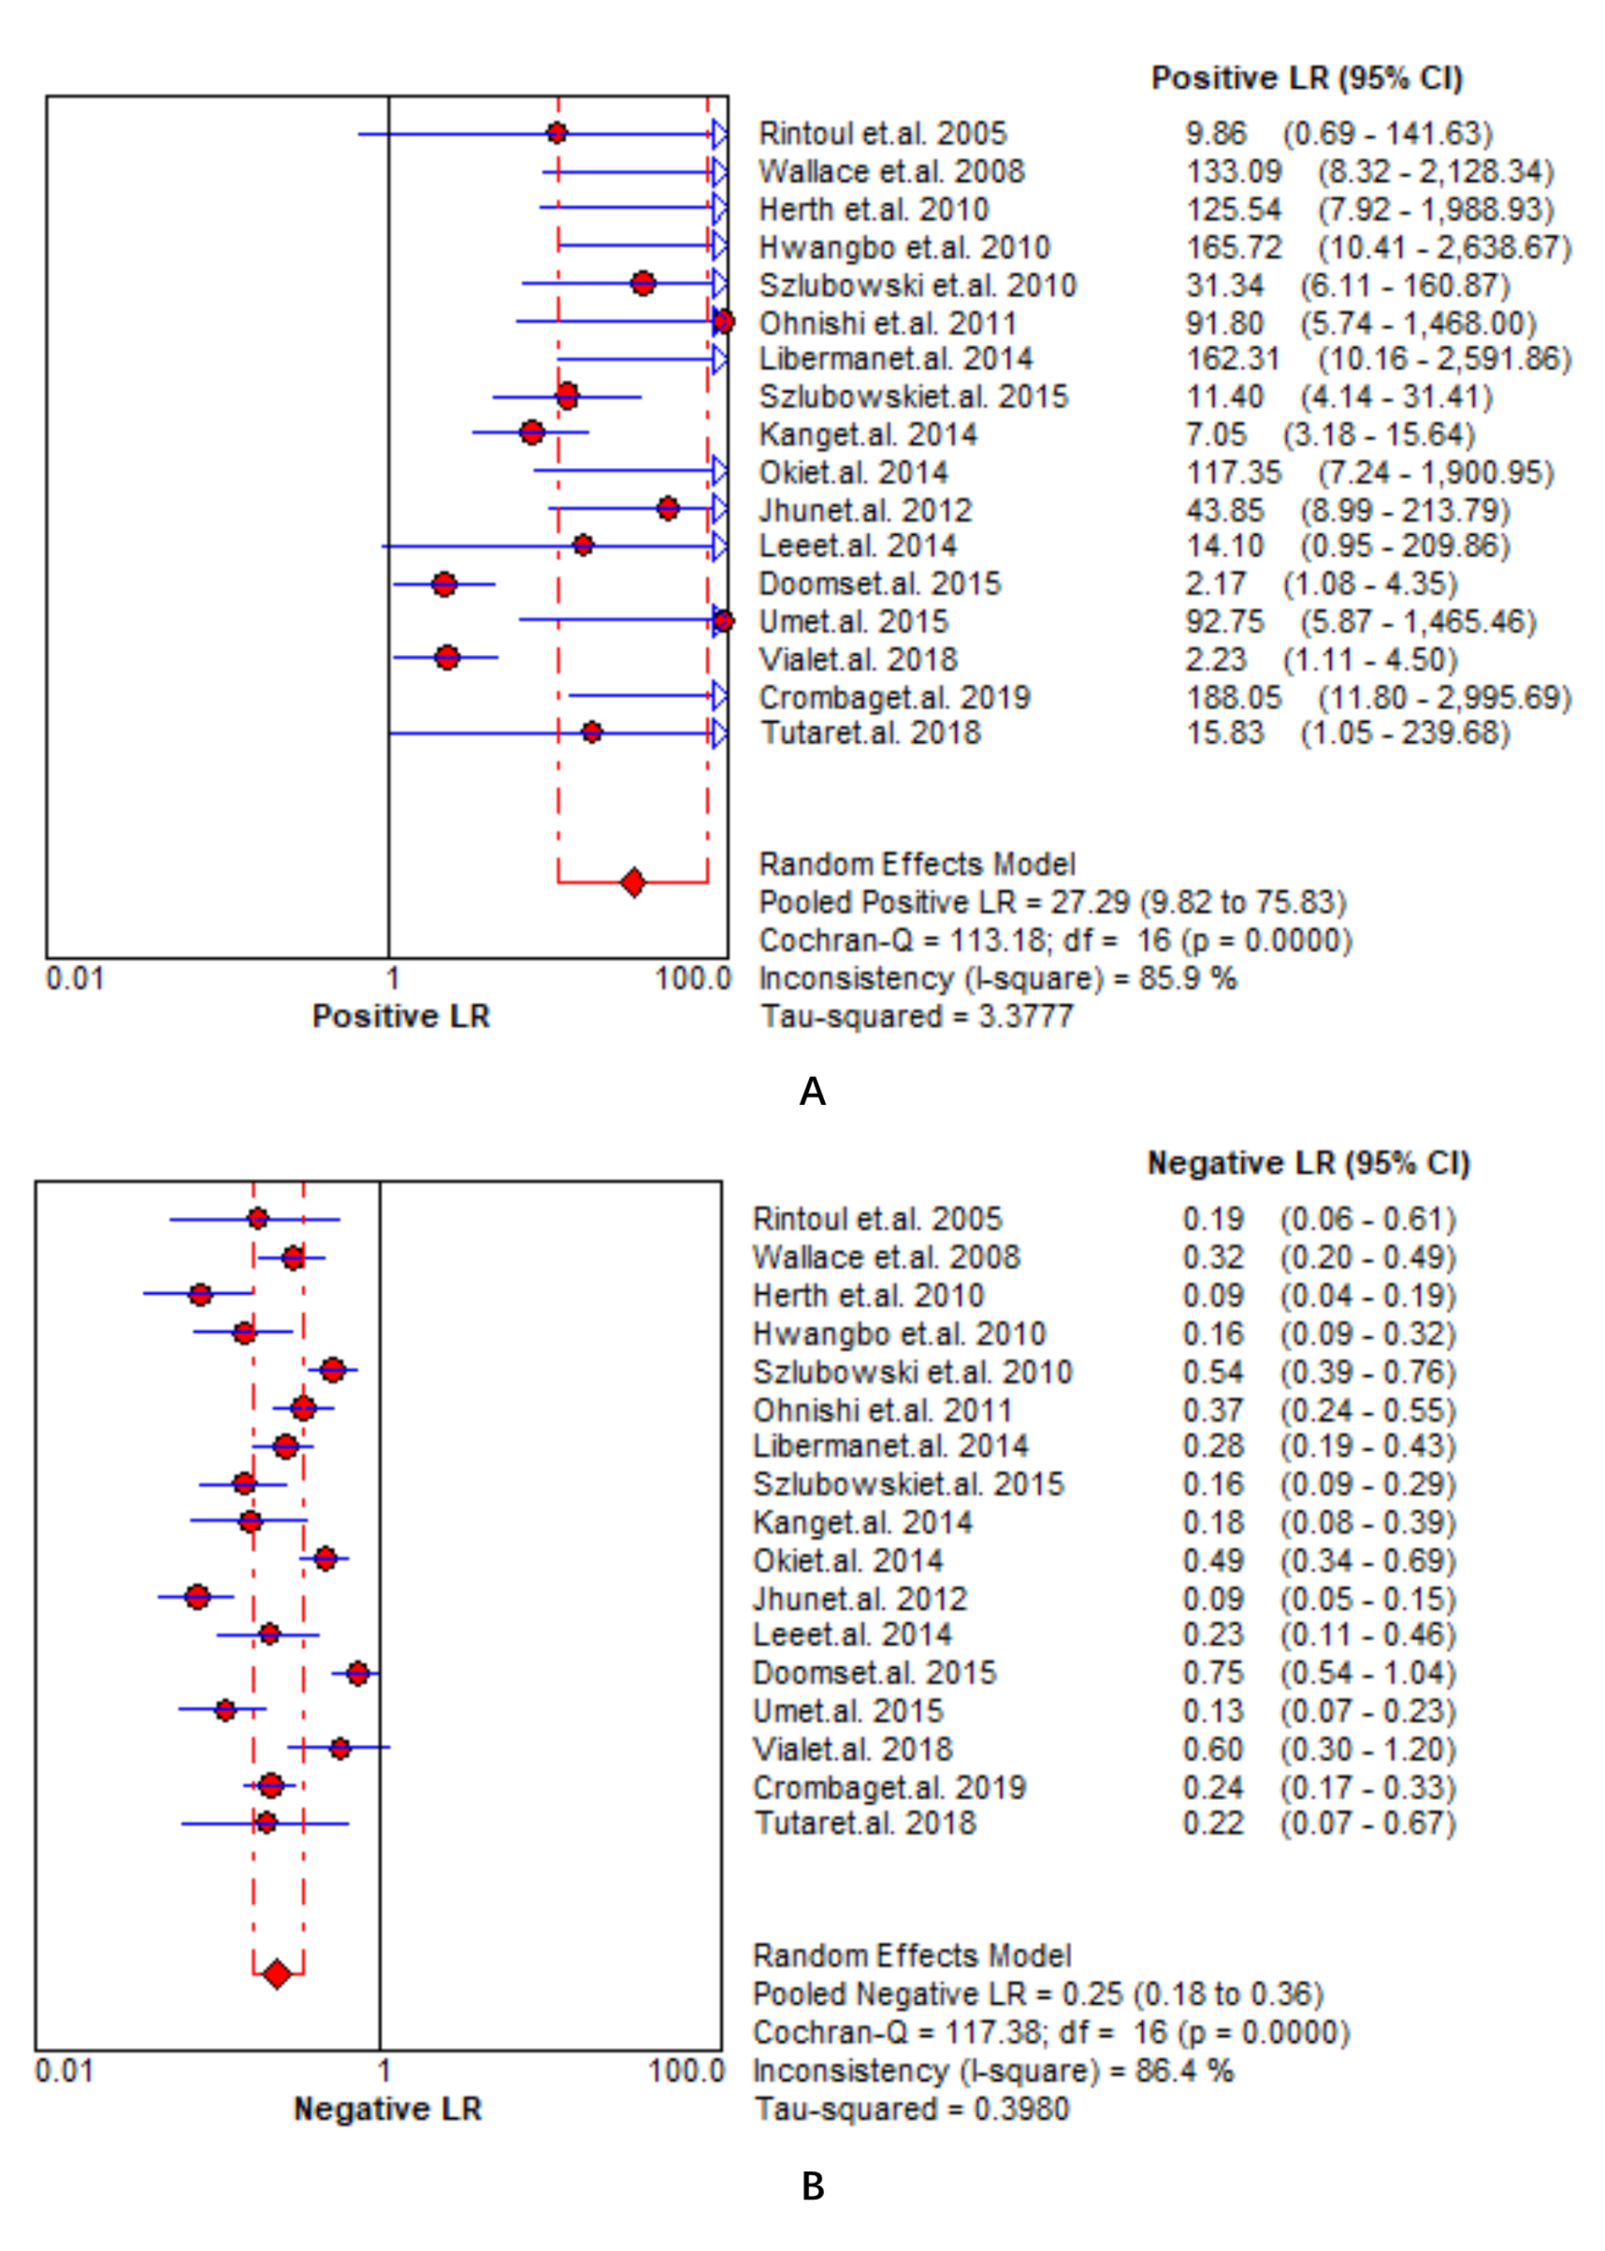

Figure S1. Summary of pooled PLR and NLR of EBUS.

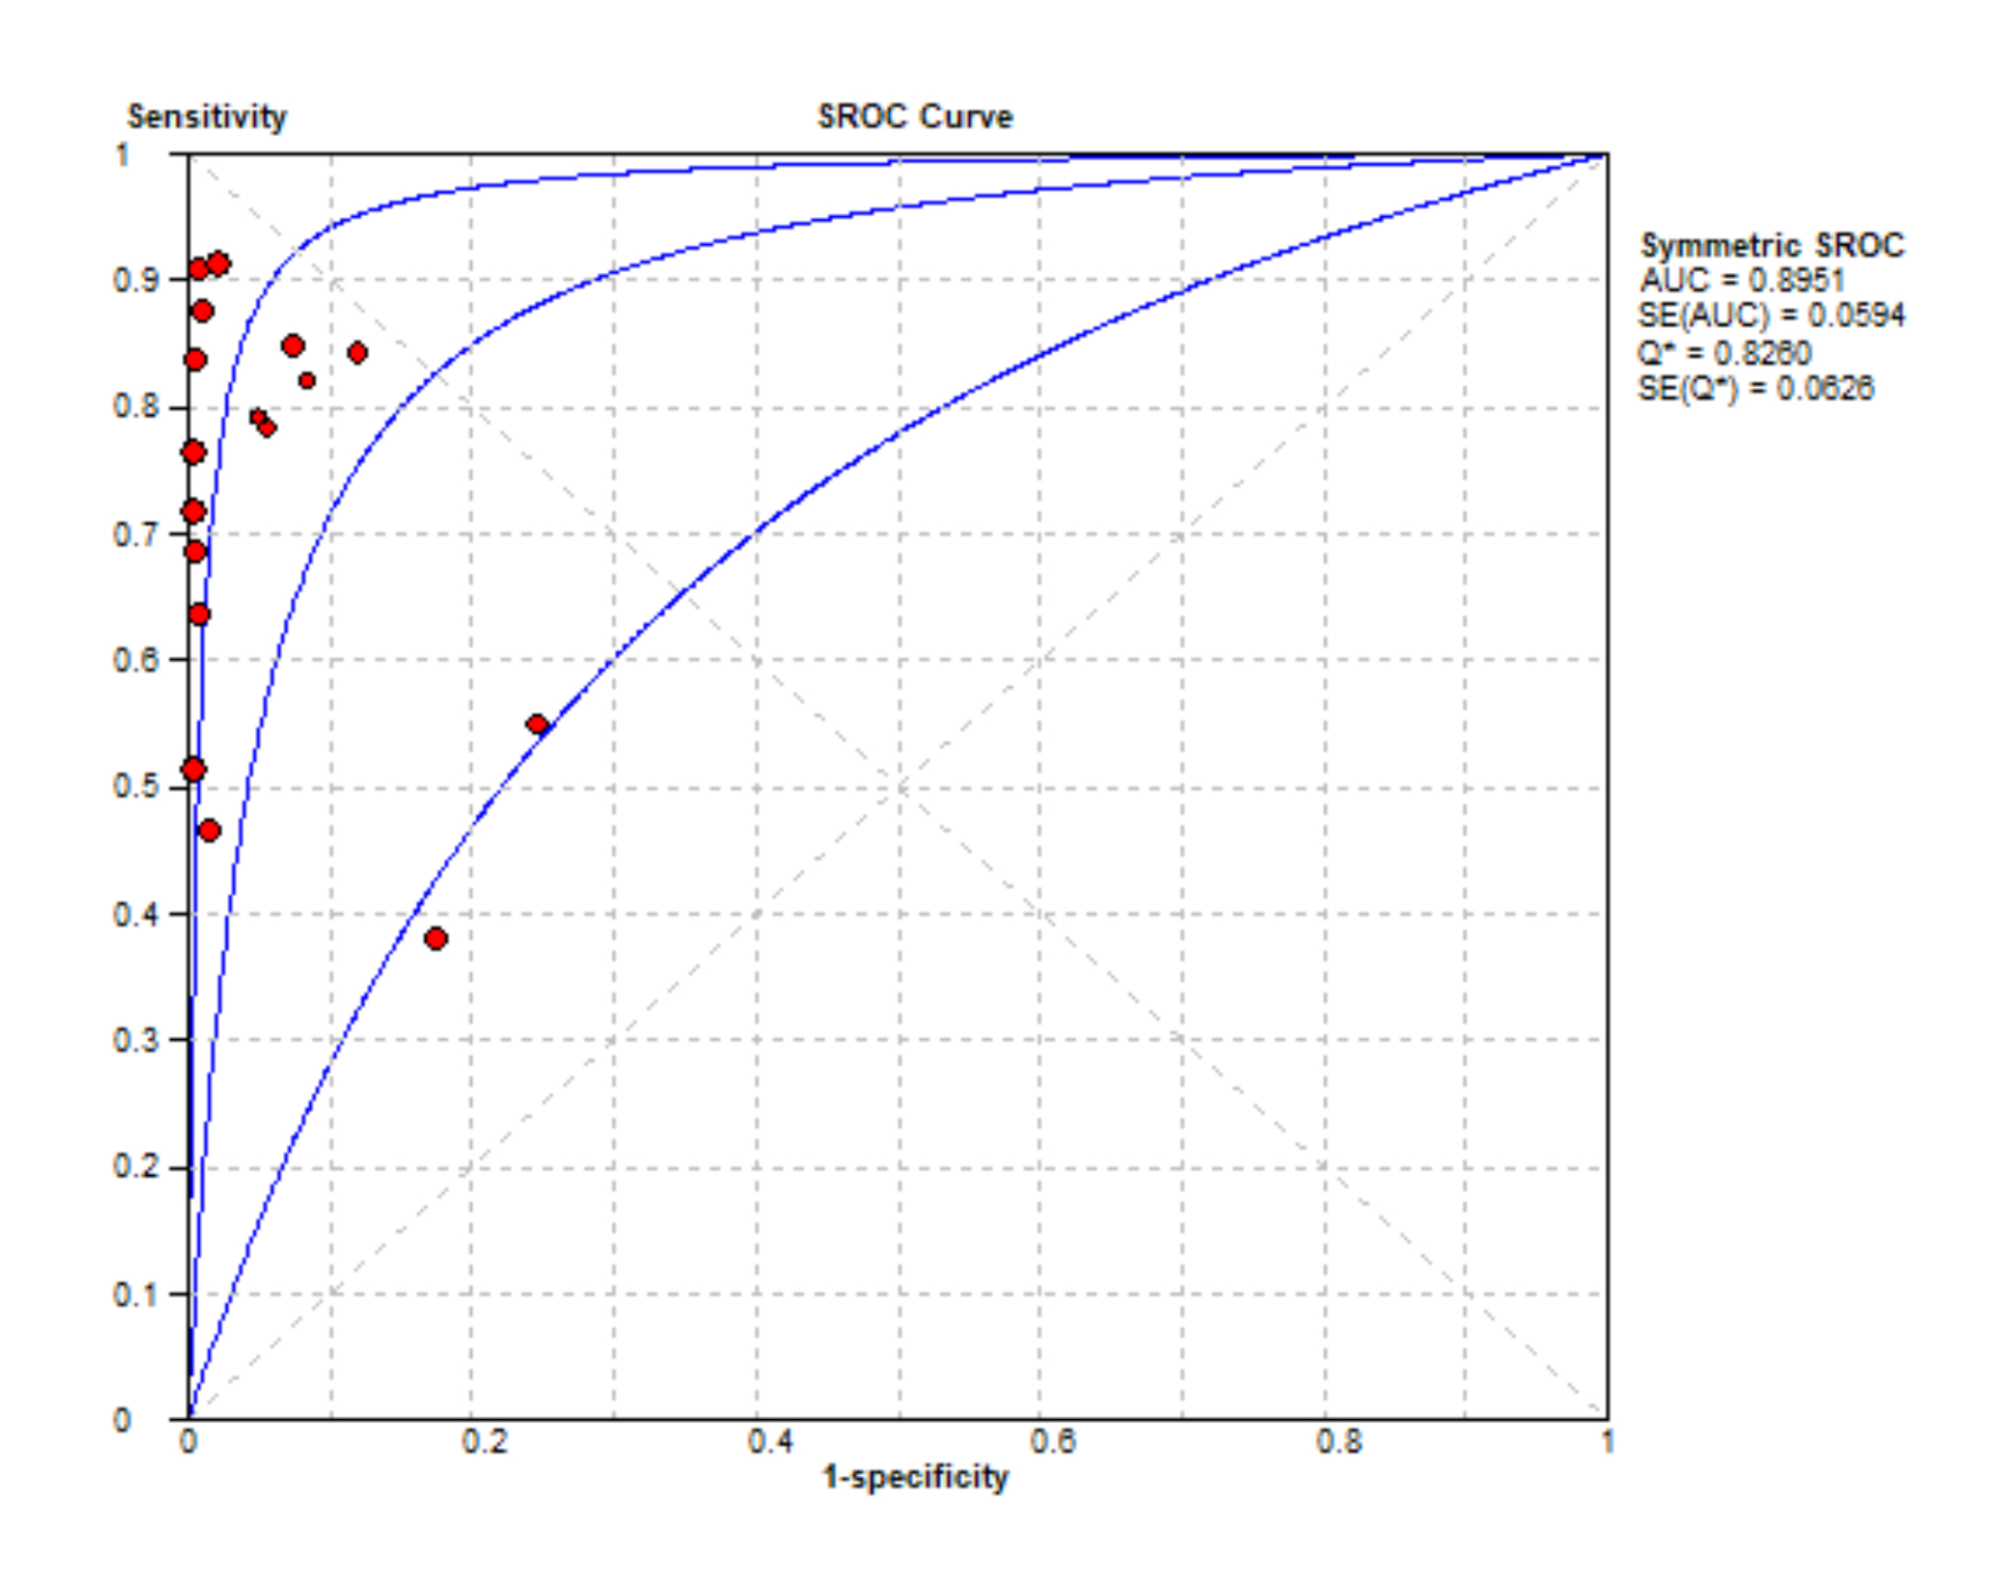

Figure S2. Summary of pooled AUC of EBUS.

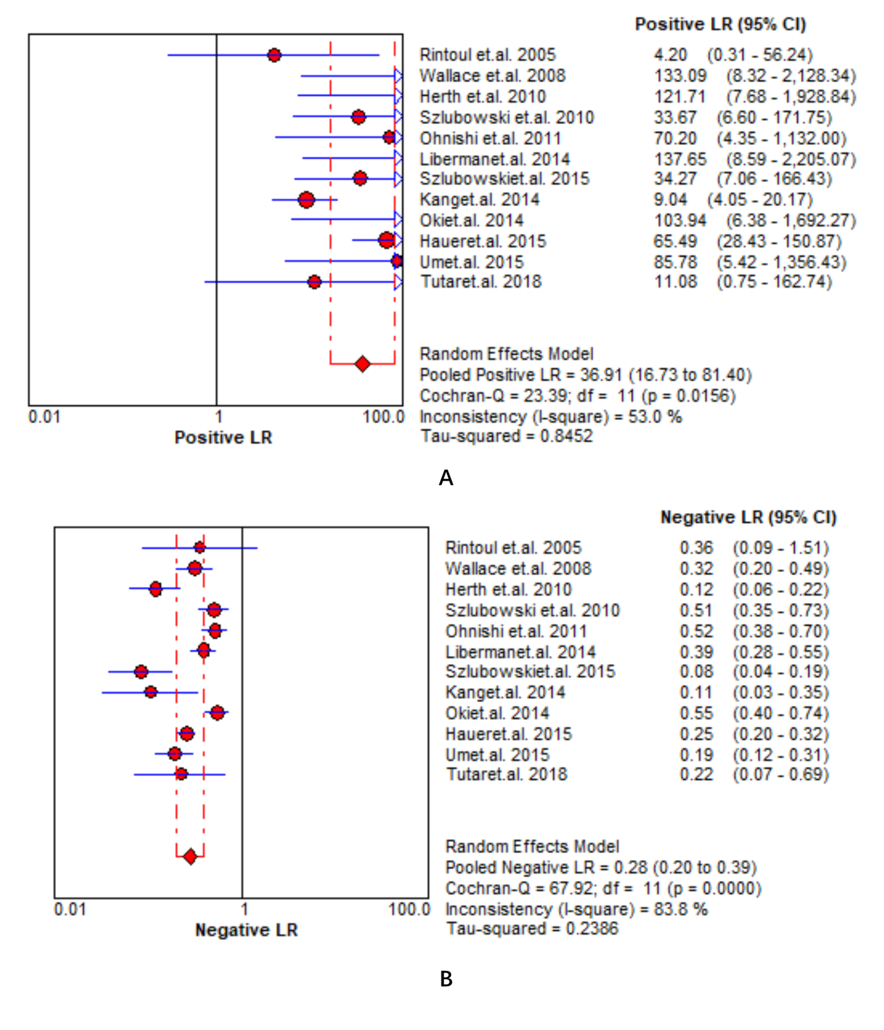

Figure S3. Summary of pooled PLR and NLR of EUS.

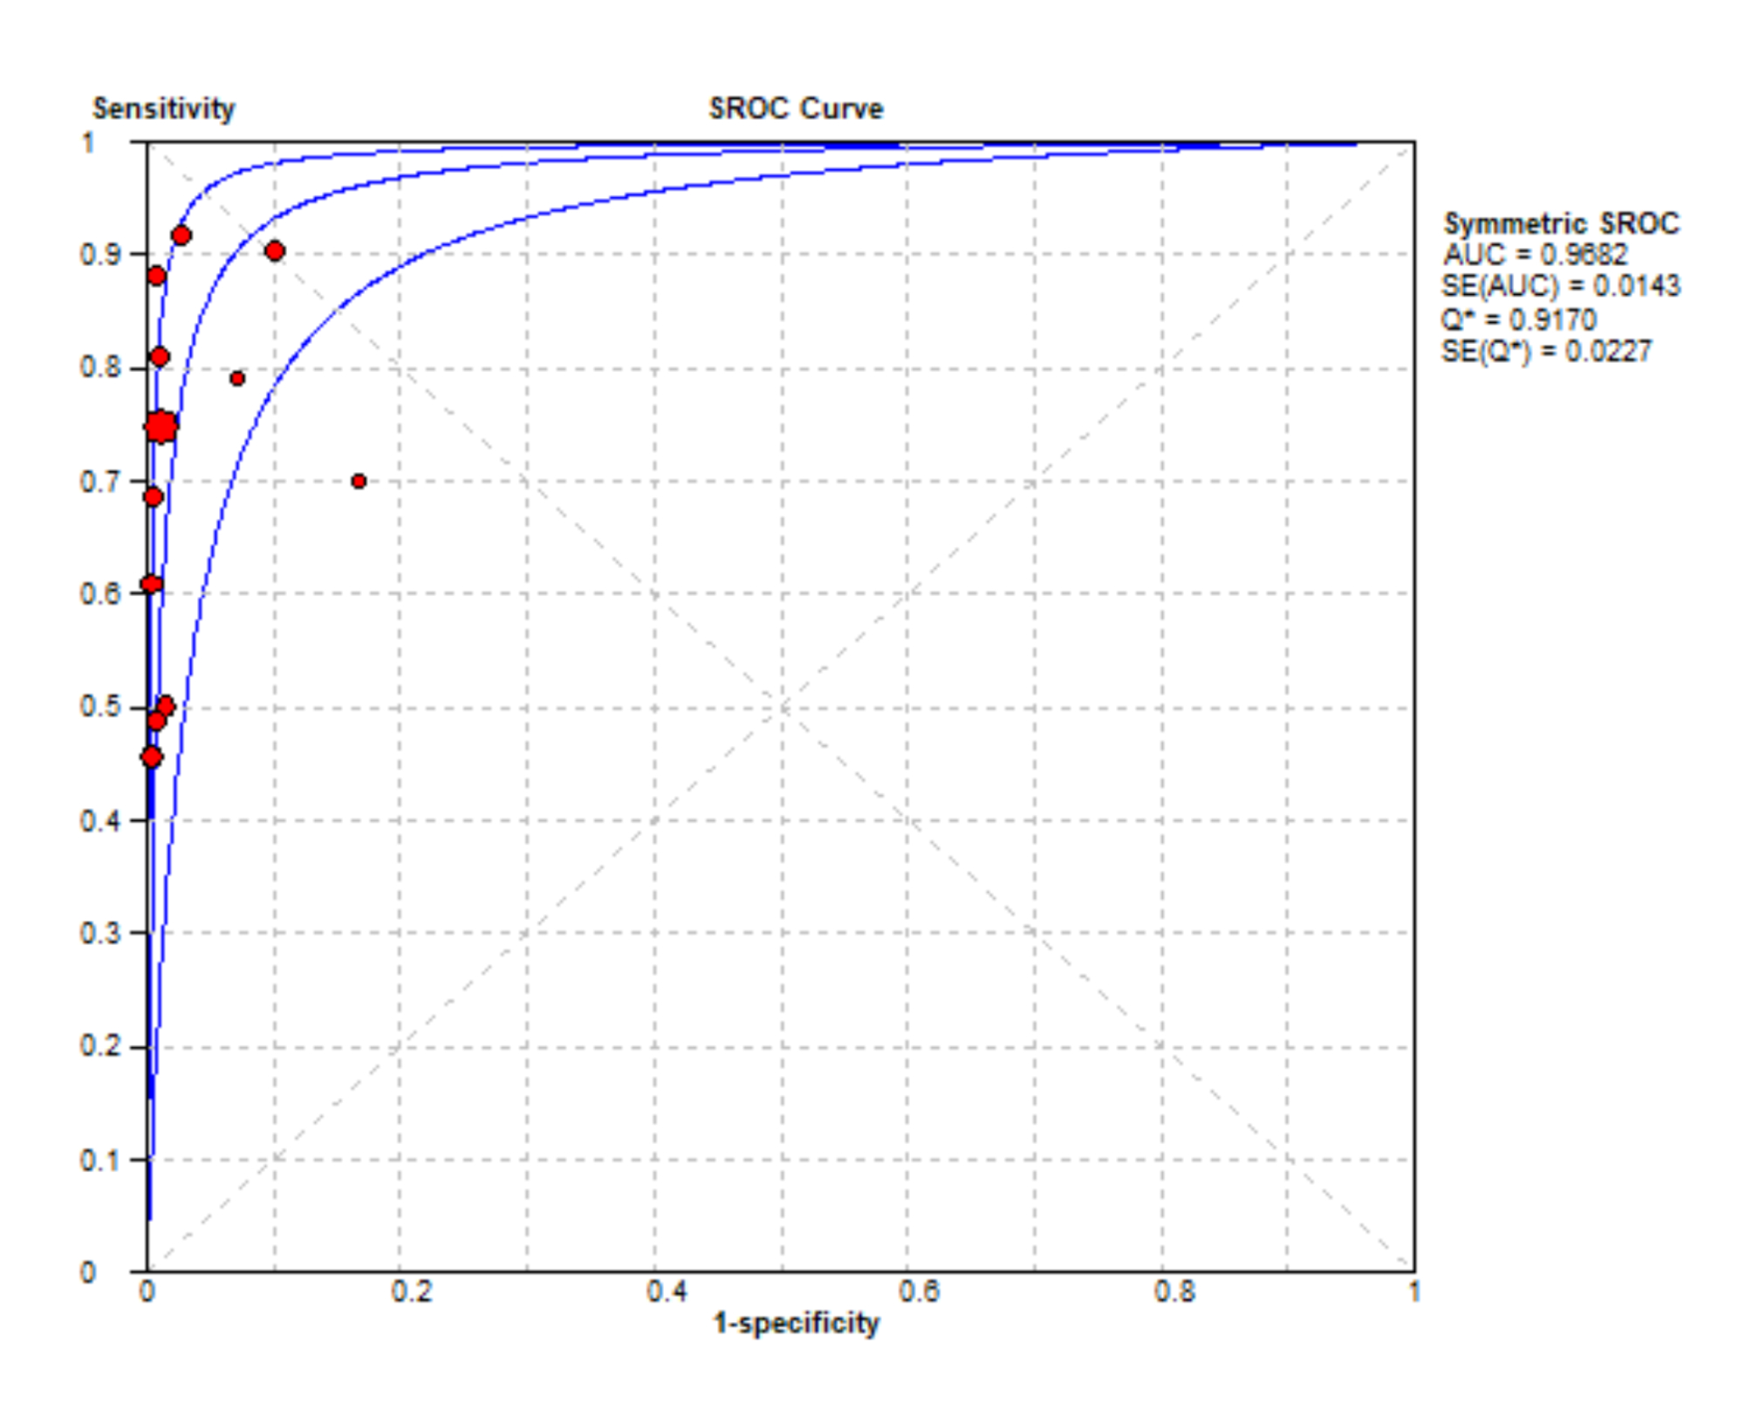

Figure S4. Summary of pooled AUC of EUS.

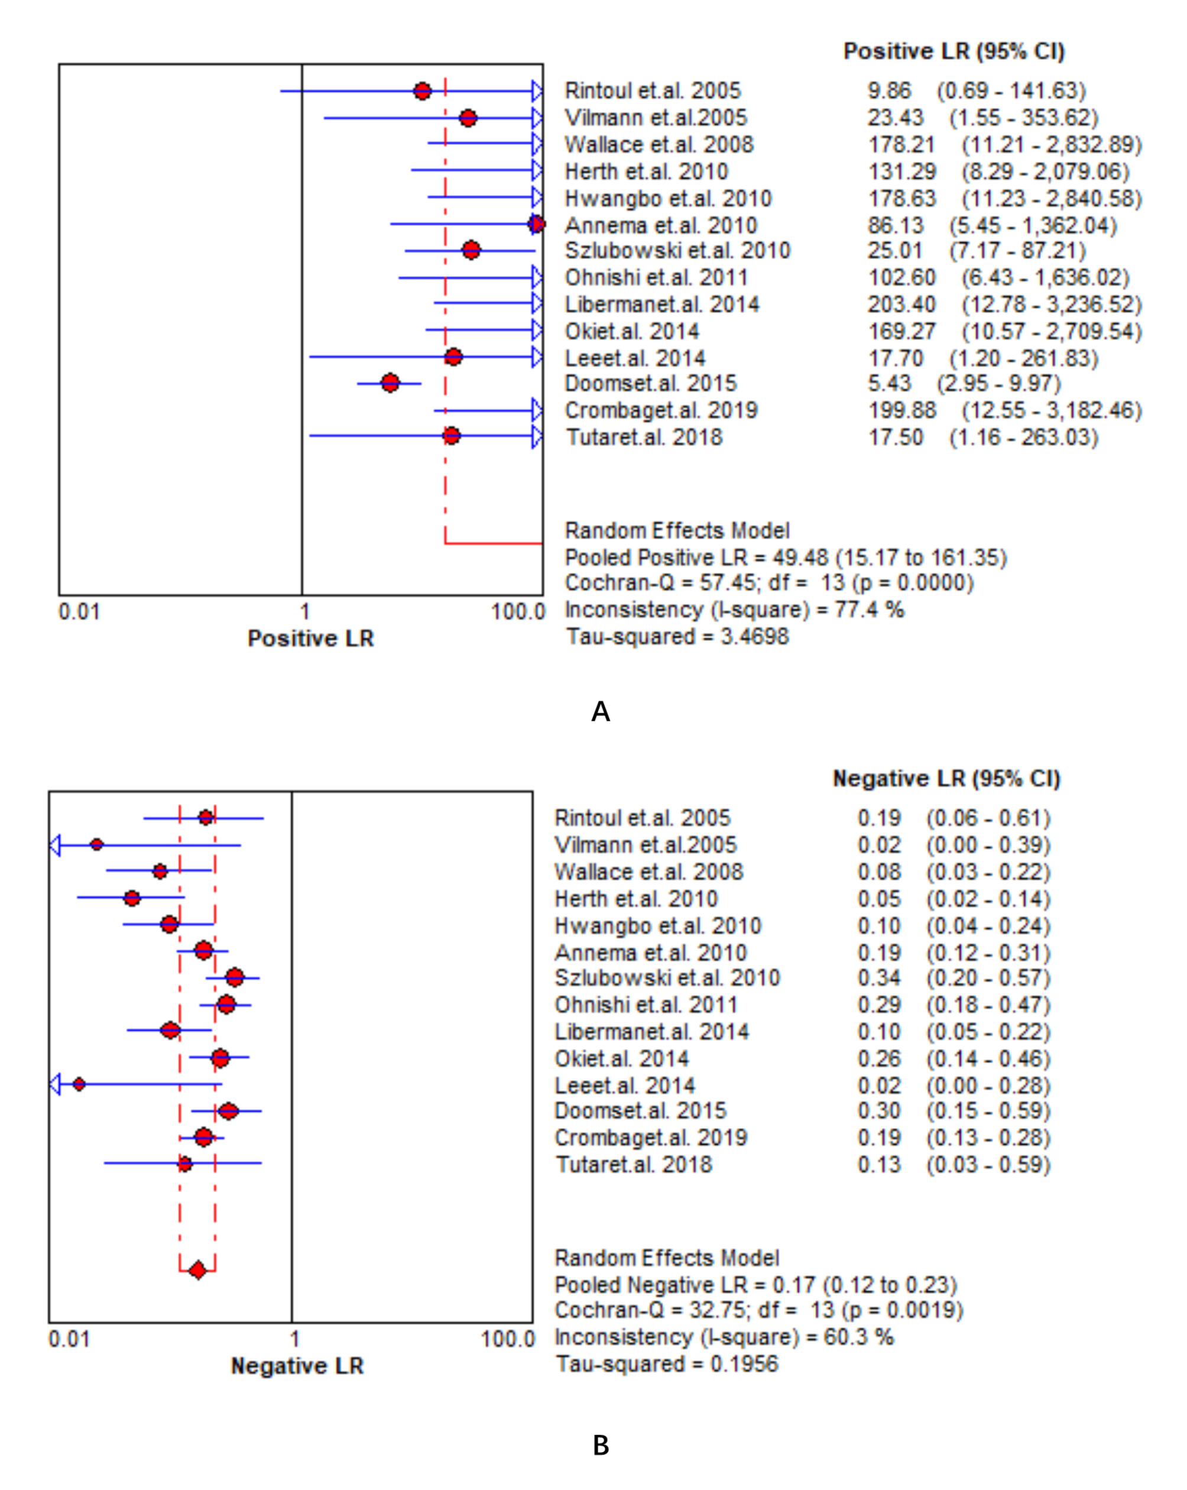

Figure S5. Summary of pooled PLR and NLR of EBUS and EUS.

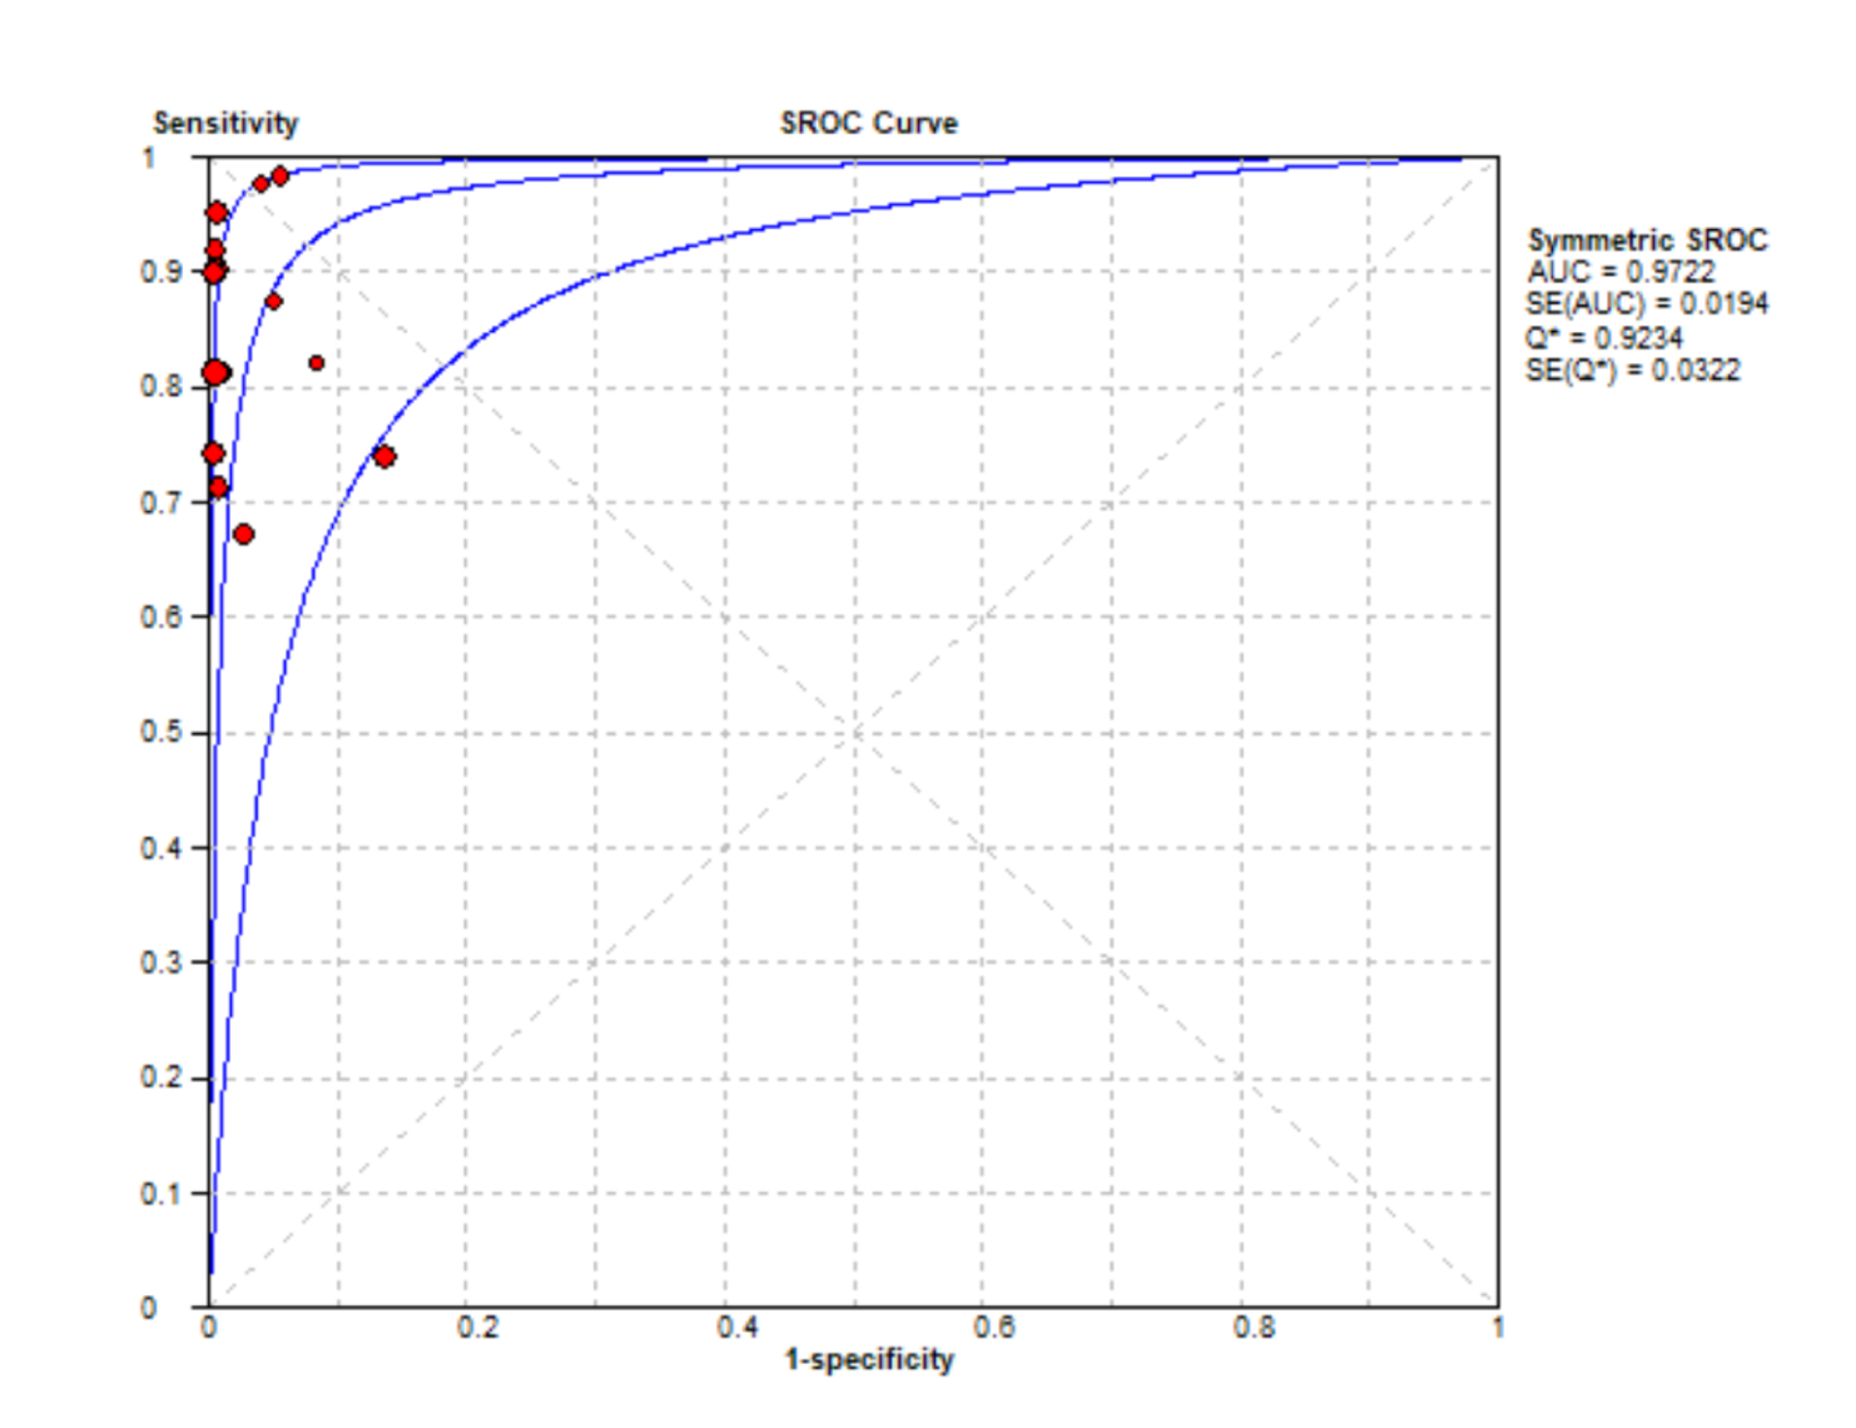

Figure S6. Summary of pooled AUC of EBUS and EUS.

