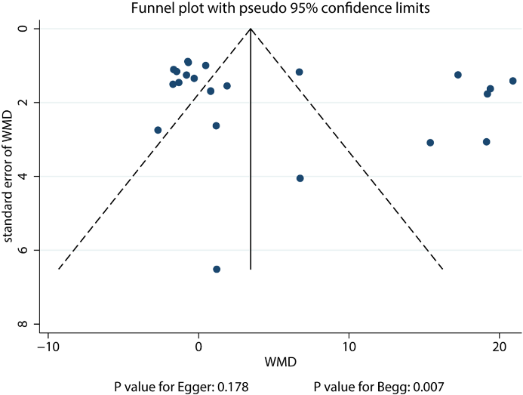
Figure S1. Funnel plot for BCVA.
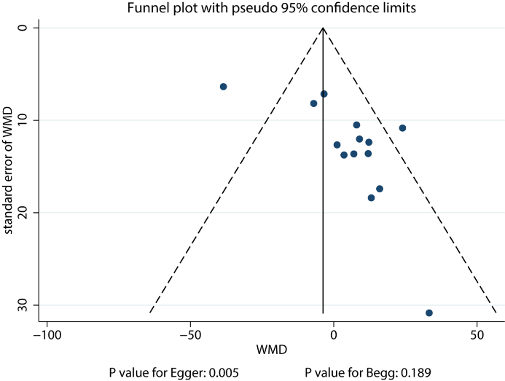
Figure S2. Funnel plot for central macular thickness.
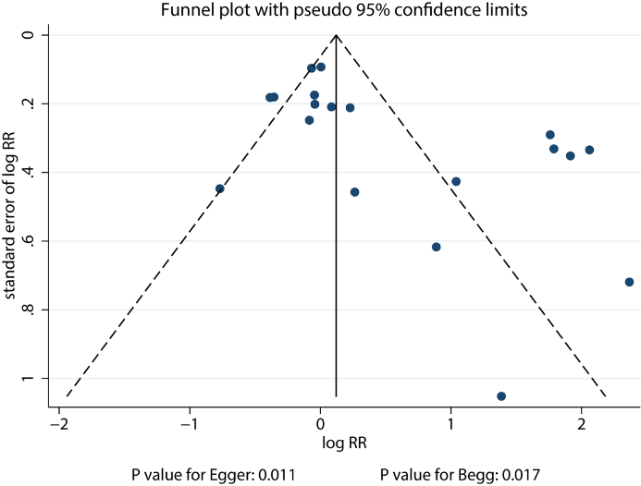
Figure S3. Funnel plot for gain of 15 or more letters visual acuity.
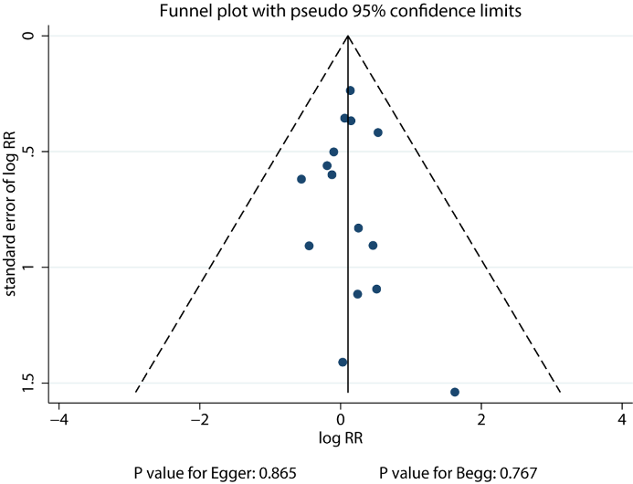
Figure S4. Funnel plot for death.
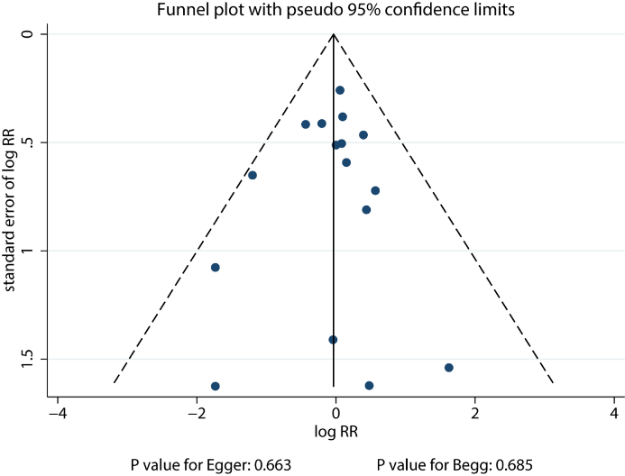
Figure S5. Funnel plot for arteriothrombotic events.

