SUPPLEMENTARY MATERIAL
Supplemental Table 1. Search strategy used in each database searched
Database (Articles Retrieved) | Search Strategy
MEDLINE  (16,385 results) | (("coronary artery disease"[MeSH Terms] OR ("coronary"[All Fields] AND "artery"[All Fields] AND "disease"[All Fields]) OR "coronary artery disease"[All Fields] OR ("Left"[All Fields] AND "main"[All Fields] AND "disease"[All Fields]) OR "left main disease"[All Fields] OR ("Left"[All Fields] AND "main"[All Fields] AND ("constriction, pathologic"[MeSH Terms] OR ("constriction"[All Fields] AND "pathologic"[All Fields]) OR "pathologic constriction"[All Fields] OR "stenosi"[All Fields] OR "stenosis"[All Fields])) OR ("Left"[All Fields] AND "main"[All Fields] AND ("coronary stenosis"[MeSH Terms] OR ("coronary"[All Fields] AND "stenosis"[All Fields]) OR "coronary stenosis"[All Fields] OR ("coronary"[All Fields] AND "artery"[All Fields] AND "stenosis"[All Fields]) OR "coronary artery stenosis"[All Fields])) OR ("LMCA"[All Fields] AND ("constriction, pathologic"[MeSH Terms] OR ("constriction"[All Fields] AND "pathologic"[All Fields]) OR "pathologic constriction"[All Fields] OR "stenosi"[All Fields] OR "stenosis"[All Fields])) OR ("unprotected"[All Fields] AND "Left"[All Fields] AND "main"[All Fields] AND ("constriction, pathologic"[MeSH Terms] OR ("constriction"[All Fields] AND "pathologic"[All Fields]) OR "pathologic constriction"[All Fields] OR "stenosi"[All Fields] OR "stenosis"[All Fields])) OR ("ULM"[All Fields] AND ("constriction, pathologic"[MeSH Terms] OR ("constriction"[All Fields] AND "pathologic"[All Fields]) OR "pathologic constriction"[All Fields] OR "stenosi"[All Fields] OR "stenosis"[All Fields])) OR "ULMCAD"[All Fields] OR ("ULMCA"[All Fields] AND ("disease"[MeSH Terms] OR "disease"[All Fields] OR "diseases"[All Fields] OR "disease s"[All Fields] OR "diseased"[All Fields])) OR ("unprotected"[All Fields] AND ("coronary artery disease"[MeSH Terms] OR ("coronary"[All Fields] AND "artery"[All Fields] AND "disease"[All Fields]) OR "coronary artery disease"[All Fields] OR ("Left"[All Fields] AND "main"[All Fields] AND "disease"[All Fields]) OR "left main disease"[All Fields])) OR ("ULM"[All Fields] AND ("disease"[MeSH Terms] OR "disease"[All Fields] OR "diseases"[All Fields] OR "disease s"[All Fields] OR "diseased"[All Fields])) OR ("LM"[All Fields] AND ("disease"[MeSH Terms] OR "disease"[All Fields] OR "diseases"[All Fields] OR "disease s"[All Fields] OR "diseased"[All Fields]))) AND ("percutaneous coronary intervention"[MeSH Terms] OR ("percutaneous"[All Fields] AND "coronary"[All Fields] AND "intervention"[All Fields]) OR "percutaneous coronary intervention"[All Fields] OR "PCI"[All Fields] OR (("percutaneous"[All Fields] OR "percutaneously"[All Fields] OR "percutanous"[All Fields]) AND ("revascularisation"[All Fields] OR "revascularisations"[All Fields] OR "revascularise"[All Fields] OR "revascularised"[All Fields] OR "revascularising"[All Fields] OR "revascularization"[All Fields] OR "revascularizations"[All Fields] OR "revascularize"[All Fields] OR "revascularized"[All Fields] OR "revascularizes"[All Fields] OR "revascularizing"[All Fields])) OR ("angioplasty, balloon, coronary"[MeSH Terms] OR ("angioplasty"[All Fields] AND "balloon"[All Fields] AND "coronary"[All Fields]) OR "coronary balloon angioplasty"[All Fields] OR ("percutaneous"[All Fields] AND "transluminal"[All Fields] AND "coronary"[All Fields] AND "angioplasty"[All Fields]) OR "percutaneous transluminal coronary angioplasty"[All Fields]) OR ("angioplasty, balloon, coronary"[MeSH Terms] OR ("angioplasty"[All Fields] AND "balloon"[All Fields] AND "coronary"[All Fields]) OR "coronary balloon angioplasty"[All Fields] OR "ptca"[All Fields]) OR (("coronaries"[All Fields] OR "heart"[MeSH Terms] OR "heart"[All Fields] OR "coronary"[All Fields]) AND ("stent s"[All Fields] OR "stentings"[All Fields] OR "stents"[MeSH Terms] OR "stents"[All Fields] OR "stent"[All Fields] OR "stented"[All Fields] OR "stenting"[All Fields]))) AND ("coronary artery bypass"[MeSH Terms] OR ("coronary"[All Fields] AND "artery"[All Fields] AND "bypass"[All Fields]) OR "coronary artery bypass"[All Fields] OR ("coronary"[All Fields] AND "artery"[All Fields] AND "bypass"[All Fields] AND "graft"[All Fields]) OR "coronary artery bypass graft"[All Fields] OR "CABG"[All Fields] OR (("surgical procedures, operative"[MeSH Terms] OR ("surgical"[All Fields] AND "procedures"[All Fields] AND "operative"[All Fields]) OR "operative surgical procedures"[All Fields] OR "surgical"[All Fields] OR "surgically"[All Fields] OR "surgicals"[All Fields]) AND ("revascularisation"[All Fields] OR "revascularisations"[All Fields] OR "revascularise"[All Fields] OR "revascularised"[All Fields] OR "revascularising"[All Fields] OR "revascularization"[All Fields] OR "revascularizations"[All Fields] OR "revascularize"[All Fields] OR "revascularized"[All Fields] OR "revascularizes"[All Fields] OR "revascularizing"[All Fields])) OR (("bypass"[All Fields] OR "bypassed"[All Fields] OR "bypasses"[All Fields] OR "bypassing"[All Fields]) AND ("surgery"[MeSH Subheading] OR "surgery"[All Fields] OR "surgical procedures, operative"[MeSH Terms] OR ("surgical"[All Fields] AND "procedures"[All Fields] AND "operative"[All Fields]) OR "operative surgical procedures"[All Fields] OR "general surgery"[MeSH Terms] OR ("general"[All Fields] AND "surgery"[All Fields]) OR "general surgery"[All Fields] OR "surgery s"[All Fields] OR "surgerys"[All Fields] OR "surgeries"[All Fields])))) AND (1000/1/1:2021/4/25[pdat])
TRIP Database  (1,489 results) | (Left main disease OR Left main stenosis OR Left main coronary artery stenosis OR LMCA stenosis OR unprotected left main stenosis or ULM stenosis OR ULMCAD OR ULMCA disease OR unprotected left main disease or ULM disease OR LM disease) AND (Percutaneous Coronary Intervention OR PCI OR Percutaneous Revascularization OR Percutaneous Transluminal Coronary Angioplasty OR PTCA OR coronary stent) AND (Coronary Artery Bypass graft OR CABG OR Surgical revascularization OR Bypass surgery).
Cochrane Central  (440 results) | (Left main disease OR Left main stenosis OR Left main coronary artery stenosis OR LMCA stenosis OR unprotected left main stenosis or ULM stenosis OR ULMCAD OR ULMCA disease OR unprotected left main disease or ULM disease OR LM disease) AND (Percutaneous Coronary Intervention OR PCI OR Percutaneous Revascularization OR Percutaneous Transluminal Coronary Angioplasty OR PTCA OR coronary stent) AND (Coronary Artery Bypass graft OR CABG OR Surgical revascularization OR Bypass surgery).

Supplemental Table 2. Quality Assesment of included Observational Studies using NewCastle-Ottawa Scale
 | Selection |  |  |  | Comparability | Outcome
Study | Representativeness of the exposed cohort | Selection of the non-exposed cohort | Ascertainment of exposure | Demonstration that the current outcome of interest was not present at start of the study | Comparability of cohorts on the basis of the design or analysis | Assessment of outcome | Was follow-up long enough for outcomes to occur | Adequacy of follow-up of cohorts | Quality Score
Palmerini 2006¹⁵ | * | * | * |  | ** |  | * | * | 8
Palmerini 2007¹⁶ | * |  | * | * | * | * |  | * | 6
Lee¹⁷ | * | * |  |  | * | * | * | * | 6
Sanmartin¹⁸ | * | * | * | * | ** | * | * | * | 9
Brener¹⁹ | * | * | * | * | ** | * | * | * | 7
C Wu²⁰ |  | * |  | * | ** | * | * |  | 6
MAIN-COMPARE²³⁻²⁶ | * | * |  | * | * |  | * |  | 5
Makkikalio²⁷ | * | * | * | * | ** | * | * | * | 9
Rittger²⁸ |  | * | * | * | * | * |  |  | 5
Rodes-Cabau²⁹ | * |  | * | * | * | * | * | * | 7
White³⁰ | * | * |  | * | ** | * | * | * | 8
Cheng³¹ |  |  | * | * | ** | * |  | * | 6
Ghenim³² | * | * |  | * | ** |  |  | * | 6
ASAN-MAIN (BMS)³³ | * | * | * |  | ** |  | * | * | 7
ASAN-MAIN (DES)³³ | * | * | * | * | * | * | * |  | 7
Chieffo³⁴ | * | * | * | * | ** | * | * | * | 9
Kang³⁵ | * | * | * | * | * | * | * |  | 7
Shimizu³⁶ | * | * | * | * | * | * | * | * | 8
Wu⁴¹ | * | * |  | * | * |  | * | * | 6
Asan Multivessel⁴² | * | * | * | * | ** | * | * | * | 8
CUSTOMIZE^{44,45} | * | * | * | * | ** | * | * | * | 9
Zhao⁴⁹ | * | * |  | * | * | * |  | * | 5
Chang⁵⁰ |  | * | * | * | ** | * | * |  | 7
CREDO-KYOTO^{51,52} | * | * | * | * | * | * | * | * | 8
DELTA⁵³ | * | * |  | * | ** | * |  | * | 6
Kawecki⁵⁴ | * | * | * | * | * | * | * | * | 8
Yi⁵⁵ | * | * |  | * | ** |  | * | * | 7
Gao⁵⁶ | * | * |  | * | * | * | * | * | 7
Jeong⁵⁷ | * | * | * |  | * | * | * |  | 6
Qin⁵⁸ |  | * | * | * | * | * | * | * | 7
Yin⁵⁹ | * | * | * | * | * | * | * | * | 8
Lu⁶² | * | * | * |  | ** | * | * | * | 8
Wei⁶⁵ | * | * |  |  | * | * | * | * | 6
Yu⁶⁶ | * | * | * | * | * | * | * | * | 8
Zheng⁶⁷ | * |  | * | * | * | * | * | * | 6
IRIS-MAIN^{68,69} | * | * | * |  | ** | * | * | * | 8
Coughlan⁷⁰ | * | * | * | * | * |  | * | * | 7
Gripenburg⁷¹ | * | * | * |  | * | * | * | * | 7
Lin⁷² | * |  |  | * | * | * | * | * | 6
Lopez-Aguilar⁷³ | * |  |  | * | ** | * | * |  | 6
Ram⁷⁵ | * |  |  | * | ** |  | * |  | 5
Su⁷⁶ | * | * | * | * | * | * | * | * | 8
Milan⁷⁷ | * | * | * | * | ** | * | * | * | 9
Slim⁷⁸ | * | * | * | * | * |  | * |  | 6
Sliman⁷⁹ | * |  | * | * | * |  | * |  | 5
Trasca⁸⁰ |  | * | * | * | * |  | * | * | 4
Joy⁸¹ | * |  |  | * | * |  | * |  | 5
Pan⁸² |  | * | * | * | * |  | * | * | 5
Song⁸³ |  |  |  | * | ** | * | * | * | 7
Mohamed⁸⁴ |  | * | * |  | * | * |  | * | 6

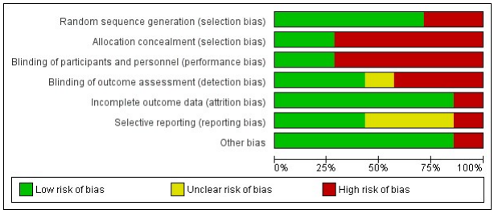
Supplemental Figure 1a. Quality Assessment of included Randomized Controlled Trials using Cochrane Risk of Bias Tool

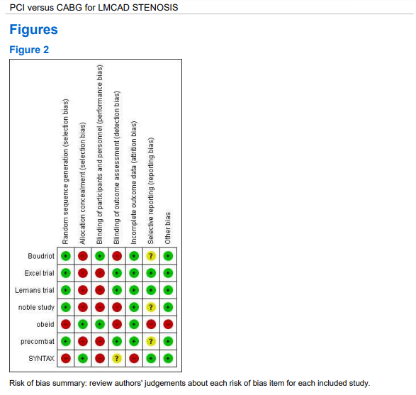
Supplemental Figure 1b. Quality Assessment of included Randomized Controlled Trials using Cochrane Risk of Bias Tool
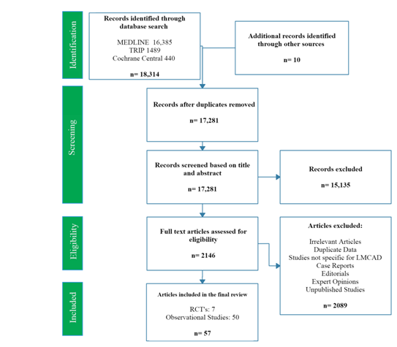
Supplemental Figure 2. PRISMA Flow Diagram
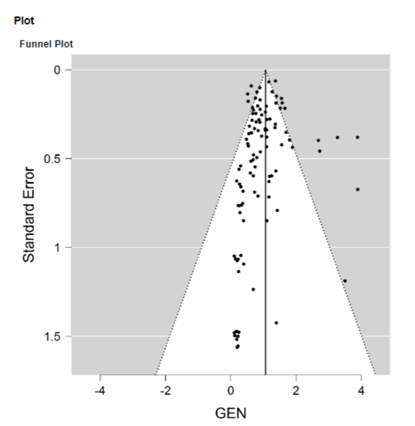
Supplemental Figure 3. Funnel Plot to assess publication bias

Supplemental Table 3. Baseline Characteristics of the patients
Author | Mean Age† |  | Male (%)  PCI / CABG | DM (%)  PCI / CABG | HTN (%)  PCI / CABG |  | HL (%)  PCI / CABG | Current or Previous  Smokers (%)  PCI / CABG |  | SYNTAX Score† (Mean) |  |  | EuroSCORE†  (Mean) |  | Stent  Type
Author | PCI CABG |  |  |  |  |  |  |  |  | PCI CABG |  |  | PCI CABG |  | Stent  Type
Palmerini 2006¹⁵ | 73.0 ± 10.9 | 69.3 ± 9.5 | 70.1 / 76 | 26.1 / 25.3 | 69.4 / 72.7 |  | 62.4 / 72.1 | 48.4 / 48.1 |  | - | - |  | 6 (0-18) | 5 (0-14) | BMS/PES/SES
Palmerini 2007¹⁶ | 81 (75-95) | 78 (75-88) | 54 / 66 | 31 / 26 | 77 / 73 |  | 53 / 47 | 39 / 39 |  | - | - |  | 8 (4–18) | 7 (3–14) | DES
Lee¹⁷ | 72 ± 15 | 70 ± 10 | 50 / 76 | 36 / 31 | 88 / 81 |  | 74 / 72 | 12 / 19 |  | - | - |  | - | - | PES / SES
Sanmartín¹⁸ | 66.0 ± 12.5 | 66.0 ±10.2 | 81 / 87 | 19 / 32 | 44.2 / 60.2 |  | 42 / 46 | 38.5 / 45.5 |  | - | - |  | 4.0 ± 2.5 | 3.9 ± 3.0 | PES / SES
Brener¹⁹ | 68 ± 11 | 68 ± 10 | 72 / 74 | 42 / 25 | 82 / 74 |  | - / - | 11 / 57 |  | - | - |  | 4.6 ± 2.2 | 4.5 ± 2.4 | SES / PES
C Wu²⁰ | 68.6 ± 11.4 | 68.9 ± 10.8 | 69.6 / 69.6 | 21.5 / 20.7 | - / - |  | - / - | - / - |  | - | - |  | - | - | BMS / DES
LEMANS Trial^{21,22} | 60.6 ± 10.5 | 61.3 ± 8.4 | 60 / 73 | 19 / 17 | 75 / 70 |  | 65 / 60 | - / - |  | 25.2 ± 8.7 | 24.7 ± 6.8 |  | 3.3 ± 2.3 | 3.5 ± 2.3 | BMS / DES
MAIN-COMPARE²³⁻²⁶ | 61.3±11.7 | 62.9±9.4 | 70.7 / 72.9 | 29.7 / 34.7 | 28.6 / 32.6 |  | 25.6 / 29.8 | 49.5 /49.4 |  | - | - |  | - | - | BMS / DES
Makkikalio²⁷ | 72.9 ± 10 | 70 ± 9 | 59 / 80 | 20 / 17 | 46 / 46 |  | - / - | 20 / 18 |  | - | - |  | 7.7 ± 7.5 | 5.2 ± 4.4 | SES / PES
Rittger²⁸ | 71.6 ± 9.89 | 68.7 ± 8.99 | 70. 5 / 76.1 | 36.8 / 33.2 | 88.4 / 60.5 |  | 56.8 / 94.6 | - / - |  | - | - |  | 5.07 ± 4.88 | 5.40 ± 6.15 | DES
Rodes-Cabau²⁹ | 85 ± 3 | 82 ± 2 | 54 / 63 | 27 / 26 | 75 / 72 |  | 61 / 82 | 3 / 6 |  | - | - |  | 9.5 ± 2.6 | 8.4 ± 2.6 | PES/SES/BMS
White³⁰ | 68.6 ± 13.2 | 72.2 ± 11.9 | 66 / 63 | 34 / 31 | 73 / 78 |  | 78 / 75 | 21 / 12 |  | - | - |  | - | - | SES / PES
Cheng³¹ | 68.0 ± 10.4 | 68.0 ± 10.4 | 73.5 / 75.9 | 39.5 / 50.5 | 70.7 / 72.7 |  | 68 / 45.8 | 22.4 / 30.6 |  | - | - |  | 7.4 ± 3.8 | 6.4 ± 3.3 | BMS/SES/PES
Ghenim³² | 80.7 ± 3.5 | 79.6 ± 3.5 | 36.2 / 28.3 | 30.5 / 23.6 | 73.3 / 65.1 |  | 63.8 / 41.5 | 20 / 24.5 |  | - | - |  | 8 (6-9) | 7 (6-8) | PES
ASAN-MAIN (BMS)³³ | 55.1 ± 10.4 | 60.7 ± 9.1 | 60 / 74.4 | 21 / 32.8 | 23 / 50 |  | 34 / 46 | 36 / 27.2 |  | - | - |  | 3.3 ± 2.1 | 4.4 ± 2.2 | BMS
ASAN-MAIN (DES)³³ | 61.1 ± 11.5 | 62.4 ± 8.1 | 71 / 74 | 29.5 / 37 | 47.2 / 55.3 |  | 35.2 / 55.3 | 17.6 / 19.6 |  | - | - |  | 3.3 ± 2.7 | 4.5 ± 2.6 | SES / PES
Chieffo³⁴ | 63.6 ± 10.3 | 67.5 ± 9.7 | - / - | 18.7 / 23.2 | 58.8 / 76 |  | 70 / 69 | 49.5 / 59.1 |  | 28.8 ± 10.4 | 29.4 ± 5.78 |  | 4.4 ± 3.6 | 4.3 ± 3.4 | PES / SES
Kang³⁵ | 64.2 ± 11.5 | 65.7 ± 10 | 70.2 / 73.9 | 37.6 / 43.6 | 63.4 / 67.3 |  | 54.6 / 59.5 | 43.4 / 49.4 |  | - | - |  | 4.2 ± 3.9 | 5.6 ± 3.4 | SES/PES/ZES
Shimizu³⁶ | 71 ± 7 | 70 ± 9 | 81 / 85 | 35 / 46 | 84 / 79 |  | 45 / 58 | 66 / 65 |  | - | - |  | - | - | SES / PES
SYNTAX³⁷⁻⁴⁰ | 65.4 ± 9.8 | 65.6 ± 10.1 | 72 / 75.6 | 23.8 / 25.6 | 66.9 / 62.4 |  | 81 / 75.4 | 17.9 / 24 |  | 29.6 ± 13.5 | 30.2 ± 12.7 |  | 3.9 ± 2.8 | 3.9 ± 2.9 | DES
Wu⁴¹ | 61.9 ±10.8 | 63.6 ± 9.1 | 76 / 83 | 27 / 29 | 65 / 62 |  | 32 / 31 | 39 / 39 |  | - | - |  | 4.2 ± 2.7 | 4.3 ± 2.4 | DES
AsanMultivessel*⁴² | 63 | 63 | 69.4 / 73.2 | 31.6 / 26.9 | 57.1 / 47.9 |  | 24.1 / 31.7 | 29.5 / 33.6 |  | 17.4 ± 7.8 | 29.9 ± 10.6 |  | 3.3 ± 2.4 | 3.9 ± 2.5 | PES / SES
Boudriot⁴³ | 66 (62-73) | 69 (63-73) | 72 / 77 | 40 / 33 | 82 / 82 |  | 68 / 64 | 35 / 28 |  | 24 (19-29) | 23 (14.8-28) |  | 2.4 (1.5-3.7) | 2.6 (1.7-4.9) | SES
CUSTOMIZE^{44,45} | 66.2 ± 11.1 | 65.8 ± 10 | 77.2 / 78.7 | 28.4 / 40.4 | 68.4 / 73.7 |  | 56.5 / 52.9 | 44.6 / 44.9 |  | 20.1 ± 6.3 | 33.6 ± 13 |  | 29.8% > 6 | 5.6 ± 2.5 | DES
PRECOMBAT⁴⁶⁻⁴⁸ | 61.8 ±10.0 | 62.7 ± 9.5 | 76 / 77 | 34 / 30 | 54.3 / 51.3 |  | 42.3 / 40 | 29.7 / 27.7 |  | 25 |  |  | 2.6 ± 1.8 | 2.8 ± 1.9 | SES
Zhao⁴⁹ | 51.4-61.5 | 54.8-72 | 73.2 / 71.6 | 100 / 100 | 57.1 / 51.7 |  | 44.6 / 42.4 | 50 / 43.5 |  | - | - |  | - | - | SES / ZES
Chang⁵⁰ | 64 ± 10.7 | 65 ± 8.7 | 73.3 / 72.2 | 33 / 39.2 | 59.1 / 55.3 |  | 31.7 / 33 | 24.2 / 25.9 |  | 25.3 ± 10.2 | 34.5 ± 14.1 |  | 3.8 ± 2.5 | 4.2 ± 2.3 | DES
CREDO-KYOTO^{51,52} | 71.4 ± 10.1 | 69.4 ± 9.2 | 71 / 77 | 42 / 45 | 86 / 85 |  | - / - | 22 / 25 |  | 26.5  (21-34) | 30  (22-44) |  | - | - | BMS / DES
DELTA⁵³ | 65.8 ± 11.5 | 66.5 ± 9.8 | 73.9 / 63.6 | 27.7 / 34 | 64 / 67.7 |  | 61.8 / 64.7 | 45.8 / 42.7 |  | 28.6 ±14.3 | 38.9 ±13.2 |  | 4.9 ± 3.6 | 5.1 ± 2.6 | DES
Kawecki⁵⁴ | 66.8 ± 10.4 | 65.6 ± 9.1 | 68 / 73 | 30 / 31 | 75 / 72 |  | 41 / 41 | 50 / 60.4 |  | - | - |  | 6.49 ±4.09 | 4.81 ±2.67 | BMS / DES
Yi⁵⁵ | 64.7 ± 10.1 | 64.2 ± 8.3 | 78.1 / 72.7 | 32.8 / 31.3 | 59.4 / 62.5 |  | - / - | - / - |  | - | - |  | - | - | DES
Gao*⁵⁶ | 61.3 ± 10.4 | 64.5 ± 9.9 | 69.8 / 73.1 | 29.3 / 33.5 | 57.5 / 61 |  | 46.5 / 43.9 | 35.6 / 32.4 |  | 27.6 + 9.4 | - |  | 27.2% > 6 | 22.8% >6 | DES
Jeong⁵⁷ | 60.9 ± 9.9 | 60.8 ± 10 | 79.2 / 79.2 | 31.4 / 30.8 | 49.1 / 49.1 |  | 1.7 / 1.7 | 20.1 / 20.1 |  | 24 ± 8 | 26 ± 7 |  | - | - | DES
Qin⁵⁸ | 64.9 ± 10.5 | 66.7 ± 8.3 | 84.5 / 87.2 | 24.5 / 27.3 | 56.7 / 69.1 |  | 35.2 / 40.1 | 48.1 / 47.2 |  | 24.1 ± 10.5 | 34.5 ± 12.0 |  | 3.7 ± 2.3 (0-11) | 4.5 ± 2.6 (0-17) | SES/PES/ZES
Yin⁵⁹ | 61.67 ± 9.23 | 60.96 ± 6.8 | 67.9 / 56.2 | 21.7 / 21.5 | 66.9 / 65.2 |  | 44.34 / 54.55 | 32.1 / 30.5 |  | 26.25 ± 4.97 | 32.45 ± 6.06 |  | - | - | SES
EXCEL Trial^{60,61} | 66.0 ± 9.6 | 65.9 ± 9.5 | 76.2 / 77.5 | 30.2 / 28 | 74.5 / 73.9 |  | 71.5 / 69.3 | 24.1 / 20.8 |  | 20.6 ± 6.2 | 20.5 ± 6.1 |  | - | - | EES
Lu⁶² | 70 ± 12 | 69 ± 11 | 84.2 / 85.6 | 47 / 46 | 78 / 83 |  | 54 / 50 | 50 / 67 |  | - | - |  | 7.1 ± 5.1 | 6.4 ± 4.0 | SES / PES /  EES / ZES
NOBLE study^{63,64} | 66.2 ± 9.9 | 66.2 ± 9.4 | 80 / 76 | 15 / 15 | 65 / 66 |  | 82 / 78 | 19 / 22 |  | 22.5 ± 7.5 | 22.4 ± 8 |  | 2 (2-4) | 2 (2-4) | BMS / DES
Wei⁶⁵ | 73.9 ± 7.4 | 71.0 ± 5.9 | 75 / 79 | 32.8 / 45.2 | 60.9 / 72.6 |  | 17.2 / 21 | 39.1 / 39.1 |  | 27.3 ± 6.9 | 35.7 ± 6.2 |  | 6.8 ± 0.22 | 6.0 ± 0.37 | SES/EES/ZES
Yu⁶⁶ | 62 (54-70) | 64 (57-70) | 78.9 / 82.5 | 30.8 / 28.7 | 61.5 / 58.9 |  | 49.7 / 34.6 | 49.5 / 44.9 |  | - | - |  | 5 (3-6) | 5 (3-6) | DES
Zheng⁶⁷ | 59.9 ± 10.7 | 62.2 ± 9.1 | 78.6 / 82 | 24.1 / 31 | 54.2 / 64.3 |  | 50.1 / 59.1 | 46.5 / 53.6 |  | 23.6 ± 6.7 | 33.3 ± 7.8 |  | 1.8 ± 1.8 | 2.8 ± 2.1 | DES
IRIS-MAIN^{68,69} | 62.7±11.0 | 63.5±9.4 | 74.7 / 76.1 | 32.4 / 37.6 | 57.1 / 57.2 |  | 42.1 / 38.9 | 25.2 / 28.5 |  | - | - |  | - | - | DES
Coughlan⁷⁰ | 69 ± 10.4 | 65.1 ± 15.3 | 85 / 82 | 18.5 / 17.2 | - / - |  | - / - | - / - |  | 33.5 ± 17.6 | 48.4 ± 11.7 |  | 4.95 ± 5.8 | 3.11 ± 3.85 | DES
Gripenburg⁷¹ | 72.4 ± 11.6 | 67 ± 8.7 | 79.8 / 85.8 | 16 / 23 | - / - |  | - / - | 57.4 / 55.2 |  | 30.2 ± 11.1 | 33.3 ± 10.5 |  | 2.36  (1.2-5.0) | 1.4  (0.9–2.2) | DES
Lin⁷² | 74.2 ± 10 | 72.8 ± 10 | 85.7 / 88.1 | 54.8 / 52.5 | 88.1 / 86.1 |  | 52 / 39 | 45 / 70 |  | - | - |  | 9.9 ± 5.2 | 8.6 ± 3.8 | SES / PES /  EES / ZES
Lopez-Aguilar⁷³ | 65 ±12 | 66 ±10 | 73 / 86 | 48 / 36 | 52 / 60 |  | 46 / 44 | 20 / 32 |  | 28 ±12 | 32 ±10 |  | (log) 16 ± 21 | (log) 5±6 | DES / BMS
Obeid**⁷⁴ | 71.7 ± 10 |  | 85.7 | 30 | 78.6 |  | 63 | - |  | - | - |  | - | -
Ram⁷⁵ | 70 ± 12 | 66 ± 10 | 75 / 81 | 43 / 45 | 82 / 76 |  | 82 / 75 | 22 / 25 |  | 26 ± 11 | 31 ± 10 |  | 3.46 ± 3.17 | 2.64 ± 2.12 | BMS / DES
Su⁷⁶ | 77 (66-83) | C-CABG:  70 (60-77) | 80.7 / 83.2 | 45.7 / 47.9 | 79 / 80.1 |  | 51.6 / 49.3 | 56.5 / 61.5 |  | 30 (24-37) | C-CABG:  37 (30-44) |  | - | - | DES / BMS
 |  | R-CABG:  66 (59-72) |  |  |  |  |  |  |  |  | R-CABG: 35 (28-43)
Milan*⁷⁷ | 56.9  (50.4–62.7) | 53.0  (47.7–58.4) | 79.9 / 87.9 | 11.6 / 8.6 | 40.5 / 21.6 |  | 27.4 / 22.4 | 58 / 57.8 |  | - | - |  | - | - | -
Slim⁷⁸ | 61.06 ± 11.6 | 61.32 ± 9.1 | 72 / 73 | 58 / 47 | 54 / 56 |  | 27 / 34 | 52 / 54 |  | 23.3 ± 9.96 | 32.5 ± 8.7 |  | 2.21 ± 2.02 | 3.58 ± 9.16 | DES / BMS
Sliman⁷⁹ | 86.0±3.5 | 82.7±2.6 | 63 / 57 | 23 / 32 | 92 / 100 |  | 85 / 79 | 36 / 15 |  | - | - |  | - | - | DES
Trasca⁸⁰ | 64.32 ± 6.51 | 63.14 ± 6.21 | 36 / 68 | 50 / 38 | 73 / 78 |  | 87 / 89 | 75 / 66 |  | 27.53 ± 5.80 | 30.06 ± 5.33 |  | 2.9 ± 2.4 | 3.4 ± 2.1 | -
Joy⁸¹ | 71 ± 8 | 69 ± 8 | 71 / 92 | 14 / 12 | 29 / 36 |  | - / - | 0 / 10 |  | 25 ± 8 | 24 ± 9 |  | - | - | DES
Pan⁸² | 61.02 ± 11.03 | 63 ± 9.09 | 82.2 / 79.7 | 28.4 /26 | 53.4 / 60 |  | 15.1 / 20.3 | 45.8 / 40.6 |  | - | - |  | - | - | DES
Song⁸³ | 62.4 ± 10.0 | 64.0 ± 8.8 | 36 / 68 | 50 / 38 | 73 / 78 |  | 87 / 89 | 75 / 66 |  | 24.2 ± 8.5 | 27.2 ± 8.6 |  | - | - | DES: 80.5%
Mohamed⁸⁴ | 72 (63-79) | 69 (62-75) | 74.4 / 83.3 | 30.3 / 31.6 | 65.6 / 74.7 |  | 57.6 / - | 60 / 63.5 |  | - | - |  | 1.0  (0.5-2.6) | 3.3  (1.9-6.4) | DES: 90.3%
Xun Wang⁸⁵ | 67.9 ± 7.9 | 67.6 ± 8.2 | 75.2 / 76.8 | 35.4 / 42 | 85.7 / 82.1 |  | 57.8 / 53.1 | 36.6 / 34.8 |  | - | - |  | - | - | DES
* Baseline characteristics of patients in the whole cohort. However, only the left main cohort was analysed
** Baseline characteristics for the entire left main cohort (PCI + CABG)
† Data provided as mean ± standard deviation or median (IQR)
- : Data not provided

Abbrevations: PCI =percutaneous coronary intervention; CABG = coronary artery bypass grafting; DM = diabetes mellitus; HTN = hypertension; HL = hyperlipidemia / hypercholesterolemia; SYNTAX = Synergy
between Percutaneous Coronary Intervention with TAXUS and Cardiac Surgery; EuroSCORE = European System for Cardiac Operative Risk Evaluation; LEMANS = Left Main Coronary Artery Stenting;
MAIN-COMPARE = Revascularization for Unprotected Left Main Coronary Artery Stenosis: Comparison of Percutaneous Coronary Angioplasty Versus Surgical Revascularization; ASAN-MAIN =ASAN Medical
Center-Left MAIN Revascularization; CUSTOMIZE= The Appraise a Customized Strategy for Left Main Revascularization Registry; PRECOMBAT = Premier of Randomized Comparison of Bypass Surgery Versus
Angioplasty Using Sirolimus-Eluting Stent in Patients With Left Main Coronary Artery Disease ; CREDO-KYOTO = Coronary Revascularization Demonstrating Outcome Study in Kyoto; DELTA = Drug Eluting Stent
for Left Main Coronary Artery; EXCEL=Evaluation of XIENCE versus Coronary Artery Bypass Surgery for Effectiveness of Left Main Revascularization; NOBLE=Nordic-Baltic-British Left Main Revascularization;
IRIS-MAIN =Interventional Research Incorporation Society-Left Main Revascularization registry; BMS= bare-metal stent; DES = drug-eluting stent; SES = sirolimus-eluting stent; PES =paclitaxel-eluting stent;
EES = everolimus-eluting stent; ZES = zotarolimus-eluting stent

Supplemental Table 4. Pooled patient characteristics for gender, Diabetes Mellitus,Hypertension, Hyperlipidemia and Smokers
Characteristic [n/sample size, (%)] | PCI | CABG
Total | 30,259 | 26,442
Male | 22,122 / 29,666 (74.6) | 20,391 /25,665 (79.5)
Diabetes Mellitus | 9,152 / 29,871 (30.6) | 8,496 / 25,807 (32.9)
Hypertension | 19,078 / 29,615 (64.4) | 17,543 / 26,095 (67.2)
Hyperlipidemia | 15,637 / 28,962 (54.0) | 8,356 / 15,949 (52.4)
Current / Previous Smokers | 13,703 / 29,434 (47.0) | 11,650 / 25,257 (46.1)

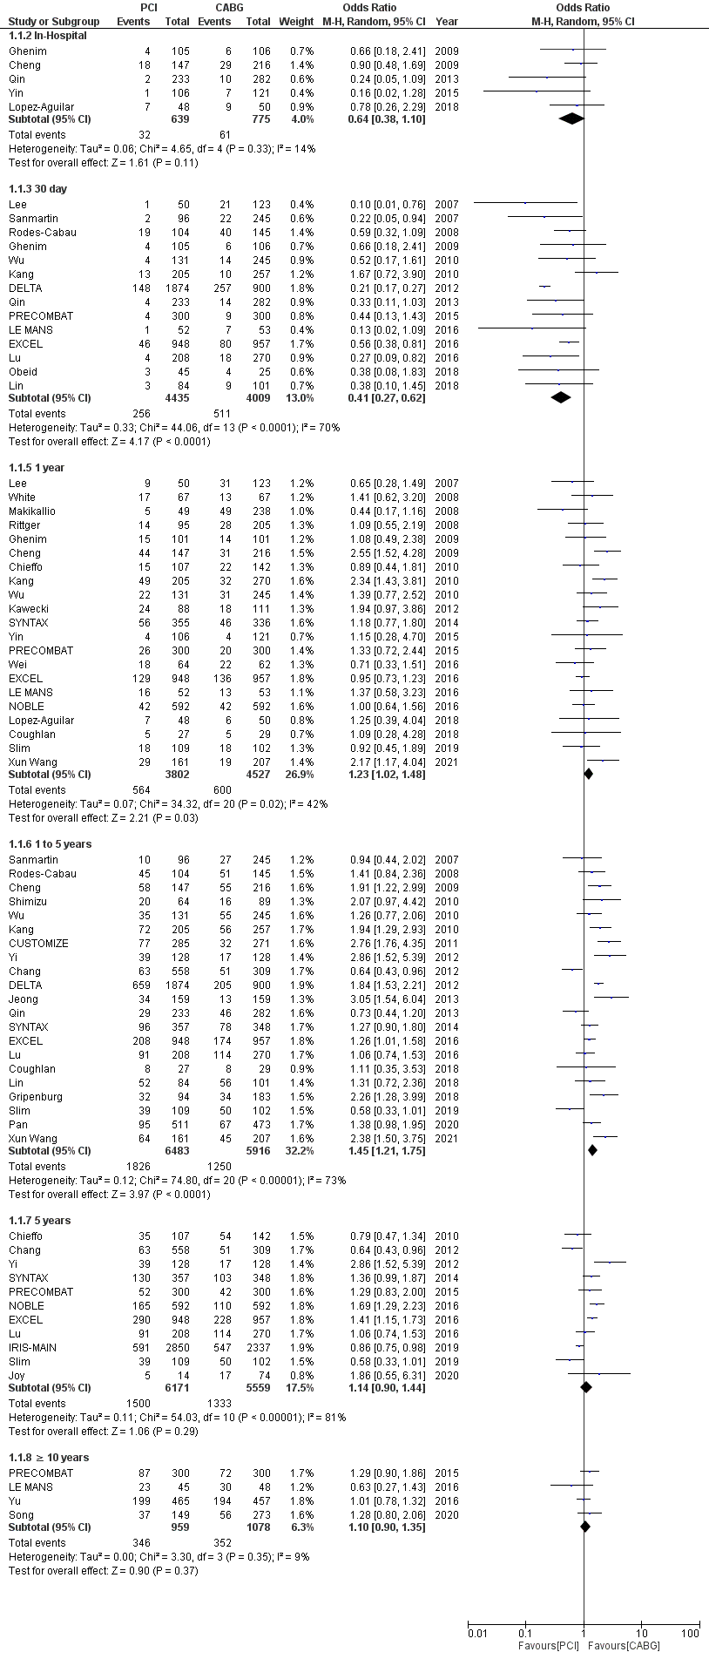
Supplemental Figure 4. Forest plot of Major adverse cardiovascular and cerebrovascular events (MACCE) outcome in percutaneous coronary intervention (PCI) versus coronary artery bypass grafting (CABG) for unprotected left main coronary artery disease for varying follow-up lengths

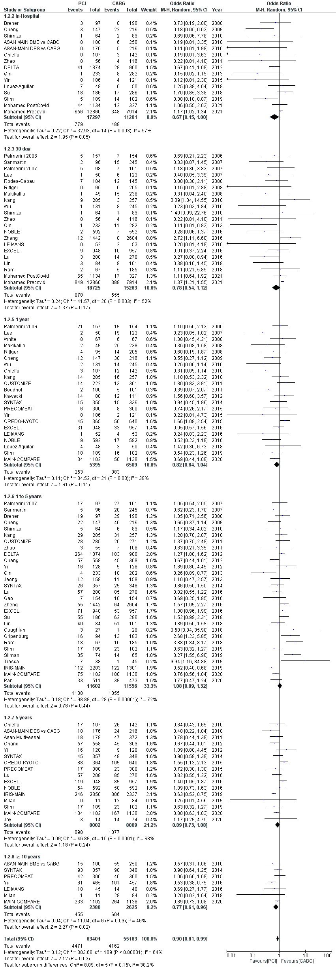
Supplemental Figure 5. Forest plot for All-cause Mortality outcome in percutaneous coronary intervention (PCI) versus coronary artery bypass grafting (CABG) for unprotected left main coronary artery disease for varying follow-up lengths

