Supplementary Figure 1: PRISMA Check List
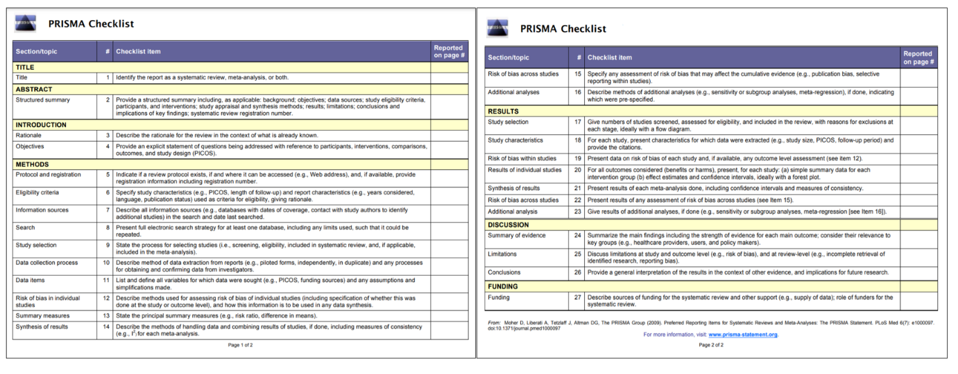
Supplementary Figure 2: All-cause mortality (Forest plot)
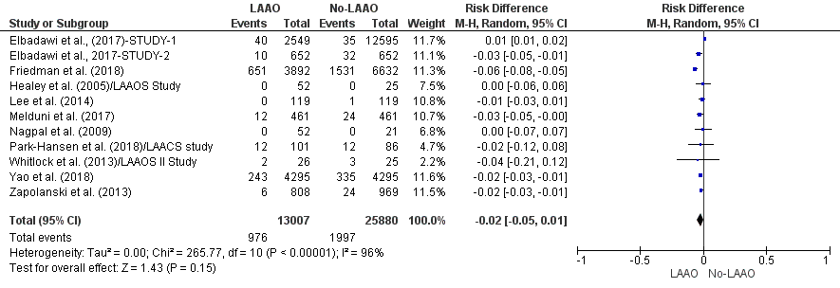
Supplementary Figure 3: Embolic events (Forest plot)
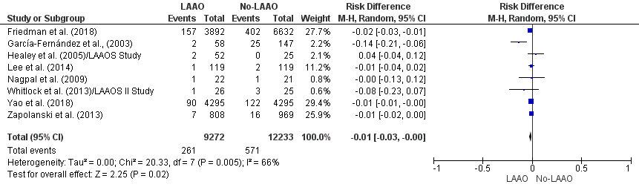
Supplementary Figure 4: Stroke (Forest plot)
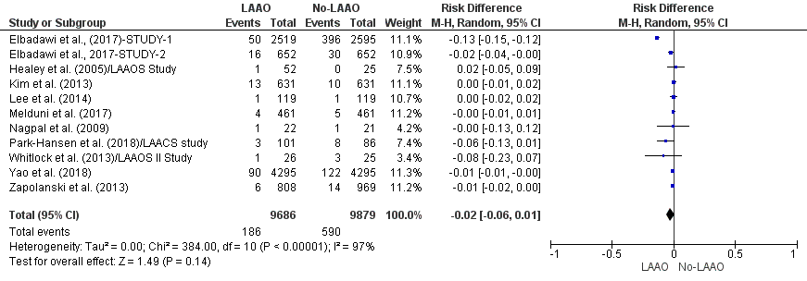
Supplementary Figure 5: MACE (Forest plot)
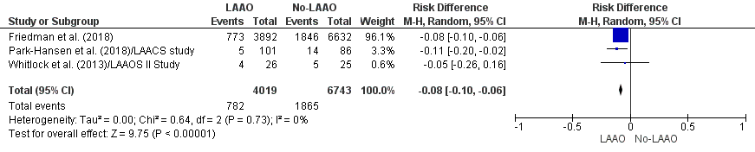
Supplementary Figure 6: Postoperative A Fib (Forest plot)
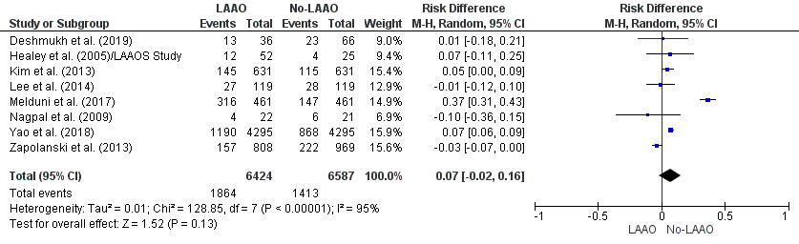
Supplementary Figure 7: Postoperative complications (Forest plot)
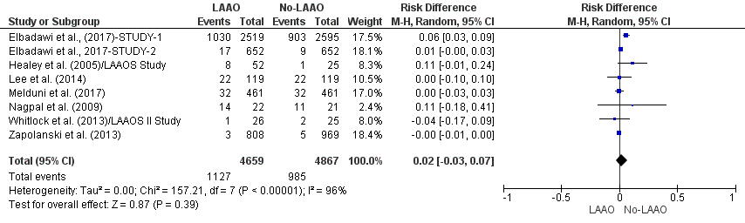
Supplementary Figure 8: Reoperation for bleeding (Forest plot)
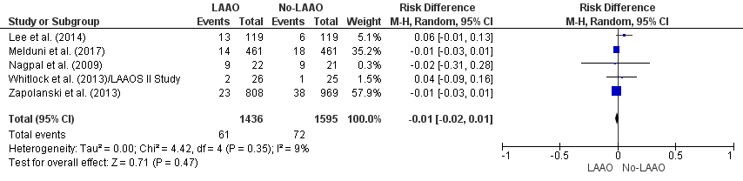
Supplementary Figure 9: All-cause mortality (Forest plot)
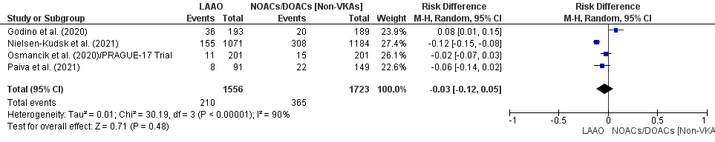
Supplementary Figure 10: Embolic events (Forest plot)
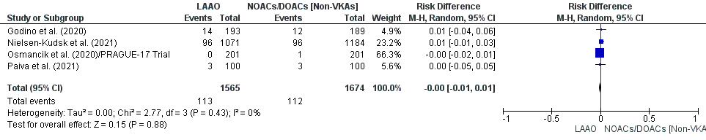
Supplementary Figure 11: Stroke (Forest plot)
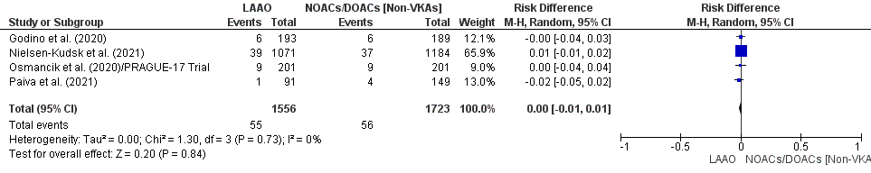
Supplementary Figure 12: MACE (Forest plot)
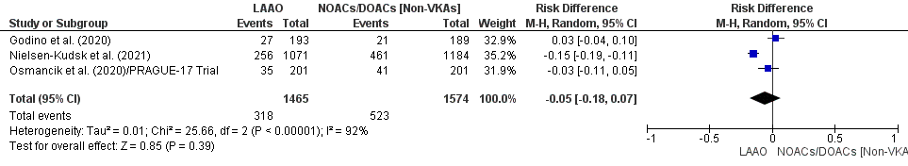
Supplementary Figure 13: Major bleeding (Forest plot)
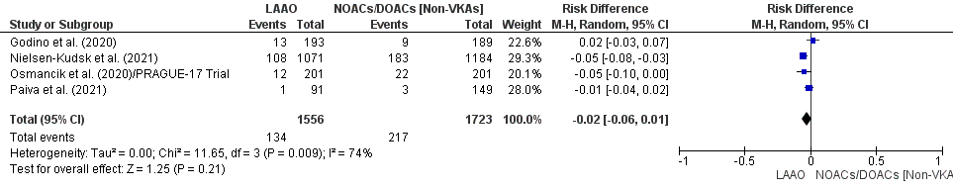
Supplementary Figure 14: All-cause mortality (Forest plot)
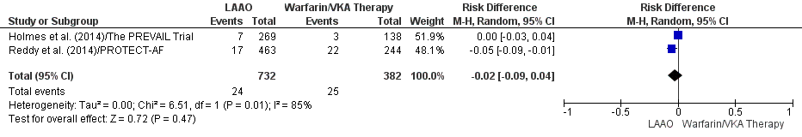
Supplementary Figure 15: Embolic events (Forest plot)
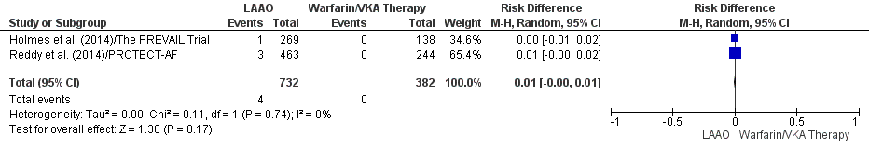
Supplementary Figure 16: Stroke (Forest plot)


