Supplementary Material

Supplementary Tables
Supplementary Table 1. Search strategy.
Database | Date | Search strings
Scopus | 09.09.2020 | ( ( ( ( ALL ( infant* ) ) OR ( ALL ( adolescent* ) ) OR ( ALL ( children ) ) OR ( ALL ( adult* ) ) OR ( ALL ( boys ) ) OR ( ALL ( girls ) ) OR ( ALL ( males ) ) OR ( ALL ( females ) ) OR ( ALL ( participants ) ) OR ( ALL ( volunteers ) ) OR ( ALL ( subjects ) ) OR ( ALL ( individuals ) ) OR ( ALL ( human* ) ) ) AND ( ALL ( ( ( nonsyndromic OR non-syndromic OR isolated ) AND ( oral OR orofacial ) AND cleft* ) ) ) AND ( ( TITLE-ABS-KEY ( cortical W/3 ( volume OR thickness OR differen* OR development ) ) ) OR ( TITLE-ABS-KEY ( brain W/3 ( structur* OR morphology* OR shape OR dysmorphology* OR morphometr* OR development OR growth ) ) ) OR ( TITLE-ABS-KEY ( ( brain OR cerebrum OR cortex ) W/3 ( abnormal OR differen* ) ) ) ) ) OR ( ALL ( infant* ) ) OR ( ALL ( adolescent* ) ) OR ( ALL ( children ) ) OR ( ALL ( adult* ) ) OR ( ALL ( boys ) ) OR ( ALL ( girls ) ) OR ( ALL ( males ) ) OR ( ALL ( females ) ) OR ( ALL ( participants ) ) OR ( ALL ( volunteers ) ) OR ( ALL ( subjects ) ) OR ( ALL ( individuals ) ) OR ( ALL ( human* ) ) ) AND ( ALL ( ( nonsyndromic OR non-syndromic OR isolated ) AND ( oral OR orofacial ) AND cleft* ) ) AND ( ( TITLE-ABS-KEY ( cortical W/3 ( volume OR thickness OR differen* OR development ) ) ) OR ( TITLE-ABS-KEY ( brain W/3 ( structur* OR morpholog* OR shape OR dysmorpholog* OR morphometr* OR development OR growth ) ) ) OR ( TITLE-ABS-KEY ( ( brain OR cerebrum OR cortex ) W/3 ( abnormal OR differen* ) ) ) )
WOS | 07.09.2020 | ALL= infant* ; ALL= adolescent*; ALL= children; ALL= adult*; ALL= females; ALL= male; ALL= girls; ALL= boys; ALL= individuals; ALL= subjects; ALL= volunteers; ALL= participants; ALL= human*  #1 OR#2 OR #3 OR #4 OR #5 OR #6 OR #7 OR #8 OR #9 OR #10 OR #11 OR #12 OR #13  ALL=((nonsyndromic OR non-syndromic OR isolated) AND (oral OR orofacial) AND cleft*)  AB=(cortical NEAR/3 (volume OR thickness OR differen* OR development) )  AB=(brain NEAR/3 (structur* OR morphology* OR shape OR dysmorphology* OR morphometr* OR development OR growth) )  AB=((brain OR cerebrum OR cortex) NEAR/3 (abnormal OR differen*) )  #18 OR #17 OR #16  #19 AND #15 AND #14
Embase | 07.09.2020 | - 'human'/exp  - 'child'/exp  - 'infant*  - 'adolescent*  - 'children  - adult*  - boys  - girls  - males  - females  - participants  - volunteers  - subjects  - individuals  - human*  - #1 OR #2 OR #3 OR #4 OR #5 OR #6 OR #7 OR #8 OR #9 OR #10 OR #11 OR #12 OR #13 OR #14 OR #15  - 'cleft lip'/exp  - 'cleft palate'/exp  - (nonsyndromic OR 'non-syndromic' OR isolated) AND (oral OR orofacial) AND cleft  - #17 OR #18 OR #19  - 'brain'/exp  - (cortical NEAR/3 (volume OR thickness OR differen* OR development)):ti,ab  - (brain NEAR/3 (structur* OR morphology* OR shape OR dysmorphology* OR morphometr* OR development OR growth)):ab,ti  - ((brain OR cerebrum OR cortex) NEAR/3 (abnormal OR differen*)):ab,ti  - #22 OR #23 OR #24  - #16 AND #20 AND #25  - #16 AND #20 AND #25 AND [humans]/lim
Ovid/Medline | 04.09.2020 | - infant*.mp.  - adolescent*.mp.  - children.mp.  - adult*.mp  - boys.mp.  - girls.mp.  - males.mp.  - females.mp.  - participants.mp.  - volunteers.mp.  - subjects.mp.  - individuals.mp.  - human*.mp.  - Humans/  - Adult/  - Child/  - Adolescent/  - Male/  - Female/  - 1 or 2 or 3 or 4 or 5 or 6 or 7 or 8 or 9 or 10 or 11 or 12 or 13 or 14 or 15 or 16 or 17 or 18 or 19  - Cleft Lip/  - Cleft Palate/  - ((nonsyndromic or non-syndromic or isolated) and (oral or orofacial) and cleft*).mp.  - 21 or 22 or 23  - (cortical adj3 (volume or thickness or differen* or development)).mp.  - (brain adj3 (structur* or morpholog* or shape or dysmorpholog* or morphometr* or development or growth)).mp.  - ((brain or cerebrum or cortex) adj3 (abnormal or differen*)).mp.  - Cerebrum/  - 25 or 26 or 27 or 28  - 20 and 24 and 29
Cochrane | 07.09.2020 | - (infant*)  - (adolescent*)  - (children)  - ((adult*))  - ((boys))  - ((girls))  - ((males))  - ((females))  - ((volunteers))  - ((subjects))  - ((participants))  - (individuals)  - (human*)  - MeSH descriptor: [Male] explode all trees  - MeSH descriptor: [Female] explode all trees  - MeSH descriptor: [Age Groups] explode all trees  - #1 OR #2 OR #3 OR #4 OR #5 OR #6 OR #7 OR #8 #9 OR #10 OR #11 OR #12 OR #13 OR #14 OR #15 OR #16  - (((nonsyndromic OR non-syndromic OR isolated) AND (oral OR orofacial) AND cleft*))  - (brain NEAR/3 (structur* OR morphology* OR shape OR dysmorphology* OR morphometr* OR development OR growth))  - ((brain OR cerebrum OR cortex) NEAR/3 (abnormal OR differen*))  - (cortical NEAR/3 (volume OR thickness OR differen* OR development))  - #19 OR #20 OR #21  - #17 AND #18 AND #22

Supplementary Table 2. Materials used for structural brain MRI analysis. CAT12: Computational Anatomy Toolbox 12; BRAINS: Brain Research: Analysis of Images, Networks, and System.
Studies | Instrument | Data processing
Nopoulos et al., 2000 | SIGNA 1.5T MRI | BRAINS
Nopoulos et al., 2001 | SIGNA 1.5T MRI | BRAINS
Nopoulos et al., 2002 | SIGNA 1.5T MRI | BRAINS
Nopoulos et al., 2007 | SIGNA 1.5T MRI | BRAINS
Weinberg et al., 2009 | SIGNA 1.5T MRI | BRAINS
Yang et al., 2012 | SIGNA 1.5T MRI | FreeSurfer 3.5
Weinberg et al., 2013 | SIGNA 1.5T MRI | BRAINS
Adamson et al., 2014 | Siemens TIM Trio 3T MRI | FreeSurfer 5.1.0
Bodoni et al., 2020 | Philips Achieva 1.5T MRI | CAT12
Li et al., 2020 | Siemens TIM Trio 3T MRI | CAT12

Supplementary Figures
Supplementary Figure 1. Forest plot for total brain white matter volume (cm³).
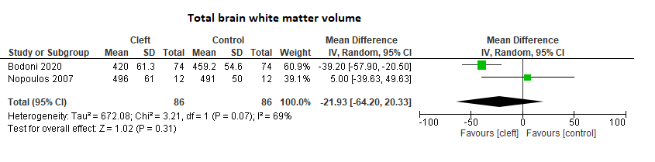
Supplementary Figure 2. Forest plot for cerebral grey matter volume (cm³).
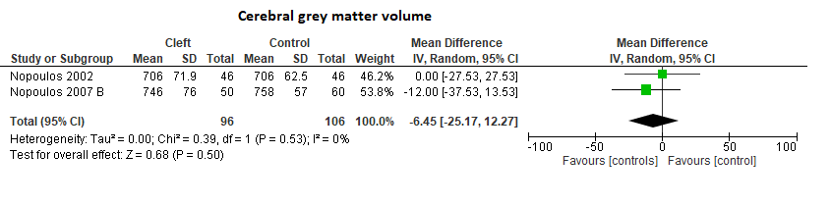
Supplementary Figure 3. Forest plot for cerebral white matter volume (cm³).
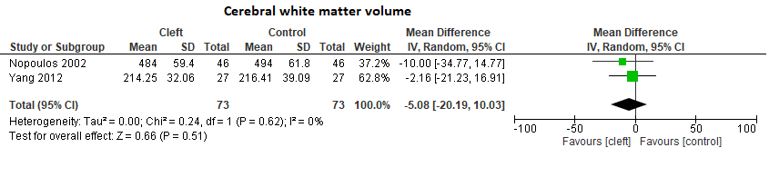
Supplementary Figure 4. Forest plot for frontal lobe volume (cm³).
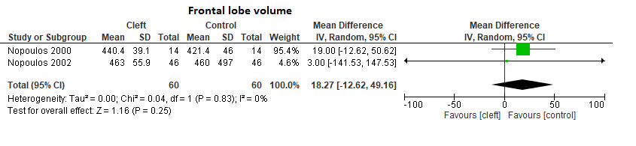
Supplementary Figure 5. Forest plot for frontal lobe grey matter volume (cm³).
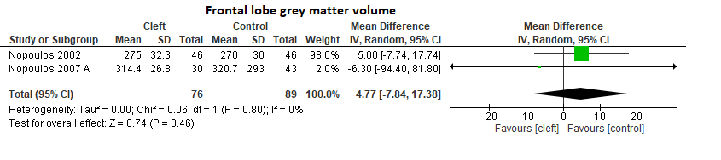
Supplementary Figure 6. Forest plot for straight gyrus (SG) volume (cm³).
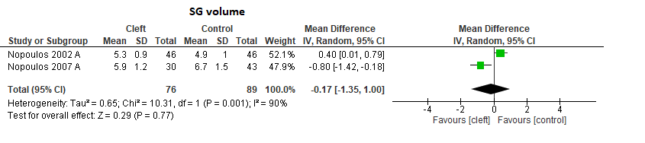
Supplementary Figure 7. Forest plot for orbitofrontal cortex (OFC) volume (cm3).
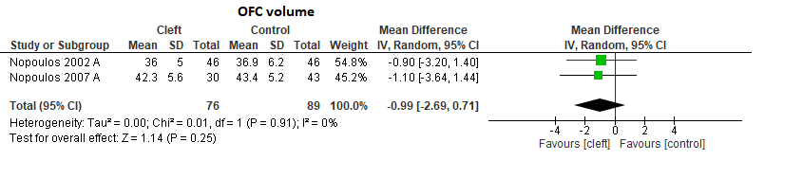
Supplementary Figure 8. Forest plot for parietal lobe volume (cm³).
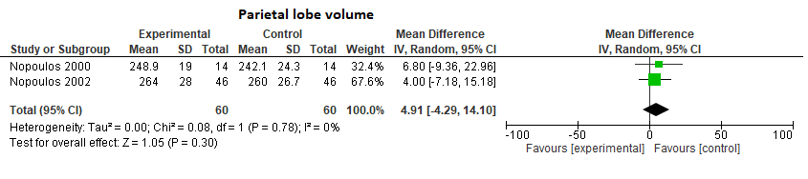
Supplementary Figure 9. Forest plot for superior temporal plane volume, left side (cm³).
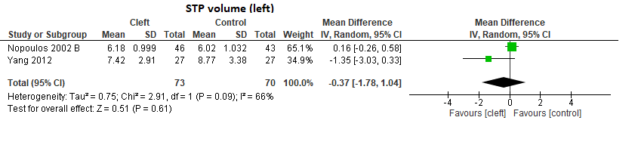
Supplementary Figure 10. Forest plot for superior temporal plane volume, right side (cm³).
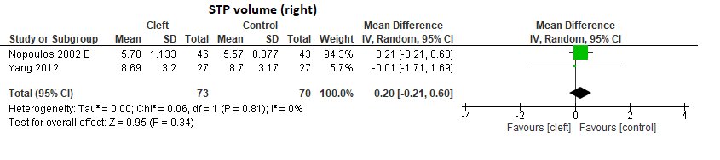
Supplementary Figure 11(A). Forest plot for total brain volume (cm³) with subgroup analysis (adults versus children).
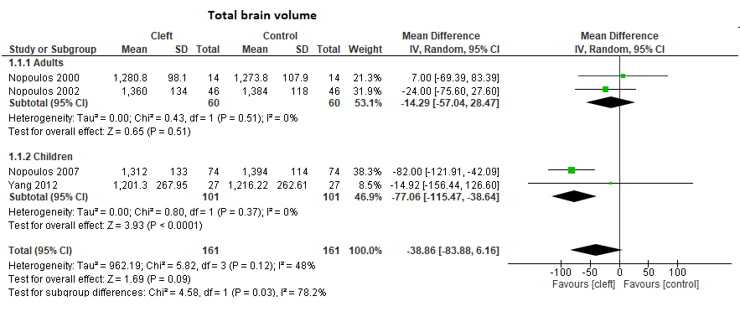

Supplementary Figure 11(B). Forest plot for total brain volume (cm³) with subgroup analysis (male versus male and female).
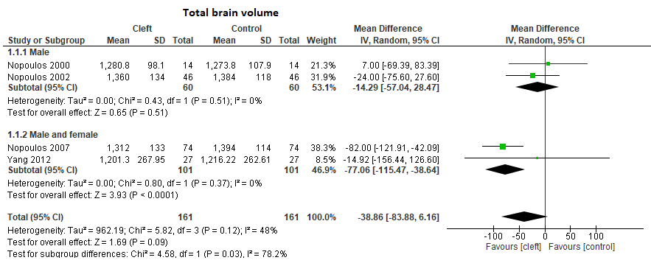
Supplementary Figure 11(C). Forest plot for total brain volume (cm³) with subgroup analysis (Caucasian versus mixed).
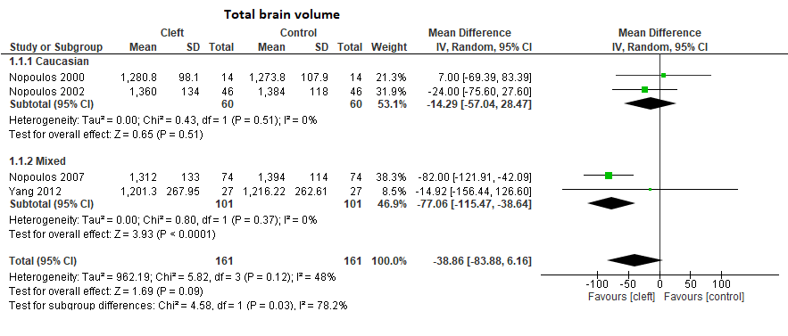

Supplementary Figure 12(A). Forest plot for total cerebral volume (cm³) with subgroup analysis (adults versus children).
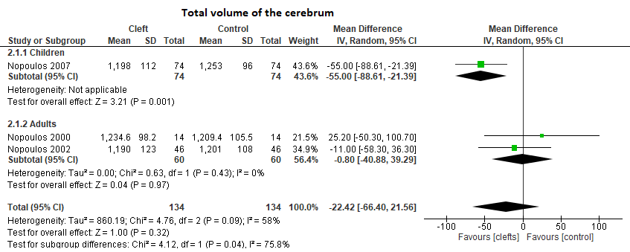
Supplementary Figure 12(B). Forest plot for cerebral volume (cm³) with subgroup analysis (male versus male and female).
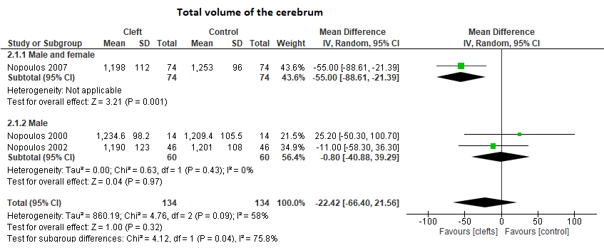

Dataset repositories: statement
A part of the dataset has been presented on a poster at the 34th ECNP Congress Hybrid, 2-5 October 2021, Lisbon, Portugal. It has been recently published as a conference abstract in the European Neuropsychopharmacology (an Official Journal of the European College of Neuropsychopharmacology).
The citation of the abstract:
P.0201 Brain structure of individuals with oral clefts: first results of a systematic review with meta-analyses. K.A. Sandor-Bajusz, E. Varga, G.N. Antonoglou, S. Lohner. 34th ECNP Congress – Lisbon 2021 Hybrid. DOI:10.1016/j.euroneuro.2021.10.194

