Appendix D – Planned subgroup analyses
Three follow-up interval subgroups were pre-specified: 1-3 months, 4-6 months, and 7+ months. Figures 6 through 8 display both results from individual trials and an overall effect estimate with respect HED within the three subgroups, and Figures 9 through 11 displays results for WAC. Note that we added stratification by pilot and full-scale trials post-hoc for 1-3 months subgroup. No pilot trials included follow-up intervals longer than 3 months.
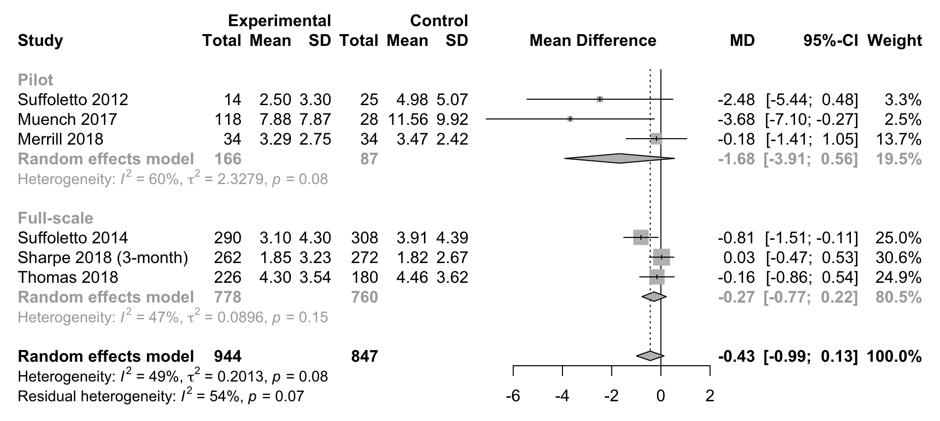
Figure 6 – Planned subgroup analysis of 1-3 months follow-up interval. Results from individual trials and overall effect estimate with respect to number of heavy drinking episodes per month (SD – standard deviation, MD – mean difference, CI – confidence interval). Stratified by pilot and full-scale trials.
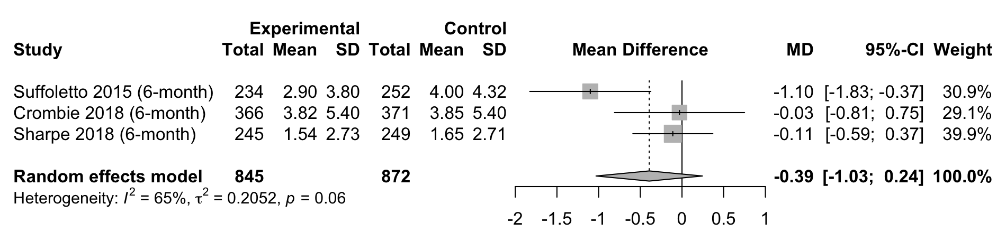
Figure 7 - Planned subgroup analysis of 4-6 months follow-up interval. Results from individual trials and overall effect estimate with respect to number of heavy drinking episodes per month (SD – standard deviation, MD – mean difference, CI – confidence interval).
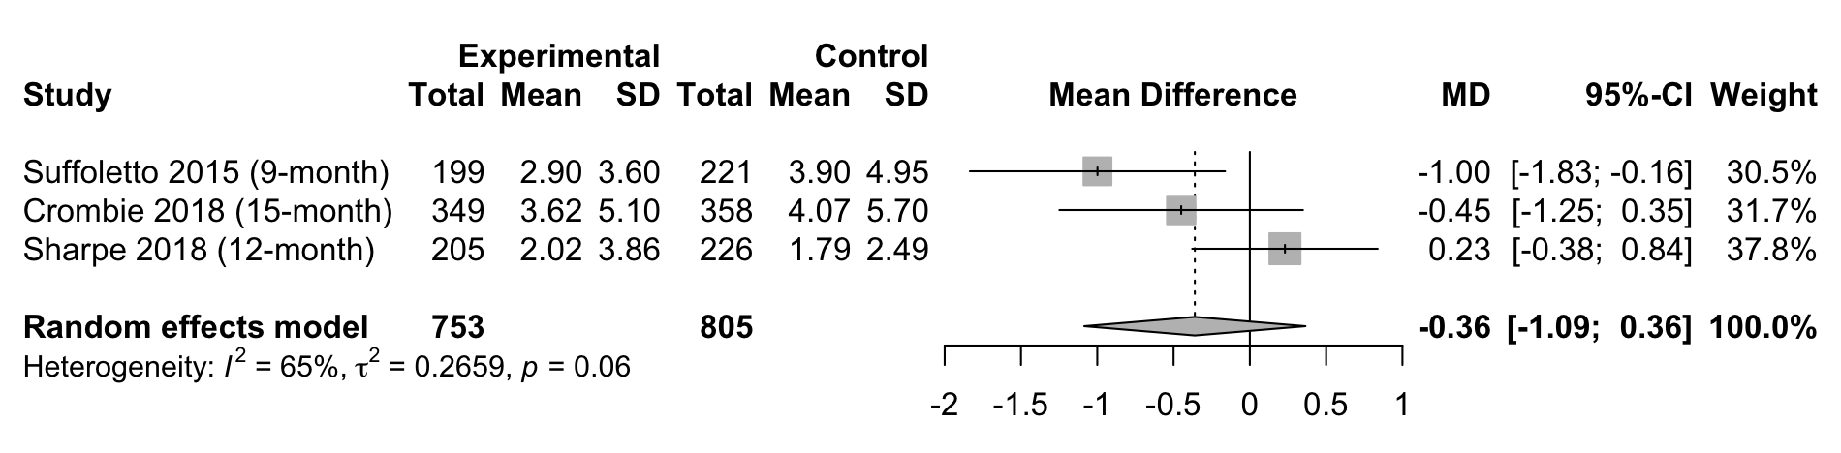
Figure 8 - Planned subgroup analysis of 7+ months follow-up interval. Results from individual trials and overall effect estimate with respect to number of heavy drinking episodes per month (SD – standard deviation, MD – mean difference, CI – confidence interval).
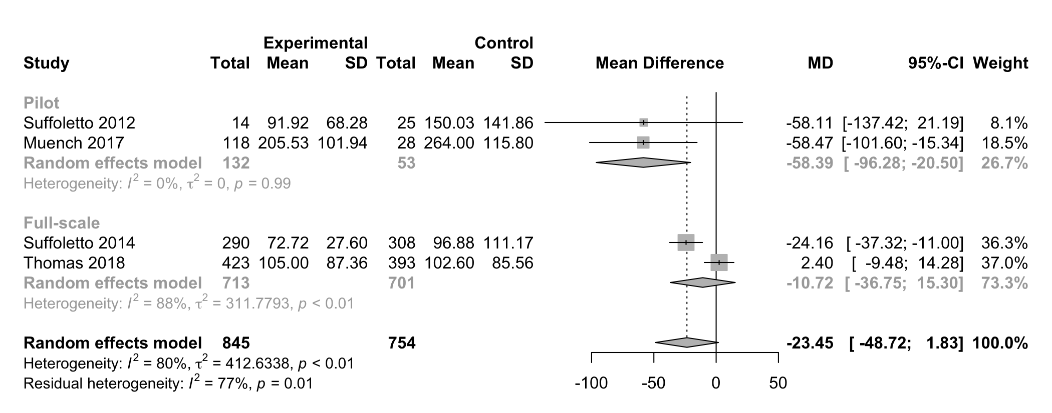
Figure 9 - Planned subgroup analysis of 1-3 months follow-up interval. Results from individual trials and overall effect estimate with respect to grams of alcohol per week (SD – standard deviation, MD – mean difference, CI – confidence interval). Stratified by pilot and full-scale trials.
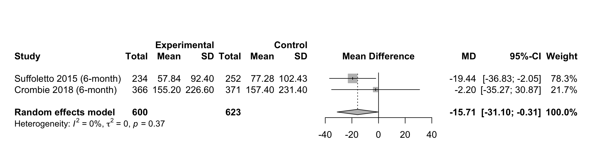
Figure 10 - Planned subgroup analysis of 4-6 months follow-up interval. Results from individual trials and overall effect estimate with respect to grams of alcohol per week (SD – standard deviation, MD – mean difference, CI – confidence interval
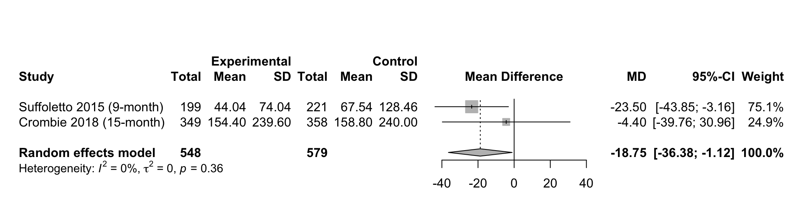Figure 11 - Planned subgroup analysis of 7+ months follow-up interval. Results from individual trials and overall effect estimate with respect to grams of alcohol per week (SD – standard deviation, MD – mean difference, CI – confidence interval).

