Supplementary materials

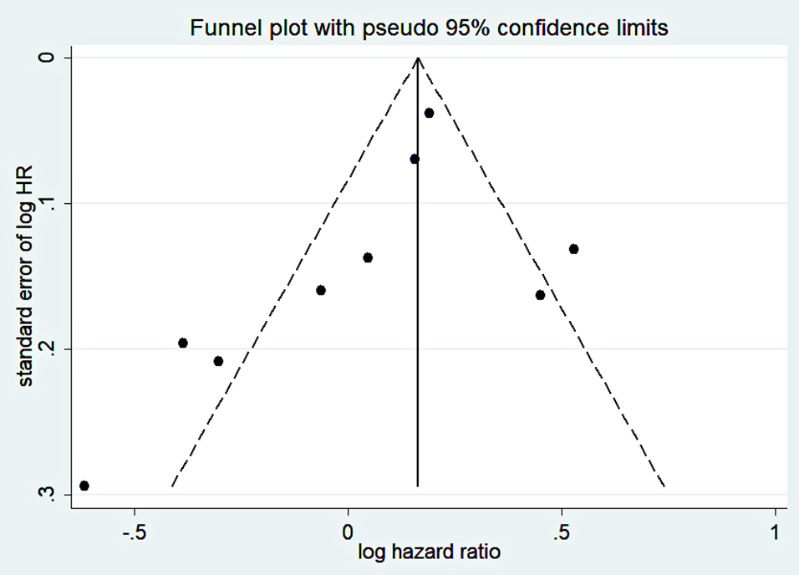
Sumplemental Figure S1. Funnel plot of publication biases of studies included in our meta-analysis focusing on the association between post-diagnostic beta blocker use and total mortality of OC patients. Each dot represents an individual study.
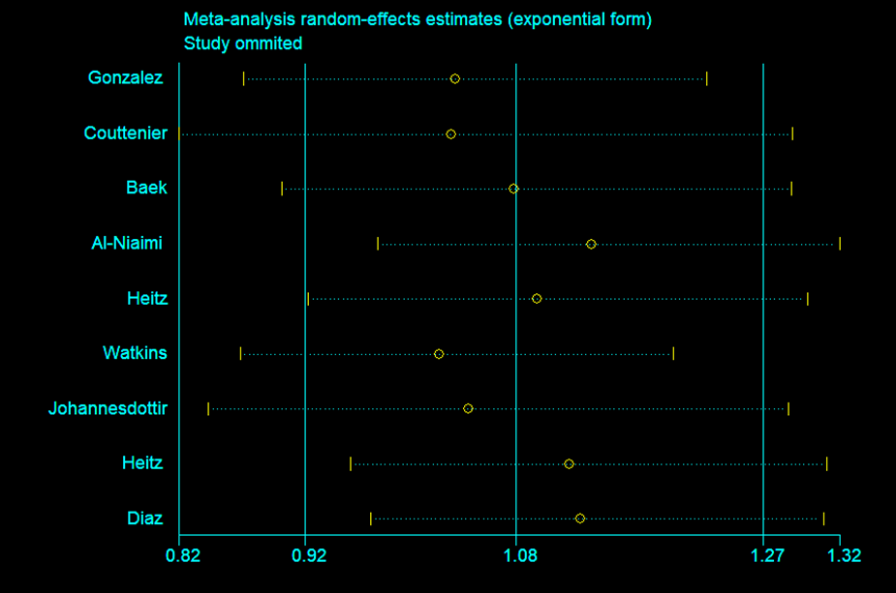
Sumplemental Figure S2. A sensitivity analysis was performed by removing each study in turn and recalculating the pooled odds hazard ratio.

