Table 1. Demographic and clinical properties of the study population
Figure 1. Pooled ORs of the univariate regression analysis of severity for d-dimer as a continuous variable
Figure 2. Pooled ORs of the univariate regression analysis of mortality for d-dimer as a continuous variable
Figure 3. Pooled ORs of the multivariate regression analysis of mortality for d-dimer as a continuous variable
Figure 4. Meta-regression analysis of pooled SMD of admission CRP levels in severe and non-severe patients including ratio of time from symptom onset to hospital admission in severe and non-severe patients as the covariate of the model.
Figure 5. Meta-regression analysis of pooled SMD of admission CRP levels in died and survived patients including ratio of time from symptom onset to hospital admission in died and survived patients as the covariate of the model.
Figure 6. Funnel plot analysis for included studies in A) Non-severe vs. Severe B) Survived vs. Died comparisons

Table 1. Demographic and clinical properties of the included studies

First | Country Date |  | Total | Groups Male |  | Age Anticoagulant |  | Onset to NOS |  | Ref. #
Author |  |  | n | n₁/n₂ | n₁/n₂ | therapy n₁/n₂ |  | admission (days)
Non-severe vs. Severe
Lu J | China | Jan 21- Feb 5 2020 | 438 | 338/100 | 154/50 | 51 (37-63) /58 (48-67) | NR | NR | 8 | 15
Zou Y | China | Jan 20-Feb 24 2020 | 303 | 277/26 | 138/20 | 50 (36-63) /65 (63-76) | NR | NR | 6 | 16
Liu W | China | Des 30, 2019 - Jan 15, 2020 | 78 | 67/11 | 32/7 | 37 (32-41) /66 (51-70) | NR | NR | 8 | 17
Liu S | China | 10 Jan - 18 Feb 2020 | 523 | 470/53 | 247/35 | 44.4(15.6)/ 60.1(13.9) | NR | NR | 8 | 18
Wang Y | China | Jan 1 - Feb 8 2020 | 69 | 51/18 | 29/13 | 41.0 (35.0-57.0) /46.0 (37.3-60.3) | NR | NR | 6 | 19
Wang D | China | Jan 1 - Jan 28 2020 | 138 | 102/36 | 53/22 | 51 (37-62)/ 66 (57-78) | NR | 5.3±3 /7.5±4.2 | 7 | 20
Chen Q | China | Jan 1 - Mar 11 2020 | 145 | 102/43 | 56/23 | 45.3±13.6/ 52.8±15.5 | NR | 5.6±4.5 /6.3 ±5.4 | 6 | 21
Guan W | China | Dec 11 2019 - Jan 29 2020 | 1099 | 926/173 | 597/100 | 45 (34–57)/ 52 (40 –65) | NR | NR | 7 | 22
Yan S | China | 22 Jan - 13 Mar 2020 | 168 | 132/36 | 60/21 | 49 (34-60)/ 61 (50.3-68) | NR | 4.5±3.7 /6.6±5.4 | 8 | 23
Zhao XY | China | Jan 16 - Feb 10 2020 | 91 | 61/30 | 35/14 | 42.00 / 50.50 | NR | 4/5 | 7 | 24
Wang Y | China | Jan 1 - Feb 10 2020 | 110 | 72/38 | 24/24 | NR | NR | NR | 7 | 25
Xu Y | China | Feb 7 - Feb 28 2020 | 69 | 44/24 | 22/13 | 49 (36-60)/ 67 (58-79) |  | NR | 7 | 26
He R | China | Jan 10 - Feb 13 2020 | 204 | 135/69 | 42/37 | 43 (31-53)/ 61 (52-74) | NR | NR | 6 | 27
Zheng X | China | -Mar 9 2020 | 52 | 30/22 | 12/11 | 45.63±15.97/ 58.18±13.16 | NR | 5.7±6.0/ 4.6±3.7 | 8 | 28
Zhang G | China | Jan 2 - Feb 10 2020 | 221 | 166/55 | 73/35 | 51(36-64.3)/ 62 (52-74) | NR | 6.6±3.7 /7.6±3.1 | 7 | 29
Wan S | China | 23 Jan - 8 Feb 2020 | 135 | 95/40 | 52/21 | 44(33-49)/  56(52-73) | NR | NR | 6 | 30
Huang C | China | Dec 16 2019 - Jan 2 2020 | 41 | 28/13 | 19/11 | 49·0 (41·0–57·5)/  49·0 (41·0–61·0) | NR | 2.8±4.3/9±7.4 | 7 | 31
Cao M | China | Jan 20 - Feb 15 2020 | 198 | 179/19 | 84/17 | 48.6 (15.6)/  63.7 (16.8) | NR | 4.3±3.7 / 7±3.2 | 7 | 32
Zhu Z | China | Jan 23 - Feb 20 2020 | 105 | 95/10 | 73/9 | 49.95 ± 15.52/ 57.50 ± 11.70 | NR | 5.13 ±3.79/ 6.88 ± 2.83 | 8 | 33
Huang Y | China | Jan 1 - March 8 2020 | 223 | 125/98 | 61/65 | 52.0 (26.0-65.5)/ 66 (56.25-71.0) | NR | NR | 7 | 34
Cai Q | China | Jan 11 - Feb 6 2020 | 298 | 240/58 | 106/39 | 41 (31-56)/  62.5 (56-66) | NR | 4.5±3.7 /5.2±2.1 | 7 | 35
Ma K | China | 21 Jan - 2 March 2020 | 84 | 60/24 | 36/12 | 46.5(39.2-54.8)/ 58.0(48.5-74.5) | NR | 2.6±2.9 /3.4±3.6 | 8 | 36
Feng Y | China | Jan 1 - Feb 15 2020 | 406 | 352/54 | 190/33 | 51(37-63)/ 58(48-67) | NR | 6.3±5.2 / 7±4.5 | 7 | 37
Huang Z | China | Jan 28 - Mar 08 2020 | 248 | 63/185 | 32/103 | 58.0±14.4/ 64.6±12.6 | NR | 10.5±4.8/ 11.8±5.1 | 7 | 38
Lu H | China | -Feb 7 2020 | 265 | 243/22 | NR | NR | NR | NR | 7 | 39
Gao Y | China | Jan 23 - Feb2 2020 | 43 | 28/15 | 17/9 | 42.96±14/ 45.2 ± 7.68 | NR | NR | 8 | 40
Wu J | China | 20 Jan -19 Feb 2020 | 280 | 197/83 | 106/45 | 37.55±17.1/63.04 ± 10.2 | NR | NR | 8 | 41
Qian GQ | China | 20 Jan - 11 Feb 2020 | 91 | 82/9 | 37 | 49(35.3-56)/ 66(54-80) | NR | NR | 7 | 42
Chen X | China | Jan 23 - Feb 14 2020 | 291 | 212/50 | 102/27 | 41.0(32- 53)/ 60.5 (46-70) | NR | 5.3±3.7 / 6.3±3.8 | 7 | 43
Zheng Y | China | Jan 16 - Feb 20 2020 | 94 | 62/32 | NR | NR | NR | NR | 6 | 44
Wang F | China | NR | 50 | 30/20 | 37 | 52.2 (12.4)/ 60.8(12.3) | NR | NR | 7 | 45
Zhou Y | China | NR | 377 | 260/117 | 102/68 | 48.35 (16.17)/ 65.63 (14.03) | NR | NR | 8 | 46
Bai X | China | Jan 3 - Feb 13 2020 | 133 | 79/54 | 40/26 | 48.51±12.04/  59.13±10.66 | NR | 8.51±4.08/ 9.13±4.01 | 6 | 47
Pei G | China | - February 9 2020 | 333 | 144/133 | 67/79 | 50.9612.5/ 58.1612.3 | NR | 8.3±3.7 / 9.3±3 | 7 | 48
Yao Q | China | Jan 30 - Feb 11 2020 | 108 | 83/13 | 30/6 | 50(34-56)/ 56(50.5,63.5) | NR | 5.6±3 /6±3.3 | 8 | 49
Li X | China | Jan 26 - Feb 5 2020 | 548 | 279/269 | 126/153 | 56 (44-66)/ 65 (54-72) | 5/11 | 9.3±3.7 /9.6±3.7 | 8 | 50
Han M | China | Jan 20 - Feb 17 2020 | 154 | 122/32 | 63/23 | 39.9±14.97/ 52.2±13.99 | NR | 4±3.7 / 6.8±5 | 6 | 51
Deng Q | China | Jan 6 - Feb 20 2020 | 122 | 45/67 | 19/38 | 56 (39-67)/ 68 (57-77) | NR | NR | 7 | 52
Gong J | China | Jan 20 - March 2 2020 | 189 | 161/28 | 72/16 | 45(33-62)/ 63.5 (54.5-72) | NR | NR | 7 | 53
Survived vs. Died
Huang Z | China | Jan 28 - Mar 08 2020 | 248 | 63/185 | 32/103 | 58.0±14.4/ 64.6±12.6 | NR | 10.5±4.8/ 11.8±5.1 | 7 | 38
Tang N | China | Jan 1 - Feb 3 2020 | 183 | 162/21 | 86/16 | 52.4 ±15.6/ 64.0± 20.7 | NR | NR | 6 | 54
Bai T | China | Dec 26 2019 - Jan 31 2020 | 127 | 91/36 | 52/28 | 50 (42-60)/ 67 (60-74) | NR | NR | - | 55
Wang K | China | Jan 7 - Feb 11 2020 | 305 | 283/22 | 131/11 | 46.4(14.4)/ 65.6 (12.6) | NR | NR | 7 | 56
Chen M | China | Jan 1 - Feb 15 2020 | 123 | 92/31 | 39/22 | 53 ± 14/72 ± 9 | NR | NR | 8 | 57
Chen T | China | 13 Jan - 12 Feb 2020 | 274 | 161/113 | 88/83 | 51. (37-66)/ 68(62-77) | NR | 9±4.5 / 10±4.5 | 7 | 58
Zhou F | China | Dec 29 2019 - Jan 31 2020 | 191 | 137/54 | 81/38 | 52(45–58)/ 69 (63–76) | NR | 10.6±3.7/11.3±5.3 | 8 | 59
Wang L | China | Jan 1 - Feb 6 2020 | 339 | 274/65 | 127/39 | 68(64-74)/ 76(70-83) | NR | 10±4.5 /10.3±5.3 | 8 | 60
Cai Y | China | Jan 1 - Mar 16 2020 | 349 | 297/52 | 137/36 | 60(50-67) /69 (63.2-75.5) | NR | NR | 7 | 61
Wang Z | China | Feb 23 - Mar 11 2020 | 116 | 101/15 | 53/12 | 60(50-69) /68.9(57-79) | NR | NR | 6 | 62
Bonetti G | Italy | Mar 1 - Mar 30 2020 | 144 | 74/70 | 51/45 | 62.1 (53–72.8)/ 78 (64.2–84) | NR | 7/4 | 6 | 63
Zhang F | China | Dec 25 2019 – Feb 15 2020 | 48 | 31/17 | 21/12 | 66.16±13.66/ 78.65±8.31 | NR | 6.3±4.6/7±6.5 | 7 | 64
Zhang S | China | Dec 29 2019 - Feb 17 2020 | 262 | 176/86 | 106/52 | 49.9 (13.0)/66.5 (10.3) | NR | NR | 7 | 65
Du RH | China | Decem 25, 2019 and Feb 7 | 179 | 158/21 | 87/10 | 56.0±13.5/ 70.2±7.7 | NR | NR | 8 | 66
Zhang S | China | Jan 12 - Feb 3 2020 | 315 | 268/47 | 137/38 | 56(41-65)/66(61-72) | NR | 9.4(4.2)/8.7(4.5) | 7 | 67
Xu B | China | Dec 26 2019 - Mar 1 2020 | 145 | 117/28 | 59/17 | 56(43 -66)/ 7 (68 77.2) | NR | NR | 7 | 68
NOS, The Newcastle-Ottowa Scale NR not reported

Figure 1.

Figure 2.

Figure 3.

Figure 4.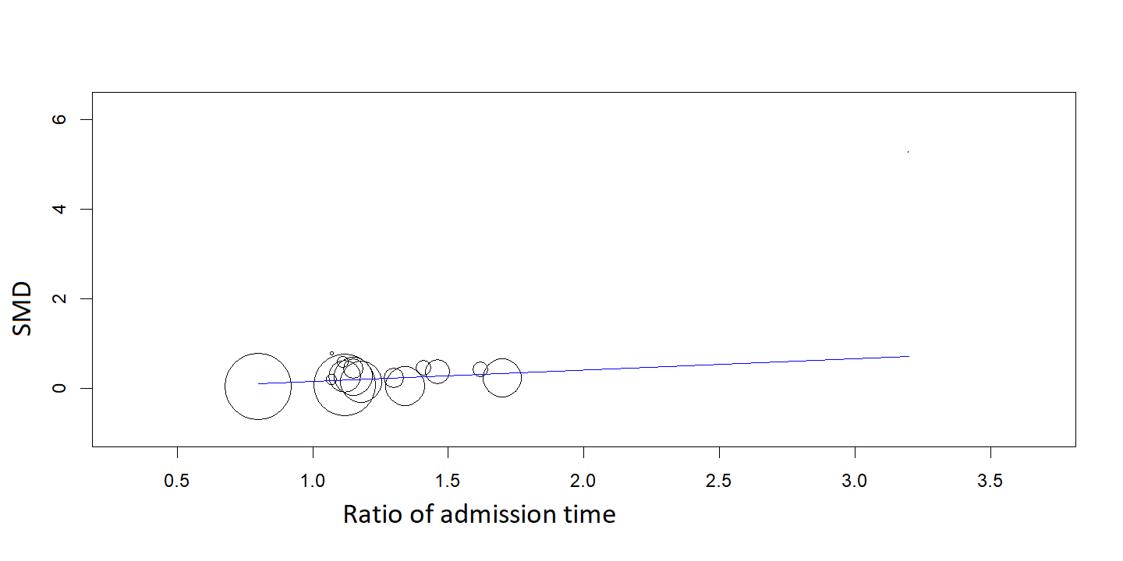

Figure 5.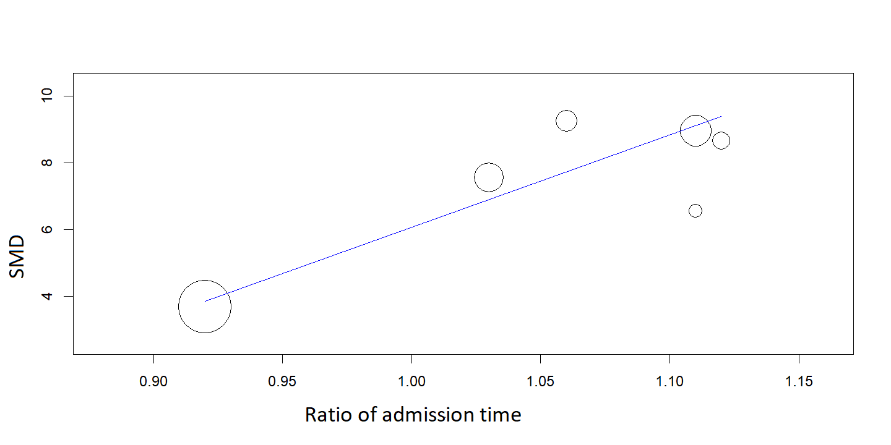

Figure 6.



