Table S1
Main characteristics of all eligible studies reporting the prevalence of serum antibodies to SARS-CoV-2 in people of general populations
Reference ⁎ | Country | Study period | Type of serological method used | Description | Sensitivity  (%) | Specificity  (%) | City or region | Income level of the countries | Number of people screened (total) | Number of people sero-positive  for serum anti-SARS-CoV-2 antibodies (IgG or IgG and IgM)
Herzog et al. [1] | Belgium | March-April, 2020 | ELISA | Commerical kit | 65 | 100 | Wallonia, Brussels | High | 3910 | 100
Herzog et al. [1] | Belgium | March-April, 2020 | ELISA | Commerical kit | 65 | 100 | Wallonia, Flanders, Brussels | High | 3391 | 193
Filho et al. [2]⁂ | Brazil | April-April, 2020 | LFIA | Commerical kit | 85 | 99 | Rio de Janeiro | Upper middle | 2857 | 114
Hallal et al. [3] | Brazil | May, 2020 | LFIA | Commerical kit | 86.4 | 96 | Northeast of the country | Upper middle | 6552 | 46
Hallal et al. [3] | Brazil | May, 2020 | LFIA | Commerical kit | 86.4 | 96 | North of the country | Upper middle | 5064 | 273
Hallal et al. [3] | Brazil | May, 2020 | LFIA | Commerical kit | 86.4 | 96 | Central-West of the country | Upper middle | 2477 | 0
Hallal et al. [3] | Brazil | May, 2020 | LFIA | Commerical kit | 86.4 | 96 | Southeast of the country | Upper middle | 5833 | 23
Hallal et al. [3] | Brazil | May, 2020 | LFIA | Commerical kit | 86.4 | 96 | South of the country | Upper middle | 5069 | 5
Silveira et al. [4] | Brazil | March-May, 2020 | LFIA | Commerical kit | 86.4 | 96 | Canoas | Upper middle | 500 | 1
Silveira et al. [4] | Brazil | March-May, 2020 | LFIA | Commerical kit | 86.4 | 96 | Caxias do Sul | Upper middle | 500 | 1
Silveira et al. [4] | Brazil | March-May, 2020 | LFIA | Commerical kit | 86.4 | 96 | Ijuí | Upper middle | 500 | 2
Silveira et al. [4] | Brazil | March-May, 2020 | LFIA | Commerical kit | 86.4 | 96 | Passo Fundo | Upper middle | 500 | 4
Silveira et al. [4] | Brazil | March-May, 2020 | LFIA | Commerical kit | 86.4 | 96 | Pelotas | Upper middle | 500 | 3
Silveira et al. [4] | Brazil | March-May, 2020 | LFIA | Commerical kit | 86.4 | 96 | Porto Alegre | Upper middle | 500 | 4
Silveira et al. [4] | Brazil | March-May, 2020 | LFIA | Commerical kit | 86.4 | 96 | Santa Cruz do Sul | Upper middle | 500 | 1
Silveira et al. [4] | Brazil | March-May, 2020 | LFIA | Commerical kit | 86.4 | 96 | Santa Maria | Upper middle | 500 | 1
Silveira et al. [4] | Brazil | March-May, 2020 | LFIA | Commerical kit | 86.4 | 96 | Uruguaiana | Upper middle | 500 | 1
Torres et al. [5]⁂ | Chile | April, 2020 | LFIA | Commerical kit | NM | NM | Santiago | High | 235 | 39
Torres et al. [5]⁋ | Chile | April, 2020 | LFIA | Commerical kit | NM | NM | Santiago | High | 1009 | 100
Chang et al. [6] | China | April, 2020 | VN | Commerical kit | 98 | 98 | Wuhan | Upper middle | 17794 | 515
Chang et al. [6] | China | April, 2020 | VN | Commerical kit | 98 | 98 | Shenzhen | Upper middle | 6810 | 3
Chang et al. [6] | China | April, 2020 | VN | Commerical kit | 98 | 98 | Shijiazhuang | Upper middle | 13540 | 1
To et al. [7] | China | December, 2019-Februray, 2020 | ELISA | In-house | 73 | 100 | Hong Kong | Upper middle | 1214 | 29
Liang et al. [8] | China | January-April, 2020 | CLIA | Commerical kit | 96.6 | 97.3 | Wuhan | Upper middle | 8272 | 174
Liang et al. [8] | China | January-April, 2020 | CLIA | Commerical kit | 96.6 | 97.3 | Guangzhou | Upper middle | 8782 | 53
Liu et al. [9]⁂ | China | February-April, 2020 | CLIA | In-house | 98 | 98 | Wuhan | Upper middle | 19555 | 900
Xu et al. [10] | China | March-April, 2020 | CLIA | In-house | NM | 99.3 | Wuhan | Upper middle | 10449 | 81
Jerković et al. [11] | Croatia | April, 2020 | LFIA | Commerical kit | 91 | 96.4 | Split-Dalmatia | High | 1316 | 13
Jerković et al. [11] | Croatia | April, 2020 | LFIA | Commerical kit | 91 | 96.4 | Knin | High | 178 | 6
Erikstrup et al. [12]⁂ | Denmark | April-May, 2020 | LFIA | Commerical kit | 82.5 | 99.5 | All of the country | High | 20640 | 412
Petersen et al. [13] | Denmark | April-May, 2020 | ELISA | Commerical kit | 94 | 100 | Faroe Islands | High | 1075 | 6
Ward et al. [14]⁂ | England | June-July, 2020 | LFIA | Commerical kit | 84 | 98 | North East | High | 3574 | 196
Ward et al. [14]⁂ | England | June-July, 2020 | LFIA | Commerical kit | 84 | 98 | North West | High | 11996 | 714
Ward et al. [14]⁂ | England | June-July, 2020 | LFIA | Commerical kit | 84 | 98 | Yorkshire | High | 6519 | 284
Ward et al. [14]⁂ | England | June-July, 2020 | LFIA | Commerical kit | 84 | 98 | East Midlands | High | 12684 | 601
Ward et al. [14]⁂ | England | June-July, 2020 | LFIA | Commerical kit | 84 | 98 | West Midlands | High | 9620 | 547
Ward et al. [14]⁂ | England | June-July, 2020 | LFIA | Commerical kit | 84 | 98 | East of England | High | 14433 | 805
Ward et al. [14]⁂ | England | June-July, 2020 | LFIA | Commerical kit | 84 | 98 | London | High | 9547 | 1045
Ward et al. [14]⁂ | England | June-July, 2020 | LFIA | Commerical kit | 84 | 98 | South East | High | 21979 | 995
Ward et al. [14]⁂ | England | June-July, 2020 | LFIA | Commerical kit | 84 | 98 | South West | High | 9556 | 357
Gallian et al. [15] | France | March-April, 2020 | VN | In-house | NM | 100 | Seine-Saint-Denis | High | 358 | 9
Gallian et al. [15] | France | March-April, 2020 | VN | In-house | NM | 100 | Bouches-du-Rhône | High | 297 | 4
Gallian et al. [15] | France | March-April, 2020 | VN | In-house | NM | 100 | Oise | High | 74 | 3
Gallian et al. [15] | France | March-April, 2020 | VN | In-house | NM | 100 | Haut-Rhin | High | 269 | 11
Grzelak et al. [16] | France | March, 2020 | ELISA | In-house | 96 | 99 | Lille | High | 200 | 3
Fischer et al. [17] | Germany | March-June, 2020 | ELISA | Commerical kit | 65 | 100 | North Rhine-Westphalia | High | 1700 | 16
Fischer et al. [17] | Germany | March-June, 2020 | ELISA | Commerical kit | 65 | 100 | Lower Saxony | High | 576 | 7
Fischer et al. [17] | Germany | March-June, 2020 | ELISA | Commerical kit | 65 | 100 | Hesse | High | 910 | 6
Weis et al. [18] | Germany | May, 2020 | ELISA | Commerical kit | 85.7 | 97.8 | Neustadt-am-Rennsteig | High | 620 | 52
Bogogiannidou et al. [19] | Greece | March-April, 2020 | CLIA | Commerical kit | 96.7 | 100 | All of the country | High | 6586 | 24
Merkely et al. [20] | Hungary | May, 2020 | CLIA | Commerical kit | 99 | 100 | All of the country | High | 10474 | 69
Shakiba et al. [21] | Iran | April, 2020 | LFIA | Commerical kit | 81-97 | 100 | Guilan province | Upper middle | 528 | 117
Percivalle et al. [22] | Italy | January-February, 2020 | VN | In-house | 95 | 100 | Lombardy | High | 390 | 91
Percivalle et al. [22] | Italy | January-February, 2020 | VN | In-house | 95 | 100 | Lombardy | High | 300 | 5
Valenti et al. [23] | Italy | February-April, 2020 | LFIA | Commerical kit | 100 | 98.3 | Milan | High | 729 | 40
Fiore et al. [24]⁂ | Italy | May, 2020 | CLIA | Commerical kit | 91.2 | 97 | Foggia | High | 904 | 9
Doi et al. [25] | Japan | March-April, 2020 | LFIA | Commerical kit | 76.5 | 100 | Kobe | High | 1000 | 33
Takita et al. [26] | Japan | April-May, 2020 | LFIA | Commerical kit | 87 | 97 | Tokyo | High | 1071 | 41
Takita et al. [27] | Japan | April-May, 2020 | LFIA | Commerical kit | 87 | 97 | Tokyo | High | 147 | 7
Uyoga et al.[28]⁂ | Kenya | April-June, 2020 | ELISA | In-house | 83 | 99 | Kilifi | Lower middle | 3098 | 174
Song et al. [29] | Korea | May-June, 2020 | LFIA | Commerical kit | 100 | 92 | Daegu | High | 198 | 15
Kammon et al. [30] | Libya | April-May, 2020 | LFIA | Commerical kit | 86.4 | 96 | Alzintan | Upper middle | 130 | 6
Snoeck et al. [31]⁂ | Luxembourg | April-May, 2020 | ELISA | Commerical kit | 85.7 | 97.8 | Luxembourg | High | 1862 | 35
Sam et al. [32] | Malaysia | January-June, 2020 | VN | Commerical kit | 100 | 100 | Kuala Lumpur and Selangor | Upper middle | 816 | 3
Pollán et al. [33] | Spain | April-May, 2020 | LFIA | Commerical kit | 97.2 | 100 | Asturias | High | 1550 | 30
Pollán et al. [33] | Spain | April-May, 2020 | LFIA | Commerical kit | 97.2 | 100 | Cantabria | High | 1504 | 55
Pollán et al. [33] | Spain | April-May, 2020 | LFIA | Commerical kit | 97.2 | 100 | Galicia | High | 4070 | 103
Pollán et al. [33] | Spain | April-May, 2020 | LFIA | Commerical kit | 97.2 | 100 | La Rioja | High | 1323 | 46
Pollán et al. [33] | Spain | April-May, 2020 | LFIA | Commerical kit | 97.2 | 100 | Navarra | High | 1744 | 100
Pollán et al. [33] | Spain | April-May, 2020 | LFIA | Commerical kit | 97.2 | 100 | País Vasco | High | 2838 | 134
Pollán et al. [33] | Spain | April-May, 2020 | LFIA | Commerical kit | 97.2 | 100 | Castilla-La Mancha | High | 5065 | 578
Pollán et al. [33] | Spain | April-May, 2020 | LFIA | Commerical kit | 97.2 | 100 | Castilla y León | High | 6979 | 561
Pollán et al. [33] | Spain | April-May, 2020 | LFIA | Commerical kit | 97.2 | 100 | Madrid | High | 3186 | 361
Pollán et al. [33] | Spain | April-May, 2020 | LFIA | Commerical kit | 97.2 | 100 | Aragón | High | 2752 | 132
Pollán et al. [33] | Spain | April-May, 2020 | LFIA | Commerical kit | 97.2 | 100 | Cataluña | High | 6323 | 336
Pollán et al. [33] | Spain | April-May, 2020 | LFIA | Commerical kit | 97.2 | 100 | Comunidad Valenciana | High | 4288 | 117
Pollán et al. [33] | Spain | April-May, 2020 | LFIA | Commerical kit | 97.2 | 100 | Murcia | High | 1391 | 20
Pollán et al. [33] | Spain | April-May, 2020 | LFIA | Commerical kit | 97.2 | 100 | Andalucía | High | 9773 | 257
Pollán et al. [33] | Spain | April-May, 2020 | LFIA | Commerical kit | 97.2 | 100 | Extremadura | High | 2784 | 99
Pollán et al. [33] | Spain | April-May, 2020 | LFIA | Commerical kit | 97.2 | 100 | Baleares | High | 1372 | 33
Pollán et al. [33] | Spain | April-May, 2020 | LFIA | Commerical kit | 97.2 | 100 | Canarias | High | 2368 | 61
Pollán et al. [33] | Spain | April-May, 2020 | LFIA | Commerical kit | 97.2 | 100 | Ceuta | High | 838 | 12
Pollán et al. [33] | Spain | April-May, 2020 | LFIA | Commerical kit | 97.2 | 100 | Melilla | High | 927 | 19
Lundkvist et al. [34] | Sweden | June, 2020 | LFIA | Commerical kit | 97.2 | 100 | Stockholm | High | 213 | 32
Stringhini et al. [35] | Switzerland | April-May, 2020 | ELISA | Commerical kit | 93 | 100 | Geneva | High | 2766 | 219
Bendavid et al. [36] | USA | April, 2020 | LFIA | Commerical kit | 91.8 | 99.5 | Santa Clara | High | 3330 | 50
Biggs et al. [37] | USA | April-May, 2020 | CLIA | Commerical kit | 93.2 | 99 | Georgia | High | 696 | 19
Bryan et al. [38]⁂ | USA | April, 2020 | CLIA | Commerical kit | 99 | 100 | Boise | High | 4856 | 87
Dietrich et al. [39]⁋ | USA | March-May, 2020 | ELISA | In-house | NM | NM | Louisiana | High | 812 | 62
Feehan et al. [40] | USA | May, 2020 | CLIA | Commerical kit | 99 | 100 | New Orleans | High | 2640 | 181
Havers et al. [41] | USA | March-May, 2020 | ELISA | In-house | 96 | 99 | Western Washington State | High | 3264 | 37
Havers et al. [41] | USA | March-May, 2020 | ELISA | In-house | 96 | 99 | New York | High | 2482 | 172
Havers et al. [41] | USA | March-May, 2020 | ELISA | In-house | 96 | 99 | Louisiana | High | 1184 | 68
Havers et al. [41] | USA | March-May, 2020 | ELISA | In-house | 96 | 99 | South Florida | High | 1742 | 33
Havers et al. [41] | USA | March-May, 2020 | ELISA | In-house | 96 | 99 | Pennsylvania | High | 824 | 26
Havers et al. [41] | USA | March-May, 2020 | ELISA | In-house | 96 | 99 | Missouri | High | 1882 | 51
Havers et al. [41] | USA | March-May, 2020 | ELISA | In-house | 96 | 99 | Utah | High | 1132 | 25
Havers et al. [41] | USA | March-May, 2020 | ELISA | In-house | 96 | 99 | San Francisco Bay area | High | 1224 | 12
Havers et al. [41] | USA | March-May, 2020 | ELISA | In-house | 96 | 99 | Connecticut | High | 1431 | 70
Havers et al. [41] | USA | March-May, 2020 | ELISA | In-house | 96 | 99 | Minnesota | High | 860 | 21
McLaughlin et al. [42] | USA | May, 2020 | CLIA | Commerical kit | 99 | 100 | Blaine | High | 917 | 208
Menachemi et al. [43] | USA | April, 2020 | CLIA | In-house | 100 | 99.6 | Indiana | High | 3518 | 38
Menachemi et al. [43] | USA | April, 2020 | CLIA | In-house | 100 | 99.6 | Indiana | High | 889 | 51
Ng et al. [44] | USA | March, 2020 | CLIA | Commerical kit | 99 | 100 | San Francisco Bay Area | High | 1000
Rosenberg et al. [45]⁂ | USA | April, 2020 | MIA | Commerical kit | 87.9 | 99.7 | New York | High | 15101 | 1887
Sood et al. [46] | USA | April, 2020 | LFIA | Commerical kit | 82.7 | 99 | Los Angeles | High | 863 | 35
Sutton et al. [47] | USA | May–June, 2020 | CLIA | Commerical kit | 96.7 | 100 | Oregon | High | 897 | 9
Abbreviations: NA, not available; USA, United States of America; LFIA, lateral flow immunoassays; ELISA, enzyme-linked immunosorbent assay; CLIA, chemiluminescence enzyme immunoassays; VN, virus neutralisation; MIA, microsphere immunoassay.
⁎ Datasets are sorted based on name of country
⁂ Datasets recruited only adults
⁋ Datasets recruited only children

Table S2
The Joanna Briggs Institute (JBI) Prevalence Critical Appraisal Tool used to assess the risk of bias of included studies of the prevalence of serum antibodies to SARS-CoV-2 in humans
References/studies⁎ | Was the sample representative of the target population? | Were study participants recruited in an appropriate way? | Was the sample adequate? | Were the study subjects and the setting described in detail? | Was the data analysis conducted with sufficient coverage of the identified sample? | Were objective, standard criteria used for the measurement of the condition? | Was the condition measured reliably? | Was there appropriate statistical analysis? | Are all important confounding factors/subgroups/differences identified and accounted for? | Were subpopulations identified using objective criteria? | Total number of ‘yes’ answers per study⁂
Herzog et al. [1] | Yes | Yes | Yes | Yes | Yes | Yes | Yes | Yes | No | Yes | 9
Filho et al. [2] | Yes | Yes | Yes | Yes | Yes | Yes | Yes | Yes | Yes | Yes | 10
Hallal et al. [3] | Yes | Yes | Yes | Yes | Yes | Yes | Yes | Yes | Yes | Yes | 10
Silveira et al. [4] | Yes | Yes | Yes | Yes | Yes | Yes | Yes | Yes | Yes | Yes | 10
Torres et al. [5] | Yes | Yes | Yes | Yes | Yes | Yes | Yes | Yes | No | Yes | 9
Chang et al. [6] | Yes | Yes | Yes | Yes | Yes | Yes | Yes | Yes | Yes | Yes | 10
To et al. [7] | Yes | Yes | Yes | Yes | Yes | Yes | Yes | Yes | No | No | 8
Liang et al. [8] | Yes | Yes | Yes | Yes | Yes | Yes | Yes | Yes | No | Yes | 9
Liu et al. [9] | Yes | Yes | Yes | Yes | Yes | Yes | Yes | Yes | No | No | 10
Xu et al. [10] | Yes | Yes | Yes | Yes | Yes | Yes | Yes | Yes | No | Yes | 9
Jerković et al. [11] | Yes | Yes | Yes | Yes | Yes | Yes | Yes | Yes | No | No | 8
Erikstrup et al. [12] | Yes | Yes | Yes | Yes | Yes | Yes | Yes | Yes | Yes | Yes | 10
Petersen et al. [13] | Yes | Yes | Yes | Yes | Yes | Yes | Yes | Yes | Yes | Yes | 10
Ward et al. [14] | Yes | Yes | Yes | Yes | Yes | Yes | Yes | Yes | Yes | Yes | 10
Gallian et al. [15] | Yes | Yes | No | Yes | Yes | Yes | Yes | Yes | No | No | 7
Grzelak et al. [16] | Yes | Yes | No | Yes | No | Yes | Yes | Yes | No | No | 6
Fischer et al. [17] | Yes | Yes | Yes | Yes | Yes | Yes | Yes | Yes | No | Yes | 9
Weis et al. [18] | Yes | Yes | Yes | Yes | Yes | Yes | Yes | Yes | Yes | Yes | 10
Bogogiannidou et al. [19] | Yes | Yes | Yes | No | Yes | Yes | Yes | Yes | No | Yes | 8
Merkely et al. [20] | Yes | Yes | Yes | Yes | Yes | Yes | Yes | Yes | Yes | Yes | 10
Shakiba et al. [21] | Yes | Yes | No | Yes | Yes | Yes | Yes | Yes | No | Yes | 8
Percivalle et al. [22] | Yes | Yes | Yes | Yes | Yes | Yes | Yes | Yes | No | No | 8
Valenti et al. [23] | Yes | Yes | No | Yes | Yes | Yes | Yes | Yes | No | Yes | 8
Fiore et al. [24] | Yes | Yes | Yes | Yes | No | Yes | Yes | Yes | No | Yes | 8
Doi et al. [25] | Yes | No | Yes | Yes | Yes | Yes | No | Yes | Yes | No | 7
Takita et al. [26] | Yes | Yes | Yes | Yes | Yes | Yes | Yes | Yes | Yes | Yes | 10
Takita et al. [27] | Yes | Yes | No | Yes | No | Yes | Yes | Yes | No | No | 6
Uyoga et al. [28] | Yes | Yes | Yes | Yes | Yes | Yes | Yes | Yes | Yes | Yes | 10
Song et al. [29] | Yes | Yes | No | Yes | No | Yes | Yes | Yes | Yes | Yes | 8
Kammon et al. [30] | Yes | Yes | No | Yes | No | Yes | Yes | Yes | No | No | 6
Snoeck et al. [31] | Yes | Yes | Yes | Yes | Yes | Yes | Yes | Yes | Yes | Yes | 10
Sam et al. [32] | Yes | Yes | No | Yes | No | Yes | Yes | Yes | No | Yes | 7
Pollán et al. [33] | Yes | Yes | Yes | Yes | Yes | Yes | Yes | Yes | Yes | Yes | 10
Lundkvist et al. [34] | Yes | Yes | No | Yes | No | Yes | Yes | Yes | No | No | 6
Stringhini et al. [35] | Yes | Yes | Yes | Yes | Yes | Yes | Yes | Yes | Yes | Yes | 10
Bendavid et al. [36] | Yes | Yes | Yes | Yes | Yes | Yes | Yes | Yes | No | Yes | 9
Biggs et al. [37] | Yes | Yes | No | Yes | Yes | Yes | Yes | Yes | Yes | Yes | 9
Bryan et al. [38] | Yes | Yes | Yes | No | Yes | Yes | Yes | Yes | Yes | Yes | 9
Dietrich et al. [39] | Yes | No | Yes | Yes | No | Yes | Yes | Yes | Yes | Yes | 8
Feehan et al. [40] | Yes | Yes | Yes | Yes | Yes | Yes | Yes | Yes | No | Yes | 9
Havers et al. [41] | Yes | Yes | Yes | Yes | Yes | Yes | Yes | Yes | Yes | Yes | 10
McLaughlin et al. [42] | Yes | Yes | Yes | Yes | Yes | Yes | Yes | Yes | Yes | Yes | 10
Menachemi et al. [43] | Yes | Yes | Yes | Yes | Yes | Yes | Yes | Yes | Yes | Yes | 10
Ng et al. [44] | Yes | Yes | Yes | Yes | Yes | Yes | Yes | Yes | No | Yes | 9
Rosenberg et al. [45] | Yes | Yes | Yes | Yes | Yes | Yes | Yes | Yes | Yes | Yes | 10
Sood et al. [46] | Yes | Yes | No | Yes | No | Yes | Yes | Yes | Yes | Yes | 8
Sutton et al. [47] | Yes | Yes | No | Yes | Yes | Yes | Yes | Yes | Yes | Yes | 9
⁂ Studies with 7–10, 4–6 and 1–3 “yes” answer were ranked as “low risk”, “moderate risk”, and “high risk”, respectively.

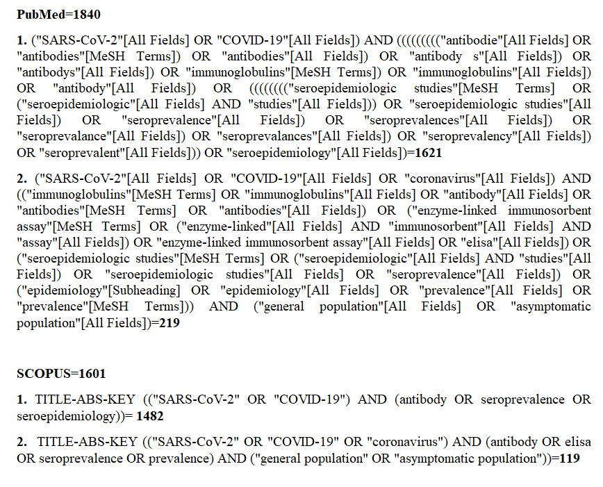

Supplementary Fig. 1. Search strategy
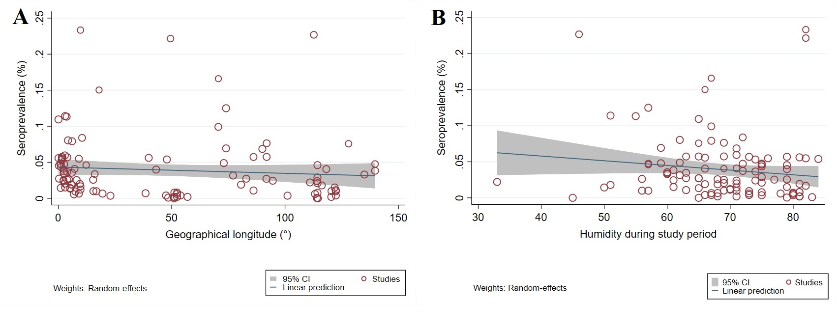
Fig. S2. Random effects meta-regression analyses of the seroprevalence of SARS-CoV-2 infection/exposure in the general population, according to: (A) geographical longitude, showing a statistically non-significant downward trend in prevalence with increasing geographical longitude (C = -0.00008; P-value = 0.316); (B) the relative humidity, showing a statistically non-significant downward trend in prevalence in areas with higher relative humidity (C = -0.0006, P-value = 0.12).

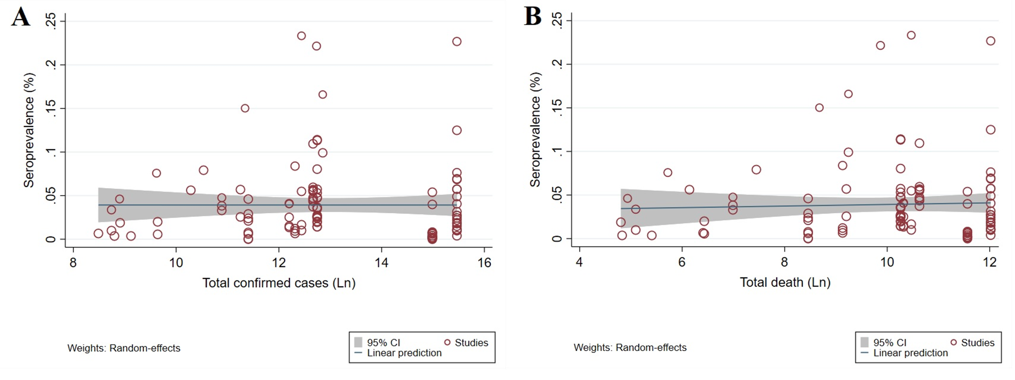
Supplementary Fig. 3. Random effects meta-regression analyses of the association between seroprevalence and (A) confirmed COVID-19 cases (i.e. disease), showing statistically non-significant upward trend in seroprevalence with increasing in number of confirmed COVID-19 cases (C = 0.0002; P-value = 0.921); and (B) death, showing a statistically non-significant upward trend in seroprevalence with increasing in number of death (C = 0.0001; P-value = 0.640).

References
[1] Herzog S, De Bie J, Abrams S, Wouters I, Ekinci E, Patteet L, et al. Seroprevalence of IgG antibodies against SARS coronavirus 2 in Belgium: a prospective cross-sectional study of residual samples. medRxiv 2020; published online July 30. DOI:10.1101/2020.06.08.20125179 (preprint). .
[2] Filho LA, Szwarcwald CL, Mateos SdOG, de Leon ACMP, de Andrade Medronho R, Veloso VG, et al. Seroprevalence of IgG and IgM anti-SARS-CoV-2 among voluntary blood donors in Rio de Janeiro, Brazil. Rev Saude Publica 2020;54:69.
[3] Hallal P, Hartwig F, Horta B, Victora GD, Silveira M, Struchiner C, et al. Remarkable variability in SARS-CoV-2 antibodies across Brazilian regions: nationwide serological household survey in 27 states. medRxiv 2020; published online May 30. DOI:10.1101/2020.05.30.20117531 (preprint).
[4] Silveira MF, Barros AJ, Horta BL, Pellanda LC, Victora GD, Dellagostin OA, et al. Population-based surveys of antibodies against SARS-CoV-2 in Southern Brazil. Nat Med 2020;26:1196–9.
[5] Torres JP, Piñera C, De La Maza V, Lagomarcino AJ, Simian D, Torres B, et al. SARS-CoV-2 antibody prevalence in blood in a large school community subject to a Covid-19 outbreak: a cross-sectional study. Clin Infect Dis 2020; published online July 10. DOI:10.1093/cid/ciaa955.
[6] Chang L, Hou W, Zhao L, Zhang Y, Wang Y, Wu L, et al. The prevalence of antibodies to SARS-CoV-2 among blood donors in China. medRxiv 2020; published online July 14. Doi:10.1101/2020.07.13.20153106 (preprint). .
[7] To KK-W, Cheng VC-C, Cai J-P, Chan K-H, Chen L-L, Wong L-H, et al. Seroprevalence of SARS-CoV-2 in Hong Kong and in residents evacuated from Hubei province, China: a multicohort study. Lancet Microbe 2020;1:e111–e8.
[8] Liang W, Lin Y, Bi J, Li J, Liang Y, Wong S-S, et al. Serosurvey of SARS-CoV-2 among hospital visitors in China. Cell Res 2020;1–2. Doi.10.1038/s41422-020-0371-0.
[9] Liu T, Wu S, Tao H, Zeng G, Zhou F, Guo F, et al. Prevalence of IgG antibodies to SARS-CoV-2 in Wuhan-implications for the ability to produce long-lasting protective antibodies against SARS-CoV-2. medRxiv 2020; published online June 16. DOI:10.1101/2020.06.13.20130252 (preprint).
[10] Xu X, Sun J, Nie S, Li H, Kong Y, Liang M, et al. Seroprevalence of immunoglobulin M and G antibodies against SARS-CoV-2 in China. Nat Med 2020;26:pages1193–5.
[11] Jerkovic I, Ljubic T, Basic Z, Kruzic I, Kunac N, Bezic J, et al. SARS-CoV-2 antibody seroprevalence in industry workers in Split-Dalmatia and Sibenik-Knin County, Croatia. medRxiv 2020; published online May 15. DOI:10.1101/2020.05.11.20095158 (preprint). .
[12] Erikstrup C, Hother CE, Pedersen OBV, Mølbak K, Skov RL, Holm DK, et al. Estimation of SARS-CoV-2 infection fatality rate by real-time antibody screening of blood donors. Clini Infect Dis 2020; published online June 25. Doi:10.1093/cid/ciaa849
[13] Petersen MS, Strøm M, Christiansen DH, Fjallsbak JP, Eliasen EH, Johansen M, et al. Seroprevalence of SARS-CoV-2–Specific Antibodies, Faroe Islands. Emerg Infect Dis 2020; published online July 29. DOI:10.3201/eid2611.202736.
[14] Ward H, Atchison C, Whitaker M, Ainslie K, Elliott J, Okell L, et al. Antibody prevalence for SARS-CoV-2 following the peak of the pandemic in England: REACT2 study in 100,000 adults. medRxiv 2020; published online August 21. DOI:10.1101/2020.08.12.20173690 (preprint). .
[15] Gallian P, Pastorino B, Morel P, Chiaroni J, Ninove L, de Lamballerie X. Lower prevalence of antibodies neutralizing SARS-CoV-2 in group O French blood donors. Antiviral Research 2020;181:104880.
[16] Grzelak L, Temmam S, Planchais C, Demeret C, Huon C, Guivel F, et al. SARS-CoV-2 serological analysis of COVID-19 hospitalized patients, pauci-symptomatic individuals and blood donors. medRxiv 2020; published online April 24. DOI:10.1101/2020.04.21.20068858 (preprint). .
[17] Fischer B, Knabbe C, Vollmer T. SARS-CoV-2 IgG seroprevalence in blood donors located in three different federal states, Germany, March to June 2020. Eur Surveill 2020;25:2001285.
[18] Weis S, Scherag A, Baier M, Kiehntopf M, Kamradt T, Kolanos S, et al. Seroprevalence of SARS-CoV-2 antibodies in an entirely PCR-sampled and quarantined community after a COVID-19 outbreak-the CoNAN study. medRxiv 2020; published online July 17. DOI:10.1101/2020.07.15.20154112 (preprint). .
[19] Bogogiannidou Z, Vontas A, Dadouli K, Kyritsi MA, Soteriades S, Nikoulis DJ, et al. Repeated leftover serosurvey of SARS-CoV-2 IgG antibodies, Greece, March and April 2020. Eur Surveill 2020;25:2001369.
[20] Merkely B, Szabó AJ, Kosztin A, Berényi E, Sebestyén A, Lengyel C, et al. Novel coronavirus epidemic in the Hungarian population, a cross-sectional nationwide survey to support the exit policy in Hungary. GeroScience 2020;42:1063–74.
[21] Shakiba M, Nazari SSH, Mehrabian F, Rezvani SM, Ghasempour Z, Heidarzadeh A. Seroprevalence of COVID-19 virus infection in Guilan province, Iran. medRxiv 2020; published online May 1. DOI:10.1101/2020.04.26.20079244 (preprint).
[22] Percivalle E, Cambiè G, Cassaniti I, Nepita EV, Maserati R, Ferrari A, et al. Prevalence of SARS-CoV-2 specific neutralising antibodies in blood donors from the Lodi Red Zone in Lombardy, Italy, as at 06 April 2020. Eur Surveill 2020;25:2001031.
[23] Valenti L, Bergna A, Pelusi S, Facciotti F, Lai A, Tarkowski M, et al. SARS-CoV-2 seroprevalence trends in healthy blood donors during the COVID-19 Milan outbreak. medRxiv 2020; published online May 31. DOI:10.1101/2020.05.11.20098442 (preprint). .
[24] Fiore JR, Centra M, De Carlo A, Granato T, Rosa A, Sarno M, et al. Far away from herd immunity to SARS-CoV-2: results from a survey in healthy blood donors in South Eastern Italy. J Med Virol 2020; published online August 13. DOI:10.1002/jmv.26425
[25] Doi A, Iwata K, Kuroda H, Hasuike T, Nasu S, Kanda A, et al. Seroprevalence of novel coronavirus disease (COVID-19) in Kobe, Japan. medRxiv 2020; published online May 5. Doi:10.1101/2020.04.26.20079822 (preprint). .
[26] Takita M, Matsumura T, Yamamoto K, Yamashita E, Hosoda K, Hamaki T, et al. Geographical Profiles of COVID-19 Outbreak in Tokyo: An Analysis of the Primary Care Clinic–Based Point-of-Care Antibody Testing. J Prim Care Community Health 2020;11:2150132720942695.
[27] Takita M, Matsumura T, Yamamoto K, Yamashita E, Hosoda K, Hamaki T, et al. Preliminary Results of Seroprevalence of SARS-CoV-2 at Community Clinics in Tokyo. medRxiv 2020; published online May 5. DOI:10.1101/2020.04.29.20085449 (preprint).
[28] Uyoga S, Adetifa IM, Karanja HK, Nyagwange J, Tuju J, Wanjiku P, et al. Seroprevalence of anti-SARS-CoV-2 IgG antibodies in Kenyan blood donors. medRxiv 2020; published online July 29. DOI:10.1101/2020.07.27.20162693 (preprint). .
[29] Song S-K, Lee D-H, Nam J-H, Kim K-T, Do J-S, Kang D-W, et al. IgG Seroprevalence of COVID-19 among Individuals without a History of the Coronavirus Disease Infection in Daegu, Korea. J Korean Med Sci 2020;35:e269.
[30] Kammon AM, El-Arabi AA, Erhouma EA, Mehemed TM, Mohamed OA. Seroprevalence of antibodies against SARS-CoV-2 among public community and health-care workers in Alzintan City of Libya. medRxiv 2020; published online May 26. DOI:10.1101/2020.05.25.20109470 (preprint). .
[31] Snoeck CJ, Vaillant M, Abdelrahman T, Satagopam VP, Turner JD, Beaumont K, et al. Prevalence of SARS-CoV-2 infection in the Luxembourgish population: the CON-VINCE study. medRxiv 2020; published online May 18. DOI:10.1101/2020.05.11.20092916 (preprint). .
[32] Sam I-C, Chong YM, Tan CW, Chan YF. Low post-pandemic wave SARS-CoV-2 seroprevalence in Kuala Lumpur and Selangor, Malaysia. J Med Virol 2020; published online August 13. DOI:10.1002/jmv.26426.
[33] Pollán M, Pérez-Gómez B, Pastor-Barriuso R, Oteo J, Hernán MA, Pérez-Olmeda M, et al. Prevalence of SARS-CoV-2 in Spain (ENE-COVID): a nationwide, population-based seroepidemiological study. Lancet 2020;396:535–44.
[34] Lundkvist Å, Hanson S, Olsen B. Pronounced difference in Covid-19 antibody prevalence indicates cluster transmission in Stockholm, Sweden. Infect Ecol Epidemiol 2020;10:1806505.
[35] Stringhini S, Wisniak A, Piumatti G, Azman AS, Lauer SA, Baysson H, et al. Seroprevalence of anti-SARS-CoV-2 IgG antibodies in Geneva, Switzerland (SEROCoV-POP): a population-based study. Lancet 2020;396:313–9.
[36] Bendavid E, Mulaney B, Sood N, Shah S, Ling E, Bromley-Dulfano R, et al. COVID-19 Antibody Seroprevalence in Santa Clara County, California. medRxiv 2020; published online April 30. Doi:10.1101/2020.04.14.20062463 (preprint).
[37] Biggs HM, Harris JB, Breakwell L, Dahlgren FS, Abedi GR, Szablewski CM, et al. Estimated Community Seroprevalence of SARS-CoV-2 Antibodies—Two Georgia Counties, April 28–May 3, 2020. Morb Mortal Wkly Rep 2020;69:965.
[38] Bryan A, Pepper G, Wener MH, Fink SL, Morishima C, Chaudhary A, et al. Performance characteristics of the Abbott Architect SARS-CoV-2 IgG assay and seroprevalence in Boise, Idaho. J Clin Microbiol 2020;58:e00941-20.
[39] Dietrich ML, Norton EB, Elliott D, Smira AR, Rouelle JA, Bond NG, et al. SARS-CoV-2 Seroprevalence Rates of Children in Louisiana During the State Stay at Home Order. medRxiv 2020; published online July 8. Doi:10.1101/2020.07.07.20147884 (preprint). .
[40] Feehan AK, Fort D, Garcia-Diaz J, Price-Haywood E, Velasco C, Sapp E, et al. Point prevalence of SARS-CoV-2 and infection fatality rate in Orleans and Jefferson Parish, Louisiana, May 9-15, 2020. medRxiv 2020; published online June 24. DOI:10.1101/2020.06.23.20138321 (preprint).
[41] Havers FP, Reed C, Lim T, Montgomery JM, Klena JD, Hall AJ, et al. Seroprevalence of antibodies to SARS-CoV-2 in 10 sites in the United States, March 23-May 12, 2020. JAMA Intern Med 2020; published online July 21, Doi:10.1001/jamainternmed.2020.4130.
[42] McLaughlin CC, Doll MK, Morrison KT, McLaughlin WL, O’Connor T, Sholukh AM, et al. High Community SARS-CoV-2 Antibody Seroprevalence in a Ski Resort Community, Blaine County, Idaho, US. Preliminary Results. medRxiv 2020; published online July 21. DOI:10.1101/2020.07.19.20157198 (preprint). .
[43] Menachemi N, Yiannoutsos CT, Dixon BE, Duszynski TJ, Fadel WF, Wools-Kaloustian KK, et al. Population Point Prevalence of SARS-CoV-2 Infection Based on a Statewide Random Sample—Indiana, April 25–29, 2020. Morb Mortal Wkly Rep 2020;69:960.
[44] Ng D, Goldgof G, Shy B, Levine A, Balcerek J, Bapat SP, et al. SARS-CoV-2 seroprevalence and neutralizing activity in donor and patient blood from the San Francisco Bay Area. medRxiv 2020; published online May 27. DOI:10.1101/2020.05.19.20107482 (preprint). .
[45] Rosenberg ES, Tesoriero JM, Rosenthal EM, Chung R, Barranco MA, Styer LM, et al. Cumulative incidence and diagnosis of SARS-CoV-2 infection in New York. medRxiv 2020; published online May 29. DOI:10.1101/2020.05.25.20113050 (preprint). .
[46] Sood N, Simon P, Ebner P, Eichner D, Reynolds J, Bendavid E, et al. Seroprevalence of SARS-CoV-2–Specific Antibodies Among Adults in Los Angeles County, California, on April 10-11, 2020. JAMA 2020;323.
[47] Sutton M, Cieslak P, Linder M. Seroprevalence Estimates of SARS-CoV-2 Infection in Convenience Sample — Oregon, May 11–June 15, 2020. Morb Mortal Wkly Rep 2020;69:1100-1.

