1. Drug discontinuation due to adverse effect
Odds for drug discontinuation due to intolerance is (OR 1.26, 95% CI 0.50 to 3.19; participants = 1488; studies = 3; I² = 62%).

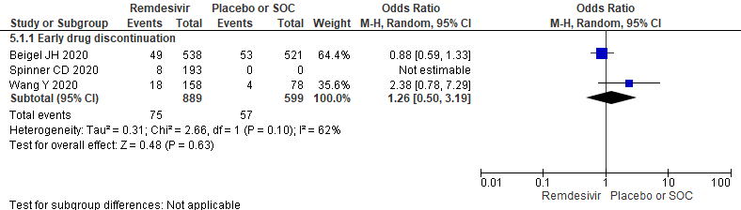
Figure 1. Meta-analysis for drug discontinuation
2. Baseline ventilation and respiratory support
Result showed no statistical differences between two arms (OR 0.87, 95% CI 0.71 to 1.06; participants = 2991; studies = 5; I² = 16%). On subgroup analysis; NIMV and high-flow oxygen (OR 1.01, 95% CI 0.76 to 1.34; participants = 1692; studies = 3; I² = 0%) and IMV or ECMO (OR 0.76, 95% CI 0.57 to 1.00; participants = 1299; studies = 2; I² = 0%) requirement also showed similar result.
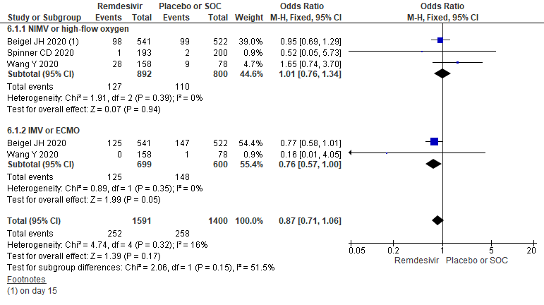
Figure 2. Forest plot for baseline ventilation and respiratory support comparing remdesivir versus placebo or standard of care

