Supplementary Figure 2E.
Network Forest Plot of Indirect Comparisons of Different Therapeutic Modalities for Achalasia (Abnormal gastroesophageal acid reflux)
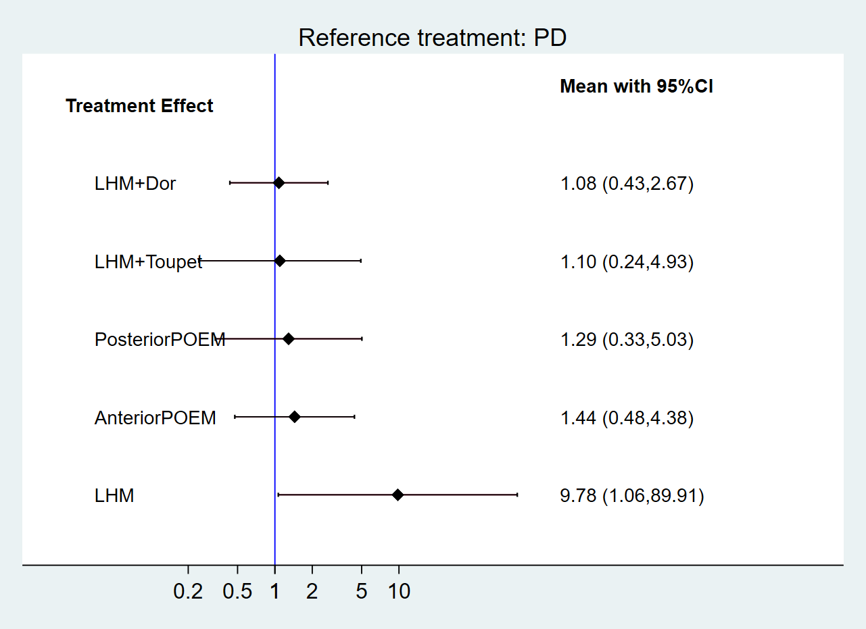
PD, pneumatic dilation; LHM, laparoscopic Heller’s myotomy; POEM, per-oral endoscopic myotomy.

