Supplementary Figure 2F.
Network Forest Plot of Indirect Comparisons of Different Therapeutic Modalities for Achalasia (Moderate-to-severe adverse events)
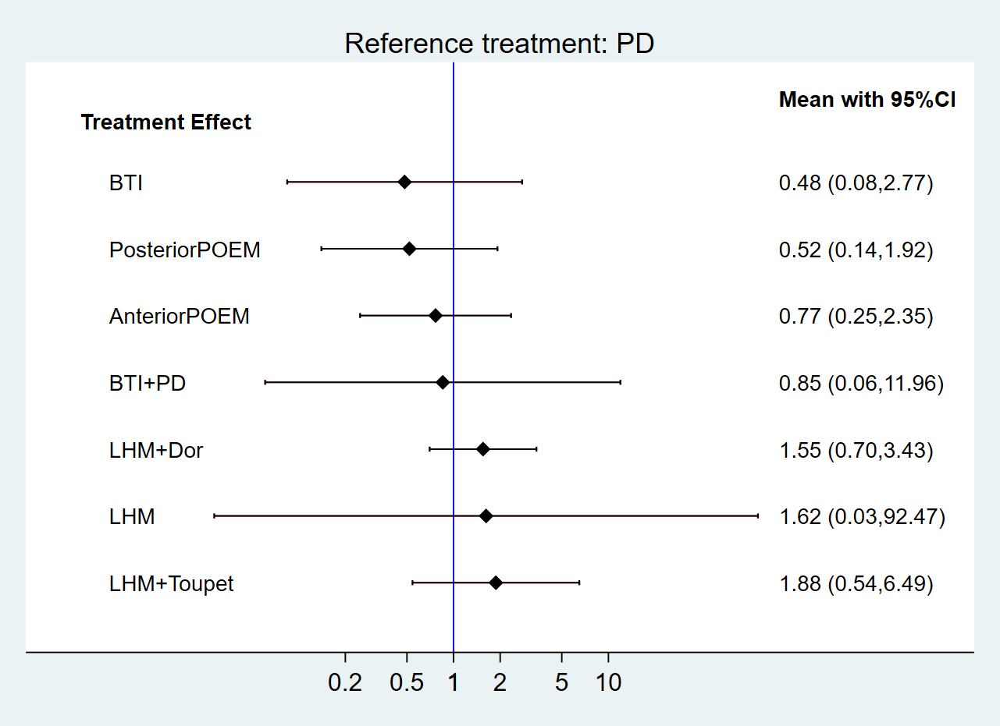
BTI, botulinum toxin injection; PD, pneumatic dilation; LHM, laparoscopic Heller’s myotomy; POEM, per-oral endoscopic myotomy.

