Supplementary Figure 3C.
Cumulative SUCRA Ranking Curves for Overall Efficacy of Different Therapeutic Modalities for Achalasia
(Treatment naïve + ≤ 1-year follow-up period)
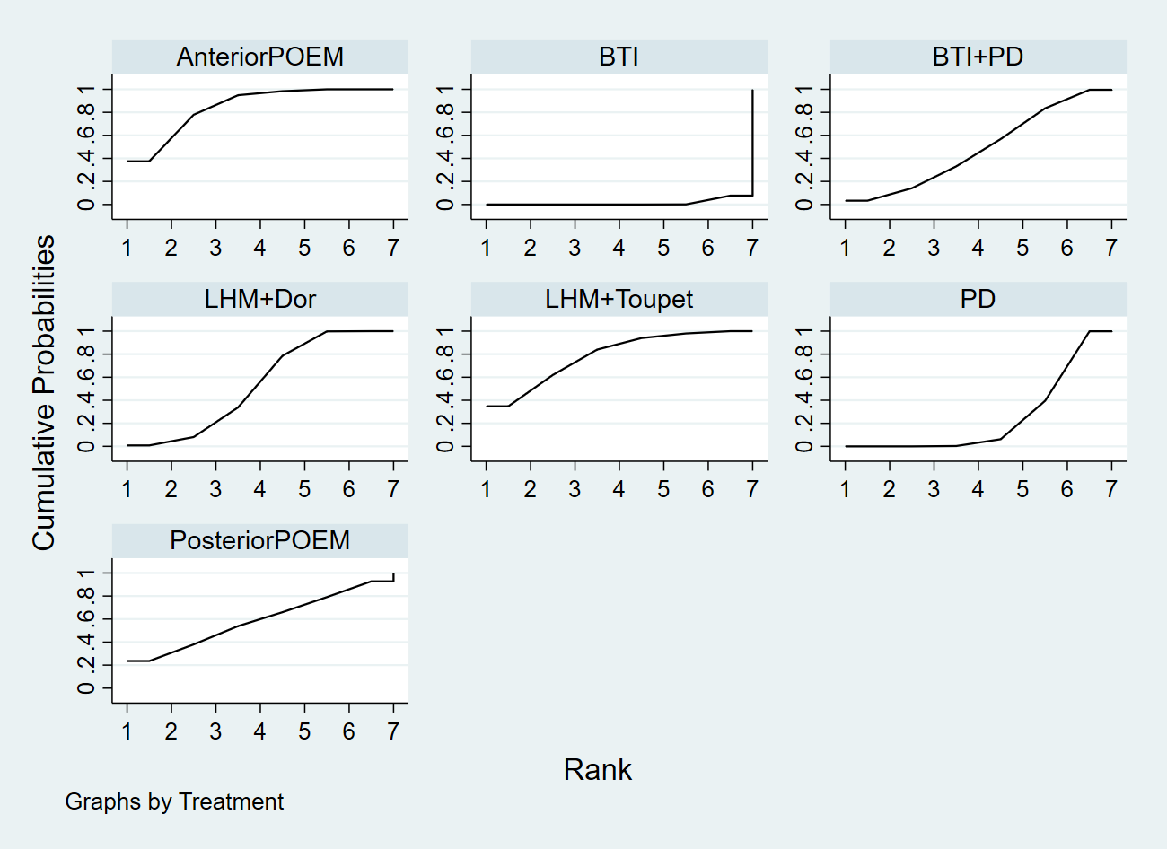
BTI, botulinum toxin injection; PD, pneumatic dilation; LHM, laparoscopic Heller’s myotomy; POEM, per-oral endoscopic myotomy.

