Supplementary Figure 4F.
Comparison-adjusted Network Funnel Plot of Different Therapeutic Modalities for Achalasia (Abnormal gastroesophageal acid reflux)
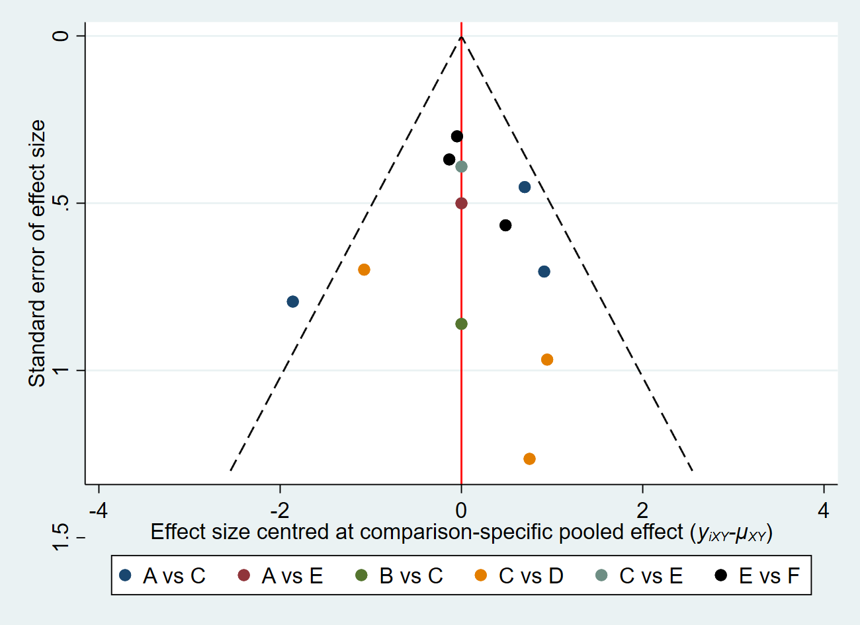
A: PD, B: LHM; C: LHM+Dor, D: LHM+Toupet, E: AnteriorPOEM; F: PosteriorPOEM.

