Supplementary Figure 4G.
Comparison-adjusted Network Funnel Plot of Different Therapeutic Modalities for Achalasia (Moderate-to-severe adverse events)
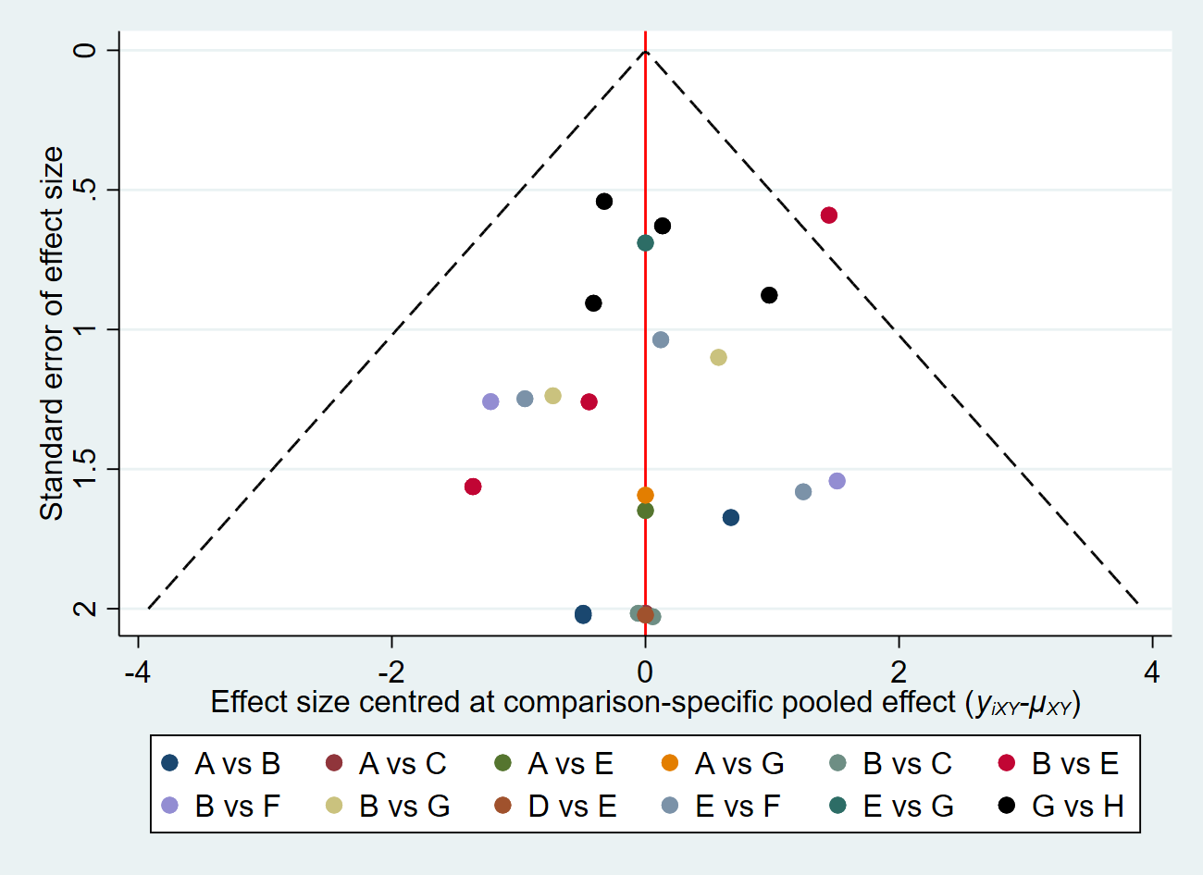
A: BTI, B: PD; C: BTI+PD, D: LHM; E: LHM+Dor, F: LHM+Toupet, G: AnteriorPOEM, H: PosteriorPOEM.

