Supplementary Figure 4C.
Comparison-adjusted Network Funnel Plot of Different Therapeutic Modalities for Achalasia (Treatment naïve + ≤ 1-year follow-up period)
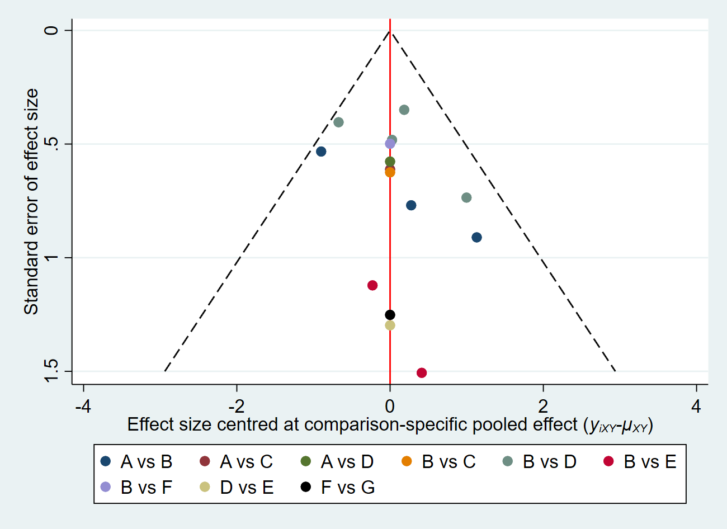
A: BTI, B: PD; C: BTI+PD, D: LHM+Dor, E: LHM+Toupet, F: AnteriorPOEM, G: PosteriorPOEM.

