Supplementary Figure 4E.
Comparison-adjusted Network Funnel Plot of Different Therapeutic Modalities for Achalasia (Single vs double sessions PD + ≤ 1-year follow-up period)
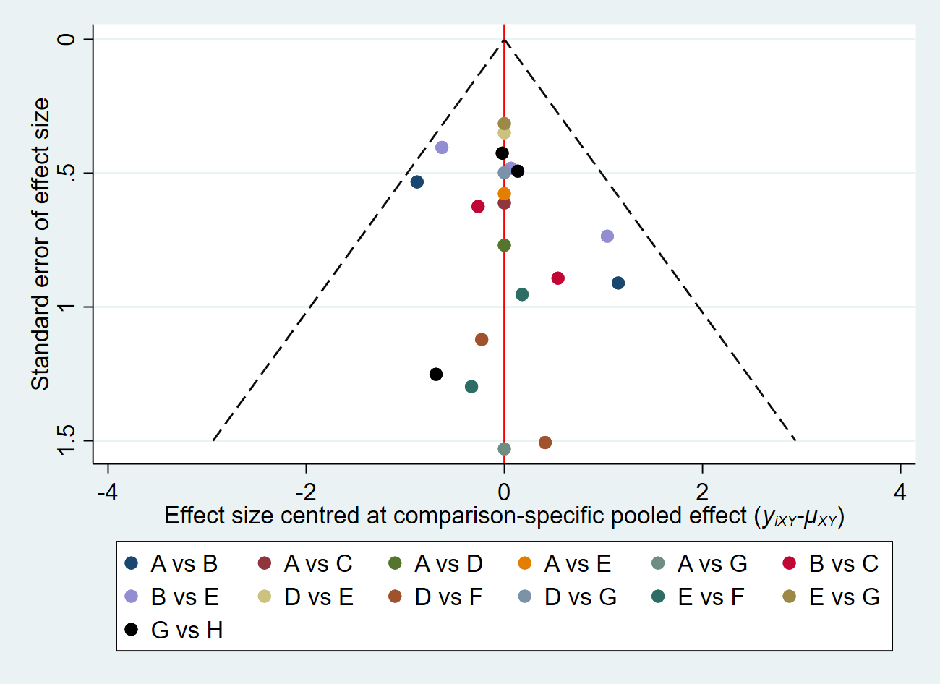
A: BTI, B: sPD; C: BTI+sPD, D: dPD; E: LHM+Dor, F: LHM+Toupet, G: AnteriorPOEM, H: PosteriorPOEM.

