Supplementary Figure 1C.
Network Comparisons Geometry of Different Therapeutic Modalities for Achalasia (Treatment naïve + 2-year follow-up period)
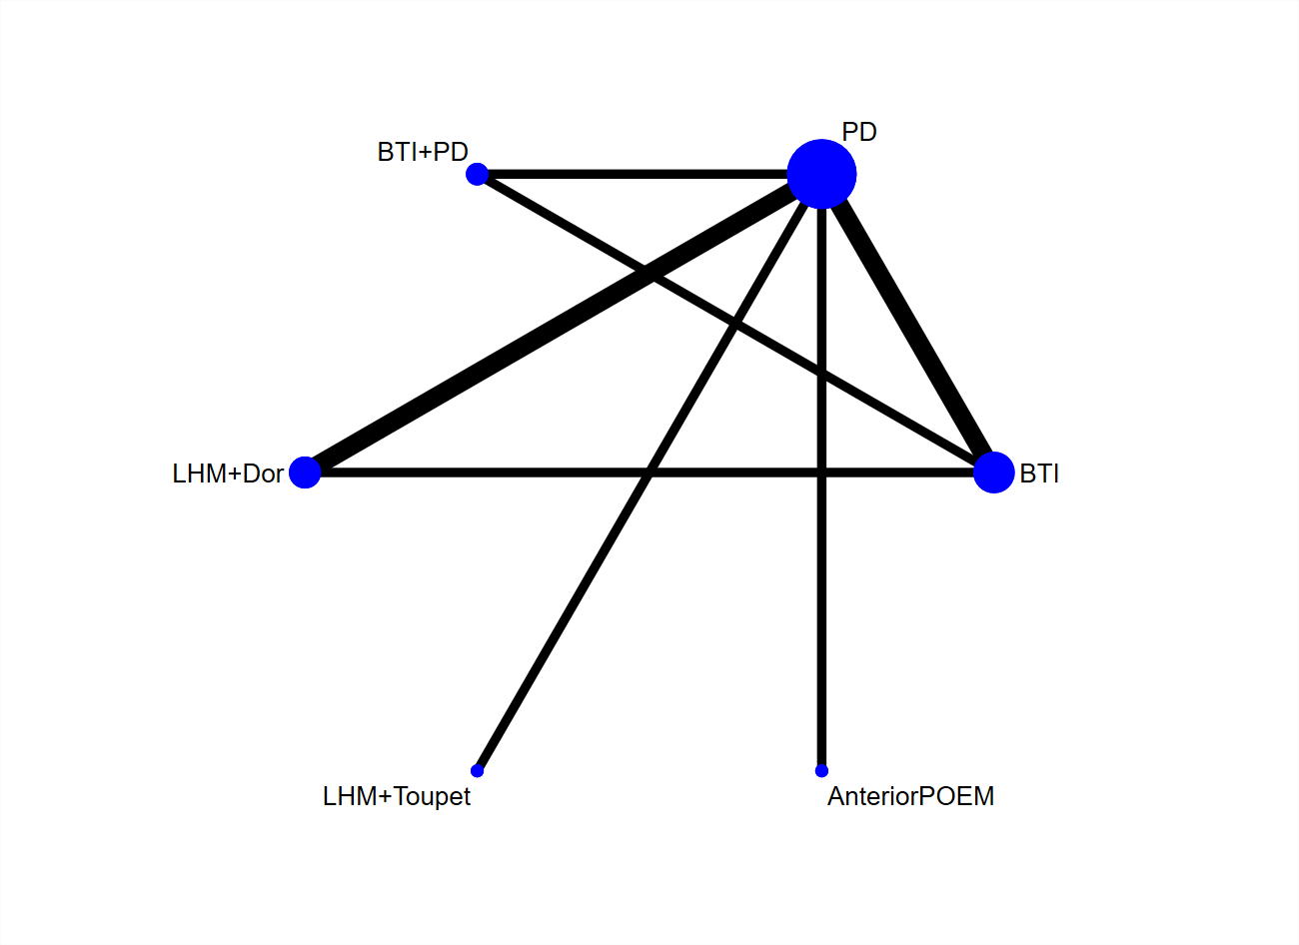
BTI, botulinum toxin injection; PD, pneumatic dilation; LHM, laparoscopic Heller’s myotomy; POEM, per-oral endoscopic myotomy.

