Supplementary Figure 1D.
Network Comparisons Geometry of Different Therapeutic Modalities for Achalasia (Single vs double sessions PD + ≤ 1-year follow-up period)
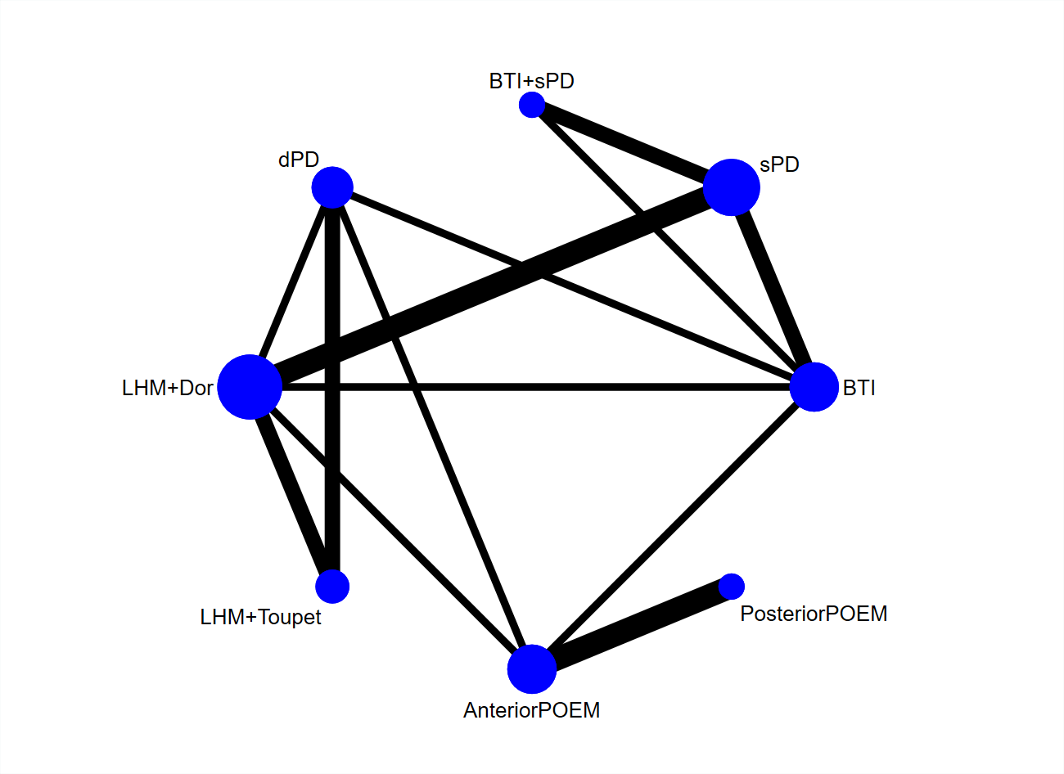
BTI, botulinum toxin injection; sPD, single session pneumatic dilation; dPD, double sessions pneumatic dilation; LHM, laparoscopic Heller’s myotomy; POEM, per-oral endoscopic myotomy.

