Supplementary Figure 2B.
Network Forest Plot of Indirect Comparisons of Different Therapeutic Modalities for Achalasia (Treatment naïve + ≤ 1-year follow-up period)
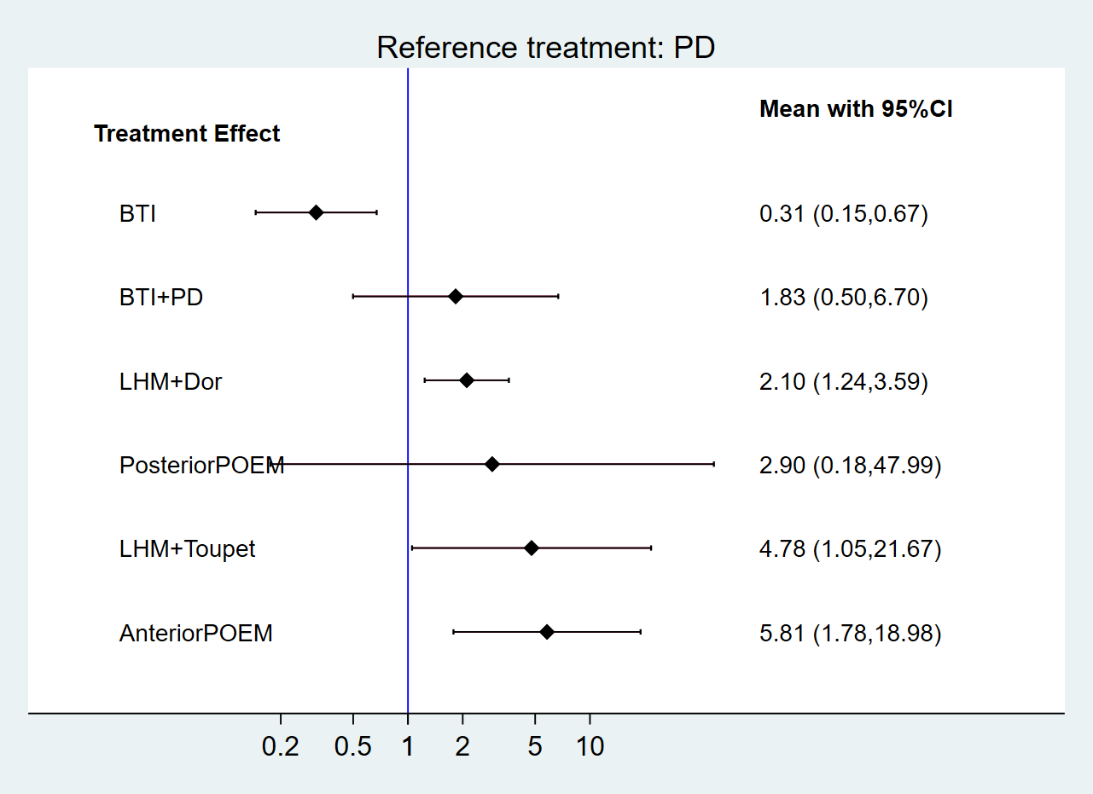
BTI, botulinum toxin injection; PD, pneumatic dilation; LHM, laparoscopic Heller’s myotomy; POEM, per-oral endoscopic myotomy.

