Supplementary Figure 1. Pooled union rate of induced membrane technique in interval between two stages during the periods of 6-8 weeks
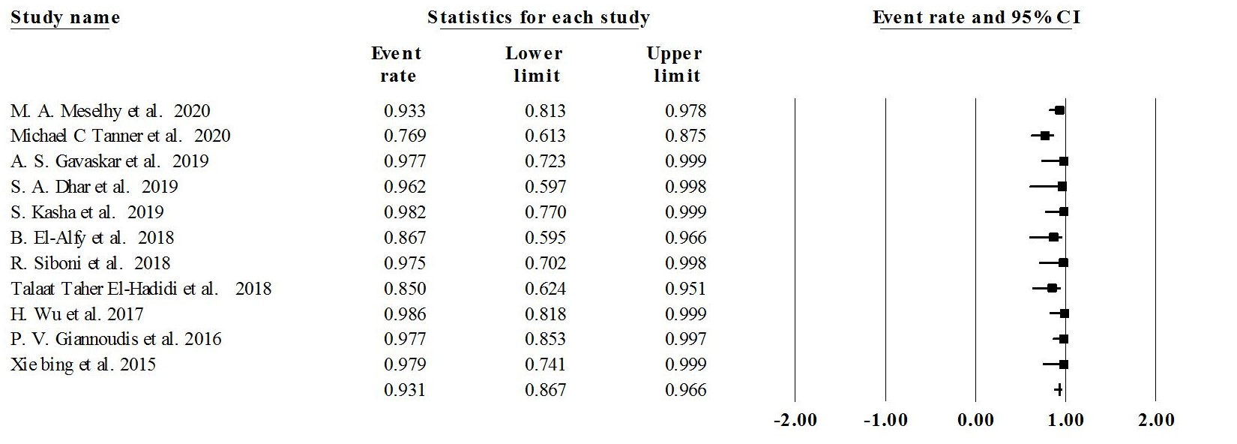

Supplementary Figure 2. Pooled union rate of induced membrane technique in interval between two stages during the periods of 8-12 weeks
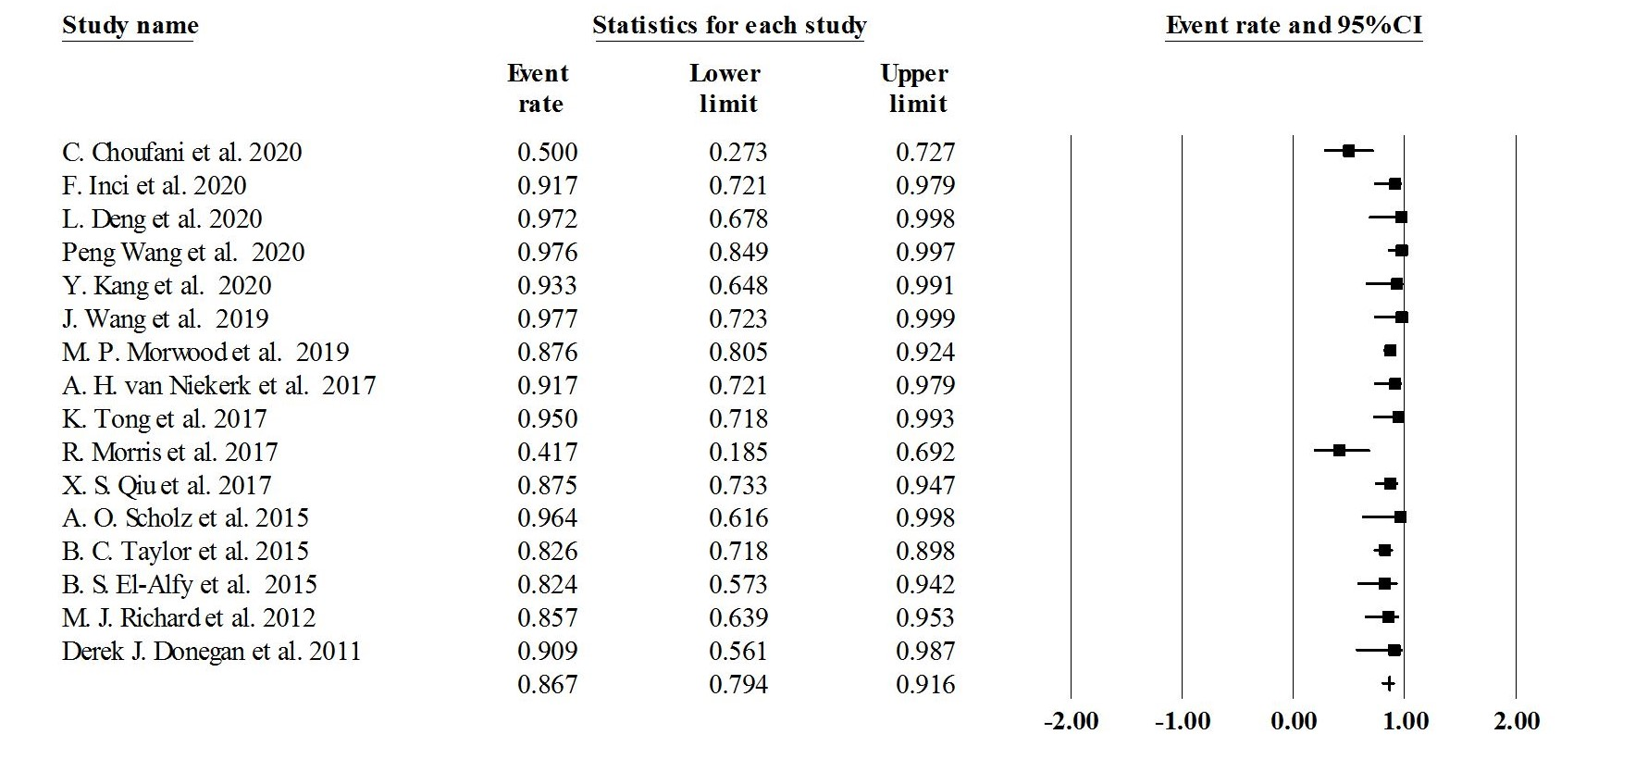

Supplementary Figure 3. Pooled union rate of induced membrane technique in interval between two stages during the periods of ≥ 12 weeks


