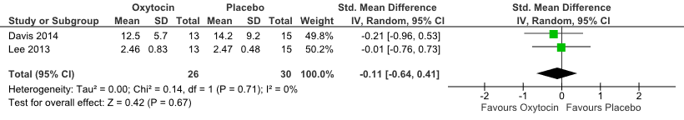
Supplementary Figure S1. Forest plot for studies for the effects of intra-nasal oxytocin on the amotivation dimensions of negative symptoms. Effect sizes are mean standardized differences at endpoint between intranasal oxytocin and placebo groups.

