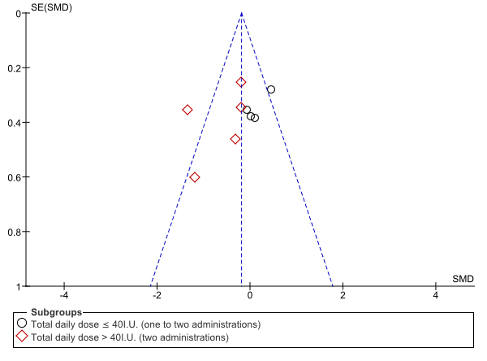
Supplementary Figure S2. Funnel plot for negative symptoms

