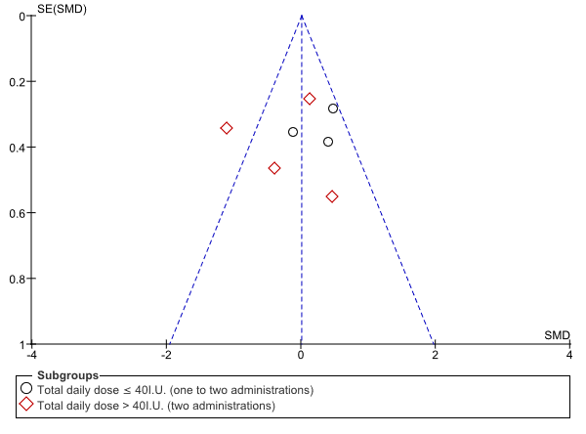
Supplementary Figure S3. Funnel plot for positive symptoms

