Negative symptoms | Positive symptoms
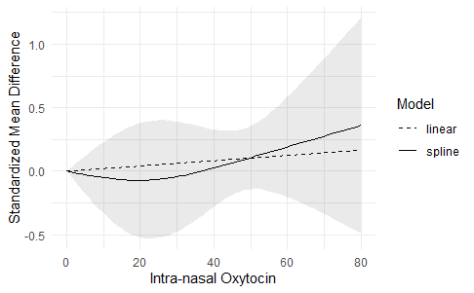 | 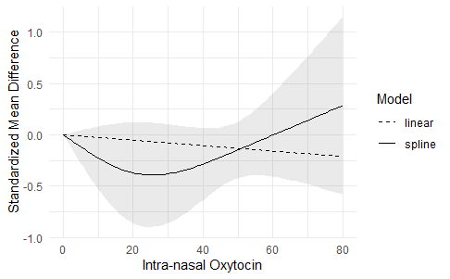

Predicted SMD for negative symptoms |  |  |  | Predicted SMD for positive symptoms
Dose | spl.pred | 95% CI |  | Dose | spl.pred | 95% CI
0 | 0.000 | (0.000 ; 0.000) |  | 0 | 0.000 | (0.000 ; 0.000)
20 | -0.072 | (-0.520; 0.376) |  | 20 | -0.432 | (-0.862 ; 0.120)
40 | 0.023 | (-0.282; 0.328) |  | 40 | -0.331 | (-0.638 ; 0.064)
60 | 0.190 | (-0.201; 0.582) |  | 60 | 0.172 | (-0.409 ; 0.399)
80 | 0.360 | (-0.487; 1.206) |  | 80 | 0.792 | (-0.582 ; 1.146)

Supplementary Figure S4. Sensitivity analysis for the dose-response meta-analysis: exclusion of Modabbernia et al. for negative symptoms (n=8) and positive symptoms (n=6).

In this sensitivity analysis, we excluded the outlier study of Modabbernia et al..
For positive symptoms, the trend-level effect significance found prior to exclusion of this study dissipated.
For negative and positive symptoms, both effect sizes were nonsignificant (SMD, 0.011; 95% CI, -0.03 to +0.05; p=0.62; and; SMD, 0.03; 95% CI, -0.015 to +0.07; p=0.27; respectively).

