Supplementary material
Variable Diagnostic Performance of Stool Xpert in Pediatric Tuberculosis: a systematic review and meta-analysis

Meseret Gebre, Lindsay Hatzenbuehler Cameron, Getachew Tadesse, Yohannes Woldeamanuel, Liya Wassie

Table S1-PRISMA checklist
Figure S1-Risk of bias assessment using QUADAS 2
Figure S2 (A&B)-Forest plot excluding Di Nardo
Text S1- Search strategies used

Figure S1-Risk of bias assessment

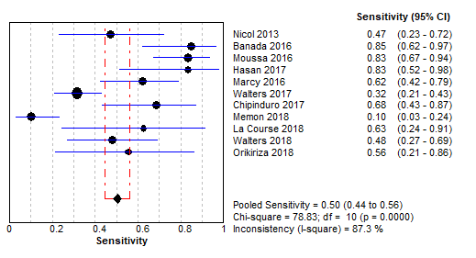
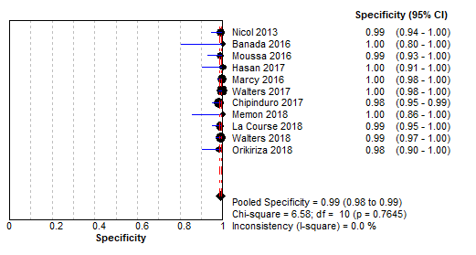

Figure S2

Text S1-Search strategies used
Search executed in PubMed, EMBASE, BIOSIS
- TOPIC: Diagnosis of TB in children using Xpert MTB/RIF.

(((Xpert MTB/RIF) AND ((tuberculosis) OR (mycobacterium OR mycobacterium infection)))) AND (child OR children OR pediatric)

- TOPIC: Diagnosis of tb using stool or feces.

mycobacterium tuberculosis AND (diagnosis OR assay OR detect* OR identification) AND (stool OR feces OR fecal)

