Supplementary Table 1. Search strategy
Pubmed
P  Population / Patient (problem, disease, coexisting problems) | ("endovascular procedures"[MeSH Major Topic] OR endovascular[Title/Abstract] OR endovascular procedure[Title/Abstract] OR endovascular treatment[Title/Abstract] OR intervention[Title/Abstract] OR interventional neuroradiology[Title/Abstract] OR intra-arterial[Title/Abstract] OR intra-arterial treatment[Title/Abstract] OR thrombolytic[Title/Abstract] OR thrombolytic therapy[Title/Abstract] OR thrombectomy[Title/Abstract] OR mechanical thrombectomy[Title/Abstract] OR aspiration[Title/Abstract] OR stent retriever[Title/Abstract] OR large vessel[Title/Abstract] OR large vessel occlusion[Title/Abstract] OR reperfusion[Title/Abstract] OR recanalization[Title/Abstract] OR revascularization[Title/Abstract])
I  Intervention I (Therapy) | (anticoagulants[MeSH Terms] OR anticoagulants OR anticoagulation[Title/Abstract] OR anticoagulation therapy[Title/Abstract] OR direct oral anticoagulants[Title/Abstract] OR DOAC[Title/Abstract] OR novel oral anticoagulants[Title/Abstract] OR NOAC[Title/Abstract] OR non-vitamin K antagonist oral anticoagulants[Title/Abstract] OR vitamin K antagonists[Title/Abstract] OR VKA[Title/Abstract] OR coumarin[Title/Abstract] OR warfarin[Title/Abstract] OR internationalized normalized ratio[Title/Abstract] OR INR[Title/Abstract])
C  Comparison | /
O  Outcome | (intracerebral hemorrhage[Title/Abstract] OR intracerebral haemorrhage[Title/Abstract] OR intracranial hemorrhage[Title/Abstract] OR intracranial haemorrhage[Title/Abstract] OR symptomatic intracerebral hemorrhage[Title/Abstract] OR symptomatic intracerebral haemorrhage[Title/Abstract] OR symptomatic intracranial hemorrhage[Title/Abstract] OR symptomatic intracranial haemorrhage[Title/Abstract] OR hematoma[Title/Abstract])

Embase
P  Population / Patient (problem, disease, coexisting problems) | ‘endovascular’:ab,ti OR ‘endovascular procedure’:ab,ti OR ‘endovascular treatment’:ab,ti OR ‘intervention’:ab,ti OR ‘interventional neuroradiology’:ab,ti OR ‘intra-arterial’:ab,ti OR ‘intra-arterial treatment’:ab,ti OR ‘thrombolytic’:ab,ti OR ‘thrombolytic therapy’:ab,ti OR ‘thrombectomy’:ab,ti OR ‘mechanical thrombectomy’:ab,ti OR ‘aspiration’:ab,ti OR ‘stent retriever’:ab,ti OR ‘large vessel’:ab,ti OR ‘large vessel occlusion’:ab,ti OR ‘reperfusion’:ab,ti OR ‘recanalization’:ab,ti OR ‘revascularization’:ab,ti
I  Intervention I (Therapy) | ‘anticoagulants’:ab,ti OR ‘anticoagulation’:ab,ti OR ‘anticoagulation therapy’:ab,ti OR ‘direct oral anticoagulants’:ab,ti OR ‘DOAC’:ab,ti OR ‘novel oral anticoagulants’:ab,ti OR ‘NOAC’:ab,ti OR ‘non-vitamin K antagonist oral anticoagulants’:ab,ti OR ‘vitamin K antagonists’:ab,ti OR ‘VKA’:ab,ti OR ‘coumarin’:ab,ti OR ‘warfarin’:ab,ti OR ‘internationalized normalized ratio’:ab,ti OR ‘INR’:ab,ti
C  Comparison | /
O  Outcome | ‘intracerebral hemorrhage’:ab,ti OR ‘intracerebral haemorrhage’:ab,ti OR ‘intracranial hemorrhage’:ab,ti OR ‘intracranial haemorrhage’:ab,ti OR ‘symptomatic intracerebral hemorrhage’:ab,ti OR ‘symptomatic intracerebral haemorrhage’:ab,ti OR ‘symptomatic intracranial hemorrhage’:ab,ti OR ‘symptomatic intracranial haemorrhage’:ab,ti OR ‘hematoma’:ab,ti

Cochrane
P  Population / Patient (problem, disease, coexisting problems) | endovascular procedures OR endovascular OR endovascular procedure OR endovascular treatment OR intervention OR interventional neuroradiology OR intra-arterial OR intra-arterial treatment OR thrombolytic OR thrombolytic therapy OR thrombectomy OR mechanical thrombectomy OR aspiration OR stent retriever OR large vessel OR large vessel occlusion OR reperfusion OR recanalization OR revascularization
I  Intervention I (Therapy) | anticoagulants OR anticoagulants OR anticoagulation OR anticoagulation therapy OR direct oral anticoagulants OR DOAC OR novel oral anticoagulants OR NOAC OR non-vitamin K antagonist oral anticoagulants OR vitamin K antagonists OR VKA OR coumarin OR warfarin OR internationalized normalized ratio OR INR
C  Comparison | /
O  Outcome | intracerebral hemorrhage OR intracerebral haemorrhage OR intracranial hemorrhage OR intracranial haemorrhage OR symptomatic intracerebral hemorrhage OR symptomatic intracerebral haemorrhage OR symptomatic intracranial hemorrhage OR symptomatic intracranial haemorrhage OR hematoma

Supplementary Figure 1. Risk of bias assessment
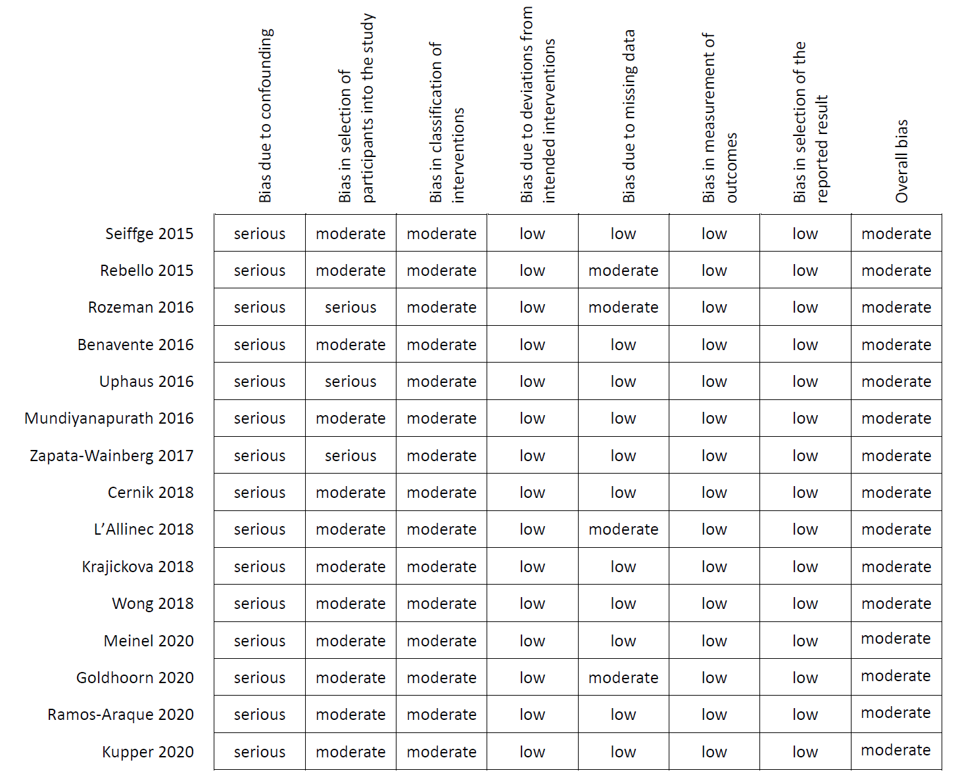
Supplementary Figure 2. Funnel plot for VKA/DOAC vs. non-OAC regarding sICH

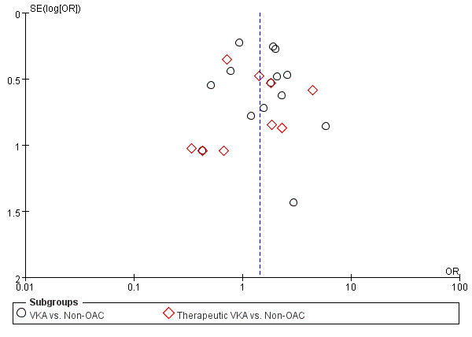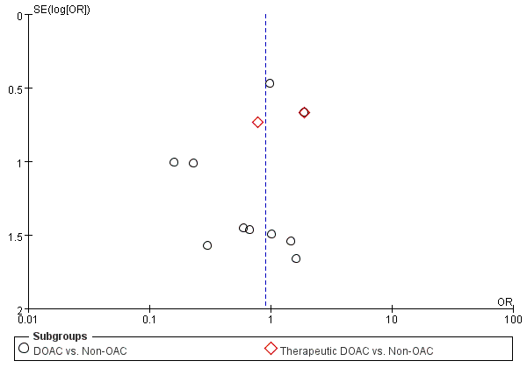

Supplementary Figure 3. Funnel plot for VKA/DOAC vs. non-OAC regarding mortality

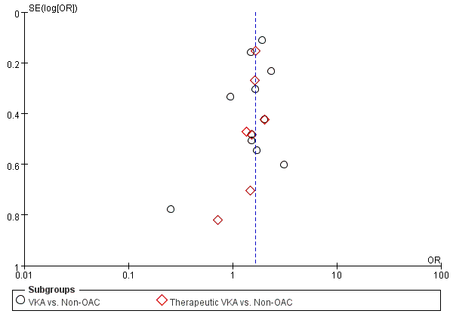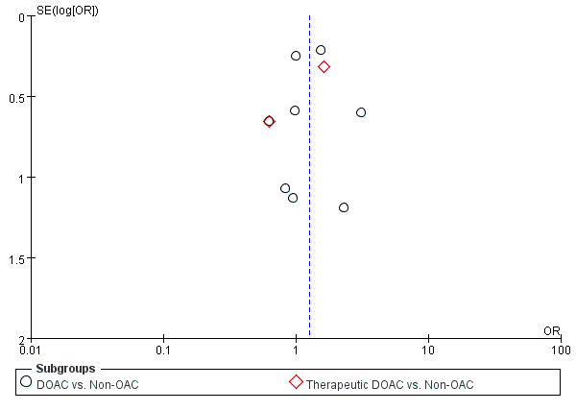

Supplementary Figure 4. Funnel plot for VKA/DOAC vs. non-OAC regarding functional outcome

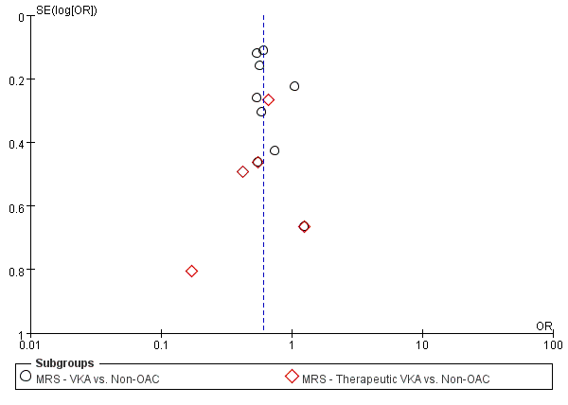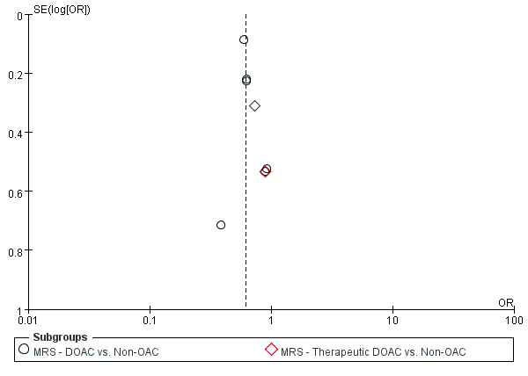

Supplementary Figure 5. Funnel plot for VKA/DOAC vs. non-OAC regarding successful reperfusion



