Supplementary Figure 1. Funnel plot with pseudo 95% confidence intervals for studies
exploring differences in blood interleukin-6 levels between subjects with vascular dementia and controls
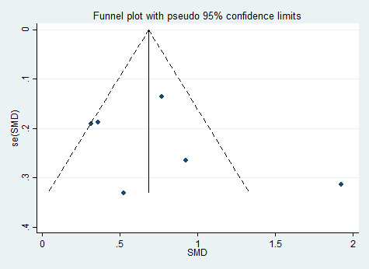

Supplementary Figure 2. Funnel plot with pseudo 95% confidence intervals for studies exploring differences in blood interleukin-6 levels between subjects with vascular dementia and Alzheimer’s disease
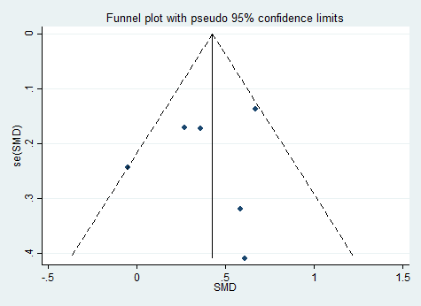

Supplementary Figure 3. Funnel plot with pseudo 95% confidence intervals for studies
exploring blood interleukin-6 levels and risk of incident vascular dementia
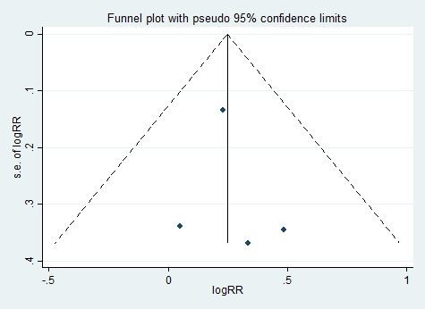

Supplementary Figure 4. Funnel plot with pseudo 95% confidence intervals for studies exploring differences in blood C-reactive protein levels between subjects with vascular dementia and controls
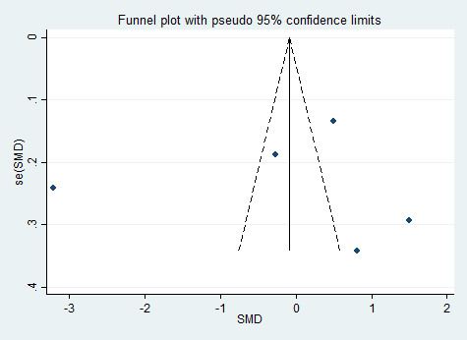

Supplementary Figure 5. Funnel plot with pseudo 95% confidence intervals for studies
exploring differences in blood C-reactive protein levels between subjects with vascular dementia and Alzheimer’s disease
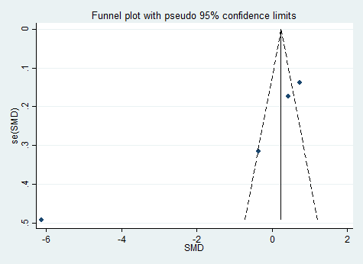

Supplementary Figure 6. Funnel plot with pseudo 95% confidence intervals for studies exploring blood C-reactive protein levels and risk of incident vascular dementia
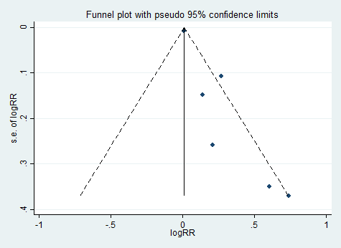

Supplementary Figure 7. Funnel plot with pseudo 95% confidence intervals for studies
exploring differences in blood tumor necrosis factor-α levels between subjects with vascular dementia and controls
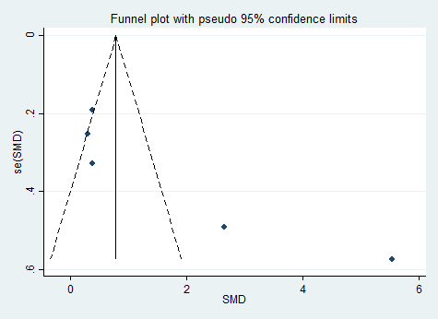

Supplementary Figure 8. Funnel plot with pseudo 95% confidence intervals for studies exploring differences in blood tumor necrosis factor-α levels between subjects with vascular dementia and Alzheimer’s disease
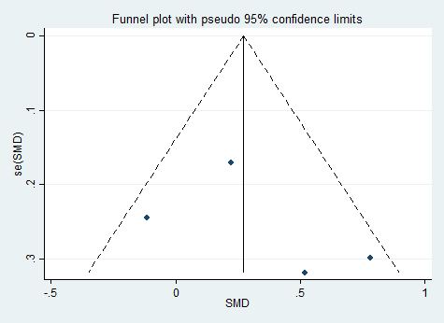

Supplementary Figure 9. Funnel plot with pseudo 95% confidence intervals for studies exploring differences in cerebrospinal fluid interleukin-6 levels between subjects with vascular dementia and controls
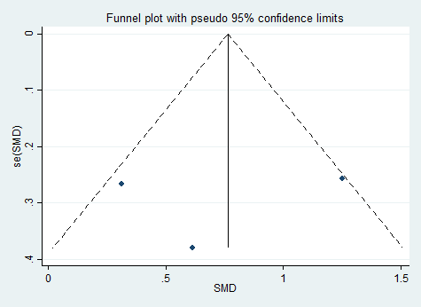

Supplementary Figure 10. Funnel plot with pseudo 95% confidence intervals for studies exploring differences in cerebrospinal fluid interleukin-6 levels between subjects with vascular dementia and Alzheimer’s disease
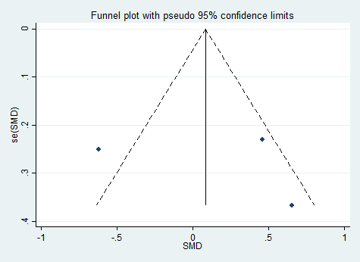

Supplementary Table 1. Newcastle-Ottawa quality assessment scale for evaluation of the quality of observational studies

 |  | Selection |  |  |  | Comparability |  | Outcome
ID | First author, year | #1 | #2 | #3 | #4 | #5 | #6 | #7 | #8 | #9 | Total
Case-control studies
1 | De Luigi, 2001 |  | ★ |  | ★ | ★ |  |  | ★ | ★ | 5
2 | Dukic, 2016 | ★ | ★ |  | ★ |  |  |  | ★ | ★ | 5
3 | Jia, 2005 | ★ |  |  | ★ | ★ |  |  | ★ | ★ | 5
4 | Li, 2010 | ★ | ★ |  | ★ | ★ |  | ★ | ★ | ★ | 7
5 | Mancinella, 2009 | ★ | ★ | ★ | ★ | ★ | ★ | ★ | ★ | ★ | 9
6 | Paganelli, 2002 | ★ |  | ★ | ★ |  |  |  | ★ | ★ | 5
7 | Tarkowski, 1999 | ★ | ★ |  | ★ |  |  |  | ★ | ★ | 5
8 | Uslu, 2012 | ★ | ★ | ★ | ★ | ★ |  | ★ | ★ | ★ | 8
9 | Vishnu, 2017 | ★ |  | ★ | ★ |  |  | ★ | ★ |  | 5
10 | Wada-Isoe, 2004 | ★ |  |  | ★ |  |  |  | ★ | ★ | 4
11 | Wehr, 2019 | ★ | ★ | ★ | ★ |  |  | ★ | ★ | ★ | 7
12 | Zhang, 2017 | ★ | ★ | ★ | ★ |  |  |  | ★ | ★ | 6
13 | Zuliani, 2007 | ★ | ★ |  | ★ | ★ | ★ |  | ★ | ★ | 7
Cohort studies
14 | Engelhart, 2004 | ★ | ★ | ★ | ★ | ★ | ★ | ★ | ★ | ★ | 9
15 | Gallacher, 2010 |  | ★ | ★ | ★ | ★ | ★ |  | ★ |  | 6
16 | Hsu, 2017 | ★ | ★ | ★ | ★ | ★ | ★ |  | ★ | ★ | 8
17 | Miwa, 2016 | ★ | ★ | ★ | ★ | ★ | ★ |  | ★ | ★ | 8
18 | Ravaglia, 2007 | ★ | ★ | ★ | ★ | ★ | ★ |  | ★ | ★ | 8
19 | Schmidt, 2002 | ★ |  | ★ | ★ | ★ | ★ | ★ | ★ | ★ | 8
20 | Van Oijen, 2005 | ★ | ★ | ★ | ★ | ★ | ★ | ★ | ★ | ★ | 9
#1. Adequate case definition/ Representativeness of patients with VaD
#2. Representativeness of the cases/ Selection of the Comparative patients without VaD #3. Selection of Controls/Ascertainment of VaD station/ distinction with AD
#4. Definition of Controls/ Demonstration that VaD was not present at start of study #5. Study controls for age
#6. Study controls for gender/other
#7. Ascertainment of exposure (case-control studies)/outcome (cohort studies)
#8. Same method of ascertainment for cases and controls/ Was follow-up long enough for VaD to occur
#9. Non-Response rate/Adequacy of follow up

