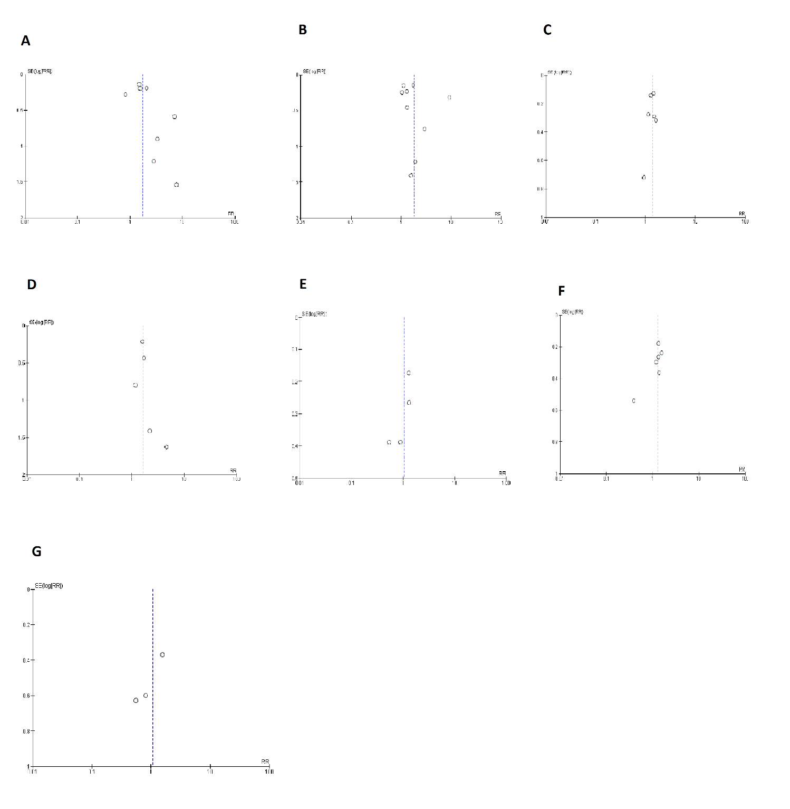
Figure S1. Funnel plots for publication bias of short term outcomes.(A)Mortality; (B) Myocardial infarction; (C) Major adverse cardiac outcomes; (D) Stent thrombosis; (E)Target vessel revascularization (TVR); (F) Target lesion revascularization (TLR); (G)Coronary Artery Bypass Graft Surgery (CABG). SE, standard error; RR, risk ratio

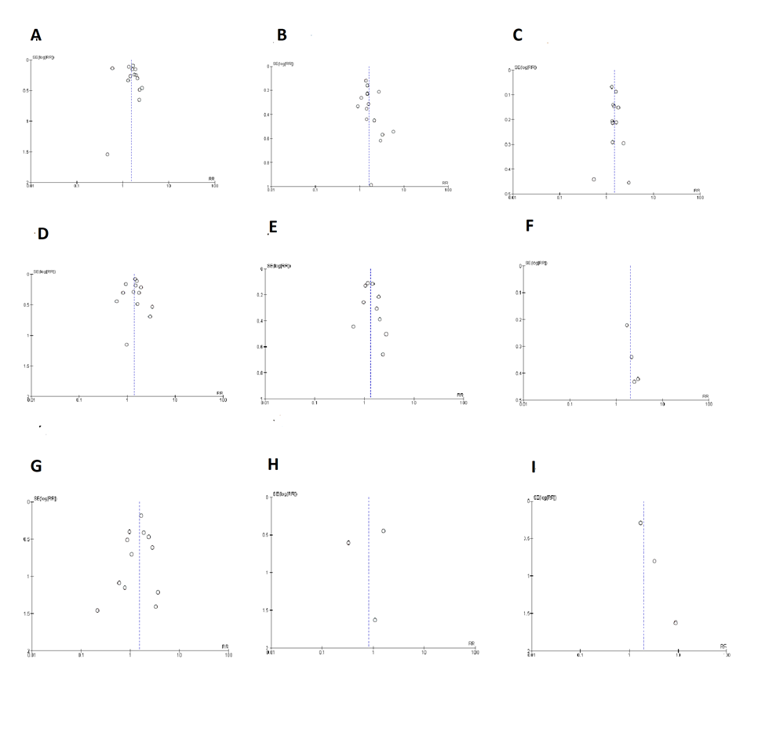

Figure S2. Funnel plots for publication bias of long term outcomes.
(A)Mortality; (B) Myocardial infarction; (C)Major adverse cardiac outcomes (D) Target lesion revascularization (TLR) (E) Target vessel revascularization (TVR) (F) Target lesion failure (TLF) (G) Stent thrombosis (H) CABG (I) Stroke . SE, standard error; RR, risk ratio

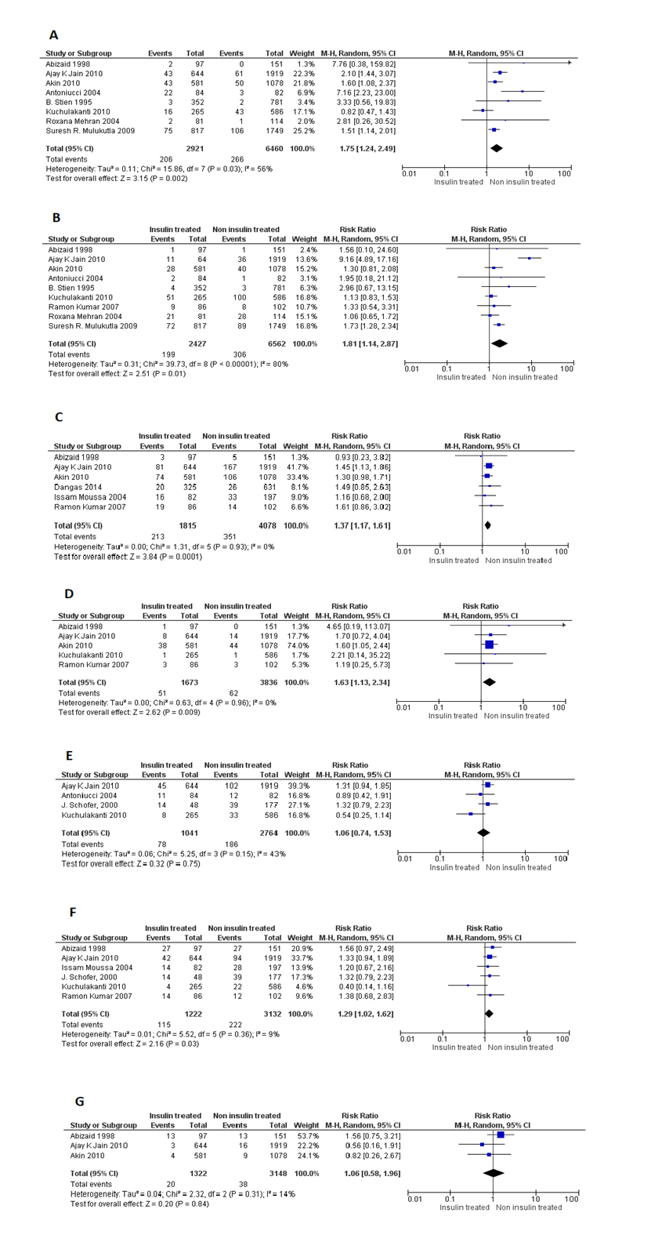
(A)Mortality; (B) Myocardial infarction; (C)Major adverse cardiac outcomes, (D) Stent thrombosis; (E)Target vessel revascularization (TVR); (F) Target lesion revascularization (TLR); (G) Coronary Artery Bypass Graft Surgery CABG
Figure S3. Short term follow- up cardiovascular outcomes of insulin treated DM group versus non-insulin treated DM group undergoing percutaneous intervention (PCI)

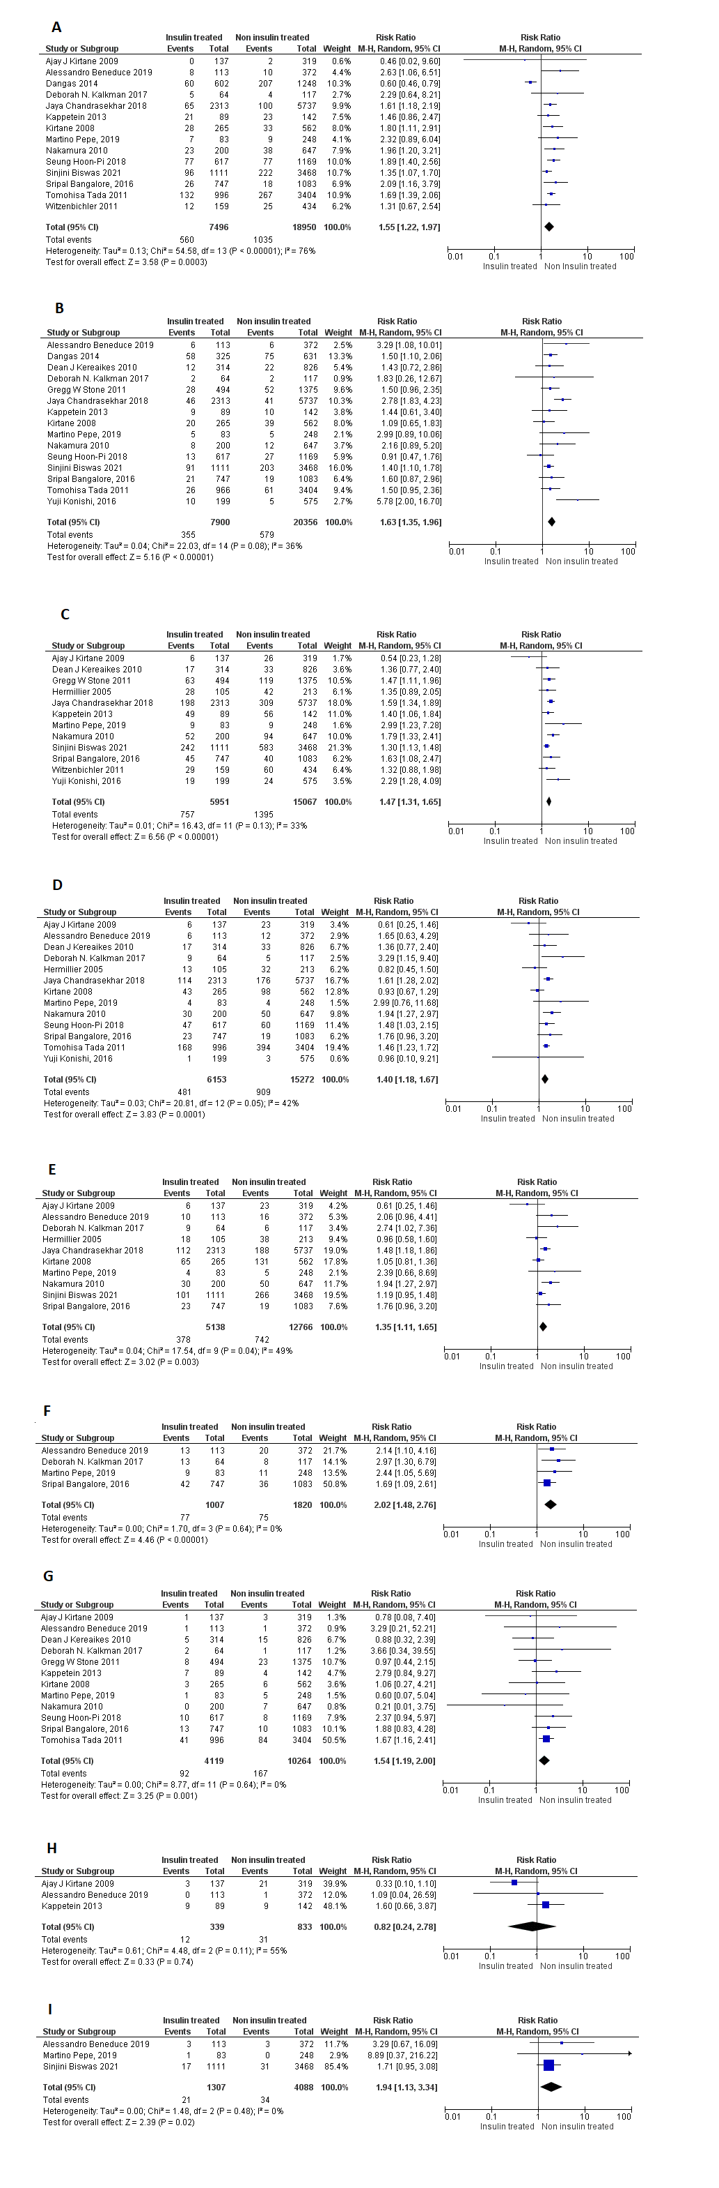
(A)Mortality; (B) Myocardial infarction; (C)Major adverse cardiac outcomes (D) Target lesion revascularization (TLR) (E) Target vessel revascularization (TVR) (F) Target lesion failure (TLF) (G) Stent thrombosis (H) CABG (I) Stroke
Figure S4. Long term follow- up cardiovascular outcomes of insulin treated DM group versus non-insulin treated DM group undergoing percutaneous intervention (PCI)

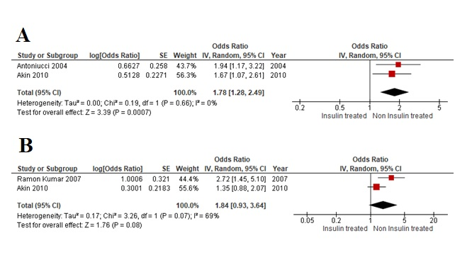
(A)Mortality; (B)Major adverse cardiac outcomes
Figure S5. Propensity matched data for short term follow- up cardiovascular outcomes of insulin treated DM group versus non-insulin treated DM group undergoing percutaneous intervention (PCI)

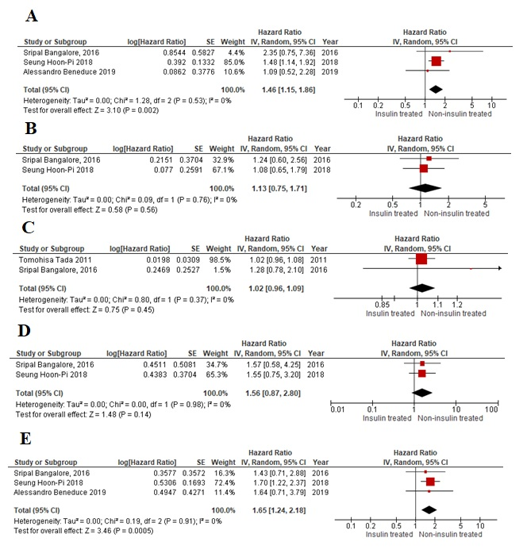
(A)Mortality; (B) Myocardial infarction; (C)Major adverse cardiac outcomes (D) Stent thrombosis; (E) Target lesion revascularization (TLR)
Figure S6. Propensity matched data for long term follow- up cardiovascular outcomes of insulin treated DM group versus non-insulin treated DM group undergoing percutaneous intervention (PCI)

Author | Cohort  Representability | Selection of  Non-exposed  Cohort | Ascertainment  of Exposure | Outcome  Not  Present at  Baseline | Comparability  of Cohorts  for Important  Factors | Comparability  of Cohorts  for Other  Variables | Assessment  of  Outcome | Follow- Up Long  Enough for  Outcome  to Occur | Adequacy  of Follow-  Up | Overall  Risk of  Bias
Biswas, S., 2021 | 1 | 1 | 1 | 1 | 1 | 1 | 1 | 1 | 1 | Low
Pepe, M., 2019 | 1 | 1 | 1 | 1 | 1 | 1 | 1 | 1 | 1 | Low
Pi, S. H., 2018 | 1 | 1 | 1 | 1 | 1 | 1 | 1 | 1 | 1 | Low
Schofer, J., 2000 | 1 | 1 | 1 | 1 | 1 | 1 | 1 | 1 | 1 | Low
Stien, B., 1995 | 1 | 1 | 1 | 1 | 1 | 1 | 1 | … | … | Low
Beneduce, A., 2019 | 1 | 1 | 1 | … | 1 | 1 | 1 | 1 | 1 | Low
Chandrasekhar, J., 2018 | 1 | 1 | 1 | … | 1 | 1 | 1 | 1 | 1 | Low
Tada, T., 2011 | 1 | 1 | 1 | … | 1 | 1 | 1 | 1 | 1 | Low
Nakamura, M., 2010 | 1 | 1 | 1 | 1 | 1 | 1 | 1 | 1 | 1 | Low
Mulukutla, S. R., 2009 | 1 | 1 | 1 | 1 | 1 | 1 | 1 | 1 | 1 | Low
Kumar, R., 2007 | 1 | 1 | 1 | 1 | 1 | 1 | 1 | 1 | 1 | low
Mehran, R., 2004 | 1 | 1 | 1 | 1 | 1 | 1 | 1 | … | … | Low
Abizaid, A., 1998 | 1 | 1 | 1 | 1 | 1 | 1 | 1 | 1 | 1 | Low
Akin, I., 2010 | 1 | 1 | 1 | 1 | 1 | 1 | 1 | 1 | 1 | Low
Antoniucci, D., 2004 | 1 | 1 | 1 | 1 | 1 | … | 1 | 1 | 1 | Low
Jain, A. K., 2010 | 1 | 1 | 1 | 1 | 1 | 1 | 1 | 1 | 1 | Low
Kuchukulanti, P. K., 2010 | 1 | 1 | 1 | … | 1 | 1 | 1 | 1 | 1 | Low
Konishi, Y., 2016 | 1 | 1 | 1 | … | 1 | 1 | 1 | 1 | 1 | Low

Table S1. Quality assessment of cohort studies by New Castle-Ottawa scale.

Article | Selection Bias |  | Performance Bias | Detection bias | Attrition bias | Reporting Bias | Other bias | Our evaluation
Article | Random Sequence Generation | Allocation concealment | Blinding of participants and  personnel | Blinding of outcome assessment | Incomplete outcome data | Selective Reporting | Anything else, ideally prespecified | Our evaluation
Kirtane, A. J., 2009 | low | Unclear | low | low | low | low | low | Good quality
Kereiakes, D. J, 2010 | low | low | low | low | low | low | low | Good quality
Hermiller, J. B, 2004 | low | Unclear | low | Unclear | low | low | low | Fair quality
Dangas, G. D. 2014 | low | high | low | high | low | low | low | Poor quality
Moussa, I., 2004 | Unclear | Unclear | low | low | low | low | low | Fair quality
Bangalore, S., 2016 | low | low | high | low | low | low | low | Fair quality
Kalkman, D. N., 2017 | unclear | high | unclear | unclear | low | low | low | Poor quality
Kappetein, A. P., 2013 | low | high | uncler | unclear | low | low | low | Poor quality
Stone, G. W., 2011 | low | low | low | low | low | low | low | Good quality
Witzenbichler, B., 2011 | low | low | unclear | unclear | low | low | low | Poor quality
Kirtane, A. J. 2008 | low | low | low | low | unclear | unclear | low | Fair quality

Table S2. Cochrane Tool for Accessing Risk of Bias in RCTs; Quality Assessment of published studies included in the meta-analysis

Study | Total no of patients |  | All-cause mortality (n) |  | MI (n) |  | Major adverse cardiac effects (n) |  | Stent thrombosis (n) |  | TVR (n) |  | TLR  ( n) |  | CABG (n)
 | ITDM | Non-ITDM | ITDM | Non-ITDM | ITDM | Non-ITDM | ITDM | Non-ITDM | ITDM | Non-ITDM | ITDM | Non-ITDM | ITDM | Non-ITDM | ITDM | Non-ITDM
J. Schofer, 2000 | 48 | 177 |  |  |  |  |  |  |  |  | 14/48 | 39/177
B. Stien, 1995 | 352 | 781 | 3/352 | 2/781 | 4/352 | 3/781
Ramon Kumar 2007 | 86 | 102 |  |  | 9/86 | 8/102 | 19/86 | 14/102 | 3/86 | 3/102 |  |  | 14/86 | 12/102
Roxana Mehran 2004 | 81 | 114 | 2/81 | 1/114 | 21/81 | 28/114
Antoniucci 2004 | 84 | 82 | 22/84 | 3/82 | 2/84 | 1/82 |  |  |  |  | 11/84 | 12/82
Kuchulakanti 2010 | 265 | 586 | 16/265 | 43/586 | 51/265 | 100/586 |  |  | 1/265 | 1/586 | 8/265 | 33/586 | 4/265 | 22/586
Abizaid 1998 | 97 | 151 | 2/97 | 0/151 | 1/97 | 1/151 | 3/97 | 5/151 | 1/97 | 0/151 |  |  | 27/97 | 27/151 | 13/97 | 13/151
Akin 2010 | 581 | 1078 | 43/581 | 50/1078 | 28/581 | 40/1078 | 74/581 | 106/1078 | 38/581 | 44/1078 |  |  |  |  | 4/581 | 9/1078
Suresh R. Mulukutla,2009 | 817 | 1749 | 75/817 | 106/1749 | 72/817 | 89/1749
Ajay K Jain,2010 | 644 | 1919 | 43/644 | 61/1919 | 11/644 | 36/1919 | 81/644 | 167/1919 | 8/644 | 14/1919 | 45/644 | 102/1919 | 42/644 | 94/1919 | 3/644 | 16/1919
Issam Moussa 2004 | 82 | 197 |  |  |  |  | 16/82 | 33/197 |  |  |  |  | 14/82 | 28/197
Dangas 2014 | 325 | 631 |  |  |  |  | 20/325 | 26/631
Events/ Total number of patients in each outcome | 3462 | 7567 | 206/2921 | 266/6460 | 199/2427 | 306/6562 | 213/1815 | 351/4078 | 51/1673 | 62/3836 | 78/1041 | 186/2764 | 115/1222 | 222/3132 | 14/3462 | 9/7567

Table S3. Short term follow-up outcomes of insulin versus non-insulin DM group undergoing PCI

Study | Total no of patients |  | All -cause mortality (n) |  | MI (n) |  | Major adverse cardiac effects |  | Stent thrombosis (n) |  | TLF (Target lesion failure) (n) |  | TVR (Target vessel revascularization) (n) |  | TLR (Target lesion revascularization)  (n) |  | CABG (n) |  | Stroke (n)
 | ITDM | Non-ITDM | ITDM | Non-ITDM | ITDM | Non-ITDM | ITDM | Non-ITDM | ITDM | Non-ITDM | ITDM | Non-ITDM | ITDM | Non-ITDM | ITDM | Non-ITDM | ITDM | Non-ITDM | ITDM | Non-ITDM
Kappetein 2013 | 89 | 142 | 21/89 | 23/142 | 9/89 | 10/142 | 49/89 | 56/142 | 7/89 | 4/142 |  |  |  |  |  |  | 9/89 | 9/142
Gregg W Stone 2011 | 494 | 1375 |  |  | 28/494 | 52/1375 | 63/494 | 119/1375 | 8/494 | 23/1375
Tomohisa Tada 2011 | 996 | 3404 | 132/996 | 267/3404 | 26/996 | 61/3404 |  |  | 41/996 | 84/3404 |  |  |  |  | 168/996 | 394/3404
Nakamura 2010 | 200 | 647 | 23/200 | 38/647 | 8/200 | 12/647 | 52/200 | 94/647 | 0/200 | 7/647 |  |  | 30/200 | 50/647 | 30/200 | 50/647
Dangas 2014 | 325 | 631 | 62 | 91 | 58 | 75
Sinjini Biswas 2021 | 1111 | 3468 | 96/1111 | 222/3468 | 91/1111 | 203/3468 | 242/1111 | 583/3468 |  |  |  |  | 101/1111 | 266/3478 |  |  |  |  | 17/1111 | 31/3468
Martino Pepe, 2019 | 83 | 248 | 7/83 | 9/248 | 5/83 | 5/248 | 9/83 | 9/248 | 1/83 | 5/248 | 9/83 | 11/248 | 4/83 | 5/248 | 4/83 | 4/248 |  |  | 1/83 | 0/248
Seung Hoon-Pi, 2018 | 617 | 1169 | 77/617 | 77/1169 | 13/617 | 27/1169 |  |  | 47/617 | 60/1169 |  |  |  |  | 47/617 | 60/1169
Sripal Bangalore, 2016 | 747 | 1083 | 26/747 | 18/1083 | 21/747 | 19/1083 | 45/747 | 40/1083 | 10/747 | 8/1083 | 42/747 | 36/1083 | 23/747 | 19/1083 | 23/747 | 19/1083
Witzenbichler 2011 | 159 | 434 | 12/159 | 25/434 |  |  | 29/159 | 60/434
Alessandro Beneduce 2019 | 113 | 372 | 8/113 | 10/372 | 6/113 | 6/372 |  |  | 1/113 | 1/372 | 13/113 | 20/372 | 10/113 | 16/372 | 6/113 | 12/372 | 0/113 | 1/372 | 3/113 | 3/372
Jaya Chandrasekhar 2018 | 2313 | 5737 | 65/2313 | 100/5737 | 46/2313 | 41/5737 | 198/2313 | 309/5737 |  |  |  |  | 112/2313 | 188/5737 | 114/2313 | 176/5717
Deborah N. Kalkman 2017 | 64 | 117 | 5/64 | 4/117 | 2/64 | 2/117 |  |  | 2/64 | 1/117 | 13/64 | 8/117 | 9/64 | 6/117 | 9/64 | 5/117
Hermillier 2005 | 105 | 213 |  |  |  |  | 28/105 | 42/213 |  |  |  |  | 18/105 | 38/213 | 13/105 | 32/213
Dean J Kereaikes,,2010 | 314 | 826 |  |  | 12/314 | 22/826 | 17/314 | 33/826 | 5/314 | 15/826 |  |  |  |  | 17/314 | 33/826
Ajay J Kirtane,2009 | 137 | 319 | 0/137 | 2/319 |  |  | 6/137 | 26/319 | 1/137 | 3/319 |  |  | 6/137 | 23/319 | 6/137 | 23/319 | 3/137 | 21/319
kirtane 2008 | 265 | 562 | 28/265 | 33/562 | 20/265 | 39/562 |  |  | 3/265 | 6/562 |  |  | 65/265 | 131/562 | 43/265 | 98/562
Yuji Konishi, 2016 | 199 | 575 |  |  | 10/199 | 5/575 | 19/199 | 24/575 |  |  |  |  |  |  | 1/199 | 3/575
Events/ Total number of patients in each outcome | 8301 | 21322 | 560/7496 | 1035/18950 | 355/7900 | 579/20356 | 757/5951 | 1395/15067 | 92/4119 | 167/10264 | 77/1007 | 75/1820 | 378/5138 | 742/12766 | 481/6153 | 909/15272 |  |  | 21/1307 | 34/4088

Table S4. Long term follow-up outcomes of insulin versus non-insulin DM group undergoing PCI

study and year | ACC/AHA lesion class B2/C n(%) |  | In-stent restenosis  n (%) |  | Left main artery involvement n (%) |  | Bifurcation lesion  n (%)
 | ITDM | Non-ITDM | ITDM | Non-ITDM | ITDM | Non-ITDM | ITDM | Non-ITDM
Biswas, S., 2021 | 759 (56.7) | 2,318 (55.2) | 98 (7.3) | 253 (6.0) | 31 (2.3) | 51 (1.2) | 141 (10.5) | 483 (11.5)
Pepe, M., 2019 | 53 (63.9) | 156 (62.9) |  |  | 7 (8.4) | 9 (3.6) | 18 (21.7) | 49 (19.8)
Pi, S. H., 2018 |  |  |  |  |  |  | 60 (9.7) | 189 (16.2)
Bangalore,S.,2016
Schofer, J., 2000 |  |  | 19 (39.6) | 58 (32.8) | 0 (0) | 0 (0)
Stien, B., 1995
Witzenbichler, B., 2011 |  |  |  |  | 3 (0.506) | 3 (0.506)
Kappetein, A. P., 2013 |  |  |  |  | 10 (2) | 10 (2)
Beneduce, A., 2019 | 108 (59) | 353 (65) | 21 (11) | 53 (9.7) | 14 (7.6) | 24 (4.4) | 28 (15) | 84 (15)
Chandrasekhar, J., 2018 | 1,691 (73.1) | 4,316 (75.2) | 433 (18.7) | 980 (17.1) | 07 (4.6) | 203 (3.5)
Kalkman, D. N., 2017 | 28 (34.6) | 52 (37.1) |  |  | 1 (1.2) | 2 (1.3)
Stone, G. W., 2011
Tada, T., 2011 |  |  |  |  | 61 (6.12) | 160 (4.7) | 266 (22.7) | 848 (24.9)
Nakamura, M., 2010 | 208 (80.6) | 676 (81.3) | 53 (20.5) | 126 (15.2) | 9 (3.5) | 27 (3.2) | 87 (33.6) | 256 (30.8)
Mulukutla S. R., 2009 |  |  |  |  | 124 (15.20) | 203 (11.60)
Kumar, R., 2007 |  |  | 9(7) | 27(12)
Mehran, R., 2004 |  |  | 38 (61) | 39 (59) | 4 (5.90) | 9 (13)
Abizaid, A., 1998 |  |  |  |  | 5 (5.20) | 6 (3.80) | 13 (13.80) | 7 (4.70)
Akin, I., 2010 | 166 (24.40) | 622 (30.50) | 78 (13.50) | 155 (14.4) | 16 (2.8) | 23 (2.10) | 75 (12.90) | 166 (15.40)
Antoniucci, D., 2004 |  |  | 0 (0) | 0 (0) | 4(5) | 1(1%)
Dangas, G. D. 2014
Hermiller, J. B, 2004
Jain, A. K., 2010 | 516 (75.6) | 1585 (77.7)
Kereiakes, D. J, 2010
Kirtane, A. J., 2009
Kirtane, A. J. 2008
Kuchukulanti, P. K., 2010
Konishi, Y., 2016 |  |  | 22 (11.1) | 69 (12.0) | 14 (7.0) | 21 (3.7) | 54 (27.1) | 132 (23.0)
Table S5: Angiographic details of patients in the included studies.

