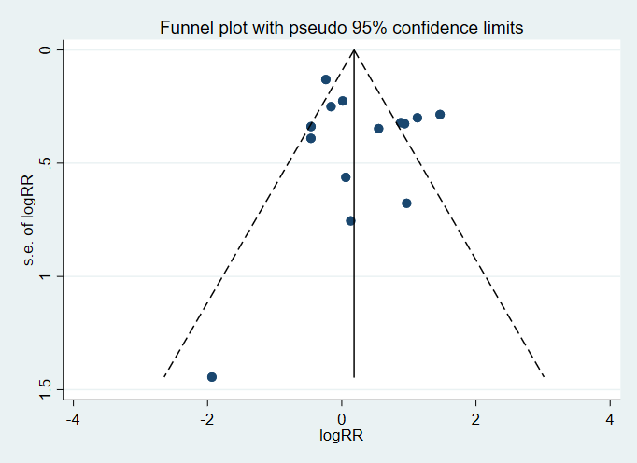
Supplement 4 Figure 1. Publication bias calculated with data in mortality & chemotherapy group
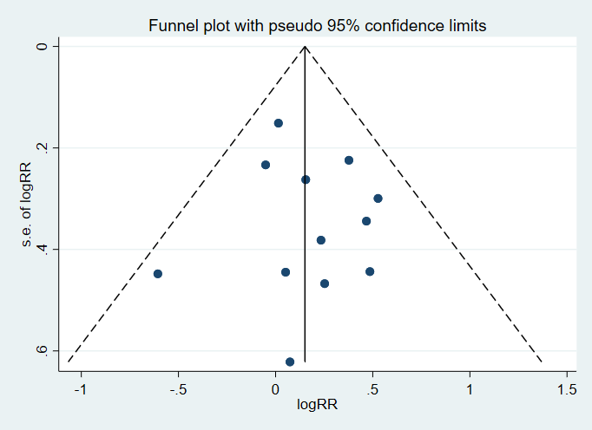
Supplement 4 Figure 2. Publication bias calculated with data in severe/critical rate & chemotherapy group

