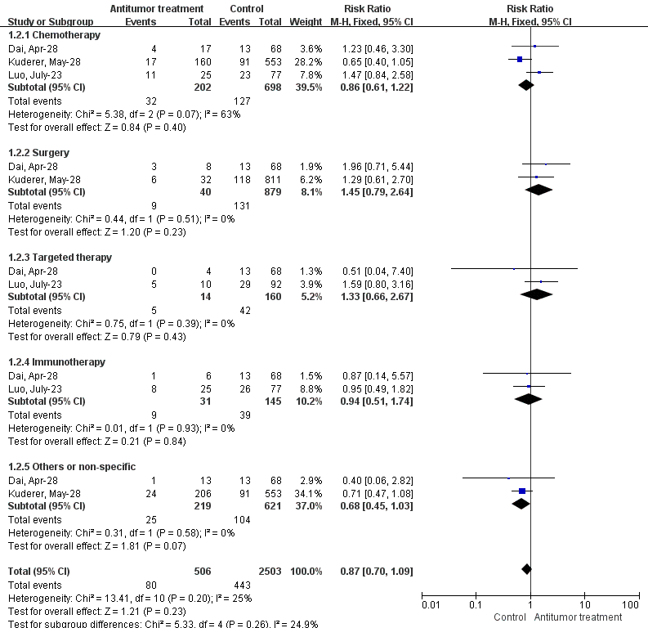
Supplement 5 Figure 1. Forest plot for the association between antitumor treatments and the ICU admission rate in cancer patients with COVID-19 using fixed-effects model.

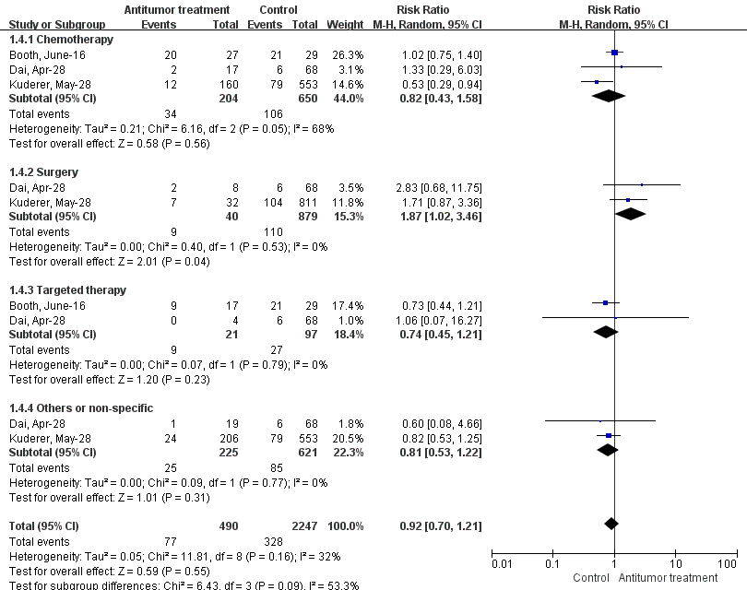
Supplement 5 Figure 2. Forest plot for the association between antitumor treatments and the rate of respiratory support in cancer patients with COVID-19 using random-effects model.

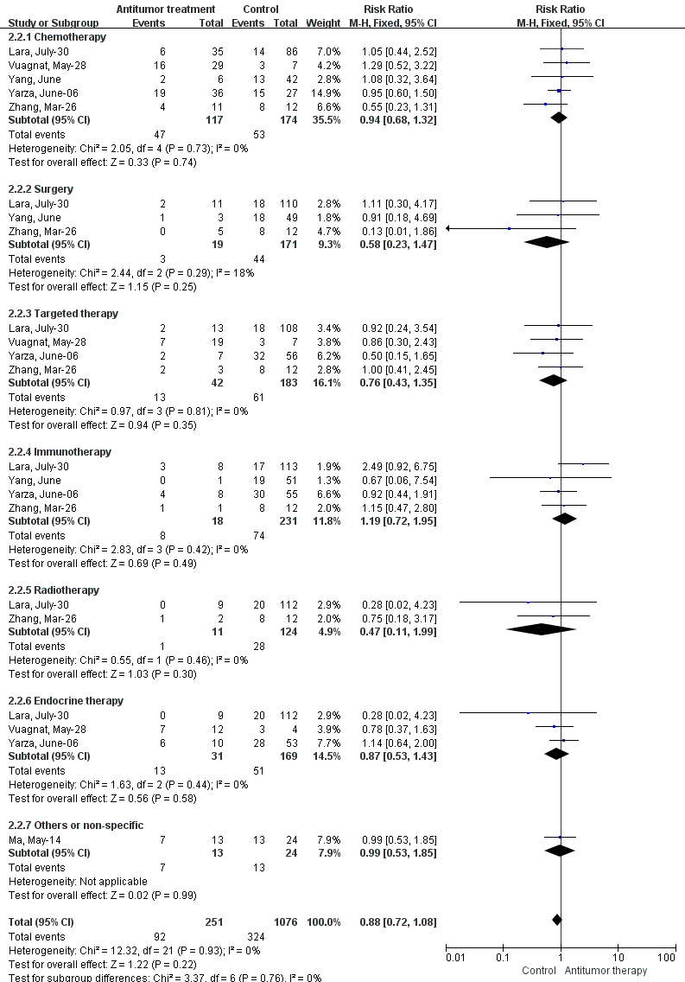
Supplement 5 Figure 3. Forest plot for the association between antitumor treatments and severe/critical rate in solid tumor patients with COVID-19 using fixed-effects model.

