Electronic supplementary material

This appendix has been provided to give readers additional information.
Screening
Included
Eligibility
Identification
Records identified through PubMed,Embase,CENTRAL searching (n=368)
Additional records identified through other sources
(n = 0)
Records after duplicates removed
(n = 195)
Full-text articles assessed for eligibility
(n = 18)
Full-text articles excluded, with reasons (n = 10)
Improper study design (n = 5)
No primary outcome (n = 1)
Secondary publication (n = 3)
Incorrect intervention (n = 1)
Studies included in qualitative synthesis
(n = 8)
Studies included in quantitative synthesis (meta-analysis)
(n = 8)

Studies excluded based on title and abstract
(n = 177)

Figure S1. Flow diagram illustrating the study selection process.
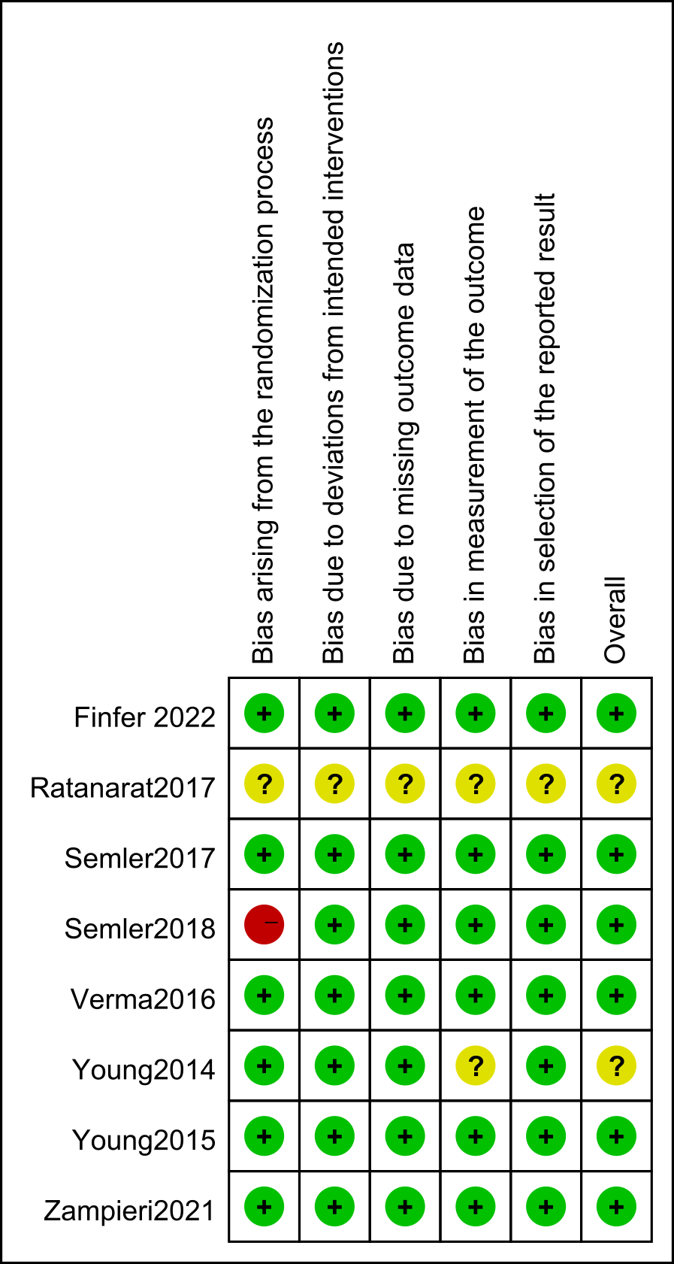
Figure S2. Risk of bias summary.

Figure S3 Funnel plots of included trials：
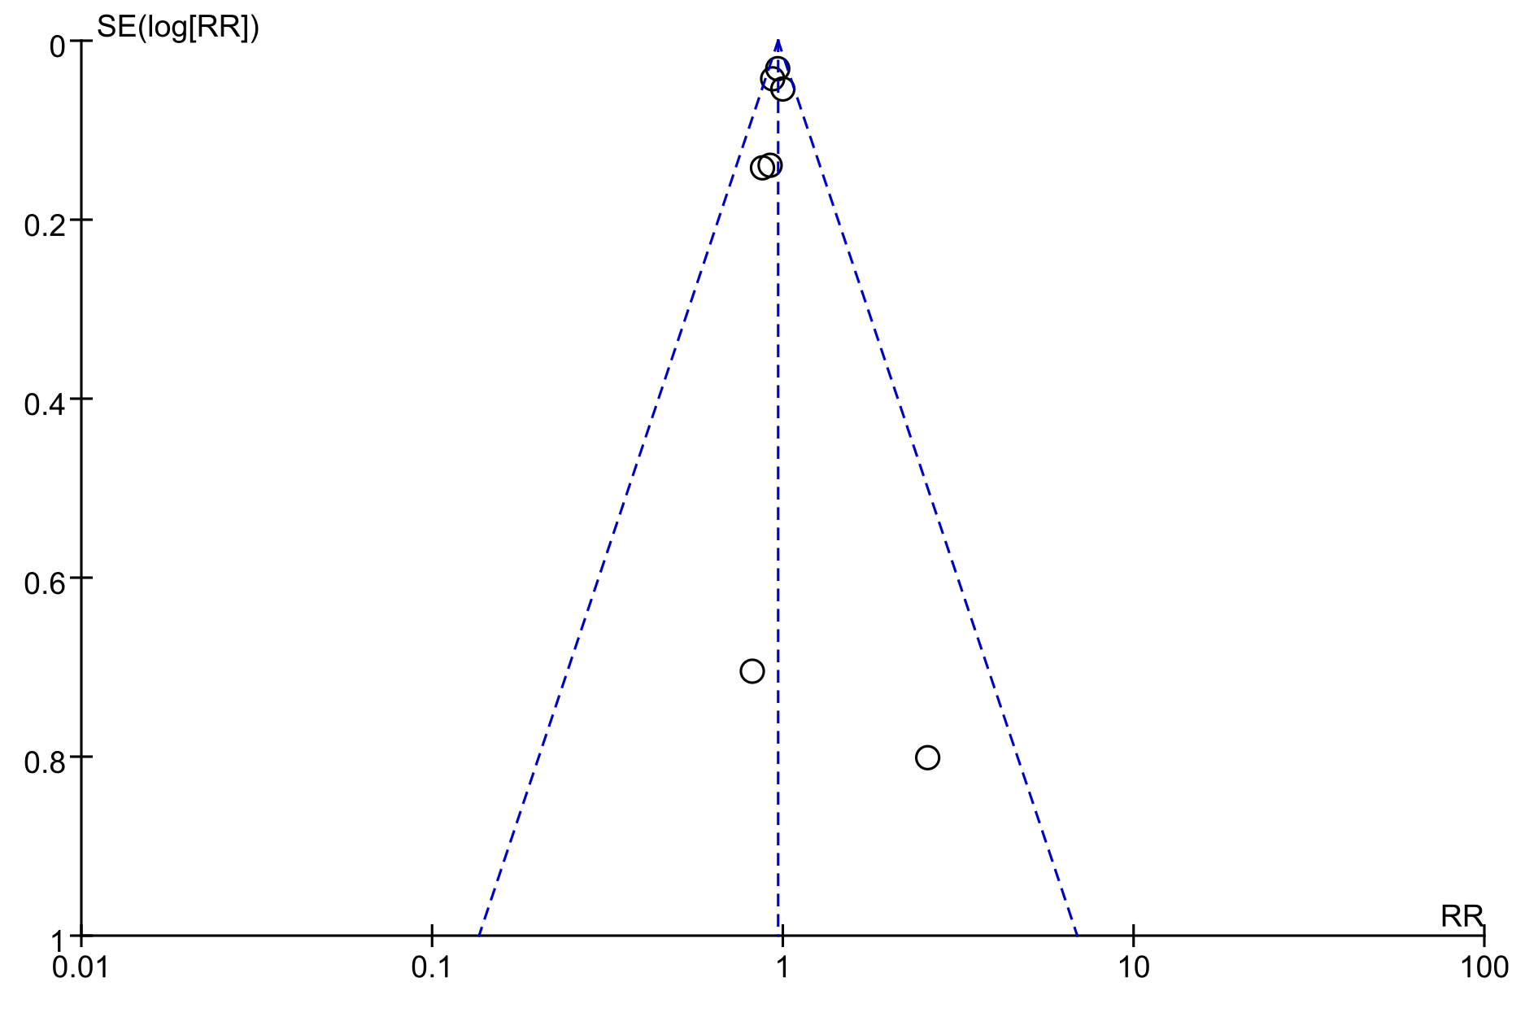
A: The plot for mortality at the longest follow-up

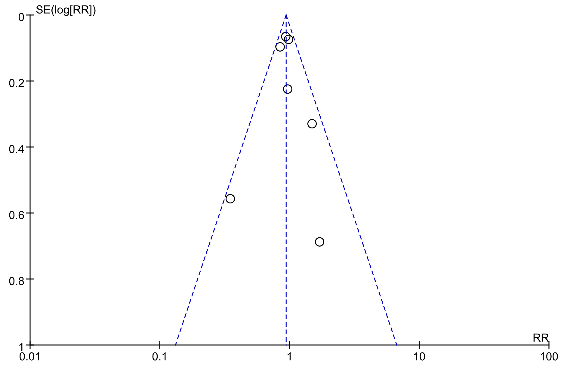
B：The plot for incidence of AKI
C: The plot for for new RRT

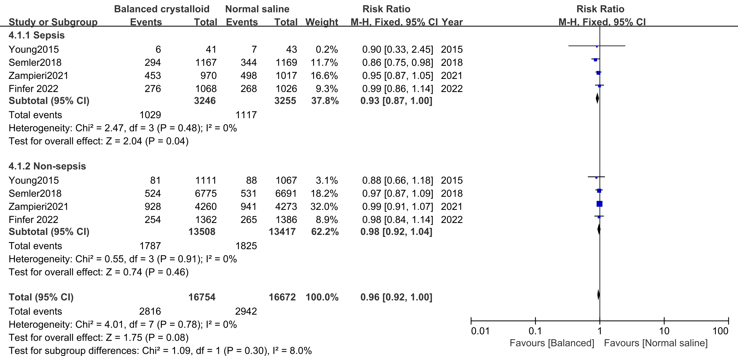
Figure S4. Forest plots for mortality for patients with sepsis.

Figure S5 Results of TSA
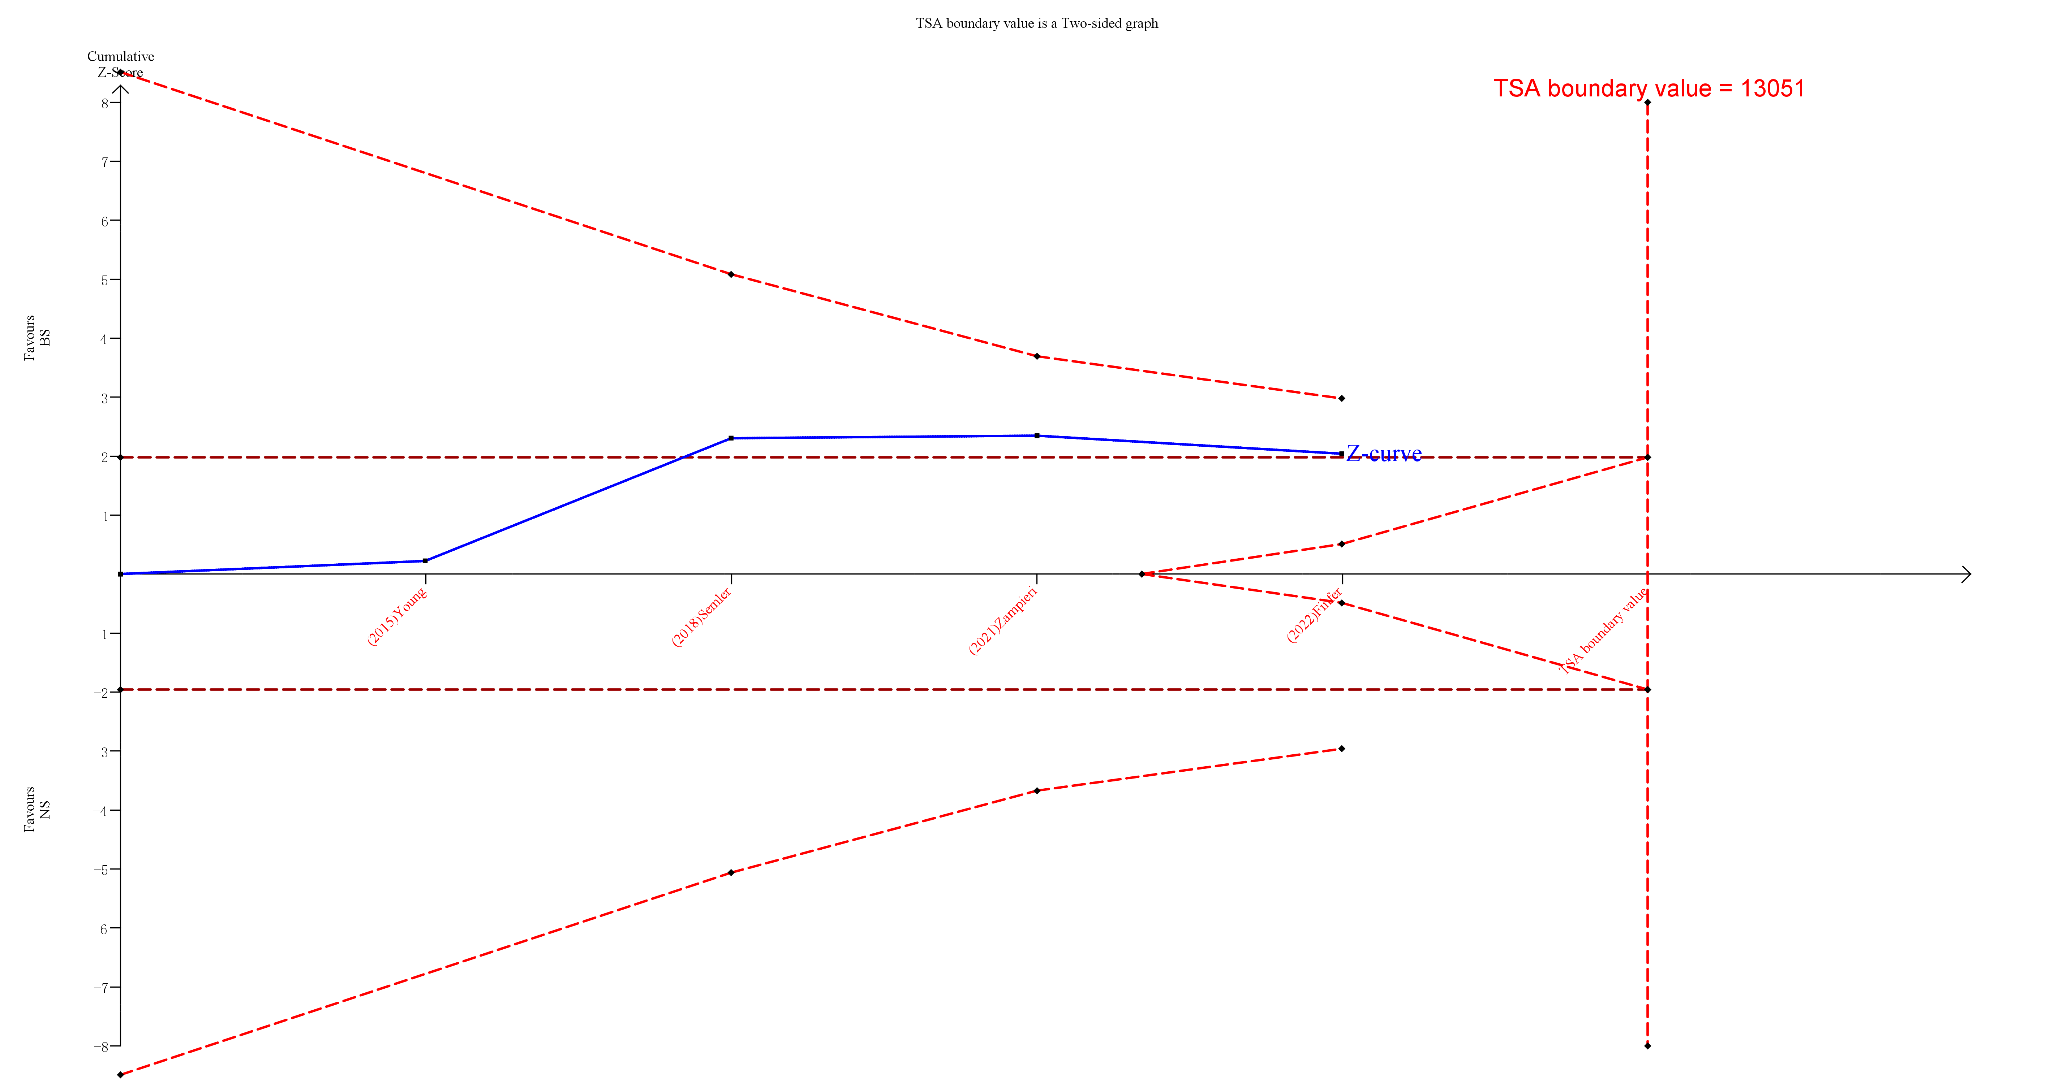
- Results of TSA for mortality for patients with sepsis.

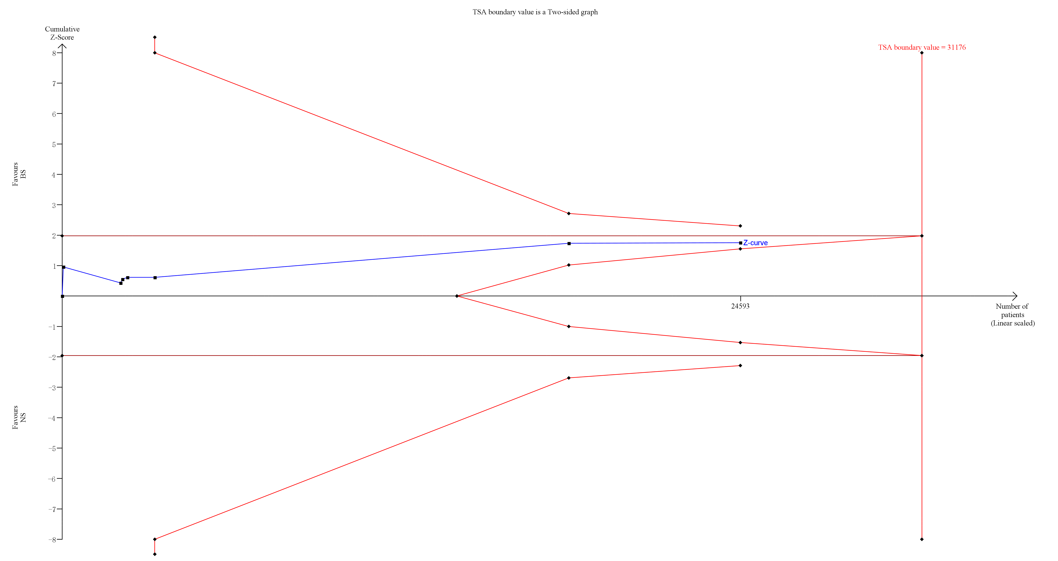
- Results of TSA for the development of moderate to severe acute kidney injury

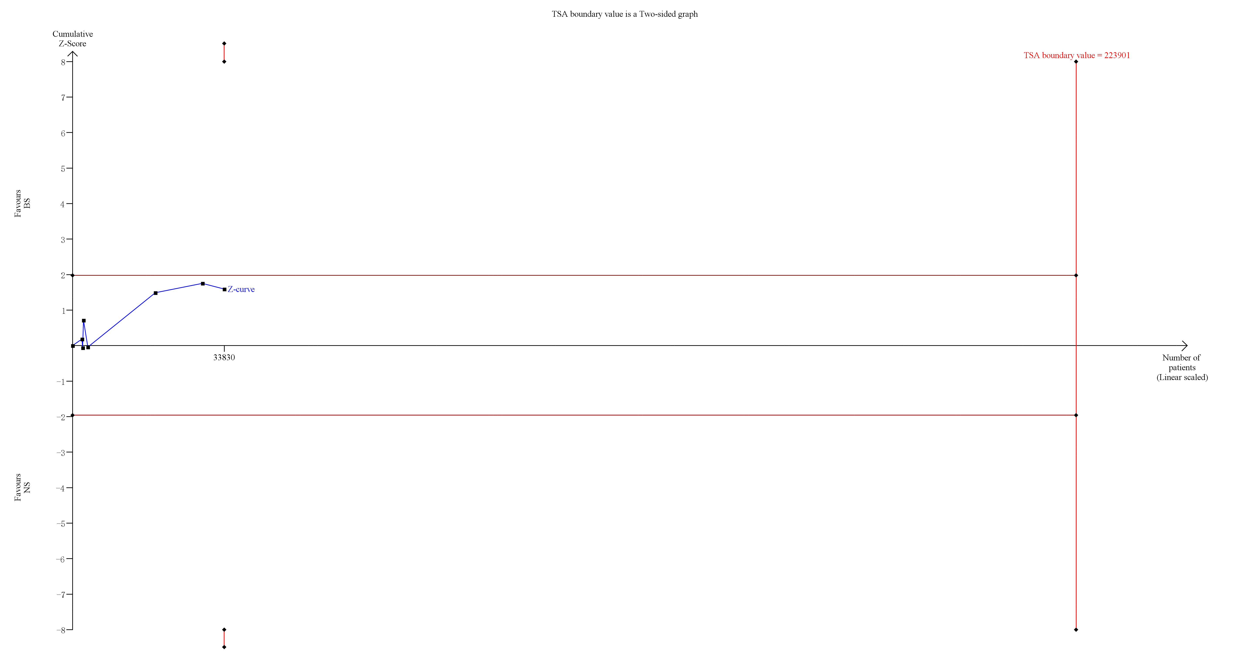
- Results of TSA for incidence of new RRT

