(S2 Fig) Risk of bias assessment

Risk of bias summary

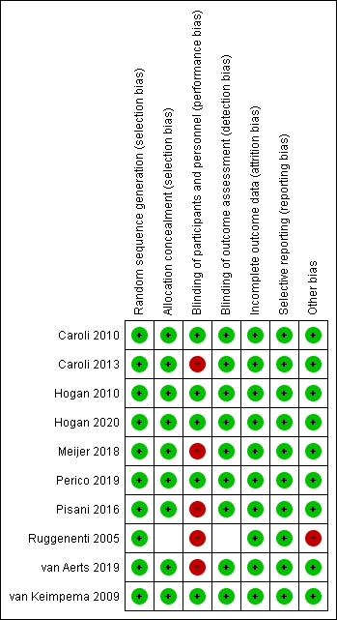

Risk of bias graph



