(S3 Fig) Sensitivity Analysis

(S3 - 1) Sensitivity analysis of TLV

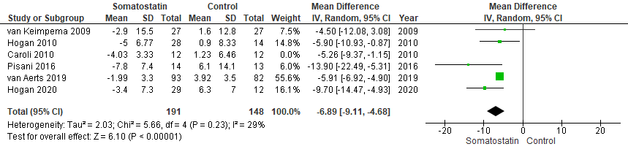

(S3 - 2) Sensitivity analysis of TKV

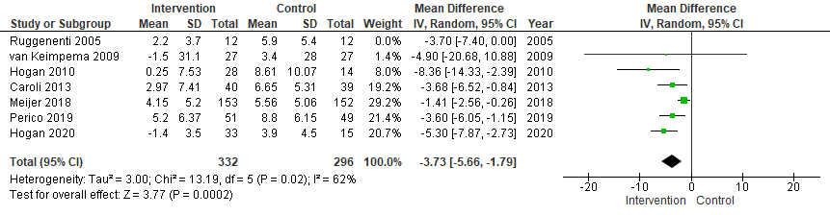

(S3 - 3) Sensitivity analysis of eGFR



