Supplemental file

Title: Interventions in Hypertension: Systematic Review and Meta-analysis of Natural and Quasi-Experiments

Table of Contents
Table S1. Search words 3
Table S2. Summary of the characteristics of the studies included in this review (n = 30) 4
Table S3. Risk of Bias Tool Assessments Across Studies (n = 30) 5
Table S4. GRADE Evidence Profiles Across Studies in Meta-analysis (n = 24) 6
Table S5. Estimates and parameters in studies that reported on the mean difference in blood pressure (n = 27) 7
Table S6. Sensitivity analysis for systolic blood pressure (SBP) and diastolic blood pressure (DBP) in meta-analysis stratified by intervention type 9
Table S7. Sensitivity analysis for systolic blood pressure (SBP) and diastolic blood pressure (DBP) in meta-analysis stratified by intervention setting 10
Table S8. Sensitivity analysis for systolic blood pressure (SBP) and diastolic blood pressure (DBP) in meta-analysis stratified by intervention duration 11
Fig. S1. Methods to calculate mean differences (MDs) 13
Fig. S2. Methods to calculate standard errors (SEs) 14
Fig. S3. Forest plot stratified by intervention settings for blood pressure 15
(A). Forest plot stratified by intervention settings for systolic blood pressure (SBP) 15
(B). Forest plot stratified by intervention settings for diastolic blood pressure (DBP) 16
Fig. S4. Forest plot stratified by intervention duration for blood pressure 17
(A). Forest plot stratified by intervention duration for systolic blood pressure (SBP) 17
(B). Forest plot stratified by intervention duration for diastolic blood pressure (DBP) 18
Fig. S5. Funnel plot of systolic blood pressure (SBP), diastolic blood pressure (DBP) stratified by intervention types 19
Fig. S6. Funnel plot of systolic blood pressure (SBP), diastolic blood pressure (DBP) stratified by intervention settings 20
Fig. S7. Funnel plot of systolic blood pressure (SBP), diastolic blood pressure (DBP) stratified by intervention duration 21
Fig. S8. Sensitivity analysis of systolic blood pressure (SBP), diastolic blood pressure (DBP) stratified by intervention types 22
Fig. S9. Sensitivity analysis of systolic blood pressure (SBP), diastolic blood pressure (DBP) stratified by intervention settings 23
Fig. S10. Sensitivity analysis of systolic blood pressure (SBP), diastolic blood pressure (DBP) stratified by intervention duration 24

Table S1. Search words
Database | Search words
Pubmed | English[Language] AND ("hypertension"[All fields] OR "blood pressure"[All fields] OR "hypertensive"[All fields] OR hyperten*[All fields] OR "high blood pressure"[All fields] OR "elevated blood pressure"[All fields] OR " abnormal blood pressure"[All fields] ) AND ("intervention"[all fields] OR "program"[all fields] OR "policy"[all fields] OR "policies"[all fields]) AND ("2008/01/01”[PDAT] : "2018/11/13”[PDAT]) AND ("environment"[all fields] OR "neighborhood"[all fields] OR "school"[all fields] OR "workplace"[all fields] OR "community"[all fields] OR " environmental"[all fields]) AND ("natural experiment"[all fields]OR "natural experiments"[all fields]OR "quasi-experiment"[all fields] OR "quasi-experimental"[all fields]OR " synthetic control method"[all fields] OR " difference-in-difference"[all fields] OR " instrumental variables"[all fields] OR " propensity score"[all fields] OR " interrupted time series"[all fields] OR " regression discontinuity"[all fields] OR "prepost"[all fields] OR "pre post"[all fields])
Web of science: choose topic | ("hypertension" OR "blood pressure" OR "hypertensive" OR hyperten* OR "high blood pressure" OR "elevated blood pressure" OR " abnormal blood pressure" ) AND ("intervention" OR "program" OR "policy" OR "policies") AND ("environment" OR "neighborhood" OR "school" OR "workplace" OR "community" OR " environmental") AND ("natural experiment" OR "natural experiments"OR "quasi-experiment" OR "quasi-experimental"OR " synthetic control method" OR " difference-in-difference" OR " instrumental variables" OR " propensity score" OR " interrupted time series" OR " regression discontinuity" OR "prepost" OR "pre post")
Embase | 'hypertension'/exp OR 'hypertension':ti,ab,kw OR 'blood pressure':ti,ab,kw OR 'hypertensive':ti,ab,kw OR 'hyperten*':ti,ab,kw OR 'high blood pressure':ti,ab,kw OR 'elevated blood pressure':ti,ab,kw OR 'abnormal blood pressure':ti,ab,kw  AND 'health care policy'/exp OR 'intervention':ti,ab,kw OR 'program':ti,ab,kw OR 'policy':ti,ab,kw OR 'policies':ti,ab,kw  AND 'school'/exp OR 'environment':ti,ab,kw OR 'neighborhood':ti,ab,kw OR 'school':ti,ab,kw OR 'workplace':ti,ab,kw OR 'community':ti,ab,kw OR 'environmental':ti,ab,kw  AND 'quasi experimental study'/exp OR 'propensity score'/exp OR 'natural experiment':ti,ab,kw OR 'natural experiments':ti,ab,kw OR 'quasi-experiment':ti,ab,kw OR 'quasi-experimental':ti,ab,kw OR 'synthetic control method':ti,ab,kw OR 'difference-in-difference':ti,ab,kw OR 'instrumental variables':ti,ab,kw OR 'propensity score':ti,ab,kw OR 'interrupted time series':ti,ab,kw OR 'regression discontinuity':ti,ab,kw OR 'prepost':ti,ab,kw OR 'pre post':ti,ab,kw  AND (2008:py OR 2009:py OR 2010:py OR 2011:py OR 2012:py OR 2013:py OR 2014:py OR 2015:py OR 2016:py OR 2017:py OR 2018:py)  AND [english]/lim

Table S2. Summary of the characteristics of the studies included in this review (n = 30)
Study characteristics | Studies  n (%)
Study Design
Pre-post design with a control group (PPCG) | 16 (53.33)
Difference-in-difference (DID) | 10 (33.33)
Propensity-score-matched (PSM) designs | 1 (3.33)
DID & PSM | 3 (10.00)
Geographic Region
Europe | 5 (16.67)
Africa | 2 (6.67)
America | 12 (40.00)
Asia | 11 (36.67)
Specific subpopulations included
Based on gender
Including only women | 2 (6.67)
Including both genders | 28 (93.33)
Based on race/ethnicity
Including only Black/African American, Latino or Hispanic | 1 (3.33)
Not specific | 29 (96.67)
Data Source
Primary data | 25 (83.33)
Secondary data | 2 (6.67)
Primary and Secondary | 3 (10.00)
Type of Intervention
Education and counseling | 13 (43.33)
Management | 4 (13.33)
Education, counseling and management | 7 (23.33)
Screening and referral for management | 6 (20.00)
Level/Setting of Intervention
Organizational level | 4 (13.33)
Health center level | 12 (40.00)
Nation level | 2 (6.67)
Community level | 12 (40.00)
Intervention duration
Short duration | 14 (46.7)
Long duration | 16 (53.3)
Outcomes reported
Changes in mean systolic and diastolic blood pressure only | 25 (83.33)
Changes in hypertension prevalence only | 3 (10.00)
Changes in mean systolic and diastolic blood pressure and hypertension prevalence | 2 (6.67)
PPCG, pre-post design with a control group; DID, difference-in-difference; PSM design, propensity-score-matched design

Table S3. Risk of Bias Tool Assessments Across Studies (n = 30)

 | Random Sequence Generation | Allocation Concealment | Blinding of Participants & Personnel | Blinding of Outcome Assessment | Incomplete Outcome Data | Selecting Reporting | Other Sources of Bias
Barnidge, 2015 | High risk | High risk | High risk | High risk | Low risk | Low risk | Low risk
Berkowitz, 2017 | High risk | High risk | High risk | High risk | Low risk | Low risk | Low risk
Chang, 2013 | High risk | High risk | High risk | High risk | Low risk | Low risk | Low risk
Chang, 2016 | High risk | High risk | Low risk | Low risk | Low risk | Low risk | Low risk
Comin, 2017 | High risk | High risk | Low risk | Low risk | Low risk | Low risk | Low risk
Darviri, 2016 | High risk | High risk | High risk | High risk | Low risk | Low risk | Low risk
Fernandez, 2008 | High risk | High risk | High risk | High risk | Low risk | Low risk | Low risk
Flannery, 2012 | Low risk | High risk | High risk | High risk | Low risk | Low risk | Low risk
Gemson, 2008 | High risk | High risk | High risk | High risk | Low risk | Low risk | Low risk
Hussain, 2016 | High risk | High risk | High risk | High risk | Low risk | Low risk | Low risk
James, 2018 | High risk | High risk | Low risk | Low risk | Low risk | Low risk | Low risk
Jung and Lee, 2017 | High risk | High risk | High risk | High risk | Low risk | Low risk | Low risk
Lin, 2017 | Low risk | High risk | High risk | High risk | Low risk | Low risk | Low risk
Fikri-Benbrahim, 2012 | Low risk | Low risk | Low risk | Low risk | Low risk | Low risk | Low risk
Panattoni, 2017 | High risk | High risk | High risk | High risk | Low risk | Low risk | Low risk
Scanlon, 2008 | High risk | High risk | High risk | High risk | Low risk | Low risk | Low risk
Scharf, 2016 | High risk | High risk | High risk | High risk | Low risk | Low risk | Low risk
Verberne, 2016 | High risk | High risk | Low risk | Low risk | Low risk | Low risk | Low risk
Xu, 2015 | High risk | High risk | High risk | High risk | Low risk | Low risk | Low risk
Yu, 2017 | High risk | High risk | High risk | High risk | Low risk | Low risk | Low  risk
Kamran, 2016 | Low risk | Low risk | High risk | High risk | Low risk | Low risk | Low risk
Ibrahim, 2016 | High risk | High risk | High risk | High risk | Low risk | Low risk | Low risk
Kassim, 2017 | High risk | High risk | High risk | High risk | Low risk | Low risk | Low risk
Fazliana, 2018 | High risk | High risk | High risk | High risk | Low risk | Low risk | Low risk
Sahli, 2016 | High risk | High risk | High risk | High risk | Low risk | Low risk | Low risk
Miao, 2016 | High risk | High risk | High risk | High risk | Low risk | Low risk | Low risk
Miao, 2018 | High risk | High risk | High risk | High risk | Low risk | Low risk | Low risk
Visanuyothin,, 2018 | Low risk | Low risk | High risk | Low risk | Low risk | Low risk | Low risk
van de Vijver, 2016 | High risk | High risk | High risk | High risk | Low risk | Low risk | Low risk
Zhu, 2018 | High risk | High risk | High risk | High risk | Low risk | Low risk | Low risk

Table S4. GRADE Evidence Profiles Across Studies in Meta-analysis (n = 24)
Outcomes | Risk of Bias¹ | Inconsistency² | Indirectness³ | Imprecision⁴ | Publication Bias⁵ | Magnitude of Effect⁶ | Residual⁷ | Dose-Response⁸ | Overall GRADE Quality
Mean SBP Change | Low (remain) | Very low (down 1) | Moderate (remain) | High (remain) | Very low (down 2) | High (remain) | Low (remain) | Low (remain) | Low
Mean DBP Change | Low (remain) | Very low (down 1) | Moderate (remain) | High (remain) | Very low (down 2) | High (remain) | Low (remain) | Low (remain) | Low
¹ Most studies in each outcome had significant limitations in the study design (high risk of most items in Appendix Table 3).
² The I² statistic indicated heterogeneity, 91.2% and 91.8% respectively.
³ We only included studies published in the English language.
⁴ Large sample size for power analysis for the estimates tested on the outcomes.
⁵ Funnel plots showed that the presence of publication bias was very likely.
⁶ The mean SBP and DBP outcomes showed large significant effects.
⁷ Data about confounders were available in most studies.
⁸ Lack of evidence in dose-response relationship between interventions and outcomes.
GRADE: Grading of Recommendations, Assessment, Development, and Evaluation; SBP: systolic blood pressure; DBP: diastolic blood pressure.

Table S5. Estimates and parameters in studies that reported on the mean difference in blood pressure (n = 27)
First author, year | Findings | First author, year | Findings | First author, year | Findings
Berkowitz, 2017 | SBP_MD = –2.6;  SBP_SE = 0.46  DBP_MD = –1.4  DBP_SE = 0.26  MD_Source = 1  SE_Source = 2 | Chang, 2013 | SBP_MD = –14.3;  SBP_SE = 2.5  DBP_MD = –7.02  DBP_SE = 1.84  MD_Source = 1  SE_Source = 2 | Verberne, 2016 | SBP_MD = –0.5;  SBP_SE = 1.12  DBP_MD = 0.2  DBP_SE = 0.63  MD_Source = 2  SE_Source = 5
Chang, 2016 | SBP_MD = –2.51;  SBP_SE = 0.13  DBP_MD = –1.46  DBP_SE = 0.08  MD_Source = 1  SE_Source = 2 | Fernandez, 2008 | SBP_MD = –2.4;  SBP_SE = 3.76  DBP_MD = –2.6  DBP_SE = 1.98  MD_Source = 2  SE_Source = 4 | Xu, 2015 | SBP_MD = –8.9;  SBP_SE = 5.23  DBP_MD = –3.4  DBP_SE = 3.29  MD_Source = 1  SE_Source = 2
Darviri, 2016 | SBP_MD = –2.62;  SBP_SE = 0.68  DBP_MD = –1  DBP_SE = 0.25  MD_Source = 1  SE_Source = 2 | Fikri-Benbrahim, 2012 | SBP_MD = –4.7;  SBP_SE = 1.24  DBP_MD = –2.2  DBP_SE = 0.82  MD_Source = 2  SE_Source = 4 | Panattoni, 2017 | SBP_MD = –1;  SBP_SE = 0.47  DBP_MD = –0.7  DBP_SE = 0.28  MD_Source = 2  SE_Source = 5
Flannery, 2012 | SBP_MD = –4.44;  SBP_SE = 5.31  DBP_MD = –6.7  DBP_SE = 3.39  MD_Source = 2  SE_Source = 5 | Gemson, 2008 | SBP_MD = –3.2;  SBP_SE = 1.14  DBP_MD = –3  DBP_SE = 1.36  MD_Source = 2  SE_Source = 4 | Scharf, 2016 | SBP_MD = –1;  SBP_SE = 1.64  DBP_MD = –3  DBP_SE = 1  MD_Source = 2  SE_Source = 6
Hussain, 2016 | SBP_MD = 9;  DBP_MD = 4  MD_Source = 1 | Jung and Lee, 2017 | SBP_MD = –10.8;  SBP_SE = 2.14  DBP_MD = –3.6  DBP_SE = 1.59  MD_Source = 2  SE_Source =4 | Yu, 2017 | SBP_MD = –0.85;  SBP_SE = 0.18  DBP_MD = 0.02  DBP_SE = 0.17  MD_Source = 2  SE_Source = 5
Scanlon, 2008 | BaselineSBP > 140_MD_per year  = -2.2;  BaselineSBP > 140_MD_per year_SE = 0.88;  BaselineSBP > 140_MD_per year_Source = 1;  BaselineSBP > 140_MD_per year_SE_Source = 2 | Lin, 2017 | SBP_MD = –2.1;  SBP_SE = 2.02  DBP_MD = –5.2  DBP_SE = 1.48  MD_Source = 2  SE_Source = 5 | Zhu, 2018 | SBP_MD = –2.7 ;  SBP_SE = 5.06  DBP_MD = –0.1  DBP_SE = 3.41  MD_Source = 2  SE_Source = 5
Kamran, 2016 | SBP_MD = –13.5;  SBP_SE = 1.35  DBP_MD = –6.6  DBP_SE = 0.80  MD_Source = 2  SE_Source = 4 | Ibrahim, 2016 | SBP_MD = –1.71;  SBP_SE = 1.16  DBP_MD = –2.63  DBP_SE = 0.59  MD_Source = 1  SE_Source = 2 | Kassim, 2017 | SBP_MD = –0.2;  SBP_SE = 1.69  DBP_MD = –0.28  DBP_SE = 1.17  MD_Source = 2  SE_Source = 5
Visanuyothin, 2018 | SBP_MD = –7.13;  SBP_SE = 2.28  DBP_MD = –4.66  DBP_SE = 1.35  MD_Source = 2  SE_Source = 5 | Miao, 2018 | SBP_MD = –2.9;  DBP_MD = –7.9  MD_Source = 1 | Miao, 2016 | SBP_MD = –5.62;  SBP_SE = 0.44  DBP_MD = –5.43  DBP_SE = 0.39  MD_Source = 1  SE_Source =1
van de Vijver, 2016 | SBP_MD = –0.32;  SBP_SE = 1.10  DBP_MD = 1.09  DBP_SE = 0.70  MD_Source = 1  SE_Source = 2 | Fazliana, 2018 | SBP_MD = 1.14;  SBP_SE = 1.14  DBP_MD = 0.02  DBP_SE = 0.75  MD_Source = 2  SE_Source = 2&5 | Sahli, 2016 | SBP_MD = –2.5;  SBP_SE = 0.81  DBP_MD = –0.4  DBP_SE = 0.50  MD_Source = 2  SE_Source = 5
SBP, systolic blood pressure; DBP, diastolic blood pressure; MD, mean difference; SE, standard error; Source refers to the methods used to calculate the mean difference and the standard error.

Table S6. Sensitivity analysis for systolic blood pressure (SBP) and diastolic blood pressure (DBP) in meta-analysis stratified by intervention type
Study omitted | Mean SBP change |  |  | Mean DBP change
Study omitted | Estimate | 95% Confidence interval |  | Estimate | 95% Confidence interval
Study omitted | Estimate | Lower limit | Upper limit | Estimate | Lower limit | Upper limit
Education and counseling
Flannery, 2012 | –4.06 | –6.90 | –1.22 | –2.48 | –4.08 | –0.88
Gemson, 2008 | –4.21 | –7.33 | –1.09 | –2.62 | –4.31 | –0.93
Lin, 2017 | –4.28 | –7.24 | –1.32 | –2.40 | –4.03 | –0.77
Chang, 2013 | –3.14 | –5.78 | –0.51 | –2.29 | –3.87 | –0.70
Verberne, 2016 | –4.50 | –7.55 | –1.44 | –3.00 | –4.71 | –1.29
Xu, 2015 | –3.85 | –6.68 | –1.03 | –2.61 | –4.24 | –0.99
Zhu, 2018 | –4.14 | –6.98 | –1.30 | –2.75 | –4.37 | –1.13
Kamran, 2016 | –2.63 | –4.54 | –0.73 | –1.96 | –3.23 | –0.69
Ibrahim, 2016 | –4.37 | –7.47 | –1.27 | –2.69 | –4.52 | –0.86
Kassim, 2017 | –4.48 | –7.45 | –1.52 | –2.90 | –4.60 | –1.20
Fazliana, 2018 | –4.66 | –7.57 | –1.75 | –2.97 | –4.70 | –1.25
Sahli, 2016 | –4.32 | –7.61 | –1.03 | –2.96 | –4.76 | –1.15
Combined | –4.07 | –6.83 | –1.32 | –2.64 | –4.22 | –1.06
Education, counseling and management
Darviri, 2016 | –6.09 | –7.91 | –4.28 | –3.87 | –5.58 | –2.15
Fernandez, 2008 | –5.54 | –7.65 | –3.43 | –3.32 | –5.80 | –0.85
Fikri-Benbrahim, 2012 | –5.57 | –8.04 | –3.11 | –3.46 | –6.18 | –0.74
Jung and Lee, 2017 | –4.54 | –6.39 | –2.70 | –3.17 | –5.68 | –0.66
Miao, 2016 | –5.43 | –8.35 | –2.52 | –2.42 | –3.87 | –0.96
Visanuyothin, 2018 | –5.12 | –7.31 | –2.93 | –2.96 | –5.49 | –0.44
Combined | –5.34 | –7.35 | –3.33 | –3.23 | –5.51 | –0.96
Screening and referral for management
Berkowitz, 2017 | –1.35 | –2.69 | –0.02 | –0.71 | –1.90 | 0.48
Scharf, 2016 | –1.72 | –2.88 | –0.55 | –0.58 | –1.54 | 0.38
Chang, 2016 | –1.35 | –2.57 | –0.12 | –0.68 | –1.86 | 0.50
Yu, 2017 | –2.31 | –2.95 | –1.66 | –1.17 | –1.93 | –0.41
van de Vijver, 2016 | –1.87 | –3.06 | –0.68 | –1.21 | –2.16 | –0.27
Combined | –1.66 | –2.77 | –0.55 | –0.86 | –1.76 | 0.05
SBP, systolic blood pressure; DBP, diastolic blood pressure.

Table S7. Sensitivity analysis for systolic blood pressure (SBP) and diastolic blood pressure (DBP) in meta-analysis stratified by intervention setting
Study omitted | Mean SBP change |  |  | Mean DBP change
Study omitted | Estimate | 95% Confidence interval |  | Estimate | 95% Confidence interval
Study omitted | Estimate | Lower limit | Upper limit | Estimate | Lower limit | Upper limit
Community
Chang, 2013 | –2.61 | –4.62 | –0.60 | –1.14 | –2.23 | –0.05
Xu, 2015 | –3.56 | –6.01 | –1.12 | –1.53 | –2.77 | –0.28
Ibrahim, 2016 | –4.14 | –6.92 | –1.37 | –1.39 | –2.67 | –0.10
Kassim, 2017 | –4.24 | –6.86 | –1.62 | –1.75 | –3.07 | –0.42
Fazliana, 2018 | –4.44 | –6.96 | –1.91 | –1.84 | –3.21 | –0.48
Sahli, 2016 | –4.11 | –7.07 | –1.15 | –1.84 | –3.30 | –0.39
Fernandez, 2008 | –3.88 | –6.39 | –1.36 | –1.52 | –2.79 | –0.25
Fikri-Benbrahim, 2012 | –3.70 | –6.36 | –1.03 | –1.52 | –2.87 | –0.17
Jung and Lee, 2017 | –2.90 | –5.14 | –0.67 | –1.40 | –2.66 | –0.15
van de Vijver, 2016 | –4.31 | –7.02 | –1.60 | –1.92 | –3.12 | –0.72
Combined | –3.77 | –6.17 | –1.37 | –1.58 | –2.79 | –0.36
Health center
Verberne, 2016 | –4.24 | –6.43 | –2.05 | –2.97 | –4.62 | –1.33
Kamran, 2016 | –2.44 | –4.15 | –0.72 | –2.00 | –3.46 | –0.53
Panattoni, 2017 | –4.27 | –6.72 | –1.82 | –2.89 | –4.76 | –1.02
Miao, 2016 | –3.37 | –5.28 | –1.47 | –1.98 | –3.14 | –0.82
Visanuyothin, 2018 | –3.46 | –5.54 | –1.37 | –2.34 | –3.92 | –0.77
Berkowitz, 2017 | –4.01 | –6.47 | –1.56 | –2.79 | –4.72 | –0.86
Scharf, 2016 | –4.10 | –6.25 | –1.96 | –2.51 | –4.12 | –0.91
Yu, 2017 | –4.31 | –6.77 | –1.84 | –3.00 | –4.75 | –1.24
Combined | –3.77 | –5.78 | –1.76 | –2.57 | –4.07 | –1.06
Nation
Darviri, 2016 | –2.51 | –2.77 | –2.25 | –1.46 | –1.62 | –1.30
Chang, 2016 | –2.62 | –3.95 | –1.29 | –1.00 | –1.48 | –0.52
Combined | –2.51 | –2.77 | –2.26 | –1.29 | –1.72 | –0.85
Organization
Flannery, 2012 | –2.92 | –4.84 | –1.01 | –3.65 | –5.80 | –1.49
Gemson, 2008 | –2.43 | –5.89 | 1.03 | –4.60 | –7.46 | –1.74
Lin, 2017 | –3.23 | –5.37 | –1.09 | –3.10 | –5.42 | –0.78
Zhu, 2018 | –2.98 | –4.90 | –1.07 | –4.22 | –6.11 | –2.34
Combined | –2.97 | –4.86 | –1.09 | –3.92 | –5.80 | –2.04
SBP, systolic blood pressure; DBP, diastolic blood pressure.

Table S8. Sensitivity analysis for systolic blood pressure (SBP) and diastolic blood pressure (DBP) in meta-analysis stratified by intervention duration
Study omitted | Mean SBP change |  |  | Mean DBP change
Study omitted | Estimate | 95% Confidence interval |  | Estimate | 95% Confidence interval
Study omitted | Estimate | Lower limit | Upper limit | Estimate | Lower limit | Upper limit
Short duration
Flannery, 2012 | –6.34 | –9.49 | –3.20 | –3.40 | –5.11 | –1.70
Lin, 2017 | –6.68 | –9.96 | –3.39 | –3.38 | –5.12 | –1.63
Chang, 2013 | –5.49 | –8.49 | –2.48 | –3.24 | –4.93 | –1.55
Xu, 2015 | –6.11 | –9.25 | –2.97 | –3.55 | –5.28 | –1.82
Zhu, 2018 | –6.44 | –9.59 | –3.29 | –3.69 | –5.42 | –1.97
Kamran, 2016 | –5.31 | –7.80 | –2.83 | –3.00 | –4.38 | –1.62
Kassim, 2017 | –6.91 | –10.14 | –3.69 | –3.91 | –5.74 | –2.08
Darviri, 2016 | –6.68 | –10.09 | –3.27 | –3.90 | –5.51 | –2.29
Fernandez, 2008 | –6.53 | –9.71 | –3.34 | –3.62 | –5.39 | –1.85
Fikri-Benbrahim, 2012 | –6.42 | –9.95 | –2.88 | –3.72 | –5.68 | –1.77
Jung and Lee, 2017 | –5.78 | –8.95 | –2.62 | –3.54 | –5.33 | –1.76
Visanuyothin, 2018 | –6.16 | –9.43 | –2.89 | –3.43 | –5.20 | –1.65
Combined | –6.25 | –9.28 | –3.21 | –3.54 | –5.21 | –1.87
Long duration
Gemson, 2008 | –1.79 | –2.74 | –0.84 | –1.25 | –2.05 | –0.45
Verberne, 2016 | –1.99 | –2.94 | –1.04 | –1.46 | –2.28 | –0.65
Ibrahim, 2016 | –1.90 | –2.85 | –0.94 | –1.21 | –2.03 | –0.39
Fazliana, 2018 | –2.11 | –3.04 | –1.18 | –1.44 | –2.26 | –0.62
Sahli, 2016 | –1.83 | –2.79 | –0.86 | –1.42 | –2.25 | –0.59
Panattoni, 2017 | –1.98 | –2.96 | –0.99 | –1.40 | –2.27 | –0.53
Miao, 2016 | –1.50 | –2.27 | –0.73 | –0.87 | –1.47 | –0.28
Berkowitz, 2017 | –1.79 | –2.80 | –0.79 | –1.33 | –2.22 | –0.44
Scharf, 2016 | –1.93 | –2.87 | –0.99 | –1.22 | –2.03 | –0.41
Chang, 2016 | –1.75 | –2.98 | –0.52 | –1.33 | –2.41 | –0.25
Yu, 2017 | –2.01 | –3.00 | –1.02 | –1.48 | –2.32 | –0.64
van de Vijver, 2016 | –2.00 | –2.95 | –1.05 | –1.53 | –2.34 | –0.73
Combined | –1.89 | –2.80 | –0.97 | –1.33 | –2.11 | –0.55
SBP, systolic blood pressure; DBP, diastolic blood pressure.

Fig. S1. Methods to calculate mean differences (MDs)
DID, difference-in-difference; MD, mean difference.

Fig. S2. Methods to calculate standard errors (SEs)
SE, standard error; SD, standard deviation; CI, confidence interval; UL, upper level; LL, lower level.

Fig. S3. Forest plot stratified by intervention settings for blood pressure

(A). Forest plot stratified by intervention settings for systolic blood pressure (SBP)
SBP, systolic blood pressure; HBP, high blood pressure.

(B). Forest plot stratified by intervention settings for diastolic blood pressure (DBP)
DBP, diastolic blood pressure; HBP, high blood pressure.

Fig. S4. Forest plot stratified by intervention duration for blood pressure

(A). Forest plot stratified by intervention duration for systolic blood pressure (SBP)
SBP, systolic blood pressure; HBP, high blood pressure.

(B). Forest plot stratified by intervention duration for diastolic blood pressure (DBP)
DBP, diastolic blood pressure; HBP, high blood pressure.

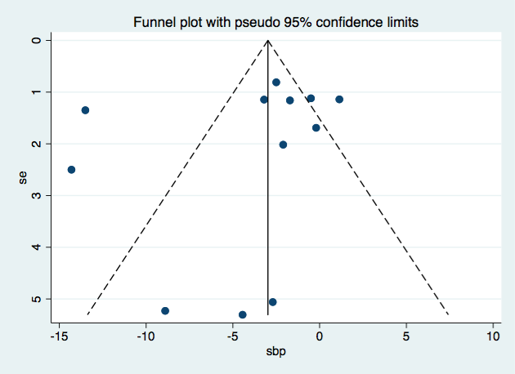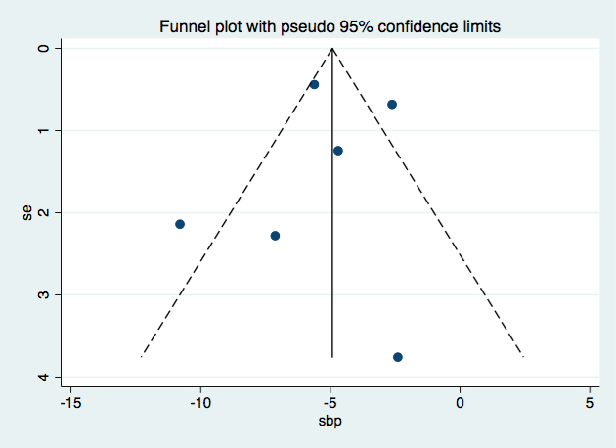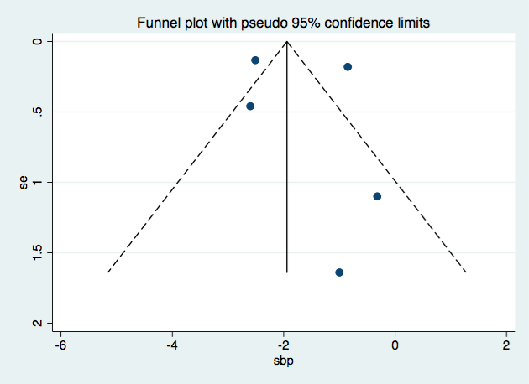
(A). Education and counseling for SBP (B). Education, counseling and management for SBP (C). Screening, referral and management for SBP

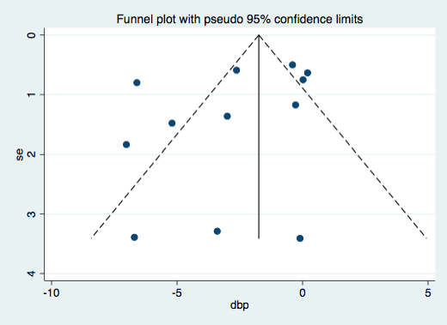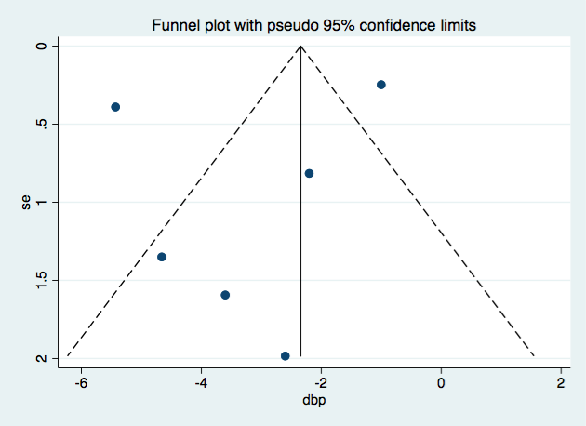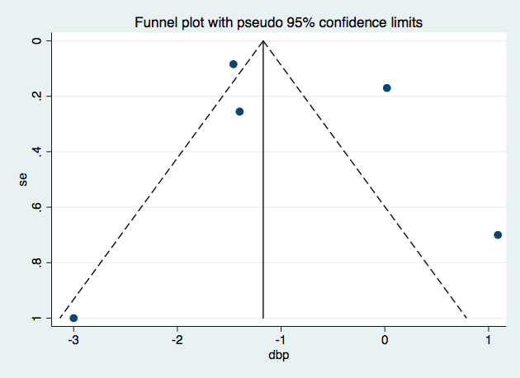
(D). Education and counseling for DBP (E). Education, counseling and management for DBP (F). Screening, referral and management for DBP

Fig. S5. Funnel plot of systolic blood pressure (SBP), diastolic blood pressure (DBP) stratified by intervention types
SBP, systolic blood pressure; DBP, diastolic blood pressure.

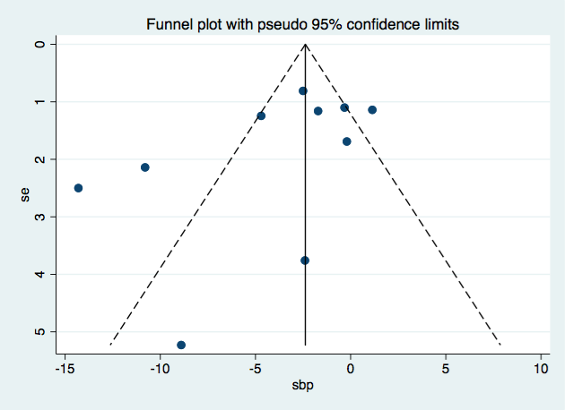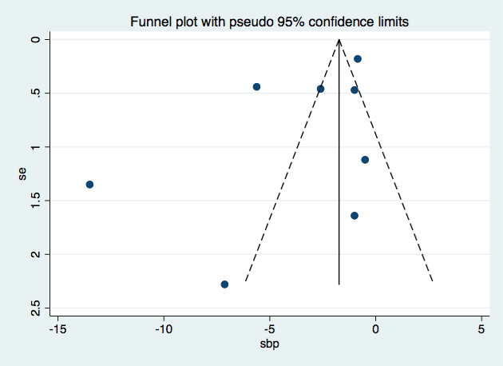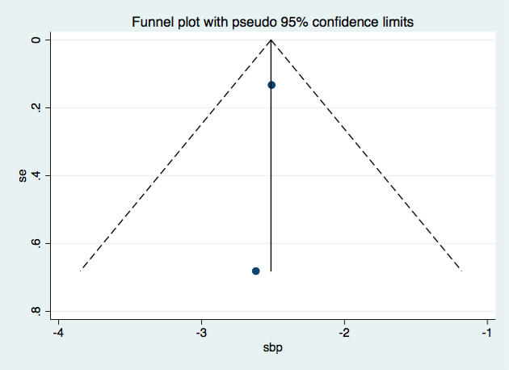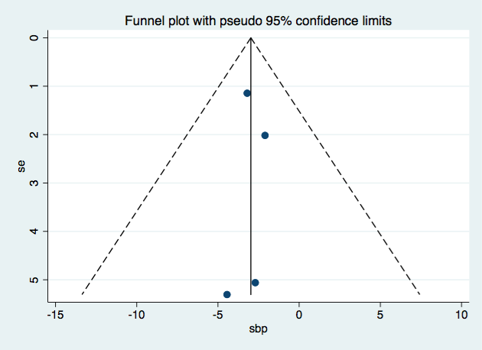
(A). Community setting for SBP (B). Health center setting for SBP (C). Nation setting for SBP (D). Organization setting for SBP

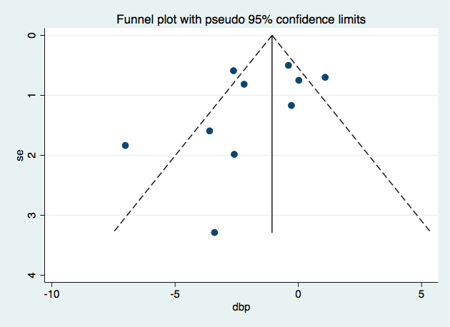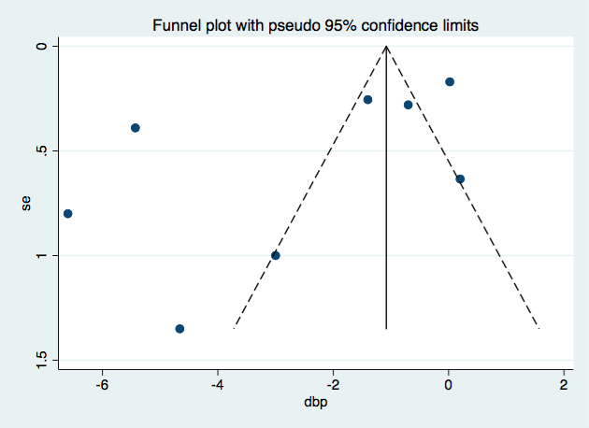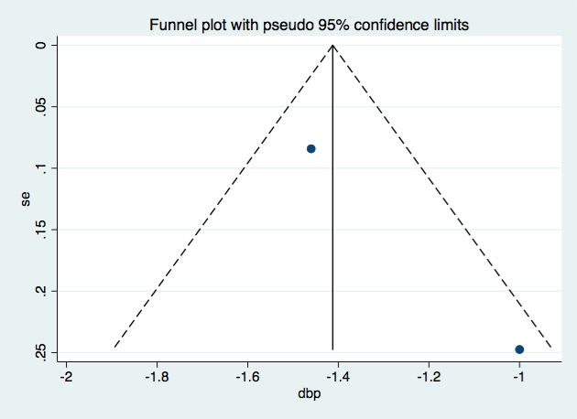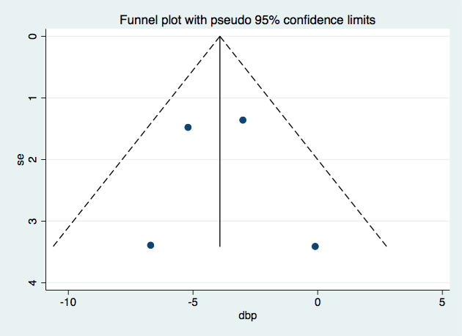
(E). Community setting for DBP (F). Health center setting for DBP (G). Nation setting for DBP (H). Organization setting for DBP

Fig. S6. Funnel plot of systolic blood pressure (SBP), diastolic blood pressure (DBP) stratified by intervention settings
SBP, systolic blood pressure; DBP, diastolic blood pressure.
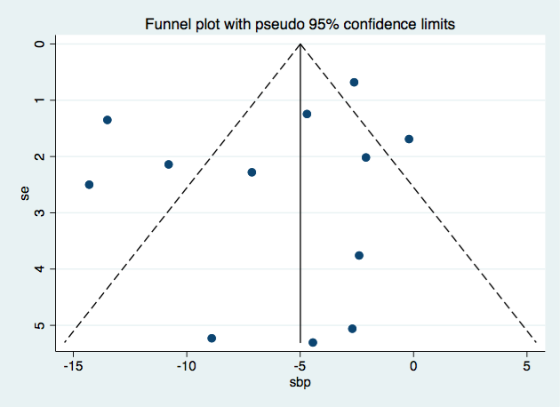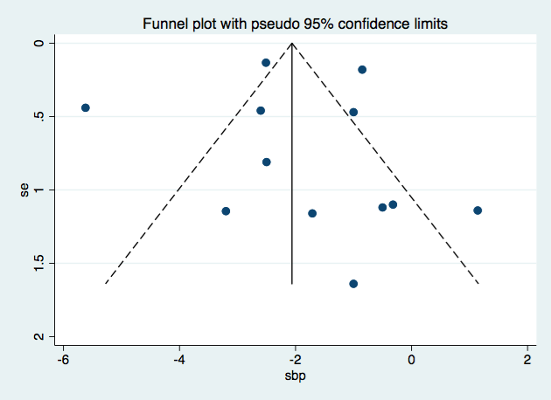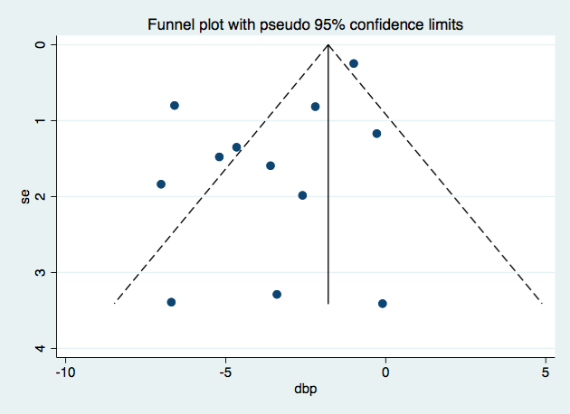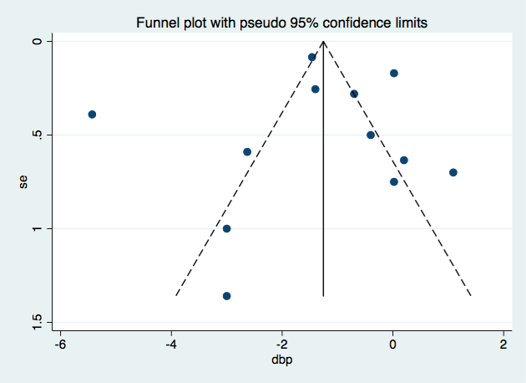
(A). Short duration for SBP (B). Long duration for SBP (C). Short duration for DBP (D). Long duration for DBP

Fig. S7. Funnel plot of systolic blood pressure (SBP), diastolic blood pressure (DBP) stratified by intervention duration
SBP, systolic blood pressure; DBP, diastolic blood pressure.

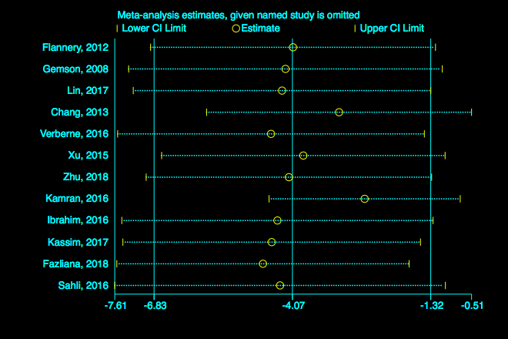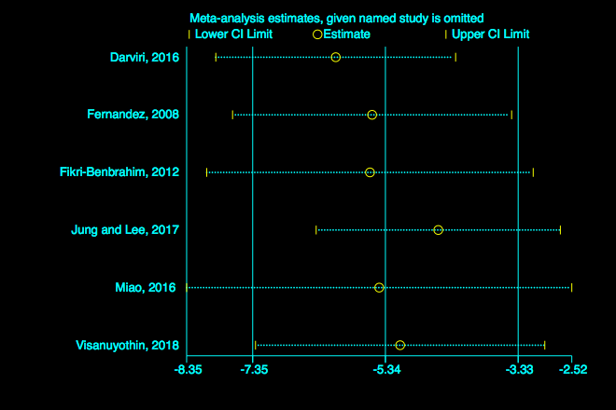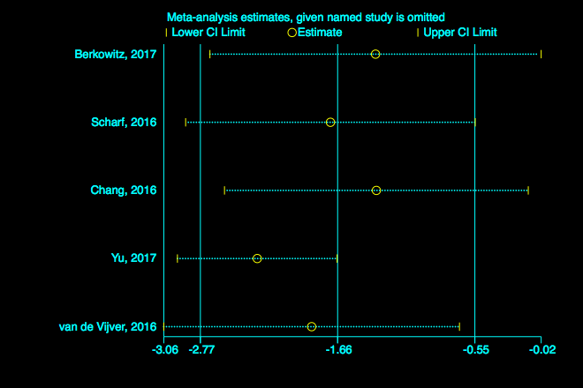
(A). Education and counseling for SBP (B). Education, counseling and management for SBP (C). Screening, referral and management for SBP 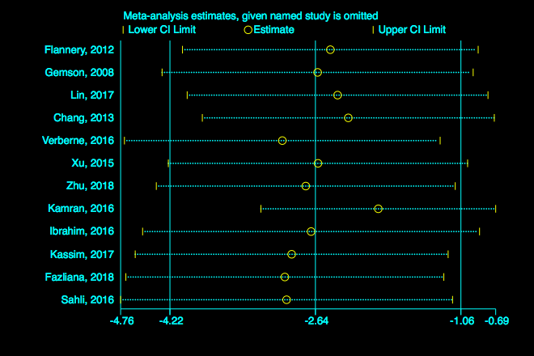 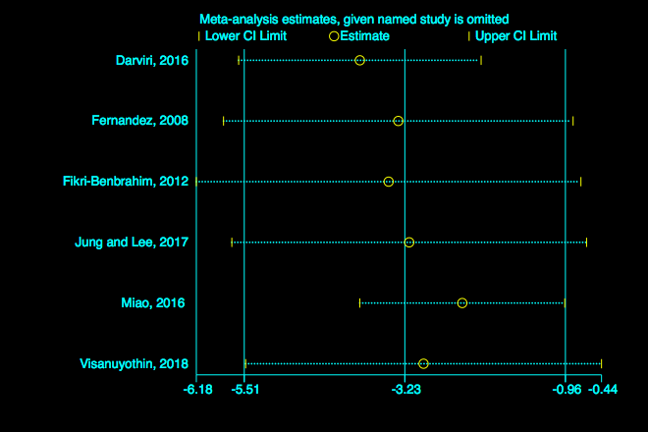 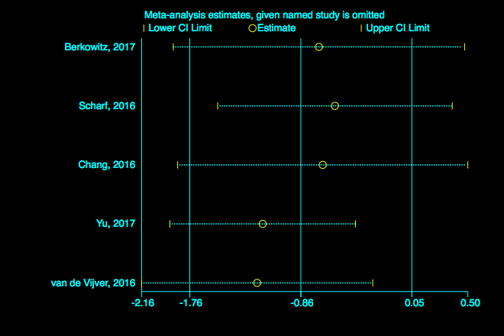
(D). Education and counseling for DBP (E). Education, counseling and management for DBP (F). Screening, referral and management for DBP

Fig. S8. Sensitivity analysis of systolic blood pressure (SBP), diastolic blood pressure (DBP) stratified by intervention types
SBP, systolic blood pressure; DBP, diastolic blood pressure.

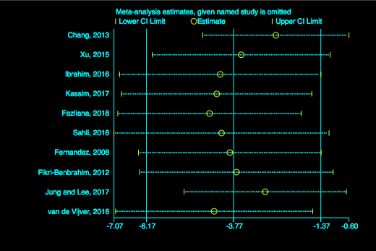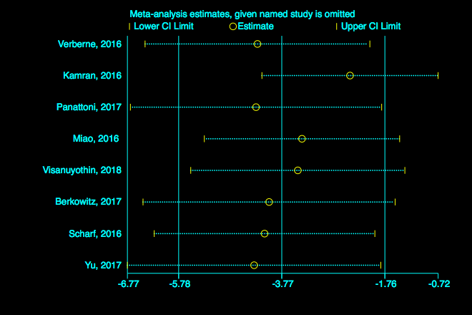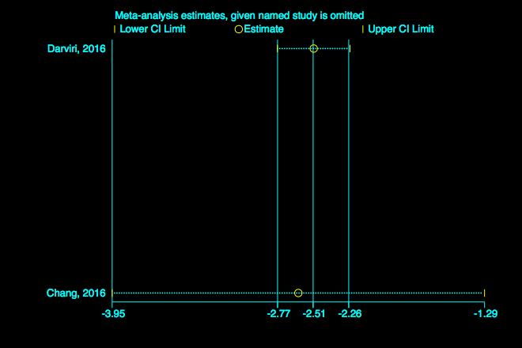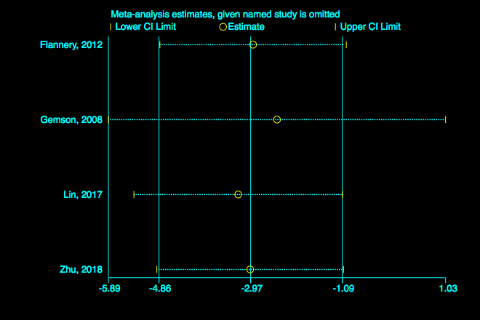
(A). Community setting for SBP (B). Health center setting for SBP (C). Nation setting for SBP (D). Organization setting for SBP

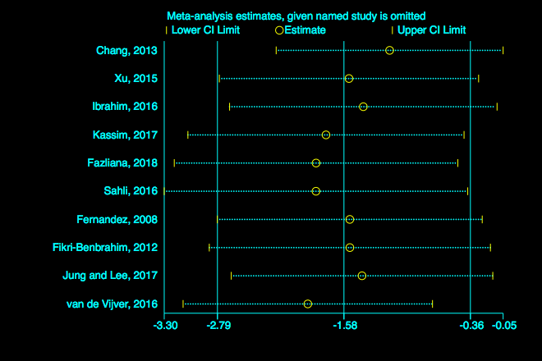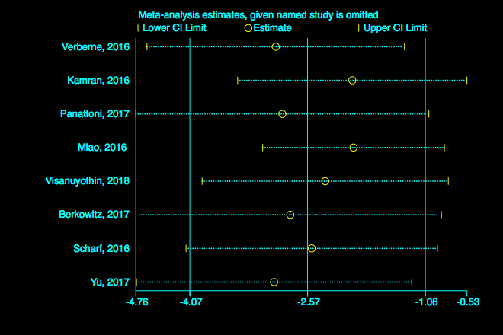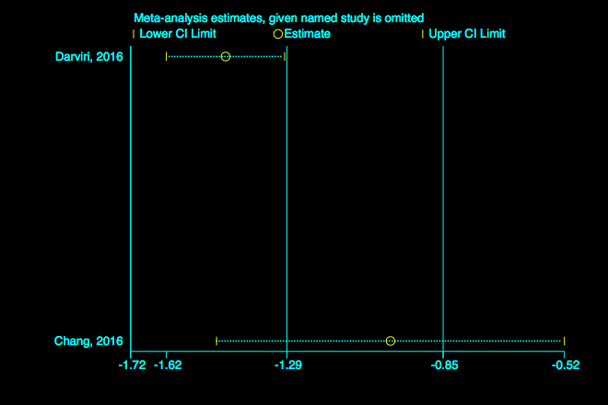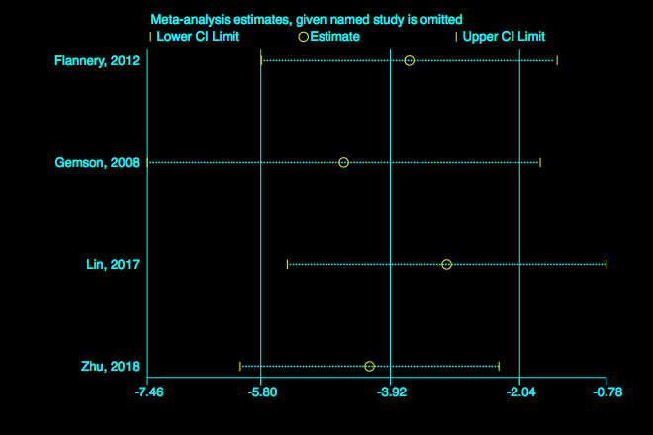
(E). Community setting for DBP (F). Health center setting for DBP (G). Nation setting for DBP (H). Organization setting for DBP

Fig. S9. Sensitivity analysis of systolic blood pressure (SBP), diastolic blood pressure (DBP) stratified by intervention settings
SBP, systolic blood pressure; DBP, diastolic blood pressure.

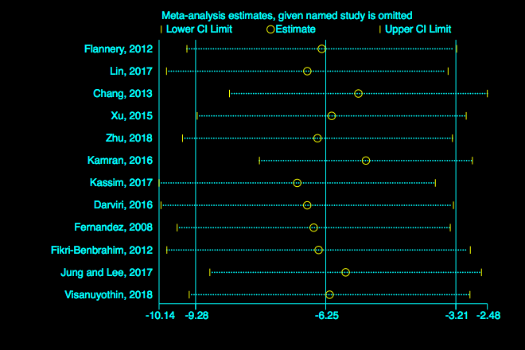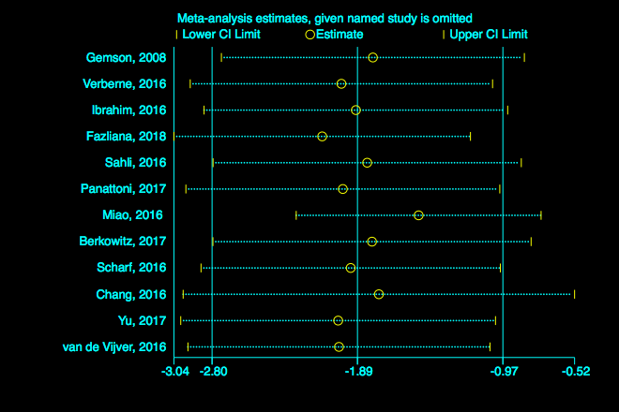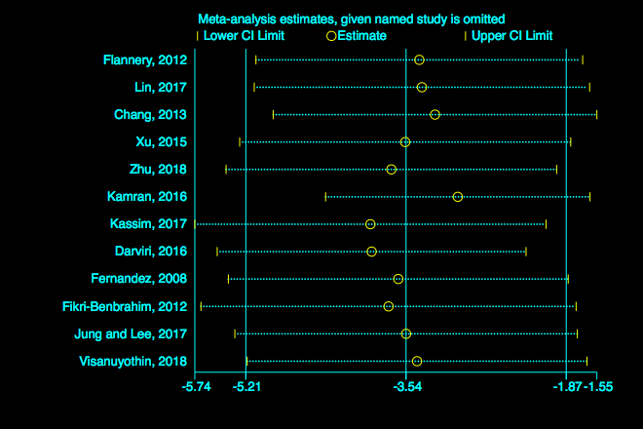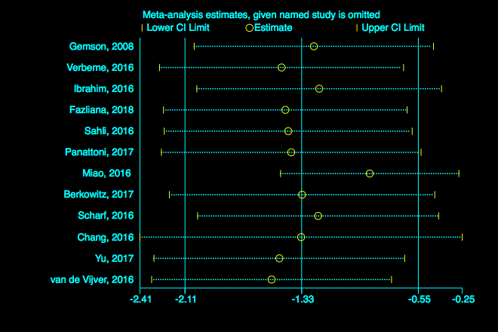
(A). Short duration for SBP (B). Long duration for SBP (C). Short duration for DBP (D). Long duration for DBP

Fig. S10. Sensitivity analysis of systolic blood pressure (SBP), diastolic blood pressure (DBP) stratified by intervention duration
SBP, systolic blood pressure; DBP, diastolic blood pressure.

