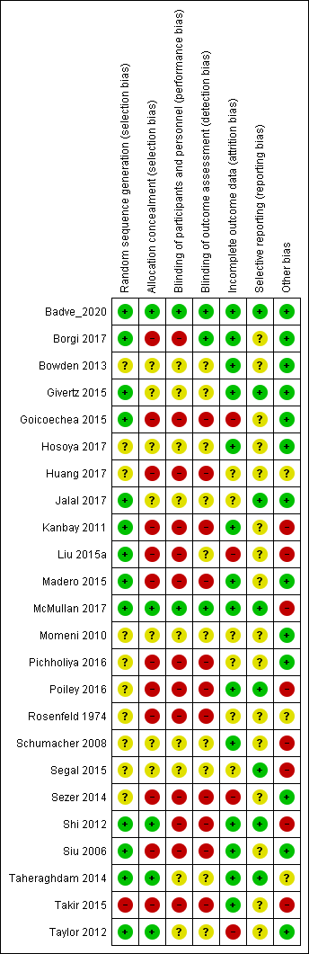
Green circle represents low risk of bias; yellow circle represents unclear risk of bias; red circle represents high risk of bias;

S1 Figure. Risk of bias of individual RCTs

