S2 Figure A | Forest plot of cardiovascular mortality
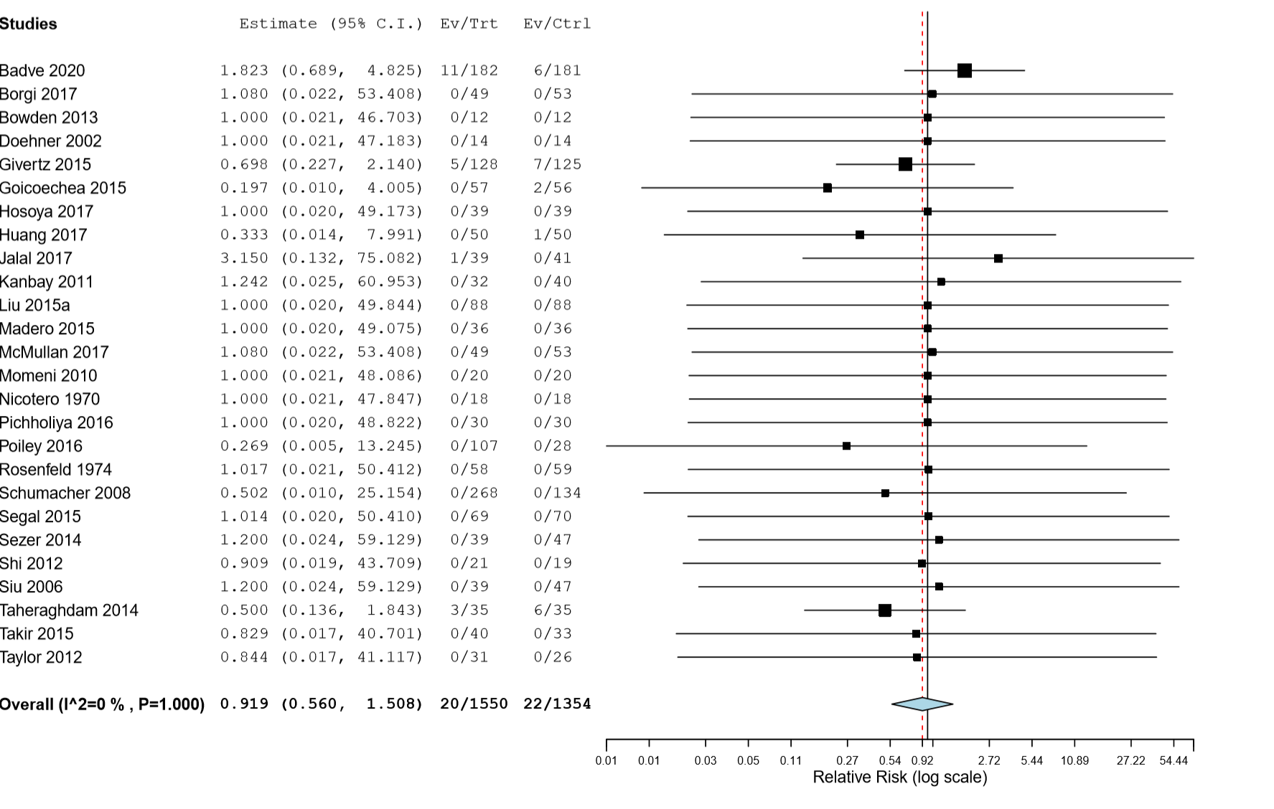
Overall effect of allopurinol on cardiovascular mortality: p=0.738
S2 Figure B | Forest plot of myocardial infarction
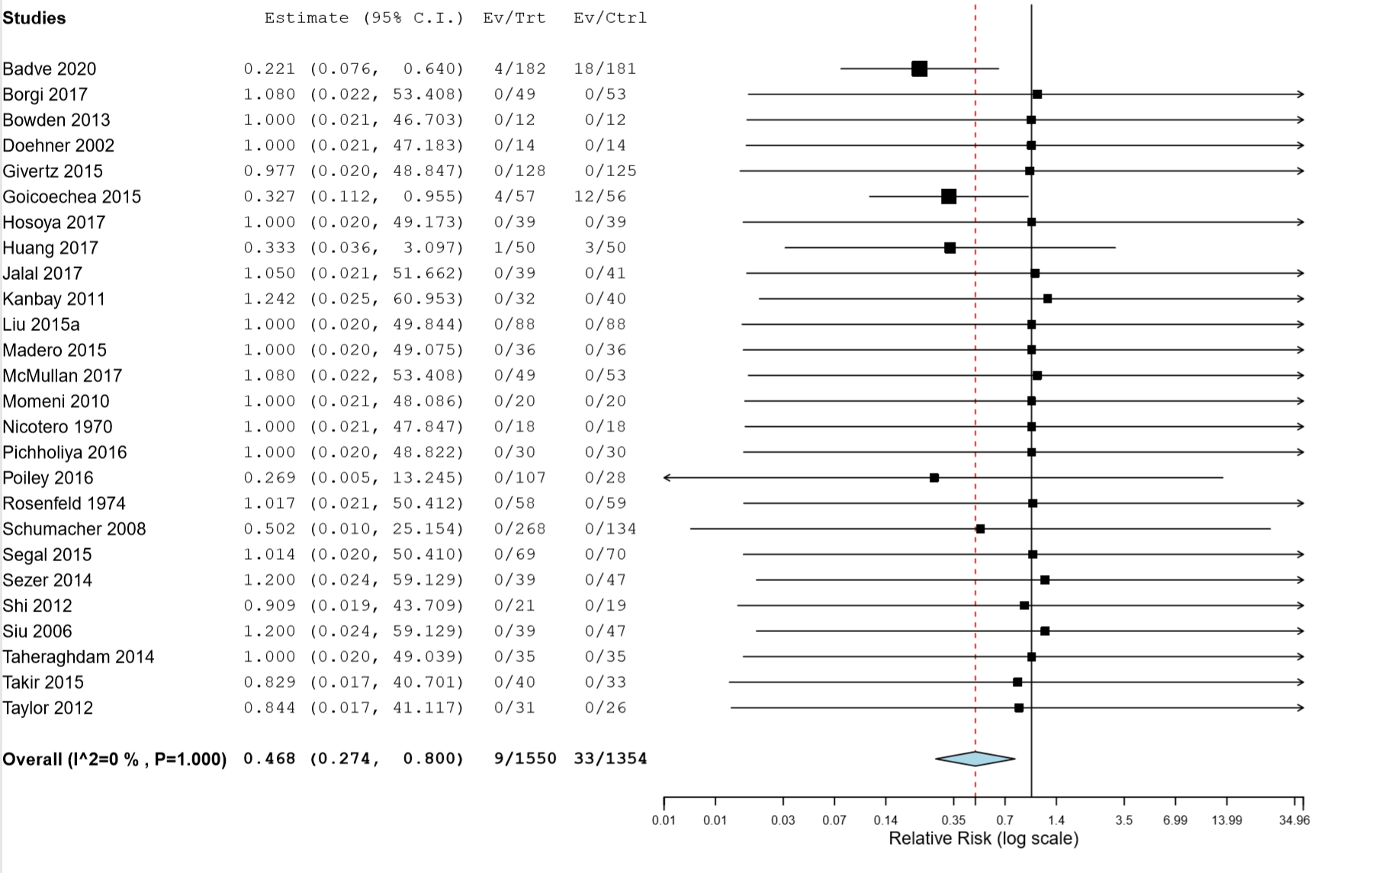
Overall effect of allopurinol on myocardial infarction: p=0.015
S2 Figure C | Forest plot of stroke.
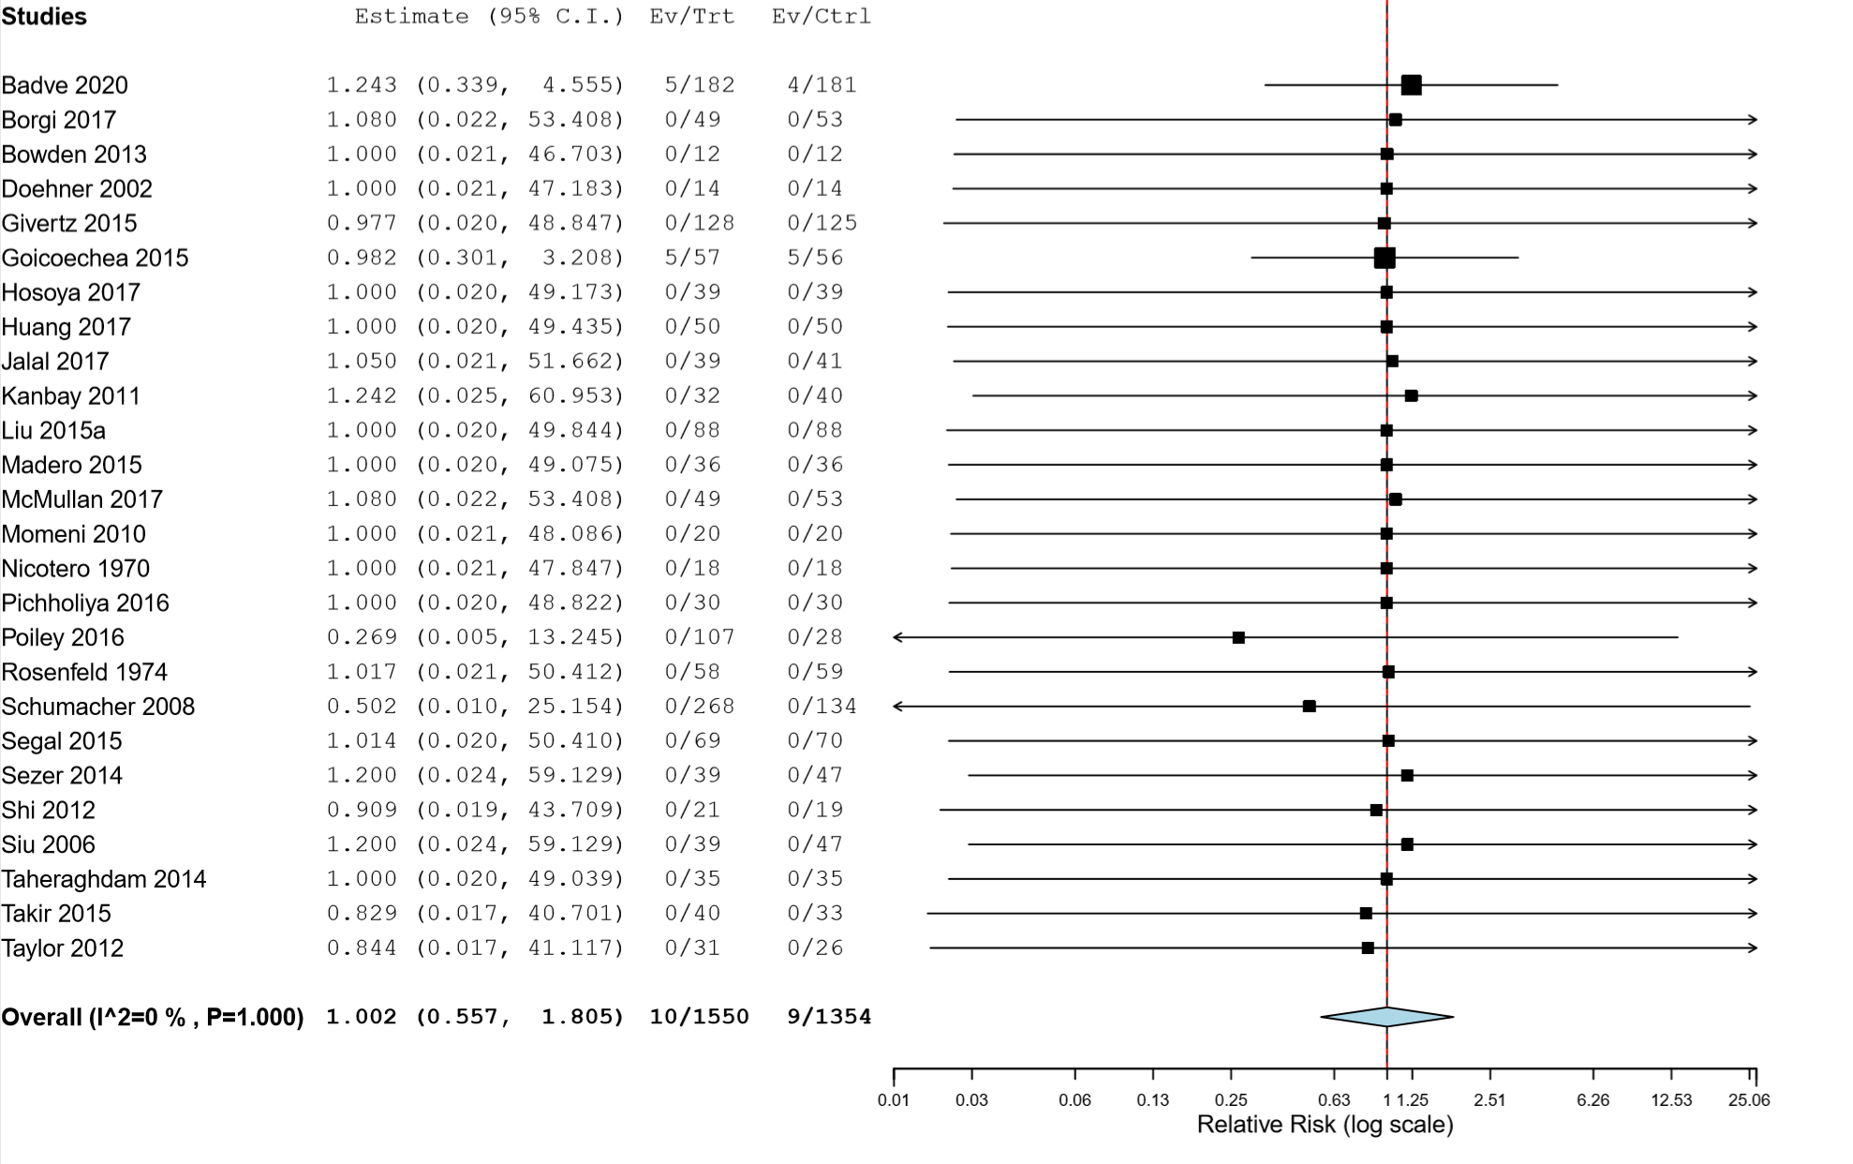
Overall effect of allopurinol on stroke: p=0.993

