Appendix 1
Search Strategy and Results Overview
Database | # results | Search String used | Comments
Medline | 130 | See screenshot below
SPORTDiscus | 157 | ( biomechanic* OR 3D OR three-dimensional OR video OR kinematic* OR kinetic* ) AND ( tackl* OR impact* OR collision* ) AND rugby | Searched ‘all fields’ except full-text  Limited to Peer Reviewed and English Language
Web of Science | 204 | ( biomechanic* OR 3D OR three-dimensional OR video OR kinematic* OR kinetic* ) AND ( tackl* OR impact* OR collision* ) AND rugby | Searched ‘Topic’ which searches title/abs/keywords  Limited to English Language
Scopus | 245 | ( biomechanic* OR 3D OR three-dimensional OR video OR kinematic* OR kinetic* ) AND ( tackl* OR impact* OR collision* ) AND rugby | Searched ‘title-abstract-keyword’  Limited to English Language
CINAHL (EBSCO) | 113 | ( biomechanic* OR 3D OR three-dimensional OR video OR kinematic* OR kinetic* ) AND ( tackl* OR impact* OR collision* ) AND rugby | Searched across all fields
ProQuest Research Library | 69 | ( biomechanic* OR 3D OR three-dimensional OR video OR kinematic* OR kinetic* ) AND ( tackl* OR impact* OR collision* ) AND rugby | Searched all fields except full text.  Limited to Peer Reviewed and English Language
PubMed | 390 | ( biomechanic* OR 3D OR three-dimensional OR video OR kinematic* OR kinetic* ) AND ( tackl* OR impact* OR collision* ) AND rugby | Searched all fields except full text.  Limited to Peer Reviewed and English Language
Embase | 87 | See screenshot below | Limited to English Language
Cochrane Library | 7 | ( biomechanic* OR 3D OR three-dimensional OR video OR kinematic* OR kinetic* ) AND ( tackl* OR impact* OR collision* ) AND rugby
Total | 1498 |  | All searches completed 13.5.2020

Medline results 13.5.2020 – 143 results
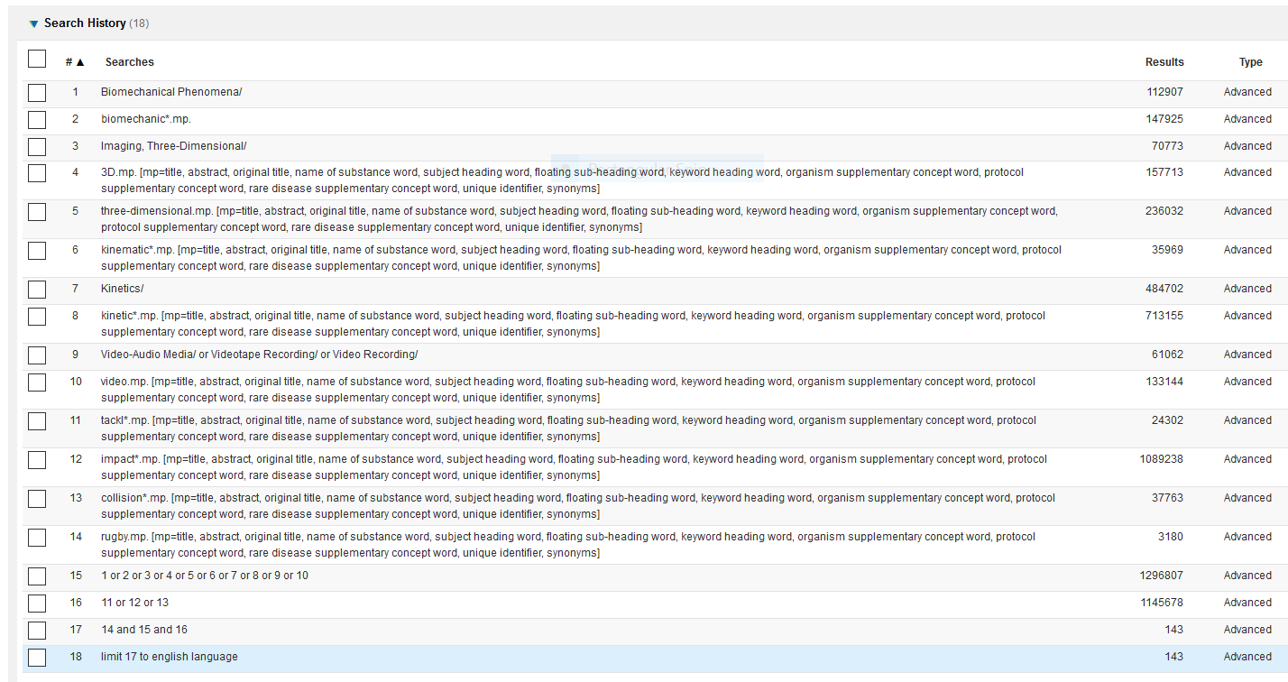

EMBASE Search 13/5/2020– 170 results


