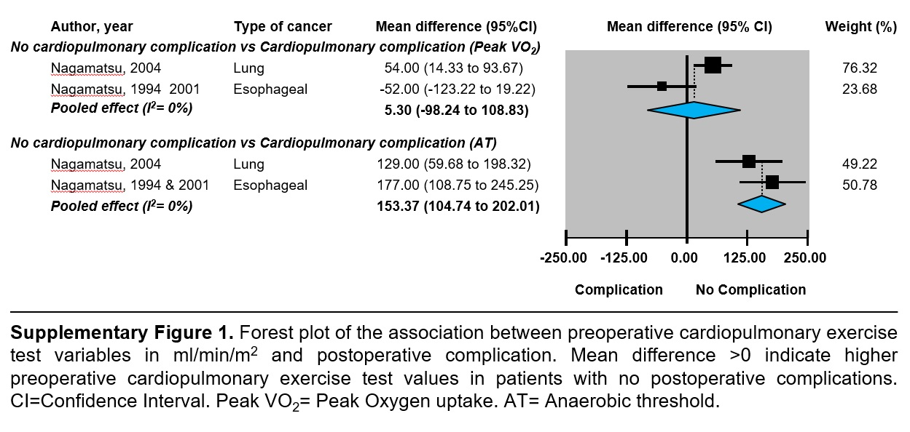

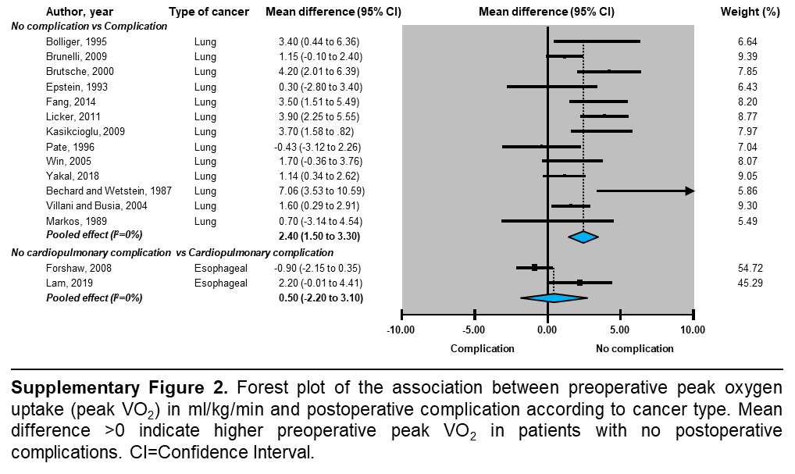

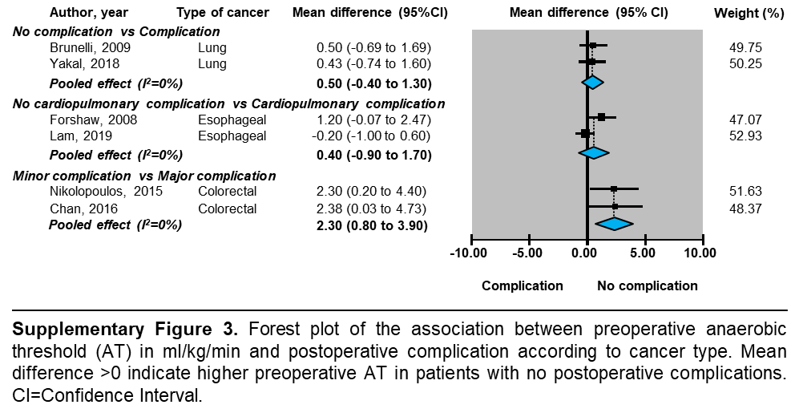

Supplementary Table 1. MEDLINE search strategy (via Ovid)
#1 | Preoperative care/ or pre-operative.mp. or preoperative period/ or preoperative.mp. or pre-operatory.mp. or preoperatory.mp. or before surgery.mp.
#2 | cardiopulmonary exercise test.mp. or Exercise Test/ or Oxygen Consumption/ or CPET.mp. or Exercise Tolerance/ or CPEX.mp.
#3 | neoplasm.mp. or exp Neoplasms/ or cancer.mp. or tumor.mp. or Adenocarcinoma/ or Neoplasms/ or tumour$.mp. or Carcinoma, Squamous Cell/ or malignan$.mp. or sarcom$.mp.
#4 | #1 and #2 and #3
#5 | Limit #4 to humans
mp= title, abstract, original title, name of substance word, subject heading word, keyword heading word, protocol supplementary concept word, rare
disease supplementary concept word, unique identifier.

