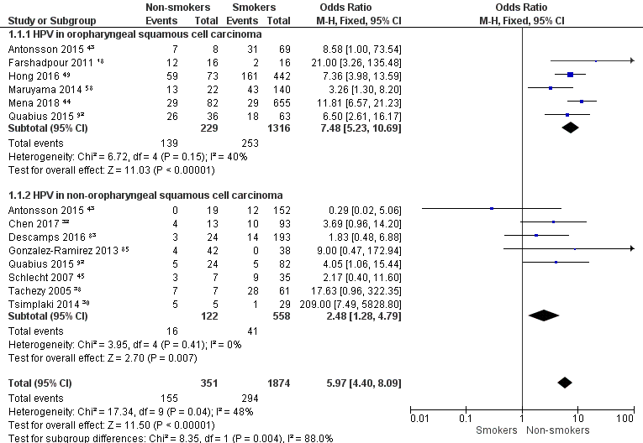

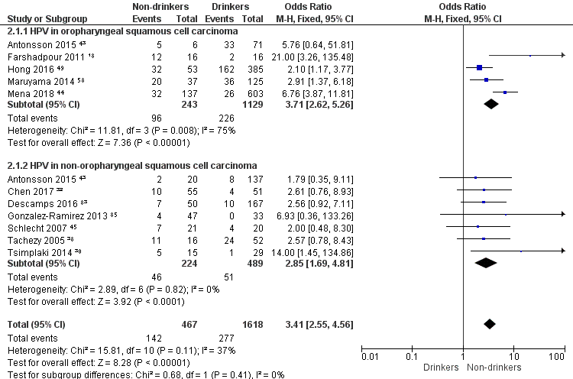

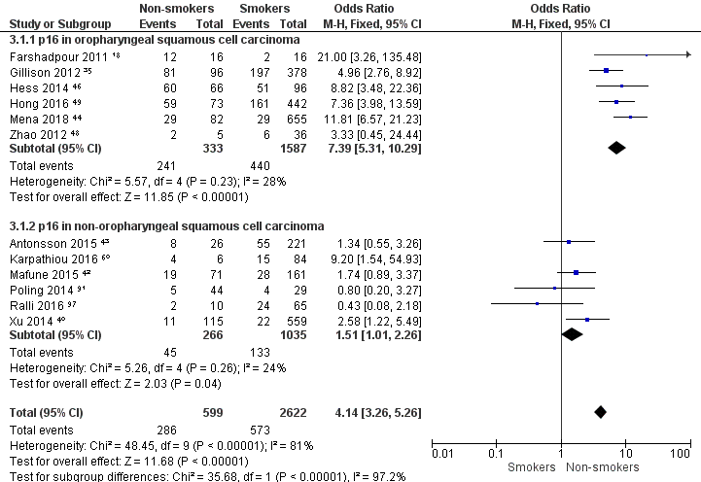

Supplementary Figure 1. Sensitivity analyses evaluating the statistical reliability of the data by only retaining studies with at least ten patients in both the non-smoking/non-drinking and smoking/drinking groups. Since exclusion of these studies did not change the conclusions, all studies remained included in the meta-analysis (Figure 3).

