Appendix: Supplemental material

Online Supplementary Figures and Tables

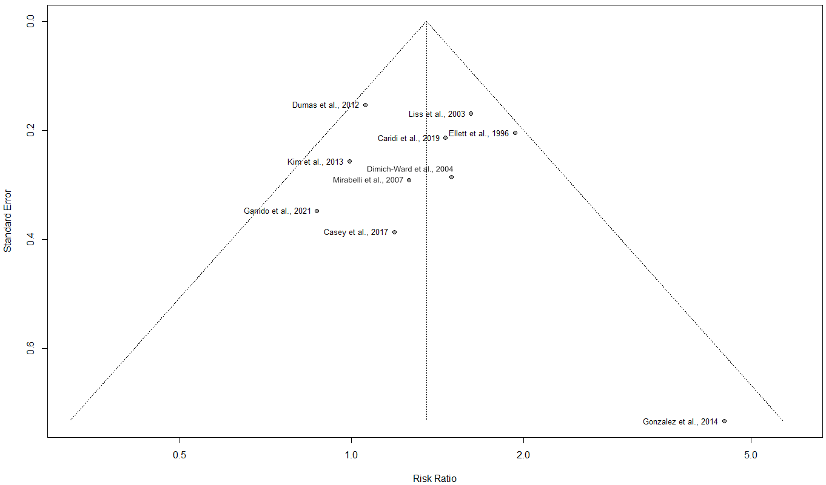
Figure S1. Funnel plot of ten studies that were pooled in a meta-analysis evaluating asthma risk in relation to exposure to cleaning or disinfecting tasks or agents.

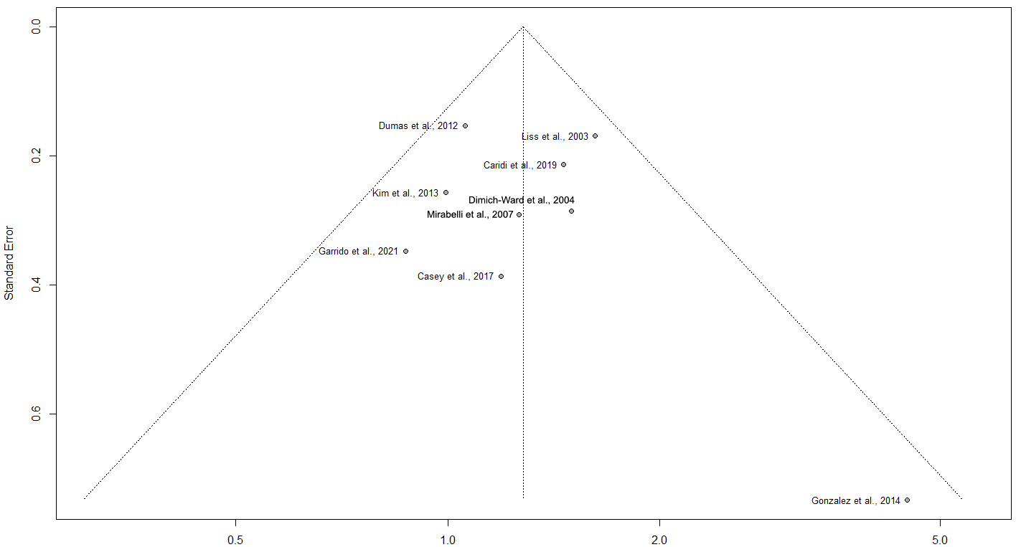
Figure S2. Funnel plot of nine studies conducted after 2000 that were pooled in a meta-analysis evaluating asthma risk in relation to exposure to cleaning or disinfecting tasks or agents.
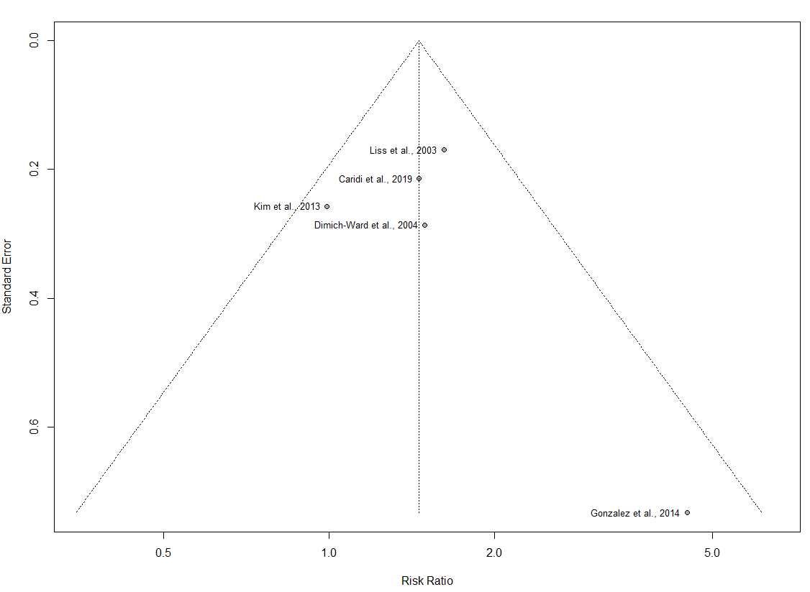
Figure S3. Funnel plot of five cross-sectional studies that were pooled in a meta-analysis evaluating the risk of new-onset, adult-onset, and reported asthma in relation to exposure to cleaning or disinfecting tasks or agents.
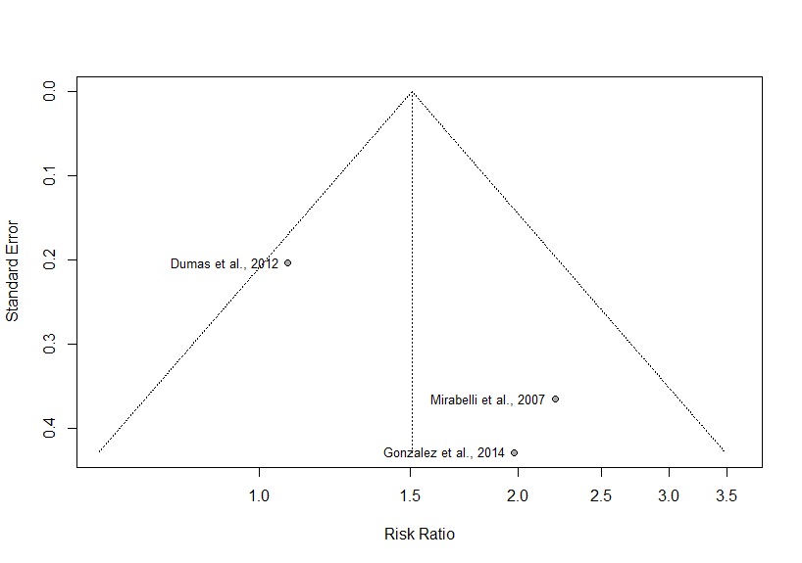
Figure S4. Funnel plot of three studies that were pooled in a meta-analysis evaluating asthma risk in relation to bleach exposure.
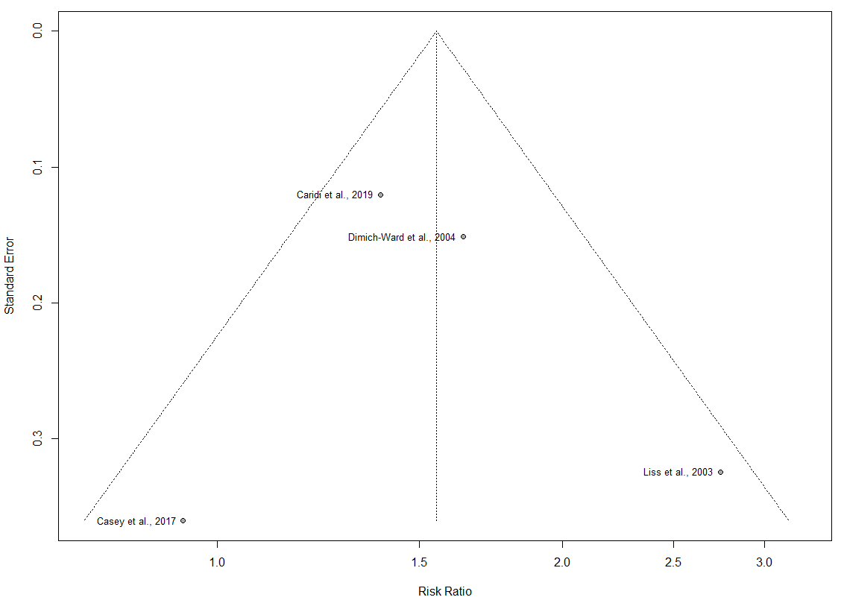
Figure S5. Funnel plot of four studies that were pooled in a meta-analysis evaluating risk of wheeze in relation to exposure to cleaning or disinfecting tasks or agents.

Table S1. Database search strategies for a) Ovid MEDLINE, b) Ovid MEDLINE Epub Ahead of Print and In-Process, In-Data-Review & Other Non-Indexed Citations, c) Embase, d) Cochrane Database of Systematic Reviews, e) Cochrane Central Register of Controlled Trials, and f) CINAHL.
a) Ovid MEDLINE(R) <1946 to August 06, 2021>
# | Searches
1 | [occupational asthma]
2 | Asthma, Occupational/
3 | exp Asthma/
4 | asthma*.mp.
5 | wheez*.mp.
6 | sibilant rhonch*.mp.
7 | Cough/
8 | cough*.mp.
9 | Bronchial Hyperreactivity/
10 | Respiratory Hypersensitivity/
11 | (airflow adj2 obstruct*).mp.
12 | (airway* adj2 responsiv*).mp.
13 | (reactive adj2 airway*).mp.
14 | (airway* adj2 hypersensitiv*).mp.
15 | (airway* adj2 hyperreactiv*).mp.
16 | (airway* adj3 allerg*).mp.
17 | (airway* adj3 insufficiency).mp.
18 | (bronchi* adj2 hypersentiv*).mp.
19 | (bronchi* adj2 hyperreactiv*).mp.
20 | (bronchi* adj2 allerg*).mp.
21 | (bronchi* adj3 insufficiency).mp.
22 | (respiratory adj2 hypersensitiv*).mp.
23 | (respiratory adj2 hyperreactiv*).mp.
24 | (respiratory adj2 hyperresponsiv*).mp.
25 | (respiratory adj2 allerg*).mp.
26 | (lung* adj2 hypersensitiv*).mp.
27 | (lung* adj2 hyperreactiv*).mp.
28 | (lung* adj2 allerg*).mp.
29 | (lung* adj3 insufficiency).mp.
30 | Bronchial Spasm/
31 | bronchospas*.mp.
32 | (bronch* adj3 spasm*).mp.
33 | Bronchoconstriction/
34 | bronchoconstriction*.mp.
35 | (bronch* adj3 constrict*).mp.
36 | (bronch* adj3 restriction).mp.
37 | or/3-36
38 | Occupational Exposure/
39 | exp Occupational Diseases/
40 | Occupational Health/
41 | Occupational Medicine/
42 | Workplace/
43 | exp Work/
44 | work*.mp.
45 | occupation*.mp.
46 | job-site*.mp.
47 | job-exposure*.mp.
48 | job-related.mp.
49 | Air Pollutants, Occupational/
50 | or/38-49
51 | 37 and 50
52 | 2 or 51
53 | [healthcare workers]
54 | exp Health Personnel/
55 | exp Health Facilities/
56 | (health* adj2 setting*).mp.
57 | (health* adj2 sector*).mp.
58 | (hospital adj2 setting*).mp.
59 | hospital-based.mp.
60 | nurse?.mp.
61 | (nurs* adj2 professional*).mp.
62 | (nurs* adj2 practitioner*).mp.
63 | (nurs* adj2 auxiliar*).mp.
64 | (nurs* adj2 assistant*).mp.
65 | (nurs* adj2 aide*).mp.
66 | (nurs* adj2 staff*).mp.
67 | (nurs* adj2 work*).mp.
68 | (nurs* adj2 personnel*).mp.
69 | (nurs* adj2 provider*).mp.
70 | (nurs* adj2 specialist*).mp.
71 | (nurs* adj2 consultant*).mp.
72 | (nurs* adj2 employ*).mp.
73 | (health* adj2 personnel*).mp.
74 | (health* adj2 professional*).mp.
75 | (health* adj2 staff*).mp.
76 | (health* adj2 work*).mp.
77 | (health* adj2 provider*).mp.
78 | (health* adj2 aide*).mp.
79 | (health* adj2 assistant*).mp.
80 | (health* adj2 specialist*).mp.
81 | (health* adj2 consultant*).mp.
82 | (health* adj2 employee*).mp.
83 | (health* adj2 manager*).mp.
84 | (health* adj2 administrat*).mp.
85 | (health* adj2 housekeep*).mp.
86 | HCW?.mp.
87 | HCP.mp.
88 | HCPs.mp.
89 | (medical adj2 professional*).mp.
90 | (medical adj2 staff*).mp.
91 | (medical adj2 personnel*).mp.
92 | (medical adj2 provider*).mp.
93 | (medical adj2 practitioner*).mp.
94 | (medical adj2 aide*).mp.
95 | (medical adj2 assistant*).mp.
96 | (medical adj2 specialist*).mp.
97 | (medical adj2 consultant*).mp.
98 | (medical adj2 employee*).mp.
99 | paramedic*.mp.
100 | hospitalist*.mp.
101 | (hospital? adj2 professional*).mp.
102 | (hospital? adj2 worker*).mp.
103 | (hospital? adj2 staff*).mp.
104 | (hospital? adj2 personnel*).mp.
105 | (hospital? adj2 provider*).mp.
106 | (hospital? adj2 practitioner*).mp.
107 | (hospital? adj2 aide*).mp.
108 | (hospital? adj2 assistant*).mp.
109 | (hospital? adj2 specialist*).mp.
110 | (hospital? adj2 consultant*).mp.
111 | (hospital? adj2 employee*).mp.
112 | (hospital? adj2 manager*).mp.
113 | (hospital? adj2 administrat*).mp.
114 | (hospital? adj2 housekeep*).mp.
115 | physician*.mp.
116 | doctor*.mp.
117 | (general adj2 practitioner*).mp.
118 | (family adj2 practitioner*).mp.
119 | social worker*.mp.
120 | support worker*.mp.
121 | PSW.mp.
122 | clinician*.mp.
123 | pharmacist*.mp.
124 | (pharmacy adj2 assistant*).mp.
125 | physiotherapist*.mp.
126 | therapist*.mp.
127 | technician*.mp.
128 | radiographer*.mp.
129 | surgeon*.mp.
130 | an?esthetist*.mp.
131 | An?esthesiologist*.mp.
132 | obstetrician*.mp.
133 | gyn?ecologist*.mp.
134 | geriatrician*.mp.
135 | gerontologist*.mp.
136 | audiologist*.mp.
137 | dietician*.mp.
138 | nutritionist*.mp.
139 | psychologist*.mp.
140 | psychiatrist*.mp.
141 | psychotherapist*.mp.
142 | counsel?or*.mp.
143 | or/54-142
144 | 52 and 143
145 | [cleaning products]
146 | exp Disinfectants/
147 | exp detergents/
148 | exp surface-active agents/
149 | exp Ammonium Compounds/
150 | exp Anti-Infective Agents, Local/
151 | exp Acetic Acid/
152 | 2-Propanol/
153 | Chloramines/
154 | exp Phenols/
155 | Decontamination/
156 | clean*.mp.
157 | disinfect*.mp.
158 | detergent*.mp.
159 | decontaminat*.mp.
160 | Biocide*.mp.
161 | (Hand adj2 Antiseptic*).mp.
162 | soap*.mp.
163 | Syndet.mp.
164 | formaldehyde*.mp.
165 | formalin*.mp.
166 | formol.mp.
167 | methanal*.mp.
168 | oxomethane*.mp.
169 | glutaral*.mp.
170 | cidex.mp.
171 | diswart*.mp.
172 | gludesin*.mp.
173 | Glutardialdehyde*.mp.
174 | Korsolex.mp.
175 | Sekumatic.mp.
176 | Sonacide*.mp.
177 | Sporicidin*.mp.
178 | Novaruca.mp.
179 | Phthalaldehyde*.mp.
180 | Orthophthaldialdehyde*.mp.
181 | ortho-Phthalic Aldehyde*.mp.
182 | bleach.mp.
183 | antiformin*.mp.
184 | clorox.mp.
185 | sodium hypochlorite*.mp.
186 | hydrogen peroxide*.mp.
187 | hydroperoxide*.mp.
188 | oxydol.mp.
189 | perhydrol.mp.
190 | superoxol.mp.
191 | paracetic acid*.mp.
192 | (peroxyacetic adj2 acid*).mp.
193 | (peroxyethanoic adj2 acid*).mp.
194 | desoxone-1.mp.
195 | dialax.mp.
196 | peracetate*.mp.
197 | (acetic adj2 acid*).mp.
198 | (isopropyl adj2 alcohol*).mp.
199 | (rubbing adj2 alcohol*).mp.
200 | 2-propanol.mp.
201 | isopropanol*.mp.
202 | ammonia.mp.
203 | ammonium hydroxide*.mp.
204 | ammonium compound*.mp.
205 | QAC?.mp.
206 | ethylene oxide*.mp.
207 | oxirane*.mp.
208 | chloramine-t.mp.
209 | tosylchloramide*.mp.
210 | Chloraseptin.mp.
211 | Chlorazol.mp.
212 | Clorina.mp.
213 | Disifin.mp.
214 | Halamid.mp.
215 | Hydroclonazone.mp.
216 | Trichlorol.mp.
217 | Minachlor.mp.
218 | phenolic*.mp.
219 | phenol?.mp.
220 | D-limonene*.mp.
221 | pine oil*.mp.
222 | latex/
223 | protective clothing/
224 | gloves, protective/
225 | latex.mp.
226 | glove*.mp.
227 | mask*.mp.
228 | exp Sterilization/
229 | sterilant*.mp.
230 | or/146-229
231 | 144 and 230
232 | animals/ not (animals/ and humans/)
233 | 231 not 232
234 | limit 233 to english language
235 | remove duplicates from 234
b) Ovid MEDLINE(R) Epub Ahead of Print and In-Process, In-Data-Review & Other Non-Indexed Citations
# | Searches
1 | asthma*.mp.
2 | wheez*.mp.
3 | sibilant rhonch*.mp.
4 | cough*.mp.
5 | (airflow adj2 obstruct*).mp.
6 | (airway* adj2 responsiv*).mp.
7 | (reactive adj2 airway*).mp.
8 | (airway* adj2 hypersensitiv*).mp.
9 | (airway* adj2 hyperreactiv*).mp.
10 | (airway* adj3 allerg*).mp.
11 | (airway* adj3 insufficiency).mp.
12 | (bronch* adj2 hypersentiv*).mp.
13 | (bronch* adj2 hyperreactiv*).mp.
14 | (bronch* adj2 allerg*).mp.
15 | (bronch* adj3 insufficiency).mp.
16 | (respiratory adj2 hypersensitiv*).mp.
17 | (respiratory adj2 hyperreactiv*).mp.
18 | (respiratory adj2 hyperresponsiv*).mp.
19 | (respiratory adj2 allerg*).mp.
20 | (lung* adj2 hypersensitiv*).mp.
21 | (lung* adj2 hyperreactiv*).mp.
22 | (lung* adj2 allerg*).mp.
23 | (lung* adj3 insufficiency).mp.
24 | bronchospas*.mp.
25 | (bronch* adj3 spasm*).mp.
26 | bronchoconstriction*.mp.
27 | (bronch* adj3 constrict*).mp.
28 | (bronch* adj3 restriction).mp.
29 | or/1-28
30 | work*.mp.
31 | occupation*.mp.
32 | job-site*.mp.
33 | job-exposure*.mp.
34 | job-related.mp.
35 | or/30-34
36 | (health* adj2 setting*).mp.
37 | (health* adj2 sector*).mp.
38 | (hospital adj2 setting*).mp.
39 | hospital-based.mp.
40 | nurse?.mp.
41 | (nurs* adj2 professional*).mp.
42 | (nurs* adj2 practitioner*).mp.
43 | (nurs* adj2 auxiliar*).mp.
44 | (nurs* adj2 assistant*).mp.
45 | (nurs* adj2 aide*).mp.
46 | (nurs* adj2 staff*).mp.
47 | (nurs* adj2 work*).mp.
48 | (nurs* adj2 personnel*).mp.
49 | (nurs* adj2 provider*).mp.
50 | (nurs* adj2 specialist*).mp.
51 | (nurs* adj2 consultant*).mp.
52 | (nurs* adj2 employ*).mp.
53 | (health* adj2 personnel*).mp.
54 | (health* adj2 professional*).mp.
55 | (health* adj2 staff*).mp.
56 | (health* adj2 work*).mp.
57 | (health* adj2 provider*).mp.
58 | (health* adj2 aide*).mp.
59 | (health* adj2 assistant*).mp.
60 | (health* adj2 specialist*).mp.
61 | (health* adj2 consultant*).mp.
62 | (health* adj2 employee*).mp.
63 | (health* adj2 manager*).mp.
64 | (health* adj2 administrat*).mp.
65 | (health* adj2 housekeep*).mp.
66 | HCW?.mp.
67 | HCP.mp.
68 | HCPs.mp.
69 | (medical adj2 professional*).mp.
70 | (medical adj2 staff*).mp.
71 | (medical adj2 personnel*).mp.
72 | (medical adj2 provider*).mp.
73 | (medical adj2 practitioner*).mp.
74 | (medical adj2 aide*).mp.
75 | (medical adj2 assistant*).mp.
76 | (medical adj2 specialist*).mp.
77 | (medical adj2 consultant*).mp.
78 | (medical adj2 employee*).mp.
79 | paramedic*.mp.
80 | hospitalist*.mp.
81 | (hospital? adj2 professional*).mp.
82 | (hospital? adj2 worker*).mp.
83 | (hospital? adj2 staff*).mp.
84 | (hospital? adj2 personnel*).mp.
85 | (hospital? adj2 provider*).mp.
86 | (hospital? adj2 practitioner*).mp.
87 | (hospital? adj2 aide*).mp.
88 | (hospital? adj2 assistant*).mp.
89 | (hospital? adj2 specialist*).mp.
90 | (hospital? adj2 consultant*).mp.
91 | (hospital? adj2 employee*).mp.
92 | (hospital? adj2 manager*).mp.
93 | (hospital? adj2 administrat*).mp.
94 | (hospital? adj2 housekeep*).mp.
95 | physician*.mp.
96 | doctor*.mp.
97 | (general adj2 practitioner*).mp.
98 | (family adj2 practitioner*).mp.
99 | social worker*.mp.
100 | support worker*.mp.
101 | PSW.mp.
102 | clinician*.mp.
103 | pharmacist*.mp.
104 | (pharmacy adj2 assistant*).mp.
105 | physiotherapist*.mp.
106 | therapist*.mp.
107 | technician*.mp.
108 | radiographer*.mp.
109 | surgeon*.mp.
110 | an?esthetist*.mp.
111 | An?esthesiologist*.mp.
112 | obstetrician*.mp.
113 | gyn?ecologist*.mp.
114 | geriatrician*.mp.
115 | gerontologist*.mp.
116 | audiologist*.mp.
117 | dietician*.mp.
118 | nutritionist*.mp.
119 | psychologist*.mp.
120 | psychiatrist*.mp.
121 | psychotherapist*.mp.
122 | counsel?or*.mp.
123 | or/36-122
124 | clean*.mp.
125 | disinfect*.mp.
126 | detergent*.mp.
127 | decontaminat*.mp.
128 | Biocide*.mp.
129 | (Hand adj2 Antiseptic*).mp.
130 | soap*.mp.
131 | Syndet.mp.
132 | formaldehyde*.mp.
133 | formalin*.mp.
134 | formol.mp.
135 | methanal*.mp.
136 | oxomethane*.mp.
137 | glutaral*.mp.
138 | cidex.mp.
139 | diswart*.mp.
140 | gludesin*.mp.
141 | Glutardialdehyde*.mp.
142 | Korsolex.mp.
143 | Sekumatic.mp.
144 | Sonacide*.mp.
145 | Sporicidin*.mp.
146 | Novaruca.mp.
147 | Phthalaldehyde*.mp.
148 | Orthophthaldialdehyde*.mp.
149 | ortho-Phthalic Aldehyde*.mp.
150 | bleach.mp.
151 | antiformin*.mp.
152 | clorox.mp.
153 | sodium hypochlorite*.mp.
154 | hydrogen peroxide*.mp.
155 | hydroperoxide*.mp.
156 | oxydol.mp.
157 | perhydrol.mp.
158 | superoxol.mp.
159 | paracetic acid*.mp.
160 | (peroxyacetic adj2 acid*).mp.
161 | (peroxyethanoic adj2 acid*).mp.
162 | desoxone-1.mp.
163 | dialax.mp.
164 | peracetate*.mp.
165 | (acetic adj2 acid*).mp.
166 | (isopropyl adj2 alcohol*).mp.
167 | (rubbing adj2 alcohol*).mp.
168 | 2-propanol.mp.
169 | isopropanol*.mp.
170 | ammonia.mp.
171 | ammonium hydroxide*.mp.
172 | ammonium compound*.mp.
173 | QAC?.mp.
174 | ethylene oxide*.mp.
175 | oxirane*.mp.
176 | chloramine-t.mp.
177 | tosylchloramide*.mp.
178 | Chloraseptin.mp.
179 | Chlorazol.mp.
180 | Clorina.mp.
181 | Disifin.mp.
182 | Halamid.mp.
183 | Hydroclonazone.mp.
184 | Trichlorol.mp.
185 | Minachlor.mp.
186 | phenolic*.mp.
187 | phenol?.mp.
188 | D-limonene*.mp.
189 | pine oil*.mp.
190 | latex.mp.
191 | glove?.mp.
192 | mask?.mp.
193 | sterilant*.mp.
194 | or/124-193
195 | 29 and 35 and 123 and 194
196 | limit 195 to english language

c) Embase <1974 to 2021 August 06>
# | Searches
1 | occupational asthma/
2 | exp asthma/
3 | asthma*.mp.
4 | wheezing/
5 | wheez*.mp.
6 | sibilant rhonch*.mp.
7 | exp coughing/
8 | cough*.mp.
9 | airway obstruction/
10 | bronchus hyperreactivity/
11 | respiratory tract allergy/
12 | (airflow adj2 obstruct*).mp.
13 | (airway* adj2 responsiv*).mp.
14 | (reactive adj2 airway*).mp.
15 | (airway* adj2 hypersensitiv*).mp.
16 | (airway* adj2 hyperreactiv*).mp.
17 | (airway* adj3 allerg*).mp.
18 | (airway* adj3 insufficiency).mp.
19 | (bronch* adj2 hypersentiv*).mp.
20 | (bronch* adj2 hyperreactiv*).mp.
21 | (bronch* adj2 allerg*).mp.
22 | (bronch* adj3 insufficiency).mp.
23 | (respiratory adj2 hypersensitiv*).mp.
24 | (respiratory adj2 hyperreactiv*).mp.
25 | (respiratory adj2 hyperresponsiv*).mp.
26 | (respiratory adj2 allerg*).mp.
27 | (lung* adj2 hypersensitiv*).mp.
28 | (lung* adj2 hyperreactiv*).mp.
29 | (lung* adj2 allerg*).mp.
30 | (lung* adj3 insufficiency).mp.
31 | bronchospasm/
32 | bronchospas*.mp.
33 | (bronch* adj3 spasm*).mp.
34 | bronchoconstriction/
35 | bronchoconstriction*.mp.
36 | (bronch* adj3 constrict*).mp.
37 | (bronch* adj3 restriction).mp.
38 | or/2-37
39 | occupational exposure/
40 | exp occupational disease/
41 | exp occupational health/
42 | occupational medicine/
43 | occupational toxicology/
44 | exp work/
45 | work*.mp.
46 | occupation*.mp.
47 | job-site*.mp.
48 | job-exposure*.mp.
49 | job-related.mp.
50 | exp air pollutant/
51 | or/39-50
52 | 38 and 51
53 | 1 or 52
54 | exp health care personnel/
55 | exp health care facility/
56 | (health* adj2 setting*).mp.
57 | (health* adj2 sector*).mp.
58 | (hospital adj2 setting*).mp.
59 | hospital-based.mp.
60 | nurse?.mp.
61 | (nurs* adj2 professional*).mp.
62 | (nurs* adj2 practitioner*).mp.
63 | (nurs* adj2 auxiliar*).mp.
64 | (nurs* adj2 assistant*).mp.
65 | (nurs* adj2 aide*).mp.
66 | (nurs* adj2 staff*).mp.
67 | (nurs* adj2 work*).mp.
68 | (nurs* adj2 personnel*).mp.
69 | (nurs* adj2 provider*).mp.
70 | (nurs* adj2 specialist*).mp.
71 | (nurs* adj2 consultant*).mp.
72 | (nurs* adj2 employ*).mp.
73 | (health* adj2 personnel*).mp.
74 | (health* adj2 professional*).mp.
75 | (health* adj2 staff*).mp.
76 | (health* adj2 work*).mp.
77 | (health* adj2 provider*).mp.
78 | (health* adj2 aide*).mp.
79 | (health* adj2 assistant*).mp.
80 | (health* adj2 specialist*).mp.
81 | (health* adj2 consultant*).mp.
82 | (health* adj2 employee*).mp.
83 | (health* adj2 manager*).mp.
84 | (health* adj2 administrat*).mp.
85 | (health* adj2 housekeep*).mp.
86 | HCW?.mp.
87 | HCP.mp.
88 | HCPs.mp.
89 | (medical adj2 professional*).mp.
90 | (medical adj2 staff*).mp.
91 | (medical adj2 personnel*).mp.
92 | (medical adj2 provider*).mp.
93 | (medical adj2 practitioner*).mp.
94 | (medical adj2 aide*).mp.
95 | (medical adj2 assistant*).mp.
96 | (medical adj2 specialist*).mp.
97 | (medical adj2 consultant*).mp.
98 | (medical adj2 employee*).mp.
99 | paramedic*.mp.
100 | hospitalist*.mp.
101 | (hospital? adj2 professional*).mp.
102 | (hospital? adj2 worker*).mp.
103 | (hospital? adj2 staff*).mp.
104 | (hospital? adj2 personnel*).mp.
105 | (hospital? adj2 provider*).mp.
106 | (hospital? adj2 practitioner*).mp.
107 | (hospital? adj2 aide*).mp.
108 | (hospital? adj2 assistant*).mp.
109 | (hospital? adj2 specialist*).mp.
110 | (hospital? adj2 consultant*).mp.
111 | (hospital? adj2 employee*).mp.
112 | (hospital? adj2 manager*).mp.
113 | (hospital? adj2 administrat*).mp.
114 | (hospital? adj2 housekeep*).mp.
115 | physician*.mp.
116 | doctor*.mp.
117 | (general adj2 practitioner*).mp.
118 | (family adj2 practitioner*).mp.
119 | social worker*.mp.
120 | support worker*.mp.
121 | PSW.mp.
122 | clinician*.mp.
123 | pharmacist*.mp.
124 | (pharmacy adj2 assistant*).mp.
125 | physiotherapist*.mp.
126 | therapist*.mp.
127 | technician*.mp.
128 | radiographer*.mp.
129 | surgeon*.mp.
130 | an?esthetist*.mp.
131 | An?esthesiologist*.mp.
132 | obstetrician*.mp.
133 | gyn?ecologist*.mp.
134 | geriatrician*.mp.
135 | gerontologist*.mp.
136 | audiologist*.mp.
137 | dietician*.mp.
138 | nutritionist*.mp.
139 | psychologist*.mp.
140 | psychiatrist*.mp.
141 | psychotherapist*.mp.
142 | counsel?or*.mp.
143 | or/54-142
144 | 53 and 143
145 | exp surfactant/
146 | exp ammonium derivative/
147 | exp topical antiinfective agent/
148 | exp disinfectant agent/
149 | 2 propanol/
150 | ammonia/
151 | ammonium hydroxide/
152 | quaternary ammonium derivative/
153 | exp phenol derivative/
154 | exp disinfection/
155 | limonene/
156 | instrument sterilization/
157 | exp protective clothing/
158 | clean*.mp.
159 | disinfect*.mp.
160 | detergent*.mp.
161 | decontaminat*.mp.
162 | Biocide*.mp.
163 | (Hand adj2 Antiseptic*).mp.
164 | soap*.mp.
165 | Syndet.mp.
166 | formaldehyde*.mp.
167 | formalin*.mp.
168 | formol.mp.
169 | methanal*.mp.
170 | oxomethane*.mp.
171 | glutaral*.mp.
172 | cidex.mp.
173 | diswart*.mp.
174 | gludesin*.mp.
175 | Glutardialdehyde*.mp.
176 | Korsolex.mp.
177 | Sekumatic.mp.
178 | Sonacide*.mp.
179 | Sporicidin*.mp.
180 | Novaruca.mp.
181 | Phthalaldehyde*.mp.
182 | Orthophthaldialdehyde*.mp.
183 | ortho-Phthalic Aldehyde*.mp.
184 | bleach.mp.
185 | antiformin*.mp.
186 | clorox.mp.
187 | sodium hypochlorite*.mp.
188 | hydrogen peroxide*.mp.
189 | hydroperoxide*.mp.
190 | oxydol.mp.
191 | perhydrol.mp.
192 | superoxol.mp.
193 | paracetic acid*.mp.
194 | (peroxyacetic adj2 acid*).mp.
195 | (peroxyethanoic adj2 acid*).mp.
196 | desoxone-1.mp.
197 | dialax.mp.
198 | peracetate*.mp.
199 | (acetic adj2 acid*).mp.
200 | (isopropyl adj2 alcohol*).mp.
201 | (rubbing adj2 alcohol*).mp.
202 | 2-propanol.mp.
203 | isopropanol*.mp.
204 | ammonia.mp.
205 | ammonium hydroxide*.mp.
206 | ammonium compound*.mp.
207 | QAC?.mp.
208 | ethylene oxide*.mp.
209 | oxirane*.mp.
210 | chloramine-t.mp.
211 | tosylchloramide*.mp.
212 | Chloraseptin.mp.
213 | Chlorazol.mp.
214 | Clorina.mp.
215 | Disifin.mp.
216 | Halamid.mp.
217 | Hydroclonazone.mp.
218 | Trichlorol.mp.
219 | Minachlor.mp.
220 | phenolic*.mp.
221 | phenol?.mp.
222 | D-limonene*.mp.
223 | pine oil*.mp.
224 | latex.mp.
225 | glove*.mp.
226 | mask*.mp.
227 | sterilant*.mp.
228 | latex/
229 | surgical glove/
230 | surgical mask/
231 | or/145-230
232 | 144 and 231
233 | (exp animals/ or exp animal experimentation/ or nonhuman/) not ((exp animals/ or exp animal experimentation/ or nonhuman/) and exp human/)
234 | 232 not 233
235 | limit 234 to english language
236 | limit 235 to (book or book series or conference abstract or conference paper or "conference review" or conference proceeding)
237 | 235 not 236
238 | remove duplicates from 237

d) Cochrane Database of Systematic Reviews <2005 to Present>
# | Searches
1 | asthma*.mp.
2 | wheez*.mp.
3 | sibilant rhonch*.mp.
4 | cough*.mp.
5 | (airflow adj2 obstruct*).mp.
6 | (airway* adj2 responsiv*).mp.
7 | (reactive adj2 airway*).mp.
8 | (airway* adj2 hypersensitiv*).mp.
9 | (airway* adj2 hyperreactiv*).mp.
10 | (airway* adj3 allerg*).mp.
11 | (airway* adj3 insufficiency).mp.
12 | (bronch* adj2 hypersentiv*).mp.
13 | (bronch* adj2 hyperreactiv*).mp.
14 | (bronch* adj2 allerg*).mp.
15 | (bronch* adj3 insufficiency).mp.
16 | (respiratory adj2 hypersensitiv*).mp.
17 | (respiratory adj2 hyperreactiv*).mp.
18 | (respiratory adj2 hyperresponsiv*).mp.
19 | (respiratory adj2 allerg*).mp.
20 | (lung* adj2 hypersensitiv*).mp.
21 | (lung* adj2 hyperreactiv*).mp.
22 | (lung* adj2 allerg*).mp.
23 | (lung* adj3 insufficiency).mp.
24 | bronchospas*.mp.
25 | (bronch* adj3 spasm*).mp.
26 | bronchoconstriction*.mp.
27 | (bronch* adj3 constrict*).mp.
28 | (bronch* adj3 restriction).mp.
29 | or/1-28
30 | work*.mp.
31 | occupation*.mp.
32 | job-site*.mp.
33 | job-exposure*.mp.
34 | job-related.mp.
35 | or/30-34
36 | (health* adj2 setting*).mp.
37 | (health* adj2 sector*).mp.
38 | (hospital adj2 setting*).mp.
39 | hospital-based.mp.
40 | nurse?.mp.
41 | (nurs* adj2 professional*).mp.
42 | (nurs* adj2 practitioner*).mp.
43 | (nurs* adj2 auxiliar*).mp.
44 | (nurs* adj2 assistant*).mp.
45 | (nurs* adj2 aide*).mp.
46 | (nurs* adj2 staff*).mp.
47 | (nurs* adj2 work*).mp.
48 | (nurs* adj2 personnel*).mp.
49 | (nurs* adj2 provider*).mp.
50 | (nurs* adj2 specialist*).mp.
51 | (nurs* adj2 consultant*).mp.
52 | (nurs* adj2 employ*).mp.
53 | (health* adj2 personnel*).mp.
54 | (health* adj2 professional*).mp.
55 | (health* adj2 staff*).mp.
56 | (health* adj2 work*).mp.
57 | (health* adj2 provider*).mp.
58 | (health* adj2 aide*).mp.
59 | (health* adj2 assistant*).mp.
60 | (health* adj2 specialist*).mp.
61 | (health* adj2 consultant*).mp.
62 | (health* adj2 employee*).mp.
63 | (health* adj2 manager*).mp.
64 | (health* adj2 administrat*).mp.
65 | (health* adj2 housekeep*).mp.
66 | HCW?.mp.
67 | HCP.mp.
68 | HCPs.mp.
69 | (medical adj2 professional*).mp.
70 | (medical adj2 staff*).mp.
71 | (medical adj2 personnel*).mp.
72 | (medical adj2 provider*).mp.
73 | (medical adj2 practitioner*).mp.
74 | (medical adj2 aide*).mp.
75 | (medical adj2 assistant*).mp.
76 | (medical adj2 specialist*).mp.
77 | (medical adj2 consultant*).mp.
78 | (medical adj2 employee*).mp.
79 | paramedic*.mp.
80 | hospitalist*.mp.
81 | (hospital? adj2 professional*).mp.
82 | (hospital? adj2 worker*).mp.
83 | (hospital? adj2 staff*).mp.
84 | (hospital? adj2 personnel*).mp.
85 | (hospital? adj2 provider*).mp.
86 | (hospital? adj2 practitioner*).mp.
87 | (hospital? adj2 aide*).mp.
88 | (hospital? adj2 assistant*).mp.
89 | (hospital? adj2 specialist*).mp.
90 | (hospital? adj2 consultant*).mp.
91 | (hospital? adj2 employee*).mp.
92 | (hospital? adj2 manager*).mp.
93 | (hospital? adj2 administrat*).mp.
94 | (hospital? adj2 housekeep*).mp.
95 | physician*.mp.
96 | doctor*.mp.
97 | (general adj2 practitioner*).mp.
98 | (family adj2 practitioner*).mp.
99 | social worker*.mp.
100 | support worker*.mp.
101 | PSW.mp.
102 | clinician*.mp.
103 | pharmacist*.mp.
104 | (pharmacy adj2 assistant*).mp.
105 | physiotherapist*.mp.
106 | therapist*.mp.
107 | technician*.mp.
108 | radiographer*.mp.
109 | surgeon*.mp.
110 | an?esthetist*.mp.
111 | An?esthesiologist*.mp.
112 | obstetrician*.mp.
113 | gyn?ecologist*.mp.
114 | geriatrician*.mp.
115 | gerontologist*.mp.
116 | audiologist*.mp.
117 | dietician*.mp.
118 | nutritionist*.mp.
119 | psychologist*.mp.
120 | psychiatrist*.mp.
121 | psychotherapist*.mp.
122 | counsel?or*.mp.
123 | or/36-122
124 | clean*.mp.
125 | disinfect*.mp.
126 | detergent*.mp.
127 | decontaminat*.mp.
128 | Biocide*.mp.
129 | (Hand adj2 Antiseptic*).mp.
130 | soap*.mp.
131 | Syndet.mp.
132 | formaldehyde*.mp.
133 | formalin*.mp.
134 | formol.mp.
135 | methanal*.mp.
136 | oxomethane*.mp.
137 | glutaral*.mp.
138 | cidex.mp.
139 | diswart*.mp.
140 | gludesin*.mp.
141 | Glutardialdehyde*.mp.
142 | Korsolex.mp.
143 | Sekumatic.mp.
144 | Sonacide*.mp.
145 | Sporicidin*.mp.
146 | Novaruca.mp.
147 | Phthalaldehyde*.mp.
148 | Orthophthaldialdehyde*.mp.
149 | ortho-Phthalic Aldehyde*.mp.
150 | bleach.mp.
151 | antiformin*.mp.
152 | clorox.mp.
153 | sodium hypochlorite*.mp.
154 | hydrogen peroxide*.mp.
155 | hydroperoxide*.mp.
156 | oxydol.mp.
157 | perhydrol.mp.
158 | superoxol.mp.
159 | paracetic acid*.mp.
160 | (peroxyacetic adj2 acid*).mp.
161 | (peroxyethanoic adj2 acid*).mp.
162 | desoxone-1.mp.
163 | dialax.mp.
164 | peracetate*.mp.
165 | (acetic adj2 acid*).mp.
166 | (isopropyl adj2 alcohol*).mp.
167 | (rubbing adj2 alcohol*).mp.
168 | 2-propanol.mp.
169 | isopropanol*.mp.
170 | ammonia.mp.
171 | ammonium hydroxide*.mp.
172 | ammonium compound*.mp.
173 | QAC?.mp.
174 | ethylene oxide*.mp.
175 | oxirane*.mp.
176 | chloramine-t.mp.
177 | tosylchloramide*.mp.
178 | Chloraseptin.mp.
179 | Chlorazol.mp.
180 | Clorina.mp.
181 | Disifin.mp.
182 | Halamid.mp.
183 | Hydroclonazone.mp.
184 | Trichlorol.mp.
185 | Minachlor.mp.
186 | phenolic*.mp.
187 | phenol?.mp.
188 | D-limonene*.mp.
189 | pine oil*.mp.
190 | latex.mp.
191 | glove*.mp.
192 | mask?.ti,ab.
193 | sterilant*.mp.
194 | or/124-193
195 | 29 and 35 and 123 and 194

e) Cochrane Central Register of Controlled Trials <2014 to Present>
# | Searches
1 | Asthma, Occupational/
2 | exp Asthma/
3 | asthma*.mp.
4 | wheez*.mp.
5 | sibilant rhonch*.mp.
6 | Cough/
7 | cough*.mp.
8 | Bronchial Hyperreactivity/
9 | Respiratory Hypersensitivity/
10 | (airflow adj2 obstruct*).mp.
11 | (airway* adj2 responsiv*).mp.
12 | (reactive adj2 airway*).mp.
13 | (airway* adj2 hypersensitiv*).mp.
14 | (airway* adj2 hyperreactiv*).mp.
15 | (airway* adj3 allerg*).mp.
16 | (airway* adj3 insufficiency).mp.
17 | (bronchi* adj2 hypersentiv*).mp.
18 | (bronchi* adj2 hyperreactiv*).mp.
19 | (bronchi* adj2 allerg*).mp.
20 | (bronchi* adj3 insufficiency).mp.
21 | (respiratory adj2 hypersensitiv*).mp.
22 | (respiratory adj2 hyperreactiv*).mp.
23 | (respiratory adj2 hyperresponsiv*).mp.
24 | (respiratory adj2 allerg*).mp.
25 | (lung* adj2 hypersensitiv*).mp.
26 | (lung* adj2 hyperreactiv*).mp.
27 | (lung* adj2 allerg*).mp.
28 | (lung* adj3 insufficiency).mp.
29 | Bronchial Spasm/
30 | bronchospas*.mp.
31 | (bronch* adj3 spasm*).mp.
32 | Bronchoconstriction/
33 | bronchoconstriction*.mp.
34 | (bronch* adj3 constrict*).mp.
35 | (bronch* adj3 restriction).mp.
36 | or/2-35
37 | Occupational Exposure/
38 | exp Occupational Diseases/
39 | Occupational Health/
40 | Occupational Medicine/
41 | Workplace/
42 | exp Work/
43 | work*.mp.
44 | occupation*.mp.
45 | job-site*.mp.
46 | job-exposure*.mp.
47 | job-related.mp.
48 | Air Pollutants, Occupational/
49 | or/37-48
50 | 36 and 49
51 | 1 or 50
52 | exp Health Personnel/
53 | exp Health Facilities/
54 | (health* adj2 setting*).mp.
55 | (health* adj2 sector*).mp.
56 | (hospital adj2 setting*).mp.
57 | hospital-based.mp.
58 | nurse?.mp.
59 | (nurs* adj2 professional*).mp.
60 | (nurs* adj2 practitioner*).mp.
61 | (nurs* adj2 auxiliar*).mp.
62 | (nurs* adj2 assistant*).mp.
63 | (nurs* adj2 aide*).mp.
64 | (nurs* adj2 staff*).mp.
65 | (nurs* adj2 work*).mp.
66 | (nurs* adj2 personnel*).mp.
67 | (nurs* adj2 provider*).mp.
68 | (nurs* adj2 specialist*).mp.
69 | (nurs* adj2 consultant*).mp.
70 | (nurs* adj2 employ*).mp.
71 | (health* adj2 personnel*).mp.
72 | (health* adj2 professional*).mp.
73 | (health* adj2 staff*).mp.
74 | (health* adj2 work*).mp.
75 | (health* adj2 provider*).mp.
76 | (health* adj2 aide*).mp.
77 | (health* adj2 assistant*).mp.
78 | (health* adj2 specialist*).mp.
79 | (health* adj2 consultant*).mp.
80 | (health* adj2 employee*).mp.
81 | (health* adj2 manager*).mp.
82 | (health* adj2 administrat*).mp.
83 | (health* adj2 housekeep*).mp.
84 | HCW?.mp.
85 | HCP.mp.
86 | HCPs.mp.
87 | (medical adj2 professional*).mp.
88 | (medical adj2 staff*).mp.
89 | (medical adj2 personnel*).mp.
90 | (medical adj2 provider*).mp.
91 | (medical adj2 practitioner*).mp.
92 | (medical adj2 aide*).mp.
93 | (medical adj2 assistant*).mp.
94 | (medical adj2 specialist*).mp.
95 | (medical adj2 consultant*).mp.
96 | (medical adj2 employee*).mp.
97 | paramedic*.mp.
98 | hospitalist*.mp.
99 | (hospital? adj2 professional*).mp.
100 | (hospital? adj2 worker*).mp.
101 | (hospital? adj2 staff*).mp.
102 | (hospital? adj2 personnel*).mp.
103 | (hospital? adj2 provider*).mp.
104 | (hospital? adj2 practitioner*).mp.
105 | (hospital? adj2 aide*).mp.
106 | (hospital? adj2 assistant*).mp.
107 | (hospital? adj2 specialist*).mp.
108 | (hospital? adj2 consultant*).mp.
109 | (hospital? adj2 employee*).mp.
110 | (hospital? adj2 manager*).mp.
111 | (hospital? adj2 administrat*).mp.
112 | (hospital? adj2 housekeep*).mp.
113 | physician*.mp.
114 | doctor*.mp.
115 | (general adj2 practitioner*).mp.
116 | (family adj2 practitioner*).mp.
117 | social worker*.mp.
118 | support worker*.mp.
119 | PSW.mp.
120 | clinician*.mp.
121 | pharmacist*.mp.
122 | (pharmacy adj2 assistant*).mp.
123 | physiotherapist*.mp.
124 | therapist*.mp.
125 | technician*.mp.
126 | radiographer*.mp.
127 | surgeon*.mp.
128 | an?esthetist*.mp.
129 | An?esthesiologist*.mp.
130 | obstetrician*.mp.
131 | gyn?ecologist*.mp.
132 | geriatrician*.mp.
133 | gerontologist*.mp.
134 | audiologist*.mp.
135 | dietician*.mp.
136 | nutritionist*.mp.
137 | psychologist*.mp.
138 | psychiatrist*.mp.
139 | psychotherapist*.mp.
140 | counsel?or*.mp.
141 | or/52-140
142 | 51 and 141
143 | exp Disinfectants/
144 | exp detergents/
145 | exp surface-active agents/
146 | exp Ammonium Compounds/
147 | exp Anti-Infective Agents, Local/
148 | exp Acetic Acid/
149 | 2-Propanol/
150 | Chloramines/
151 | exp Phenols/
152 | Decontamination/
153 | clean*.mp.
154 | disinfect*.mp.
155 | detergent*.mp.
156 | decontaminat*.mp.
157 | Biocide*.mp.
158 | (Hand adj2 Antiseptic*).mp.
159 | soap*.mp.
160 | Syndet.mp.
161 | formaldehyde*.mp.
162 | formalin*.mp.
163 | formol.mp.
164 | methanal*.mp.
165 | oxomethane*.mp.
166 | glutaral*.mp.
167 | cidex.mp.
168 | diswart*.mp.
169 | gludesin*.mp.
170 | Glutardialdehyde*.mp.
171 | Korsolex.mp.
172 | Sekumatic.mp.
173 | Sonacide*.mp.
174 | Sporicidin*.mp.
175 | Novaruca.mp.
176 | Phthalaldehyde*.mp.
177 | Orthophthaldialdehyde*.mp.
178 | ortho-Phthalic Aldehyde*.mp.
179 | bleach.mp.
180 | antiformin*.mp.
181 | clorox.mp.
182 | sodium hypochlorite*.mp.
183 | hydrogen peroxide*.mp.
184 | hydroperoxide*.mp.
185 | oxydol.mp.
186 | perhydrol.mp.
187 | superoxol.mp.
188 | paracetic acid*.mp.
189 | (peroxyacetic adj2 acid*).mp.
190 | (peroxyethanoic adj2 acid*).mp.
191 | desoxone-1.mp.
192 | dialax.mp.
193 | peracetate*.mp.
194 | (acetic adj2 acid*).mp.
195 | (isopropyl adj2 alcohol*).mp.
196 | (rubbing adj2 alcohol*).mp.
197 | 2-propanol.mp.
198 | isopropanol*.mp.
199 | ammonia.mp.
200 | ammonium hydroxide*.mp.
201 | ammonium compound*.mp.
202 | QAC?.mp.
203 | ethylene oxide*.mp.
204 | oxirane*.mp.
205 | chloramine-t.mp.
206 | tosylchloramide*.mp.
207 | Chloraseptin.mp.
208 | Chlorazol.mp.
209 | Clorina.mp.
210 | Disifin.mp.
211 | Halamid.mp.
212 | Hydroclonazone.mp.
213 | Trichlorol.mp.
214 | Minachlor.mp.
215 | phenolic*.mp.
216 | phenol?.mp.
217 | D-limonene*.mp.
218 | pine oil*.mp.
219 | latex/
220 | protective clothing/
221 | gloves, protective/
222 | latex.mp.
223 | glove*.mp.
224 | mask*.mp.
225 | exp Sterilization/
226 | sterilant*.mp.
227 | or/143-226
228 | 142 and 227
229 | limit 228 to english language

f) Database - CINAHL with Full Text and CINAHL Complete - Search History
Interface - EBSCOhost

# | Query
S229 | S142 AND S228
S228 | S143 OR S144 OR S145 OR S146 OR S147 OR S148 OR S149 OR S150 OR S151 OR S152 OR S153 OR S154 OR S155 OR S156 OR S157 OR S158 OR S159 OR S160 OR S161 OR S162 OR S163 OR S164 OR S165 OR S166 OR S167 OR S168 OR S169 OR S170 OR S171 OR S172 OR S173 OR S174 OR S175 OR S176 OR S177 OR S178 OR S179 OR S180 OR S181 OR S182 OR S183 OR S184 OR S185 OR S186 OR S187 OR S188 OR S189 OR S190 OR S191 OR S192 OR S193 OR S194 OR S195 OR S196 OR S197 OR S198 OR S199 OR S200 OR S201 OR S202 OR S203 OR S204 OR S205 OR S206 OR S207 OR S208 OR S209 OR S210 OR S211 OR S212 OR S213 OR S214 OR S215 OR S216 OR S217 OR S218 OR S219 OR S220 OR S221 OR S222 OR S223 OR S224 OR S225 OR S226 OR S227
S227 | TI sterilant* OR AB sterilant*
S226 | TI mask* OR AB mask*
S225 | TI glove* OR AB glove*
S224 | TI latex OR AB latex
S223 | TI pine oil* OR AB pine oil*
S222 | TI D-limonene* OR AB D-limonene*
S221 | TI phenol OR AB phenol
S220 | TI phenolic* OR AB phenolic*
S219 | TI Minachlor OR AB Minachlor
S218 | TI Trichlorol OR AB Trichlorol
S217 | TI Hydroclonazone OR AB Hydroclonazone
S216 | TI Halamid OR AB Halamid
S215 | TI Disifin OR AB Disifin
S214 | TI Clorina OR AB Clorina
S213 | TI Chlorazol OR AB Chlorazol
S212 | TI Chloraseptin OR AB Chloraseptin
S211 | TI tosylchloramide* OR AB tosylchloramide*
S210 | TI chloramine-t OR AB chloramine-t
S209 | TI oxirane* OR AB oxirane*
S208 | TI ethylene oxide* OR AB ethylene oxide*
S207 | TI QAC OR AB QAC
S206 | TI ammonium compound* OR AB ammonium compound*
S205 | TI ammonium hydroxide* OR AB ammonium hydroxide*
S204 | TI ammonia OR AB ammonia
S203 | TI isopropanol* OR AB isopropanol*
S202 | TI 2-propanol OR AB 2-propanol
S201 | TI (rubbing N2 alcohol*) OR AB (rubbing N2 alcohol*)
S200 | TI (isopropyl N2 alcohol*) OR AB (isopropyl N2 alcohol*)
S199 | TI (acetic N2 acid*) OR AB (acetic N2 acid*)
S198 | TI peracetate* OR AB peracetate*
S197 | TI dialax OR AB dialax
S196 | TI desoxone-1 OR AB desoxone-1
S195 | TI (peroxyethanoic N2 acid*) OR AB (peroxyethanoic N2 acid*)
S194 | TI (peroxyacetic N2 acid*) OR AB (peroxyacetic N2 acid*)
S193 | TI paracetic acid* OR AB paracetic acid*
S192 | TI superoxol OR AB superoxol
S191 | TI perhydrol OR AB perhydrol
S190 | TI oxydol OR AB oxydol
S189 | TI hydroperoxide* OR AB hydroperoxide*
S188 | TI sodium hypochlorite* OR AB sodium hypochlorite*
S187 | TI clorox OR AB clorox
S186 | TI antiformin* OR AB antiformin*
S185 | TI bleach OR AB bleach
S184 | TI ortho-Phthalic Aldehyde* OR AB ortho-Phthalic Aldehyde*
S183 | TI Orthophthaldialdehyde* OR AB Orthophthaldialdehyde*
S182 | TI Phthalaldehyde* OR AB Phthalaldehyde*
S181 | TI Novaruca OR AB Novaruca
S180 | TI Sporicidin* OR AB Sporicidin*
S179 | TI Sonacide* OR AB Sonacide*
S178 | TI Sekumatic OR AB Sekumatic
S177 | TI Korsolex OR AB Korsolex
S176 | TI Glutardialdehyde* OR AB Glutardialdehyde*
S175 | TI gludesin* OR AB gludesin*
S174 | TI diswart* OR AB diswart*
S173 | TI cidex OR AB cidex
S172 | TI glutaral* OR AB glutaral*
S171 | TI oxomethane* OR AB oxomethane*
S170 | TI methanal* OR AB methanal*
S169 | TI formol OR AB formol
S168 | TI formalin* OR AB formalin*
S167 | TI formaldehyde* OR AB formaldehyde*
S166 | TI Syndet OR AB Syndet
S165 | TI soap* OR AB soap*
S164 | TI (Hand N2 Antiseptic*) OR AB (Hand N2 Antiseptic*)
S163 | TI Biocide* OR AB Biocide*
S162 | TI decontaminat* OR AB decontaminat*
S161 | TI detergent* OR AB detergent*
S160 | TI disinfect* OR AB disinfect*
S159 | TI clean* OR AB clean*
S158 | (MH "Protective Clothing+")
S157 | (MH "Masks")
S156 | (MH "Latex")
S155 | (MH "Sterilization and Disinfection")
S154 | (MH "Decontamination, Hazardous Materials")
S153 | (MH "Ethylene Oxide")
S152 | (MH "Glutaraldehyde")
S151 | (MH "Formaldehyde")
S150 | (MH "Sodium Hypochlorite")
S149 | (MH "Phenols+")
S148 | (MH "Peroxides")
S147 | (MH "Propanols+")
S146 | (MH "Acetic Acids+")
S145 | (MH "Quaternary Ammonium Compounds+")
S144 | (MH "Surface-Active Agents+")
S143 | (MH "Antiinfective Agents, Local+")
S142 | S50 AND S141
S141 | S51 OR S52 OR S53 OR S54 OR S55 OR S56 OR S57 OR S58 OR S59 OR S60 OR S61 OR S62 OR S63 OR S64 OR S65 OR S66 OR S67 OR S68 OR S69 OR S70 OR S71 OR S72 OR S73 OR S74 OR S75 OR S76 OR S77 OR S78 OR S79 OR S80 OR S81 OR S82 OR S83 OR S84 OR S85 OR S86 OR S87 OR S88 OR S89 OR S90 OR S91 OR S92 OR S93 OR S94 OR S95 OR S96 OR S97 OR S98 OR S99 OR S100 OR S101 OR S102 OR S103 OR S104 OR S105 OR S106 OR S107 OR S108 OR S109 OR S110 OR S111 OR S112 OR S113 OR S114 OR S115 OR S116 OR S117 OR S118 OR S119 OR S120 OR S121 OR S122 OR S123 OR S124 OR S125 OR S126 OR S127 OR S128 OR S129 OR S130 OR S131 OR S132 OR S133 OR S134 OR S135 OR S136 OR S137 OR S138 OR S139 OR S140
S140 | TI counsellor* OR AB counsellor*
S139 | TI counselor* OR AB counselor*
S138 | TI psychotherapist* OR AB psychotherapist*
S137 | TI psychiatrist* OR AB psychiatrist*
S136 | TI psychologist* OR AB psychologist*
S135 | TI nutritionist* OR AB nutritionist*
S134 | TI dietician* OR AB dietician*
S133 | TI audiologist* OR AB audiologist*
S132 | TI gerontologist* OR AB gerontologist*
S131 | TI geriatrician* OR AB geriatrician*
S130 | TI ( gynecologist* OR gynaecologist* ) OR AB ( gynecologist* OR gynaecologist* )
S129 | TI obstetrician* OR AB obstetrician*
S128 | TI ( Anesthesiologist* OR Anaesthesiologist* ) OR AB ( Anesthesiologist* OR Anaesthesiologist* )
S127 | TI ( anesthetist* OR anaesthetist* ) OR AB ( anesthetist* OR anaesthetist* )
S126 | TI surgeon* OR AB surgeon*
S125 | TI radiographer* OR AB radiographer*
S124 | TI technician* OR AB technician*
S123 | TI therapist* OR AB therapist*
S122 | TI physiotherapist* OR AB physiotherapist*
S121 | TI (pharmacy N2 assistant*) OR AB (pharmacy N2 assistant*)
S120 | TI pharmacist* OR AB pharmacist*
S119 | TI clinician* OR AB clinician*
S118 | TI PSW OR AB PSW
S117 | TI support worker* OR AB support worker*
S116 | TI (family N2 practitioner*) OR AB (family N2 practitioner*)
S115 | TI (general N2 practitioner*) OR AB (general N2 practitioner*)
S114 | TI doctor* OR AB doctor*
S113 | TI physician* OR AB physician*
S112 | TI (hospital N2 housekeep*) OR AB (hospital N2 housekeep*)
S111 | TI (hospital N2 administrat*) OR AB (hospital N2 administrat*)
S110 | TI (hospital N2 manager*) OR AB (hospital N2 manager*)
S109 | TI (hospital N2 employee*) OR AB (hospital N2 employee*)
S108 | TI (hospital N2 consultant*) OR AB (hospital N2 consultant*)
S107 | TI (hospital N2 specialist*) OR AB (hospital N2 specialist*)
S106 | TI (hospital N2 assistant*) OR AB (hospital N2 assistant*)
S105 | TI (hospital N2 aide*) OR AB (hospital N2 aide*)
S104 | TI (hospital N2 practitioner*) OR AB (hospital N2 practitioner*)
S103 | TI (hospital N2 provider*) OR AB (hospital N2 provider*)
S102 | TI (hospital N2 personnel*) OR AB (hospital N2 personnel*)
S101 | TI (hospital N2 staff*) OR AB (hospital N2 staff*)
S100 | TI (hospital N2 worker*) OR AB (hospital N2 worker*)
S99 | TI (hospital N2 professional*) OR AB (hospital N2 professional*)
S98 | TI hospitalist* OR AB hospitalist*
S97 | TI paramedic* OR AB paramedic*
S96 | TI (medical N2 employee*) OR AB (medical N2 employee*)
S95 | TI (medical N2 consultant*) OR AB (medical N2 consultant*)
S94 | TI (medical N2 specialist*) OR AB (medical N2 specialist*)
S93 | TI (medical N2 assistant*) OR AB (medical N2 assistant*)
S92 | TI (medical N2 aide*) OR AB (medical N2 aide*)
S91 | TI (medical N2 practitioner*) OR AB (medical N2 practitioner*)
S90 | TI (medical N2 provider*) OR AB (medical N2 provider*)
S89 | TI (medical N2 personnel*) OR AB (medical N2 personnel*)
S88 | TI (medical N2 staff*) OR AB (medical N2 staff*)
S87 | TI (medical N2 professional*) OR AB (medical N2 professional*)
S86 | TI HCPs OR AB HCPs
S85 | TI HCP OR AB HCP
S84 | TI HCW OR AB HCW
S83 | TI (health* N2 housekeep*) OR AB (health* N2 housekeep*)
S82 | TI (health* N2 administrat*) OR AB (health* N2 administrat*)
S81 | TI (health* N2 manager*) OR AB (health* N2 manager*)
S80 | TI (health* N2 manager*) OR AB (health* N2 manager*) '
S79 | TI (health* N2 employee*) OR AB (health* N2 employee*)
S78 | TI (health* N2 consultant*) OR AB (health* N2 consultant*)
S77 | TI (health* N2 specialist*) OR AB (health* N2 specialist*)
S76 | TI (health* N2 assistant*) OR AB (health* N2 assistant*)
S75 | TI (health* N2 aide*) OR AB (health* N2 aide*)
S74 | TI (health* N2 provider*) OR AB (health* N2 provider*)
S73 | TI (health* N2 work*) OR AB (health* N2 work*)
S72 | TI (health* N2 staff*) OR AB (health* N2 staff*)
S71 | TI (health* N2 professional*) OR AB (health* N2 professional*)
S70 | TI (health* N2 personnel*) OR AB (health* N2 personnel*)
S69 | TI (nurs* N2 employ*) OR AB (nurs* N2 employ*)
S68 | TI (nurs* N2 consultant*) OR AB (nurs* N2 consultant*)
S67 | TI (nurs* N2 specialist*) OR AB (nurs* N2 specialist*)
S66 | TI (nurs* N2 provider*) OR AB (nurs* N2 provider*)
S65 | TI (nurs* N2 personnel*) OR AB (nurs* N2 personnel*)
S64 | TI (nurs* N2 work*) OR AB (nurs* N2 work*)
S63 | TI (nurs* N2 staff*) OR AB (nurs* N2 staff*)
S62 | TI (nurs* N2 aide*) OR AB (nurs* N2 aide*)
S61 | TI (nurs* N2 assistant*) OR AB (nurs* N2 assistant*)
S60 | TI (nurs* N2 auxiliar*) OR AB (nurs* N2 auxiliar*)
S59 | TI (nurs* N2 practitioner*) OR AB (nurs* N2 practitioner*)
S58 | TI (nurs* N2 professional*) OR AB (nurs* N2 professional*)
S57 | TI hospital-based OR AB hospital-based
S56 | TI (hospital N2 setting*) OR AB (hospital N2 setting*)
S55 | TI (health* N2 sector*) OR AB (health* N2 sector*)
S54 | TI (health* N2 setting*) OR AB (health* N2 setting*)
S53 | (MH "Health Facilities+")
S52 | (MH "Health Manpower+")
S51 | (MH "Health Personnel+")
S50 | S1 OR S49
S49 | S35 AND S48
S48 | S36 OR S37 OR S38 OR S39 OR S40 OR S41 OR S42 OR S43 OR S44 OR S45 OR S46 OR S47
S47 | TI job-related OR AB job-related
S46 | TI job-exposure* OR AB job-exposure*
S45 | TI job-site* OR AB job-site*
S44 | TI occupation* OR AB occupation*
S43 | TI work* OR AB work*
S42 | (MH "Air Pollutants, Occupational")
S41 | (MH "Work")
S40 | (MH "Work Environment+")
S39 | (MH "Occupational Health+")
S38 | (MH "Occupational Medicine")
S37 | (MH "Occupational Diseases+")
S36 | (MH "Occupational Exposure")
S35 | S2 OR S3 OR S4 OR S5 OR S6 OR S7 OR S8 OR S9 OR S10 OR S11 OR S12 OR S13 OR S14 OR S15 OR S16 OR S17 OR S18 OR S19 OR S20 OR S21 OR S22 OR S23 OR S24 OR S25 OR S26 OR S27 OR S28 OR S29 OR S30 OR S31 OR S32 OR S33 OR S34
S34 | TI (bronch* N3 restriction) OR AB (bronch* N3 restriction)
S33 | TI (bronch* N3 constrict*) OR AB (bronch* N3 constrict*)
S32 | TI bronchoconstriction* OR AB bronchoconstriction*
S31 | TI (bronch* N3 spasm*) OR AB (bronch* N3 spasm*)
S30 | TI bronchospas* OR AB bronchospas*
S29 | TI (lung* N3 insufficiency) OR AB (lung* N3 insufficiency)
S28 | TI (lung* N2 allerg*) OR AB (lung* N2 allerg*)
S27 | TI (lung* N2 hyperreactiv*) OR AB (lung* N2 hyperreactiv*)
S26 | TI (lung* N2 hypersensitiv*) OR AB (lung* N2 hypersensitiv*)
S25 | TI (respiratory N2 allerg*) OR AB (respiratory N2 allerg*)
S24 | TI (respiratory N2 hyperresponsiv*) OR AB (respiratory N2 hyperresponsiv*)
S23 | TI (respiratory N2 hyperreactiv*) OR AB (respiratory N2 hyperreactiv*)
S22 | TI (respiratory N2 hypersensitiv*) OR AB (respiratory N2 hypersensitiv*)
S21 | TI (bronchi* N3 insufficiency) OR AB (bronchi* N3 insufficiency)
S20 | TI (bronchi* N2 allerg*) OR AB (bronchi* N2 allerg*)
S19 | TI (bronchi* N2 hyperreactiv*) OR AB (bronchi* N2 hyperreactiv*)
S18 | TI (bronchi* N2 hypersentiv*) OR AB (bronchi* N2 hypersentiv*)
S17 | TI (airway* N3 insufficiency) OR AB (airway* N3 insufficiency)
S16 | TI (airway* N3 allerg*) OR AB (airway* N3 allerg*)
S15 | TI (airway* N2 hyperreactiv*) OR AB (airway* N2 hyperreactiv*)
S14 | TI (airway* N2 hypersensitiv*) OR AB (airway* N2 hypersensitiv*)
S13 | TI (reactive N2 airway*) OR AB (reactive N2 airway*)
S12 | TI (airway* N2 responsiv*) OR AB (airway* N2 responsiv*)
S11 | TI (airflow N2 obstruct*) OR AB (airflow N2 obstruct*)
S10 | TI cough* OR AB cough*
S9 | TI sibilant rhonch* OR AB sibilant rhonch*
S8 | TI wheez* OR AB wheez*
S7 | TI asthma* OR AB asthma*
S6 | (MH "Bronchoconstriction")
S5 | (MH "Bronchial Spasm")
S4 | (MH "Respiratory Hypersensitivity")
S3 | (MH "Cough")
S2 | (MH "Asthma+")
S1 | (MH "Asthma, Occupational")

Table S2. Inclusion and exclusion criteria.
Inclusion Criteria
1 | Population: Populations in which individuals worked in a hospital setting. Healthcare and other hospital workers of all ages, ethnic groups, and genders.
2 | Exposures: Studies of individuals with exposure at work to cleaning and/or disinfecting agents.
3 | Comparators: Studies reporting comparative effect estimates, specifically case-control or cohort studies reporting risk, rate, or odds across groups exposed to different levels of cleaning and/or disinfecting agents (including binary comparisons of exposed/unexposed), and across groups with and without asthma or asthma-like symptoms.
4 | Outcome: Studies reporting incident asthma or asthma-like symptoms.  Secondary outcome measures: suspected asthma and skin symptoms.
5 | English-language full-text available.
6 | Publication up to 6 August 2021.
7 | Randomized control trials, nonrandomized trials, cohort studies, case control studies

Table S3. Modified form of the Cochrane Public Health Group Data Extraction and Assessment Template used for data extraction.

Extraction Sheet
(Modified from Cochrane Public Health Group Data Extraction and Assessment Template and NOSGEN)
Study ID: | Report ID: | Date form completed:
First author: | Year of study: | Data extractor:
Citation:

1. General Information
Publication type Journal Article Abstract Other ___________________
Country of study:
Funding source of study: | Potential conflict of interest from funding? Y / N / unclear

2. Study Eligibility
Study Characteristics |  |  | Page/ Para/ Figure #
Type of study  INCLUDE if: 1English language  2Full text available  EXCLUDE if:  1Research in progress/conference proceedings/ dissertations/ book  2Review articles 3Case series <5 cases | Cohort studies | Case control studies
 | Case series | Other design, specify
Does the study design meet the criteria for inclusion*?
Yes No EXCLUDE Unclear
 | Description in text:
Participants  INCLUDE if:  1Healthcare workers (nursing professionals, physicians, cleaners, allied health)  2All ages  3All ethnic groups Both genders | Describe the participants included:  Subgroups of participants specified:
Do the participants meet the criteria for inclusion*?
Yes No EXCLUDE Unclear

Types of exposure  INCLUDE if:  Cleaning products used in a hospital  EXCLUDE if:  Confounding exposures present or not considered | Details of exposure
 | Specific cleaning agents described
 | Location of exposure (work vs domestic)
 | Does the exposure meet the criteria for inclusion*? | Yes No EXCLUDE Unclear
Types of outcome measures  INCUDE if:  Suspected asthma including clinician diagnosis, abnormal physiological testing, characteristic symptoms (wheeze, cough, shortness of breath, chest tightness) | List outcomes:
How was the outcome measured?
Outcome measured at a population level or individual level?
 | Do the outcome measures meet the criteria for inclusion*? | Yes No EXCLUDE Unclear
Type of secondary outcome measure  INCLUDE if:  Dermatitis occurring in association with asthma  EXCLUDE if: Dermatitis occurring without asthma | List outcomes:
 | How was the outcome measured?  Outcome measured at a population level or individual level? | Details:
 | Do the outcome measures meet the criteria for inclusion*? | Yes No EXCLUDE Unclear

Summary of Assessment for Inclusion
Include in review EXCLUDE from review
Independently assessed, and then compared? Yes No | Differences resolved Yes No
Request further details? Yes No | Contact details of authors:
Notes:

DO NOT PROCEED IF PAPER EXCLUDED FROM REVIEW

3. Study details
Study intention | Descriptions as stated in the report/paper | Page/ Para/ Figure #
Type of exposure assessed

Aim of study | What was the study designed to assess? Are these clearly stated?
Start and end date of the study
Total study duration

Methods | Descriptions as stated in the report/paper | Page/ Para/ Figure #
Method/s of recruitment of participants
(How were potential participants approached and invited to participate? Where were participants recruited from?)
Inclusion/exclusion criteria for participation in study

Representativeness of sample: Are participants in the study (exposed or non-exposed) likely to be representative of the target population?
Statistical methods used and appropriateness of these methods

Participants  Include if relevant | Include information for each group (i.e. intervention and controls) under study | Page/ Para/ Figure #
What percentage of selected individuals agreed to participate?
Was there a non-exposed group?

How were they selected and described?

Were there any significant baseline imbalances between groups? (Comparability of groups) | Yes No Unclear  Details:
Age (median, mean and range if possible)
Sex (Female %)
Race/Ethnicity

Diagnosis of asthma

Diagnosis of asthma with dermatitis
Diagnosis of dermatitis alone
Co-morbidity

Other sociodemographic (e.g. Educational level, literacy level, soci-economic status, first language. Also consider possible proxies for these e.g. low baseline nutritional status)
Subgroups | Enter a description of any participant subgroups from this paper to be analysed in the review.

Exposure
Type of exposure(s) |  | Page/ Para/ Figure #
Setting eg multicentre, university teaching hospitals, rural, metropolitan, school, workplace, community, GP clinic, etc.

Theoretical basis (include key references)

Duration of exposure and timing of symptoms with respect to exposure (since first started working with the cleaning agent(s)) | Duration of exposure:  Symptoms with respect to timing of exposure:  Time between exposure and symptom onset  Described as:  Duration of symptoms since exposure  Described as:  Timing of symptoms with the respect to the start of work day (minutes, hours, etc)
Ascertainment of exposure
(a) secure record (e.g., medical records)
b) structured interview
c) written self-report
d) no description

Other economic information (from a societal, non-healthcare view – e.g. lost wages, time) | Yes  No  Details:
Subgroups of exposure (i.e., specific cleaning agents mentioned) | Enter a description of any intervention subgroups from this report to be analysed in the review.

Comparison
Question |  | Page/ Para/ Figure #
Description of comparison exposure

Outcomes
Question | Outcome 1 (respiratory symptoms) | Page/ Para/ Figure # | Outcome 2 (skin symptoms) | Page/ Para/ Figure #
Outcome definition (with diagnostic criteria if relevant)
Time points measured

Time points reported
How was the outcome measured?
How is the outcome reported? Self or study assessor
Is this outcome/tool validated?
…And has it been used as validated?
Is it a reliable outcome measure?
Is there adequate power for this outcome?
Duration of symptoms since exposure

Timing of onset of symptoms since exposure

Results
Copy and paste the appropriate table for each outcome and subgroup at each timepoint, including baseline.
 | Exposed | Non exposed | Page/para/fig
No. participants
measured
No. missing participants and reasons
Baseline result (with variance measure)
Any other results reported
Reanalysis required? (specify)
Reanalysis possible? | yes/no/unclear
Reanalysed results

Table S4. NHLBI Study Quality Assessment Tools
a) Quality Assessment Tool for Observational Cohort and Cross-Sectional Studies
Criteria | Yes | No | Other  (CD, NR, NA)*
1. Was the research question or objective in this paper clearly stated?
2. Was the study population clearly specified and defined?
3. Was the participation rate of eligible persons at least 50%?
4. Were all the subjects selected or recruited from the same or similar populations (including the same time period)? Were inclusion and exclusion criteria for being in the study prespecified and applied uniformly to all participants?
5. Was a sample size justification, power description, or variance and effect estimates provided?
6. For the analyses in this paper, were the exposure(s) of interest measured prior to the outcome(s) being measured?
7. Was the timeframe sufficient so that one could reasonably expect to see an association between exposure and outcome if it existed?
8. For exposures that can vary in amount or level, did the study examine different levels of the exposure as related to the outcome (e.g., categories of exposure, or exposure measured as continuous variable)?
9. Were the exposure measures (independent variables) clearly defined, valid, reliable, and implemented consistently across all study participants?
10. Was the exposure(s) assessed more than once over time?
11. Were the outcome measures (dependent variables) clearly defined, valid, reliable, and implemented consistently across all study participants?
12. Were the outcome assessors blinded to the exposure status of participants?
13. Was loss to follow-up after baseline 20% or less?
14. Were key potential confounding variables measured and adjusted statistically for their impact on the relationship between exposure(s) and outcome(s)?
Quality Rating (Good, Fair, or Poor)
Rater #1 initials:
Rater #2 initials:
Additional Comments (If POOR, please state why):
*CD, cannot determine; NA, not applicable; NR, not reported

b) Quality Assessment of Case-Control Studies
Criteria | Yes | No | Other  (CD, NR, NA)*
1. Was the research question or objective in this paper clearly stated and appropriate?
2. Was the study population clearly specified and defined?
3. Did the authors include a sample size justification?
4. Were controls selected or recruited from the same or similar population that gave rise to the cases (including the same timeframe)?
5. Were the definitions, inclusion and exclusion criteria, algorithms or processes used to identify or select cases and controls valid, reliable, and implemented consistently across all study participants?
6. Were the cases clearly defined and differentiated from controls?
7. If less than 100 percent of eligible cases and/or controls were selected for the study, were the cases and/or controls randomly selected from those eligible?
8. Was there use of concurrent controls?
9. Were the investigators able to confirm that the exposure/risk occurred prior to the development of the condition or event that defined a participant as a case?
10. Were the measures of exposure/risk clearly defined, valid, reliable, and implemented consistently (including the same time period) across all study participants?
11. Were the assessors of exposure/risk blinded to the case or control status of participants?
12. Were key potential confounding variables measured and adjusted statistically in the analyses? If matching was used, did the investigators account for matching during study analysis?

Quality Rating (Good, Fair, or Poor)
Rater #1 Initials:
Rater #2 Initials:
Additional Comments (If POOR, please state why):
*CD, cannot determine; NA, not applicable; NR, not reported

