Systematic Review and Meta-Analysis of Mendelian Randomisation Analyses of Abdominal Aortic Aneurysms – Supplementary material
Supplementary table 1: Patient characteristics of all included studies
Study (author and year) | Sample size | Cases | Controls | Datasets (Cases vs controls) | Age (mean ± [SD]) | Men, % | BMI (mean ± SD) | Smoking, % | Alcohol % or g/week | Hypertension % or Mean SBP / DBP (mean ± [SD]) | History of T2DM, % | Hyperlipidemia
Allara 2019 | 367,703 | 1094 | 366,609 | UK Biobank (non-European ancestries excluded) | 57.2 ± 8.1 | 45.9 | 27.3 ± 4.8 | 10.3/50.5/39.1 * | 93.2/3.5/3.2 * | 137.6 ± 18.6 / 82.0 ± 10.1 | 4.3 | NR
Freitag 2015 | 43,421 | 4682 | 38,739 | AAA Genetics Consortium | NR | NR | NR | NR | NR | NR | NR | NR
Harrison 2018 | 52,916 | 4914 | 48,002 | The Aneurysm Consortium (1866 vs 5435), Vascular Research Consortium NZ (1005 vs 996), Geisinger Medical Centre (724 vs 1870), deCODE genetics (479 vs 36910), Utrecht Netherlands (840 vs 2791), SMART study ª | NR | NR | NR | NR | NR | NR | NR | NR
Harrison 2013 | 20,234 | 4524 | 15,710 | The Aneurysm Consortium (1596 vs 5855), New Zealand Study (1373 vs 718), SMART (631 vs 6352), Edinburgh Artery Study (62 vs 819), Utrecht Netherlands (862 vs 1866) | NR | NR | NR | NR | NR | NR | NR | NR
Larsson, Back 2020 | 367,703 | 758 | 366,945 | UK Biobank (non-white British ancestries excluded) | 57.2 [NR] | 46 | NR | 10.3/NR/NR* | 93.4/NR/NR* | NR | NR | NR
Larsson, Burgess 2020 | 367,586 | 1094 | 366,492 | UK Biobank (individuals of European descent) | NR | NR | NR | NR | NR | NR | NR | NR
Larsson, Mason 2020 | 367,643 | 1094 | 366,549 | UK Biobank (non-white Europeans excluded) | 57 [NR] | 46 | NR | 46^{b} | 93/NR/NR* | NR | NR | NR
Qin XY 2018 | 465 | 155 | 310 ^{(c)} | Chinese PLA General Hospital, Fangshan district | 69.2 ± 10.0 vs 69.6 ± 10.9 vs 69.5 ± 9.0 ^{c} | 89.0 vs 89.0 vs 89.0^{c} | 24.4 ± 3.4 vs 25.3 ± 3.2 vs 24.2 ± 3.5 ^{c} | 85.2 vs 44.5 vs 63.2^{c} | 51.0:37.4:43.2^{c} | 70.0 vs 41.3 vs 51.6^{c} | 11.6 vs 17.4 vs 12.4^{c} | 49.0 vs 21.9 vs 17.4^{c}
Rosa M 2019 | 353,378 | 821 | 352,557 | UK Biobank | NR | NR | NR | NR | NR | NR | NR | NR
Haycock 2017 | 104,830 | 4972 | 99, 858 | The Aneurysm Consortium (1846 vs 5605), New Zealand Study (1005 vs 996), Geisinger Medical centre (724 vs1231), deCODE genetics (557 vs 89,235), Utrecht Netherlands (840 vs 2791) | NR | NR | NR | NR | NR | NR | NR | NR
Van’t Hof 2017 | 3822 | 818 | 3004 | University Medical Centre Utrecht, Nijmegen Biomedical study (0 vs 1832), Nijmegen Bladder Cancer Study (0 vs 1278) | 68 [NR] vs 62 [NR] | 89.5 vs 62.3 ^{d} | NR | NR | NR | NR | NR | NR
Wade 2018 | 335,308 | 109 ^{(g)} | 335,199 | UK Biobank (white British ancestry) | NR vs 56.87 ± 8.00 | 53.78 | 27.38 ± 4.74 | 9.92/35.27/54.82e | 93.53/3.39/3.08e | NR | NR | NR
Weng 2018 | 8793 | 388 | 8405 | ARIC study (white ancestry) | 57 [NR] vs 54 [NR] | 75 vs 45 | NR | 51/NR/NR vs 23/NR/NR | 71:45^{f} | 35 vs 25 | 4.9 vs 7.7 | NR
Yuan 2019 | 367,643 | 1094 | 366,549 | UK Biobank | NR | NR | NR | NR | NR | NR | NR | NR
Klarin 2020 | 179,814 | 7642 | 172,172 | Million Veteran Program | 76.2 ± 8.4 vs 67.1 ± 13.8 | 99.3 vs 92.4 | NR | 36.4/52.6/NR vs 22.4/44.9/NR | NR | NR | 39.1 vs 28.8 | NR
Larsson, Gill 2020 | 367,586 | 1094 | 366,492 | UK Biobank | NR | NR | NR | NR | NR | NR | NR | NR

BMI: body mass index; CAD: coronary artery disease; DBP: diastolic blood pressure; FFMI: Fat free mass index; NR: Not reported; PVD: peripheral vascular disease; SBP: Systolic blood pressure; T2DM: type 2 diabetes mellitus
* - (current/ex/never); a – this study was used in drug target MR analysis, others were used in lipid MR analysis; b – had smoked at least once in their life, ‘ever’ smokers; c - control Group 1 (n = 155) : control Group 2 (n = 155); d – case:control; e - (current/ex/never); f – mean g/week of alcohol; g – AAA mortality, NOT death
Supplementary table 2: SNP selection information of all included studies
Study | Risk factor/s (# of SNPs) | Method/justification for SNP selection | Conclusion drawn | Mechanisms associated
Allara 2019 | LDL-C + HDL-C +TG (184), HMGCR (6), PCSK9 (6), APOC3 (2), LDLR (2), LPL (5) | Genetic associations with lipid concentrations (LDL-C, HDL-C, and TG) obtained from Global Lipids Genetic consortium (GLGC) 2013 results. Analyses conducted based on 184 genetic variants previously demonstrated to be associated with at least one of LDL-cholesterol, HDL-cholesterol or triglycerides at a genome-wide level of significance (p < 5 × 10-8) in the GLGC. Only one variant per gene region was included in the analysis, except for a small number of regions where a conditionally independent signal was found. Estimated with adjustment for age, sex, and genomic principal components within each participating study after inverse rank quantile normalization of lipid concentrations, and then meta-analysed across studies. | Independent positive association between genetically predicted LDL-C and AAA (as well as other cardiovascular outcomes). Inverse association between genetically predicted HDL-C and AAA, independent of BMI/T2DM | Evidence for causal roles of LDL-C and TG with AAA and other cardiovascular outcomes, likely to do with atherosclerotic processes.
Freitag 2015 | IL1Ra main score (2), IL1Ra alternate score (2) | Genetic score created combining both SNPs, which are uncorrelated variants located upstream of ILRN. These are the strongest known genetic determinants of IL-1RA protein concentrations. The genetic score is expected to mimic the effect of IL-1 inhibitors. Alternate score consisting of 2 SNPs was created to reduce artifactual results and enable analysis of additional data. These SNPs correlated with one of the variants used in the main score. | Genetic score was associated with increased risk of AAA. Inhibition of IL-1α/β signalling could increase the risk of coronary heart disease and abdominal aortic aneurysm. Findings from previous human genetic studies have shown that inhibition of IL-6 signalling could reduce the risk of these disorders. These findings highlight the complexity of inflammatory pathways underlying cardiovascular diseases | Sustained dual IL-1α/β inhibition could increase the risk of cardiovascular diseases, in part via increased pro-atherogenic lipids. The findings challenge studies in animals that have reported reductions in atherosclerosis or slowing of aneurysm growth, after pharmacological dual IL-1α/β inhibition or of components of the IL-1α/β system, such as findings from some studies of mice without the IL-1 receptor that have suggested a protective role of IL-1α/β signalling in atherosclerosis.
Harrison SC 2018 | LDL-C (75), HDL-C (84), TG (50), HMGCR (Rs12916), CETP (Rs2479409), PCSK9 (Rs11206510) | SNPs in association with at least 1 of the 3 lipid traits (LDL-C, HDL-C, or TG concentrations) at a genome-wide significance level (P < 5 × 10⁻⁸) were selected. Identified SNPs associated with lipids in the Global Lipid Genetics Consortium using SNP selection criteria by Do et al. SNPs in association with at least 1 of the 3 lipid traits (LDL-C, HDL-C, or TG concentrations) at a genome-wide significance level (P < 5 × 10−8) were selected. Loci with multiple associated SNPs, single SNPs with the strongest effect estimates were selected, and more than 1 SNP was selected only if there was evidence of minimal linkage disequilibrium (r2 < 0.05). Data were available for the 180 of 185 SNP. | MR was used to show that the major lipid fractions—LDL-C, HDL-C, and TG—are likely to play important roles in the aetiology of AAA. There appear to be independent associations between genetically instrumented levels of LDL-C, HDL-C, and TG and AAA risk. Both the LDL-C GRS and a genetic proxy for statin therapy (SNPs in HMGCR) were associated with AAA. Association found between PCSK9 variants and AAA was weak. CETP inhibition could play a role in the management of AAA | LDL-C plays an important role in the aetiology of AAA, which may explain the excess burden of CVD in patients with AAA
Harrison SC 2013 | Il6R (Rs752922) | The Asp358Ala variant (or close proxy) was selected because it has previously been shown that it has concordant effects as tocilizumab inflammatory and cardiovascular biomarkers and may be a useful genetic instrument to investigate the potential for targeted therapy. There was a consistent association between the Ala358 variant and a reduced risk of AAA, a finding that suggests targeting the IL-6R is a plausible strategy in AAA. | There was a consistent association between the Ala358 variant and a reduced risk of AAA. This suggests targeting the IL-6R is a plausible strategy in AAA. This was a statistically robust association, surpassing threshold levels of significance commonly used in genome-wide studies. | The functional analysis suggests that the Ala358 variant is associated with a reduction in the sensitivity of immune cells to IL-6 in vitro. This variant may reduce inflammation in the aortic wall in response to injury, via reduced signalling through the mIL-6R in immune cells recruited to the injury, resulting in a lower risk of AAA development.
Larsson SC, Back 2020 | BMI (96), Fat – free mass (82) | For instrumental variables, SNPs associated with BMI at the genome-wide significance threshold (P < 5 × 10⁻⁸) in a meta-analysis of genome-wide association studies, including 339 224 individuals. For fat mass and fat-free mass (assessed using bioelectrical impedance technique), we considered the 98 SNPs associated with body composition at genome-wide significance among 362 499 UK Biobank participants | Null results for genetically predicted BMI and abdominal aortic aneurysm are consistent with findings from a cohort study of 63 655 Swedish adults showing no association between baseline BMI and incidence of AAA. Fat free mass index is associated with decreased risk of AAA. | Genetically predicted BMI is associated with higher left ventricular hypertrophy and increased concentrations of triglycerides, glucose, insulin, and IL-6. This may contribute to the observed associations with CVD. Arterial hypertension is another possible mediator of the association between BMI and CVD. Genetically predicted BMI was shown to be strongly associated with arterial hypertension as well as systolic and diastolic blood pressure in a previous MR study. A strong positive association between BMI and arterial hypertension was also observed in the present MR study.
Larsson SC, Burgess 2020 | Alcoholic drink consumption per week (94) | The GSCAN genome-wide association study identified 99 conditionally independent single nucleotide polymorphisms (SNPs) associated with alcohol consumption (log-transformed alcoholic drinks per week) at the genome-wide significance threshold p<5x10⁻⁸ in 941 280 individuals of European ancestry. Linkage disequilibrium (defined as r²>0.1) between the SNPs was assessed using LDlink and was found among four SNP pairs. The SNP within each correlated pair that had the weakest association with alcohol consumption was excluded, leaving 95 independent SNPs for further consideration. Up to five SNPs were unavailable in the primary CVD outcome datasets. A suitable proxy SNP (r²>0.95 with the specified SNP) was available for two SNPs. Hence, summarized data for 92 to 94 SNPs were used in the main analyses | Causal relationship between higher alcohol consumption and increased risk of stroke and peripheral artery disease. The causal role of alcohol consumption for other cardiovascular diseases requires further research. | A possible mechanism whereby alcohol consumption may increase the risk of CVD is through blood pressure. High-impact binge alcohol drinking is associated with increased odds of clinically high total serum cholesterol and triglyceride levels. Moderate alcohol drinking leads to favourable changes in several cardiovascular biomarkers, including higher levels of high-density lipoprotein cholesterol and adiponectin and lower fibrinogen levels. There was a positive association between genetically predicted alcohol intake and higher levels of high-density lipoprotein cholesterol.
Larsson SC, Mason 2020 | Smoking initiation (361), Lifetime smoking (126) | Instrumental variables for smoking initiation were acquired from a genome-wide association meta-analysis of 29 studies, comprising a total of 1 232 091 European-descent individuals of which 383 631 individuals were part of the UK Biobank. That meta-analysis identified 378 conditionally independent genome-wide significant SNPs at 259 loci (defined as a 1MB region nearby the top P-value) associated with smoking initiation, a binary phenotype representing whether an individual had ever smoked cigarettes regularly in their life (current or former). Information about pipes/cigar/chew or other non-cigarette forms of tobacco use was not included. The smoking-associated SNPs explained 2.3% of the phenotypic variation. All but one of the SNPs were available in the UK Biobank. Linkage disequilibrium (defined as r2 > 0.1 in European populations) between SNPs was evaluated using LDlink and was detected among 16 SNP pairs. The SNP with the largest P-value was omitted, leaving 361 SNPs as instrumental variables for smoking initiation. Genetic associations with smoking were reported in standard deviation units. Hence, the reported odds ratios correspond to the increase of 1 SD in prevalence of smoking initiation. | Causal association between smoking and a broad range of CVDs, in particular coronary artery disease, heart failure, abdominal aortic aneurysm, ischaemic stroke, transient ischaemic attack, peripheral arterial disease, and arterial hypertension. These findings add to the level of evidence that smoking is a causal risk factor for CVD. | Cigarette smoke can damage the cardiovascular system through its content of oxidant gases (e.g. oxides of nitrogen and free radicals) and other toxic substances, which may increase the risk of CVD through lipid oxidation, endothelial dysfunction, inflammation platelet activation, thrombogenesis, and augmented coagulability. Furthermore, nicotine may provoke acute cardiovascular events by increasing myocardial contractility and vasoconstriction, leading to increased myocardial work and oxygen demand as well as reduced coronary and cerebral blood flow. Nicotine exposure may further promote aneurysmal rupture through actions on vascular smooth muscle cell nicotinic acetylcholine receptors containing α7 subunits. Smoking might also affect CVD risk through anti-oestrogenic effects, observed in both women and men.
Qin XY 2018 | CRP (3) | Four common single-nucleotide polymorphisms (SNPs) on this gene were selected from the International HapMap Project collection of Han Chinese data and because they were reported to be significantly related to CRP levels in a Chinese population. Linkage disequilibrium estimates obtained using data from SNP Annotation and Proxy Search, and rs1130864 was excluded from the analysis for its high linkage disequilibrium with rs1417938 (r²= 0.962). | Genetically elevated CRP concentrations were not associated with AAA, indicating that this association was not causal. | Atherosclerosis and inflammation, with increased levels of related markers, such as CRP, are considered the common pathophysiologic process for vascular-related disease. Plasma CRP may be an early predictor of AAA, but not a causal factor of the AAA development; and therefore, the observed association may derive from reverse causality. Inflammatory activation and degradation of the elastic media are the important pathophysiologic process in the development of AAA.
Rosa M 2019 | sIL6R (34) | Analysed variants in cis up to 250 kb around IL6R. IVs selected as previously preconized by selecting independent gene variants (r² < 0.1 in the European 1000 Genome Project reference panel) significantly associated with sIL6R plasma level and with a F-statistic > 15 for MR analyses. 34 IVs were identified associated with sIL6R circulating levels. There was no IV located in exon of IL6R. For stroke phenotypes (AS, AIS, LAS, and SVS), RA and asthma, there were 33, 30, and 28 IVs available for analyses. | Strong association between increased IL6 signalling and the risk of AAA. These data are in line with a recent meta-analysis of GWAS for AAA, which identified a genome-wide significant signal at rs4129267, the top variant in IL6R associated with the plasma level of sIL6R.Strong co-localization signal for sIL6R with AAA and atopic disorders. Hence, present findings also warrant that caution should be used in the design of eventual clinical trials that would examine IL6-based therapy for CVDs, especially with regard to atopic patients
Haycock 2017 | Telomere Length (16) | Searched GWAS catalogue to identify single-nucleotide polymorphisms (SNPs) associated with telomere length. To supplement the list with additional potential instruments, the original study reports curated by the GWAS catalogue (using a P value threshold of 5 × 10⁻⁸) were searched. Summary data for all SNPs identified by search from a meta-analysis of GWASs of telomere length, involving 9190 participants of European ancestry. | Decreased risk of AAA with increasing telomere length
Van’t Hof 2017 | T2DM (65), BMI (97), WHRadjBMI (47) | 65 established risk SNPs for T2DM, 97 risk SNPs for BMI and 49 SNPs for WHRadjBMI. One BMI risk SNP (rs12016871: C>T) was not present in the association study and was replaced by a proxy SNP (rs9581854: C>T; r²=1). One WHRadjBMI risk SNP (rs7759742: A>T) was excluded from further analyses, because it was not present in the association study, and no proxy SNPs (r²>0.8) were available. For each SNPs, corresponding risk allele and its published effect size was found. The results of these SNPs were extracted from IA and AAA association analysis, and computed genetic risk scores for T2D, BMI and WHRadjBMI in each individual of the IA and AAA cohorts | No evidence for a genetic overlap between genetic variants associated with T2D, BMI and WHRadjBMI and risk of IA and AAA. Mendelian randomization analyses suggest a potentially causal effect of BMI and WHRadjBMI on AAA risk. The lack of a genetic association between T2D and IA or AAA, further supported by Mendelian randomization analyses, suggests that the observed inverse relation between T2D and aneurysms is likely confounded and not real. | Hyperglycaemia and hyperinsulinemia could lead to biological changes protecting the aortic wall from AAA development. Confounding factors have also been suggested, like competing morbidity from other (cardiovascular) diseases induced by T2D. Furthermore, effects of medication used in the management of T2D could protect against aneurysm development.
Wade KH 2018 | BMI (70) | To generate the weighted GRS for MR analyses, the dosage of each genetic variant was weighted by its relative effect size on BMI reported by the Genetic Investigation of Anthropometric Traits (GIANT) consortium and summed across all variants. The resulting total was rescaled by dividing by the sum of all effect sizes on BMI reported by the GIANT consortium and multiplied by the number of genetic variants used, providing a variable reflecting the number of average BMI‐increasing alleles each participant possessed. The associations of the weighted GRS with BMI and of each covariable with BMI and the GRS were tested using linear regression, and associations of each covariable with all‐cause mortality were assessed using Cox proportional hazards regression models. Associations with the GRS were adjusted for the first 10 genetic principal components (PCs). | Role of BMI in AAA mortality does not show any significant causal associations.
Weng LC 2018 | LDL – C (78), HDL - C (85), TG (53), TC (85) | Selected SNP IVs for each lipid fraction based on the results of the Global Lipids Genetics Consortium (GLGC) genome-wide association study with MR-Base using the default thresholds for statistical significance (P < 5 x 10⁻⁸) and pruning SNPs for linkage disequilibrium (r² = 0.001). A total of 78, 85, 53, and 85 SNPs were selected as the IVs for LDL cholesterol, HDL cholesterol, triglycerides, and TC, respectively. | Using the IVW method for two-sample MR, positive associations of LDL cholesterol and TC were demonstrated with the incidence of clinical AAA in EAs from the prospective, population-based ARIC study. The association between TC and AAA risk was supported by MR-Egger and median weighted methods with similar effect sizes and p-values, while the association between LDL cholesterol and AAA risk was less consistent due to the wider confidence intervals in both methods. No significant association was observed between HDL cholesterol or triglycerides and AAA. | Oxidized lipoproteins promote recruitment of inflammatory cells into the elastic media and adventitia of the aortic wall. In vitro studies reported an inverse association between statin use and the activity of matrix metalloproteinase-9, a biomarker for AAA development. Additionally, clinical trials have shown that statin use slows AAA growth. These findings may potentially support a causal pathway between TC or LDL cholesterol and AAA risk; however, statins may prevent AAA by reducing inflammation as well.
Yuan S 2019 | ALA (1)  EPA (2)  DPA (2)  DHA (1)  LA (3)  AA (2)  POA (4)  OA (1)  PA (1)  SA (3)  Delta – 5 – Desaturase (1) | Information of the 16 single-nucleotide polymorphisms (SNPs) selected as instrumental variables for individual FAs in this MR study is summarized in. All SNPs were associated with plasma FAs at the level of genome-wide significance (p < 5×10⁻⁸). Two SNPs (rs780093 and rs780094) located in the GCKR locus were excluded because GCKR is a highly pleiotropic locus associated with a number of phenotypes, such as body mass index, alcohol intake, and serum calcium levels, which are potential confounders in analyses of plasma FA levels and CVD. All SNPs for each individual FA were in different gene regions and in linkage equilibrium. Rs174547 in the FADS1 gene was used as a proxy for 𝛥5-desaturase activity in the secondary analysis. The minor (C) allele of rs174547 is associated with lower FADS1 gene expression in human liver and is also associated with plasma phospholipid PUFA levels in the direction anticipated from reduced 𝛥5-desaturase activity. Rs174547 explained a large variation in levels of several FAs, especially AA (up to 37.6%). | Suggestive associations between genetically predicted levels of certain FAs and CVDs, such as inverse associations of higher levels of ALA, LA, OA, and POA as well as lower levels of EPA, DPA, DHA, AA, or SA levels with coronary artery disease, aortic valve stenosis and abdominal aneurysm. The observed effects of different FAs on coronary artery disease were, overall, in line with observational studies. This is the first study to examine and show that a functional variant in FADS1 is inversely associated with abdominal aortic aneurysm | Variants in or near the FADS1 gene are associated with several potential intermediates, including cholesterol and triglyceride levels and heart rate. Meta-analyses of randomized controlled trials have shown that n-3 PUFA supplementation has a beneficial effect on cholesterol and triglyceride levels as well as heart rate variability. In addition, evidence from short-term feeding trials indicates that replacement of SFAs with PUFAs or MUFAs lowers low-density lipoprotein cholesterol and triglyceride levels. Animal and cell studies have demonstrated that FAs exert effects on lipid levels by influencing low-density lipoprotein receptor and turnover, very low-density lipoprotein secretion, lipogenesis, cholesterol 7α-hydroxylase activity, lipoprotein lipase activity and reverse cholesterol transport. Therefore, plasma FAs levels play an important role in the development of CVDs via the regulation of these intermediates, in particular lipid levels. There may be additional mechanisms whereby FAs may affect the risk of CVD, such as effects on inflammation and oxidative stress. 𝛥5-desaturase produces AA and EPA from dihomo-𝛾-linolenic acid and eicosatetraenoic acid, respectively. AA-derived eicosanoids initiate and augment pro-inflammatory responses, whereas EPA-derived eicosanoids are less inflammatory or anti-inflammatory and participate in the resolution of inflammation. FA-related eicosanoids may increase atherosclerotic plaque deposition, thereby facilitating atherosclerosis formation. Atherosclerosis and thrombosis development are vital pathological processes. In addition, in the metabolism of certain FAs (such as AA) through the cyclooxygenase pathways, excessive reactive oxygen species are generated. These free radicals may damage vascular function, increase endothelial permeability, alter reactivity to vasodilators, and promote formation of focal lesions in endothelial cell membranes at very low levels by increasing vasodilation and platelet aggregatability.
Klarin D 2020 | Smoking initiation (84), Smoking heaviness (20), Smoking cessation (8), SBP (390), DBP (396) | Mendelian randomization (MR) analyses for 3 smoking phenotypes (smoking initiation, smoking heaviness, and smoking cessation) and 2 blood pressure phenotypes (SBP and DBP) with AAA development were performed. Genetic instruments were selected as DNA sequence variants that associated with the exposure at genome-wide significance (P<5x10⁻⁸) with an R²<0.001. All clumping was performed using the TwoSampleMR package of R. Genetic instruments for the smoking initiation, smoking heaviness, and smoking cessation exposures were derived from publicly available GSCAN (GWAS & Sequencing Consortium of Alcohol and Nicotine Use) data from up to 1,232,091 participants; instruments of the SBP and DBP traits were derived from the International Consortium of Blood Pressure and UK Biobank Discovery GWAS analysis in up to 757 601 individuals. | We tested AAA lead risk variants with risk of aneurysms in other vascular territories, and through MR, we demonstrate that DBP, as opposed to SBP, likely has a causal relationship with AAA development. Last, we developed a genome-wide PRS for AAA that identifies a subset of the population at greater risk for AAA independent of known smoking and family history risk factors | Given that diastole represents ≈2/3 of the cardiac cycle, our results suggest that abdominal aortic exposure to a hypertensive environment over a long period of time may be more important than exposure to brief, elevated peaks in blood pressure in promoting aneurysmal degeneration. Whereas many of the same causal pathways for atherosclerosis have been implicated in AAA, including dyslipidemia and tobacco exposure, a key difference appears to be that genetically increased SBP—previously shown to predispose to an increased risk for atherosclerosis—is not as important in the pathogenesis of AAA
Larsson, Gill 2020 | Lp(a) (43) | Genetic instrument comprising 43 single-nucleotide polymorphisms (at the LPA gene locus) conditionally associated with Lp(a) levels at genome-wide significance in 27 540 european descent participants from the CHD Exome+ Consortium (with no UK Biobank overlap). Genetic associations with Lp(a) were taken from the CHD Exome+ Consortium and were additionally validated in UK Biobank. The instrument explained 61.0% of the variance in Lp(a) levels in UK Biobank. Effect sizes of the single-nucleotide polymorphisms–outcome associations were estimated in UK Biobank using logistic regression under an additive model with adjustment for age, sex, and 10 principal components of ancestry. MR estimates were obtained using the inverse variance–weighted method with adjustment for correlations among the single-nucleotide polymorphisms. | This MR study supported Lp(a) as a causal risk factor for atherosclerotic and valvular diseases but not for thrombotic disease and hemorrhagic stroke subtypes. These findings may be used to inform the design of further research toward the treatment and prevention of atherosclerotic and valvular diseases. Whether lowered Lp(a) levels increase the risk of dementia needs further investigation.
AA: arachidonic acid; AAA: abdominal aortic aneurysm; AIS: acute ischaemic stroke; ALA: α-linolenic acid; APOC3: apolipoprotein C3; ARIC: Atherosclerosis Risk in Communities; AS: any stroke; BMI: body mass index; CETP: cholesterol ester transfer protein; CRP: C reactive protein; CVD: cardiovascular disease; DBP: diastolic blood pressure; DHA: docosahexaenoic acid; DPA: docosapentaenoic acid; EA: European American; EPA: eicosapentaenoic acid; FADS1: Fatty acid desaturase 1; FA: fatty acid; GCKR: Glucokinase regulatory protein; GWAS: Genome wide association study; HDL-C: high density lipoprotein; HMGCR: HMG-CoA Reductase; IA: Intracranial aneurysm; IL1R: interleukin 1 receptor; IL6R: interleukin 6 receptor; IV: instrument variable; IVW: inverse variance weighted; LA: linoleic acid; LAS: large artery stroke; LDL-C: low density lipoprotein – C; LDLR: low density lipoprotein receptor; Lp(a): lipoprotein A LPL: lipoprotein lipase; MB: megabases; MR: mendelian randomisation; MUFA: monounsaturated fatty acid; OA: oleic 5 acid; PA: palmitic acid; PCSK9: proprotein convertase subtilisin/kexin type 9, POA: palmitoleic acid; PRS: polygenic risk score; PUFA: polyunsaturated fatty acid; SA: stearic acid; SBP: systolic blood pressure; SD: standard deviation; SE: standard error; SFA: saturated fatty acid; SNP: single nucleotide polymorphism; SVS: small vessels stroke; TG: triglyceride; UK: United Kingdom; WHRadjBMI: waist hip ratio adjusted body mass index;

Supplementary table 3: Summary of datasets of all included studies
Dataset | Country | Study design (case: control) | Criteria used to select cases | Criteria used to select controls
UK Biobank | United Kingdom (94% self-reported European ancestry) | Prospective | Diameter NR, Imaging NR, Individuals aged 40-69 during 2006-2010 were recruited as part of recruitment phase. Follow up was conducted in the following years. | Non-AAA controls
The Aneurysm Consortium | United Kingdom and Western Australia | Case – control | Infrarenal aortic diameter of greater than 30 mm, US or CT, OR patients who presented with acute rupture | Controls taken from Wellcome Trust Case Control Consortium 2 (WTCCC2) and were unscreened for AAA. (WTCCC2 consisted of 1866 AAA cases and 5435 unscreened controls from 1958 British Birth Cohort and from the UK National Blood Service)
Vascular Research Consortium of New Zealand | New Zealand (>97% were of Anglo-European ancestry) | Case – control | Infra-renal aortic diameter ≥ 30 mm, US or CT, Approximately 80% had undergone surgical AAA repair (typically AAA’s > 50 mm in diameter). | The control group underwent an abdominal ultrasound scan to exclude (>25 mm) concurrent AAA and Anglo‐European ancestry was required for inclusion. Controls were also screened for peripheral artery disease (PAD; using ankle brachial index), carotid artery disease (ultrasound) and other cardiovascular risk factors.
Geisinger Medical Centre | Pennsylvania, USA | Case - control | Infrarenal aortic diameter ≥30 mm. AAA cases were defined as having an AAA repair procedure (case Type 1), or at least one appropriate specialty encounter (vascular clinic) with a ruptured AAA (case Type 2), or at least two specialty encounters with an unruptured AAA (case Type 3 | Controls were neither cases nor those excluded, had an encounter within the past 5 years, and had never been assigned an ICD9 code of 441. *, where * is a 1 or 2 digit code. Individuals were excluded if 1) they had a thoracic aortic aneurysm or a rare heritable disease with aortic manifestation; 2) they were younger than 40 or older than 89 years, 3) they had a single encounter with a code without mention of rupture (441.4), or 4) they had not had an encounter within the past 5 years. Rare heritable diseases were excluded because the goal of the current study was to identify non‐syndromic AA
deCODE Genetics, Landspitali University Hospital | Reykjavik, Iceland | Case – control | Infra‐renal aortic diameter ≥ 30 mm, imaging modality NR, recruited from a registry of individuals who were admitted at Landspitali University Hospital | The Icelandic controls used were selected from individuals who have participated in various genome wide association studies and who were recruited as part of genetic programs at deCODE. Individuals with known CVD were excluded as controls but controls were unscreened for AAA.
The Netherlands AAA | Utrecht, The Netherlands | Case – control | Infrarenal aorta ≥ 30 mm, imaging modality NR, Individuals were recruited if they visited their vascular surgeon in the clinic or, in rare cases, during hospital admission for elective or emergency AAA surgery | The Dutch controls used in the AAA GWAS were recruited as part of the Nijmegen Biomedical Study and the Nijmegen Bladder Cancer Study
Secondary Manifestations of ARTerial disease (SMART) study | Utrecht, The Netherlands | Prospective cohort study | Infra-renal aortic diameter ≥ 3cm. US, Patients newly referred to the hospital with (1) clinically manifest atherosclerotic vessel disease, or (2) marked risk factors for atherosclerosis were assessed | Non-AAA controls from University Medical Centre, Utrecht, Netherlands.
The Edinburgh Artery Study | Edinburgh, Scotland | Prospective population-based cohort | Infra-renal aortic diameter NR, US at 5 years of follow-up. DNA was also collected and stored for subsequent genotyping | Non – AAA controls
Chinese PLA General Hospital | Vascular and Endovascular Surgery Department of the Chinese PLA General Hospital, Fangshan District, Beijing | Case – control | US or CT, Patients with inflammatory AAA, mental disorders, or pregnant were excluded from the study. | Age, gender matched, Negative on US
ARIC Study | Forsyth County, North Carolina; Jackson, Mississippi; suburbs of Minneapolis, Minnesota; and Washington County, Maryland (US) | Prospective cohort | 1987-1989: Hospital discharge of diagnosis of AAA, or two Medicare outpatient claims that occurred at least one week apart, or relevant ICD-9 coding for AAA procedures or cause of death. 2011-2013: Additional participants selected if infra-renal AAA diameter ≥30mm on US in outer-outer antero-posterior and transverse orientations | No controls
Million Veteran Program | USA (multicentre) | Observational cohort | Imaging modality NR, United States military veterans recruited from the Veterans Health Administration (VHA) | Non – AAA controls
AAA: Abdominal aortic aneurysm; ARIC: Atherosclerosis Risk in Communities; CT: computed tomography; IRA: Infra-renal aorta; ICD9: International Classification of Diseases; NR: Not reported; PLA: People’s Liberation Army; SMART: Secondary Manifestations of ARTerial disease; US: ultrasound; USA: United States of America

Supplementary table 4: Analysis results of all included studies
Study | Risk factor | Outcomes | AAA cases | Main analysis MR estimator | Main analysis: OR [CI] | P value | Sensitivity analyses / Validation | Outcome of sensitivity analyses / Validation
Allara 2019 | Genetically predicted 1SD deviation in lipid fraction. 1 SD deviation in lipid drug targets | Risk of AAA | 1094 | Multivariable MR | LDL-C: 1.8 [1.4, 2.2], HDL-C: 0.7 [0.5, 0.9], TG: 0.9 [0.7, 1.3], HMGCR: 2.7 [0.9, 8.1], PCSK9: 1.6 [0.7, 3.6], LDLR:3.1 [1.8, 5.3], APOC3: 1.7 [0.8, 3.5], LPL: 2.7 [1.4, 5.0] | LDL-C: p <0.01, HDL-C: p <0.01, TG: p > 0.05, HMGCR: p = 0.07, PCSK9: p > 0.05, LDLR: p <0.01, APOC3: p > 0.05, LPL: p <0.01 | Inverse Variance Weighted:  p < 0.05: LDL-C, HDL-C, p > 0.05: TG.  Weighted Median: p < 0.05: LDL-C, HDL-C, TG.  MR-Egger Regression:  p < 0.05: LDL-C  p > 0.05: HDL-C, TG.  Adjusted for BMI:  p > 0.05: TG  adjustment for T2DM: p > 0.05: TG | Robust for LDL-C, HDL-C, Robust for LDL-C, HDL-C, TG, Robust for LDL-C, Not robust for TG
Freitag 2015 | Per allele inherited increase in IL1Ra | Risk of AAA | 4682 | IVW | IL1RA: 1.1 [1.0, 1.1] | IL1RA: p <0.01 | IL1RA: 1.0 [1.0, 1.1], p = 0.01 | Similar sized effects to the main score
Harrison SC 2018 | Genetically predicted 1 SD deviation in lipid fraction, HMCGR (rs12916, LDL-C lowering effect), CETP, PCSK9 | Risk of AAA | 4914 | IVW | LDL-C: 1.7 [1.4, 2.0], HDL-C: 0.7 [0.6, 0.8], TG: 1.7 [1.4, 2.0], HMGCR (rs12916, LDL-C lowering effect): 0.9 [0.9, 1.0], CETP (rs3764261, HDL-C raising/LDL-C lowering effect): 0.9 [0.9, 0.9]. PCSK9 (rs11206510, LDL-C lowering effect): 0.9 [0.9, 1.0]. PCSK9 (rs2479409, LDL-C lowering effect): 1.0 [0.9, 1.0] | LDL-C: p <0.01, HDL-C: p <0.01⁵, TG: p <0.01, HMGCR (rs12916): p <0.01, CETP (rs3764261): p <0.01, PCSK9 (rs11206510): p = 0.04. PCSK9 (rs2479409): p = 0.28 | Multivariable analysis (MVMR): LDL-C: 1.6 [1.3, 1.8], p <0.01. HDL-C: 0.7 [0.6, 0.9], p <0.01. TG: 1.2 [1.0 -0.9], p = 0.10.  MR – Egger: LDL-C: 1.9 [1.5, 2.5], p <0.01. HDL-C: 0.6 [0.4, 0.8], p < 0.01. TG: 1.7 [1.2, 2.4], p <0.01.  Weighted Median: LDL-C: 1.7 [1.3, 2.1], p < 0.01. HDL-C: 0.7 [0.6, 1.0], p = 0.02. TG: 1.7 [1.3, 2.2], p <0.01 | Robust for all except MVMR TG
Harrison SC 2013 | Per – allele deviation in IL6R (rs7529229) | Risk of AAA | 4524 | NR | 0.8 [0.8, 0.9] | P < 0.01 | Leave one out analysis | Robust
Larsson SC, Back M 2020 | Per 1 kg/m² increase in BMI, Fat mass index, Fat – free mass indices | Risk of AAA | 758 | IVW | BMI: 1.1 [1.0, 1.2], FMI: 1.3 [0.9, 1.7], FFMI: 0.6 [0.4, 1.0] | BMI: p = 0.25, FMI: p = 0.13, FFMI: p = 0.03 | MR-PRESSO, Weighted median, BMI: 1.0 (0.8-1.1), p = 0.57, MR – Egger, BMI: 1.0 (0.8-1.2), p = 0.90 | No outliers regarding AAA (BMI), Lower precision estimates (BMI), FMI/FFMI sensitivity analyses not reported
Larsson SC, Burgess S 2020 | Per 1 SD increase of log-transformed drinks per week, Rs1229984 | Risk of AAA | 1094 | IVW | 2.6 [1.2, 5.9]  Rs1229984 only: 11.8 [1.4, 4.9] | P = 0.02, P = 0.02 | Weighted median, 9.3 [2.4, 35.6], p <0.01, MR – Egger: 7.9 [1.5, 42.1], p = 0.02, MR – PRESSO: 2.6 [1.2, 5.9], p = 0.02, Multivariable MR (smoking adjusted): 2.3 [0.9, 5.9], p = 0.09  Lead variant (Rs1229984) removal: UIVW: 2.0 [0.8, 4.9], p = 0.12, Weighted median, 2.4 [0.6, 9.3], p =0.2, MR – Egger: 4.3 [0.4, 48.8], p = 0.24, MR – PRESSO: 2.0 [0.8, 4.9], p = 0.12, MVMR (smoking adjusted): 1.1 [0.5, 2.4], p = 0.81 | Association was attenuated upon adjustment for smoking initiation in the multivariable analysis, Sensitivity analysis performed on individuals who had never smoked could not be performed as cases were too low (n=167) to be analysed
Larsson SC, Mason A 2020 | Per 1 SD deviation in prevalence of smoking initiation, 1 SD increase in prevalence of lifetime smoking index | Risk of AAA | 1094 | IVW | Smoking initiation: 1.7 [1.3, 2.3], Lifetime smoking: 5.5 [3.1, 9.7], Never smokers (n=122): 1.0 (0.5-2.2) | Smoking initiation: P < 0.01, Lifetime smoking: P <0.01, Never smokers: P = 0.97 | Smoking initiation: MVMR (alcohol): 1.8 [1.3, 2.5], p <0.01, MVMR (BMI), 1.8 [1.3, 2.4], p <0.01, MVMR (education): 1.6 [1.1, 2.2], p <0.01, MVMR (CAD): 1.6 [1.2, 2.11], p <0.01, Weighted median: 1.8 [1.2, 2.6], p <0.01, MR – Egger: 1.0 [0.3, 2.9], p = 0.94.  Lifetime smokers: MVMR (alcohol): 6.6 [3.4, 12.9], p <0.01, MVMR (BMI): 5.4 [2.7, 10.5], p <0.01. MVMR (education): 4.8 [2.1, 11.0], p <0.01. MVMR (CAD): 4.4 [2.3, 8.7], p <0.01. Weighted median: 7.8 [3.3, 18.0], p <0.01, MR – Egger: 20.6 [2.2, 190.8], p <0.01.  Never smokers: MVMR (alcohol): 1.3 [0.5, 3.4], p = 0.66, MVMR (BMI): 1.2 [0.5, 2.8], p = 0.68, MVMR (education): 0.9 [0.3, 2.5], p = 0.88
Qin XY 2018 | Genetically predicted CRP level based on: Rs1800947 (per allele), Rs1205 (per allele), Genetic score cut off above or below median, a Continuous genetic score | Risk of AAA | 155 | NR | Rs1800947 (per allele): 1.2 [0.2, 7.7]  Rs1205 (per allele): 0.8 [0.2, 2.4].  Genetic score (above or below median): 1.1 [0.5, 2.4].  Continuous genetic score: 1.2 [0.6, 2.4] | Rs1800947 (per allele): P = 0.88 Rs1205 (per allele): P = 0.65. Genetic score (above or below median), P = 0.76. Continuous genetic score: P = 0.61 | Adjusted for age/gender: 1.2 [0.6, 2.5], p = 0.63.  Adjusted for smoking/drinking/physical activity: 1.3 [0.6, 2.8], p = 0.50  Adjusted for BMI/chronic diseases: 1.1 [0.5, 2.7], p = 0.78 | Robust
Rosa M 2019 | Genetically predicted plasma sIL6R | Risk of AAA | 821 | IVW | 0.8 [0.8, 0.9] | p <0.01 | MR – Egger: 0.8 [0.7, 0.9], p <0.01. Weighted median: 0.9 [0.8, 0.9], p <0.01. Lead variant removal: 0.8 [0.8, 0.9], p <0.01 | Robust
Haycock 2017 | Per 1 SD increase in Telomere length | Risk of AAA | 4972 | Wald Ratio | 0.6 [0.5, 0.8] | NR | MR – Egger: 0.5 [0.2, 1.4], p = NR. Weighted Median: 0.8 [0.5, 1.1], p = NR | Widened confidence intervals, underpowered
Van't Hof 2017 | 1 SD increase in: T2DM, BMI, WHRadjBMI | Risk of AAA | 818 | IVW | T2DM:1.0 [0.9, 1.2], BMI: 1.6 [1.0, 2.6]. WHRadjBMI: 1.8 [0.9, 3.6] | NR | T2DM: MR – Egger: 1.0 [0.7, 1.5], MR – Egger (+ simulated extrapolation): 1.0 [0.6, 1.5], Weighted Median: 0.9 [0.7, 1.2].  BMI: MR – Egger: 1.3 [0.4, 4.3], MR – Egger (+ simulated extrapolation): 1.4 [0.4, 5.4], Weighted Median: 1.7 [0.7, 4.0].  WHRadjBMI: MR – Egger: 1.6 [0.1, 18.9], MR – Egger (+ simulated extrapolation) 2.0 [0.1, 44.0], Weighted Median 2.1 [0.8, 5.5] | Robust
Wade 2018 | Per 1 kg/m² increase in BMI | AAA mortality | 109 deaths | IVW | 0.8 [0.6, 1.2], GRS: 0.8 [0.5, 1.1] | P=0.33, GRS: P=0.20 | MR – Egger: 0.6 [0.3, 1.3], p = 0.21. Weighted Median: 0.8 [0.5, 1.2], p = 0.30.  Weighted mode: 0.8 [0.5, 1.4], p = 0.49.  Adjusting for confounding factors: 0.9 [0.5, 1.3], p = 0.47
Weng 2018 | Genetically predicted 1 SD deviation in lipid fraction | Risk of AAA | 388 | IVW | LDL-C: 1.6 [1.1, 2.2], HDL-C: 0.7 [0.4, 1.1], TG: 1.1 [0.6, 1.8], TC: 1.5 [1.0, 2.2] | LDL-C: p = 0.02, HDL-C: p = 0.13, TG: p = 0.77, TC: p = 0.04 | MR – Egger: LDL-C: 1.4 [0.81, 2.5], p = 0.21. HDL-C: 0.6 [0.2, 1.4], p = 0.22. TG: 1.9 [0.9, 4.3], p = 0.12. TC: 2.0 [1.1, 3.9], p = 0.03. Weighted median: LDL-C: 1.6 [0.9, 2.7], p = 0.09, HDL-C: 0.6 [0.3, 1.2], p = 0.16, TG: 1.1 [0.5, 2.4], p = 0.83, TC: 1.7 [0.9, 3.0], p = 0.09 | For LDL-C the MR-Egger regression and weighted median estimates were similar but with wider confidence intervals. None of the IV methods showed evidence of associations for HDL-C or TG with the risk of AAA.
Yuan 2019 | Genetically predicted 1 SD deviation in fatty acid plasma levels. Secondary analysis of delta – 5 – desaturase (FADS1) | Risk of AAA | 1094 | IVW | ALA: 0.8 [0.6, 1.0], EPA: 1.4 [1.0, 1.9], DPA: 1.3 [1.1, 1.5], DHA: 0.6 [0.3, 1.2], LA: 0.9 [0.7, 1.0], AA: 1.1 [1.0, 1.3], POA: 0.9 [0.60, 1.3], OA: 0.6 [0.4, 1.0], PA: 1.4 [0.6, 3.0], SA: 1.2 [0.9, 1.8], FADS1: 0.91 [0.8, 1.0] | ALA: 0.03, EPA: 0.03, DPA: 0.01, DHA: 0.14, LA: 0.08, AA: 0.02, POA: 0.54, OA: 0.03, PA: 0.41, SA: 0.28, FADS1: P = 0.03 | In sensitivity analyses, we employed SNPs, except variants in or close to the FADS1 gene, as instrumental variables for FAs to exclude the driving effect of FADS1 | SNPs in or close to the FADS1 gene were associated with most FAs, which explained the major proportion of variance in most plasma FA levels and were driving the associations.
Klarin 2020 | Per 1 log-odds unit increase in risk of Smoking initiation, Per 1 unit (5 cigarettes) increase daily in smoking heaviness (cigarettes/day), per 1 log-odds unit increase in likelihood of smoking cessation,  Per genetic increase of 10 mmHg in SBP, DBP | Risk of AAA | 7642 | IVW | Smoking initiation: 2.7 [1.8, 4.0], Smoking heaviness (cigarettes/day): 2.5 [1.8, 3.6], Smoking cessation: 0.2 [0.1, 0.9], SBP: 1.1 [1.0, 1.2], DBP: 1.4 [1.2, 1.7] | Smoking initiation: 6.2 x 10⁻⁷. Smoking heaviness (cigarettes/day): p < 0.01  Smoking cessation:  p = 0.03  SBP: p=0.2  DBP: p < 0.01 | Weighted median MR, Leave one out, MR PRESSO, MR egger | Robust
Larsson, Gill 2020 | Per 50mg/dL increase in Lp(a) levels | Risk of AAA | 1094 | IVW | 1.4 [1.3, 1.6] | p<0.01 | Genetic instrument comprised of 2 SNPs (rs10455872, rs3798220) | Robust

AA: arachidonic acid; AAA: abdominal aortic aneurysm; AIS: acute ischaemic stroke; ALA: α-linolenic acid; APOC3: apolipoprotein C3; ARIC: Atherosclerosis Risk in Communities; AS: any stroke; BMI: body mass index; CETP: cholesterol ester transfer protein; CI: confidence intervals; CRP: C reactive protein; CVD: cardiovascular disease; DBP: diastolic blood pressure; DHA: docosahexaenoic acid; DPA: docosapentaenoic acid; EA: European American; EPA: eicosapentaenoic acid; FADS1: Fatty acid desaturase 1; FA: fatty acid; FMI: fat mass index; FFMI: fat free mass index; GCKR: Glucokinase regulatory protein; GWAS: Genome wide association study; HDL-C: high density lipoprotein; HMGCR: HMG-CoA Reductase; IA: Intracranial aneurysm; IL1R: interleukin 1 receptor; IL6R: interleukin 6 receptor; IV: instrument variable; IVW: inverse variance weighted; LA: linoleic acid; LAS: large artery stroke; LDL-C: low density lipoprotein – C; LDLR: low density lipoprotein receptor; Lp(a): lipoprotein A; LPL: lipoprotein lipase; MB: megabases; MR: mendelian randomisation; MR – PRESSO: Mendelian randomisation pleiotropy residual sum and outlier; MUFA: monounsaturated fatty acid; MVMR: multivariable mendelian randomisation; OA: oleic 5 acid; OR: odds ratio, PA: palmitic acid; PCSK9: proprotein convertase subtilisin/kexin type 9, POA: palmitoleic acid; PRS: polygenic risk score; PUFA: polyunsaturated fatty acid; SA: stearic acid; SBP: systolic blood pressure; SD: standard deviation; SE: standard error; SFA: saturated fatty acid; SNP: single nucleotide polymorphism; SVS: small vessels stroke; T2DM: Type 2 diabetes mellitus; TG: triglyceride; UK: United Kingdom; WHRadjBMI: waist hip ratio adjusted body mass index;

Supplementary figures:

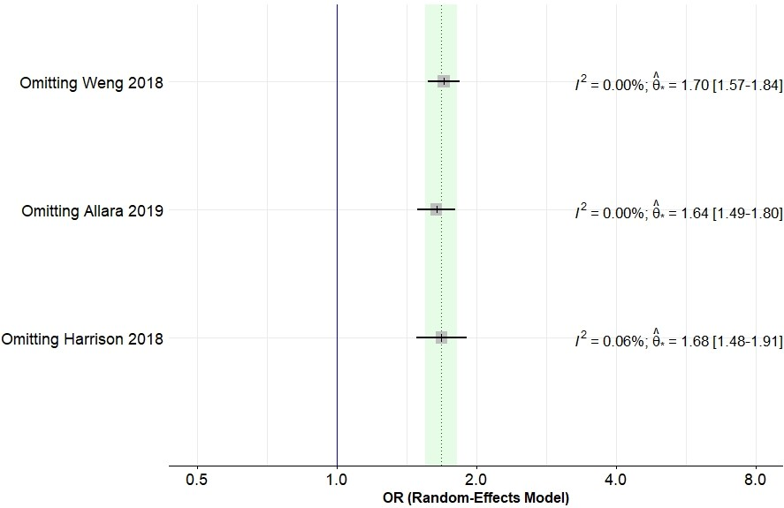
Supplementary figure 1: Leave-one-out sensitivity analysis focused on studies that reported LDL levels in AAA participants. Dotted vertical line represents the overall effect size prior to exclusion of any studies, and the green channel represents the 95% CI. Sensitivity analyses suggested the findings were not influenced by any single study.

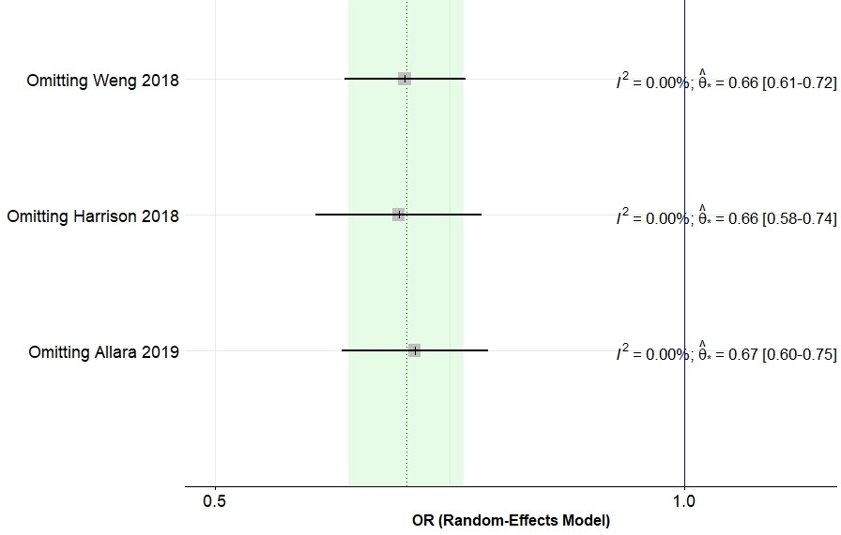
Supplementary figure 2: Leave-one-out sensitivity analysis focused on studies that reported HDL levels in AAA participants. Dotted vertical line represents the overall effect size prior to exclusion of any studies, and the green channel represents the 95% CI. Sensitivity analyses suggested the findings were not influenced by any single study.

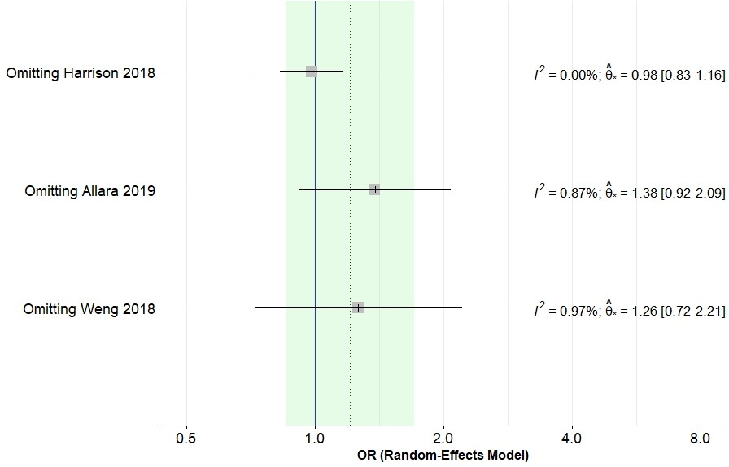
Supplementary figure 3: Leave-one-out sensitivity analysis focused on studies that reported triacyl glycerides levels in AAA participants. Dotted vertical line represents the overall effect size prior to exclusion of any studies, and the green channel represents the 95% CI. Sensitivity analyses suggested the findings were not influenced by any single study.

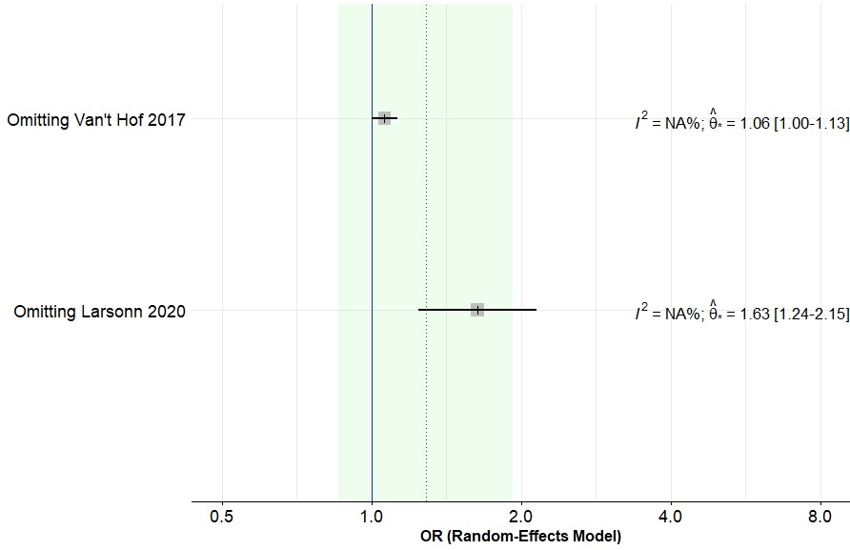
Supplementary figure 4: Leave-one-out sensitivity analysis focused on studies that reported body mass index levels in AAA participants. Dotted vertical line represents the overall effect size prior to exclusion of any studies, and the green channel represents the 95% CI. Sensitivity analyses suggested the findings were not influenced by any single study.

