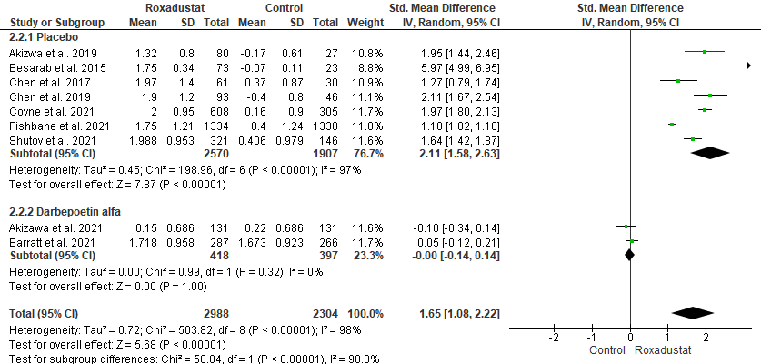
Figure S2 Forest plot of the effect of control arm type on hemoglobin level
CI: confidence interval; M-H: Mantel-Haenszel; df: degrees of freedom; I², I-squared.

