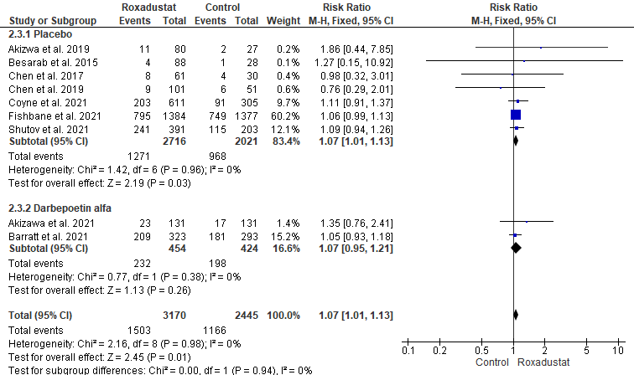
Figure S3 Forest plot of the effect of control arm type on serious adverse effects
CI: confidence interval; M-H: Mantel-Haenszel; df: degrees of freedom; I², I-squared.

