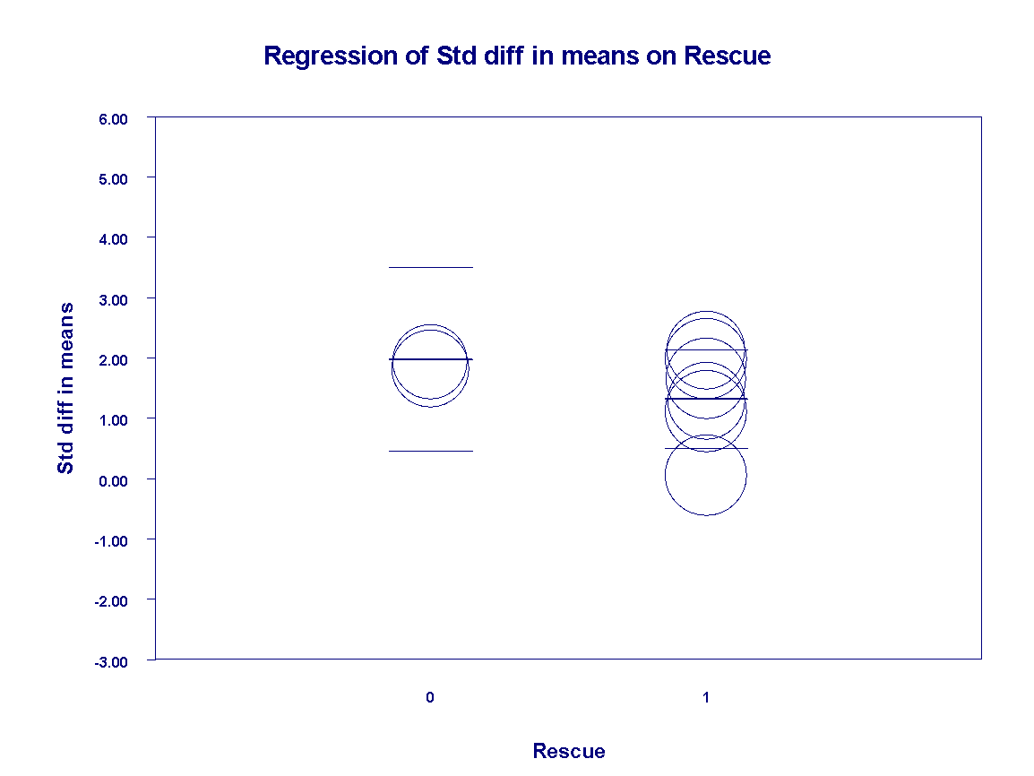
Figure S9 Regression of standardized difference in means on Rescue

