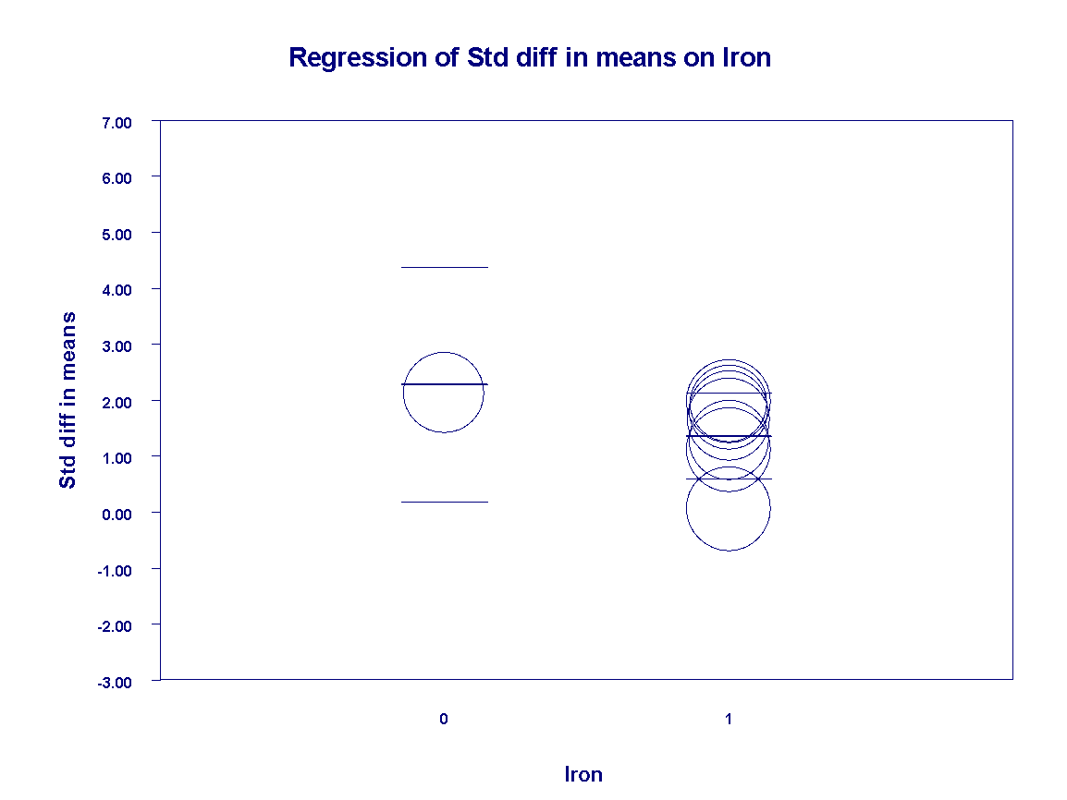
Figure S10 Regression of standardized difference in means on iron

