Supplementary file
Supplementary figure 1. Live birth rate between the stimulated and HRT cycles (without exclusion of study with publication bias).
Supplementary figure 2. Funnel plot for comparison of live birth rate (A) and ongoing pregnancy rate (B).
Supplementary figure 3. Subgroup analyses of different stages of embryo transferred for the outcome of live birth rate between the stimulated and HRT cycles.
Supplementary figure 4. Ongoing pregnancy rate between the stimulated and HRT cycles (without exclusion of study with publication bias).
Supplementary figure 5. Ongoing pregnancy rate between the stimulated and HRT cycles (exclusion of study with publication bias).
Supplementary figure 6. Clinical pregnancy rate between stimulated and HRT cycles.
Supplementary figure 7. Subgroup analyses for clinical pregnancy rate between different stimulation drugs and HRT cycles.
Supplementary figure 8. Subgroup analyses of different stages of embryo transferred for the outcome of miscarriage rate between the stimulated and HRT cycles.
Supplementary figure 9. Implantation rate between the stimulated and HRT cycles.
Supplementary figure 10. Subgroup analyses for implantation rate between different stimulation drugs and HRT cycles.
Supplementary figure 11. hCG-positive rate between the stimulated and HRT cycles.
Supplementary figure 12. Cycle cancelation rate between the stimulated and HRT cycles.
Supplementary figure 13. Ectopic pregnancy rate between the stimulated and HRT cycles.
Supplementary figure 14. Analysis of (A) preterm birth rate (per baby); (B) preeclampsia rate, (C) gestational hypertension rate, (D) gestational diabetes mellitus rate, (E) abnormal placentation rate (per women with live birth) between the stimulated and HRT cycles.
Supplementary figure 15. Mechanisms of the action of letrozole and gonadotropins in ovarian stimulation (Created with BioRender.com).

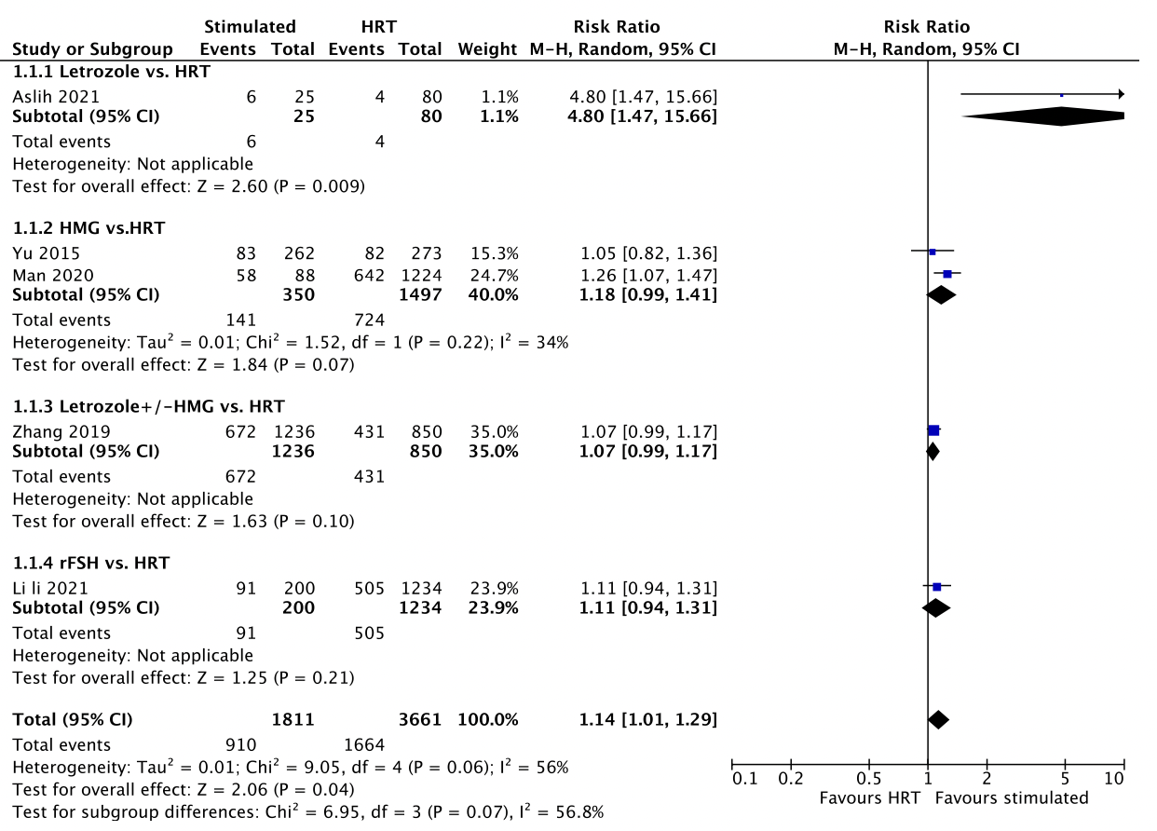Supplementary figure 1. Live birth rate between the stimulated and HRT cycles (without excluding study with publication bias).

Supplementary figure 2. Funnel plot for comparison of live birth rate (A) and ongoing pregnancy rate (B).
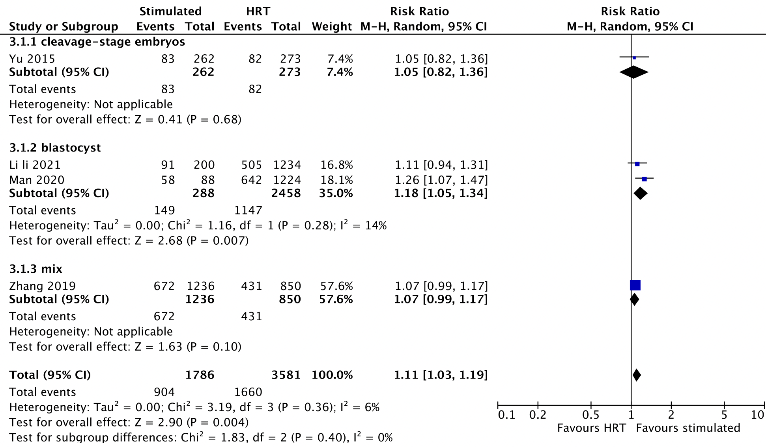
Supplementary figure 3. Subgroup analyses of different stages of embryo transferred for the outcome of live birth rate between the stimulated and HRT cycles.
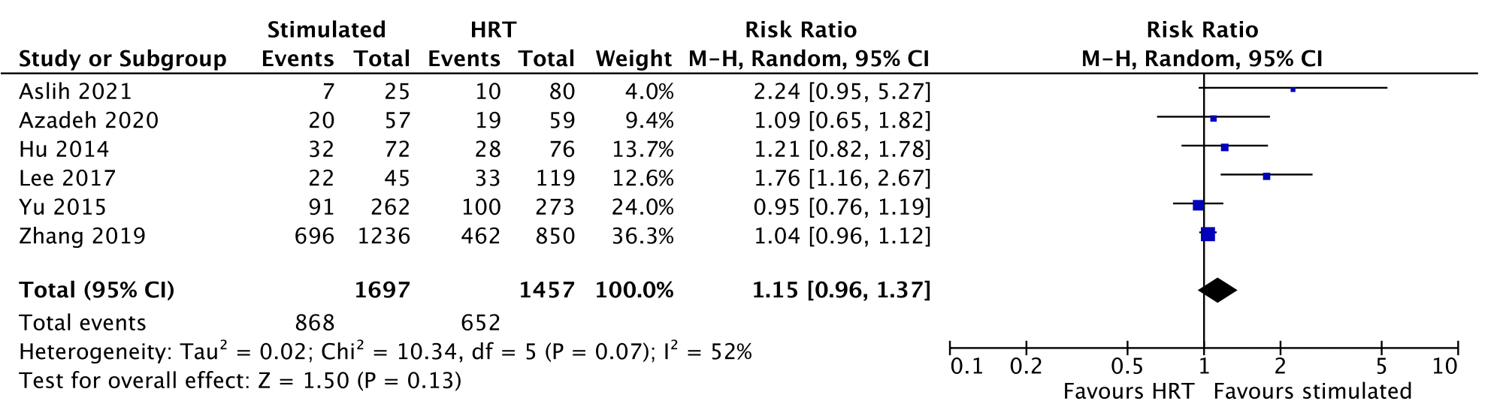
Supplementary figure 4. Ongoing pregnancy rate between the stimulated and HRT cycles (without exclusion of study with publication bias).
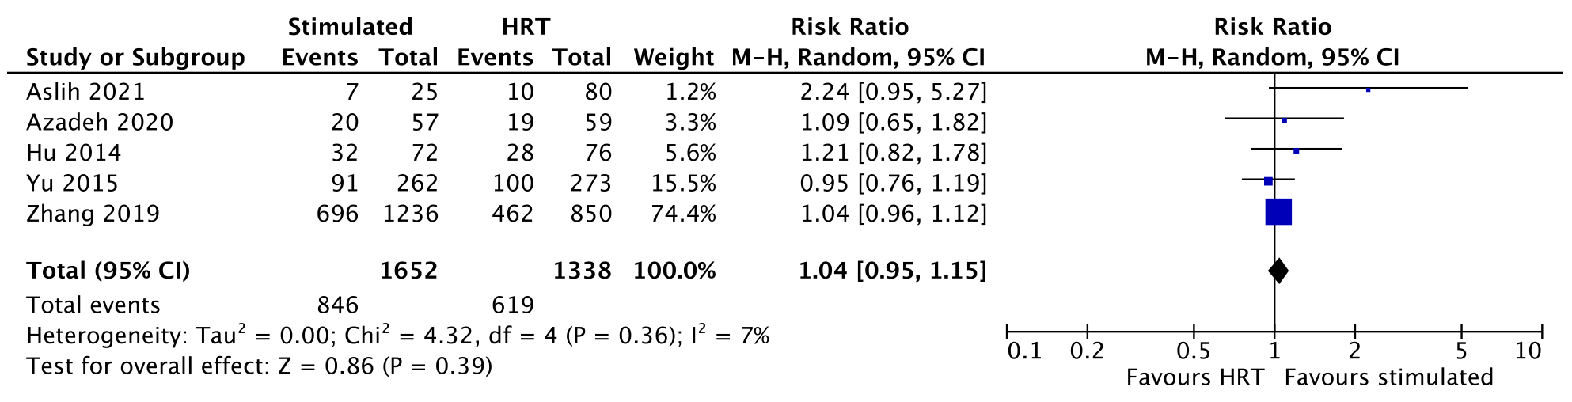
Supplementary figure 5. Ongoing pregnancy rate between the stimulated and HRT cycles (exclusion of study with publication bias).
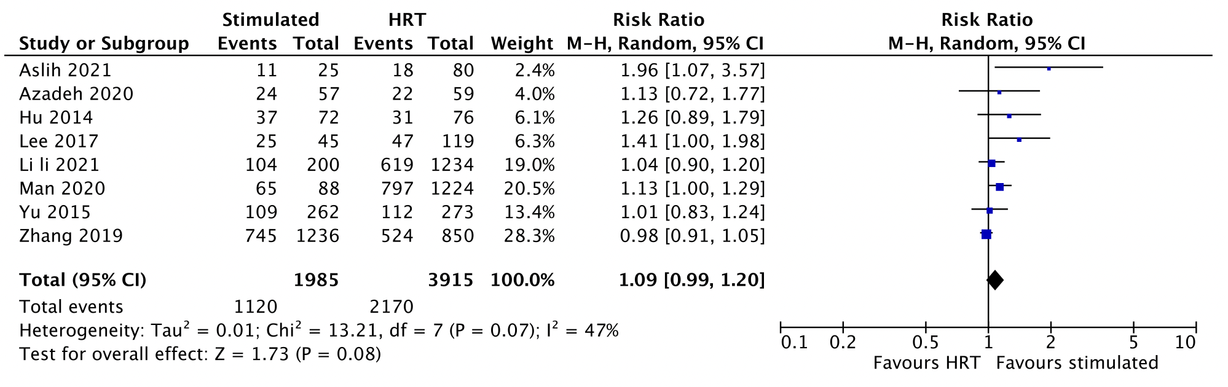Supplementary figure 6. Clinical pregnancy rate between the stimulated and HRT cycles.
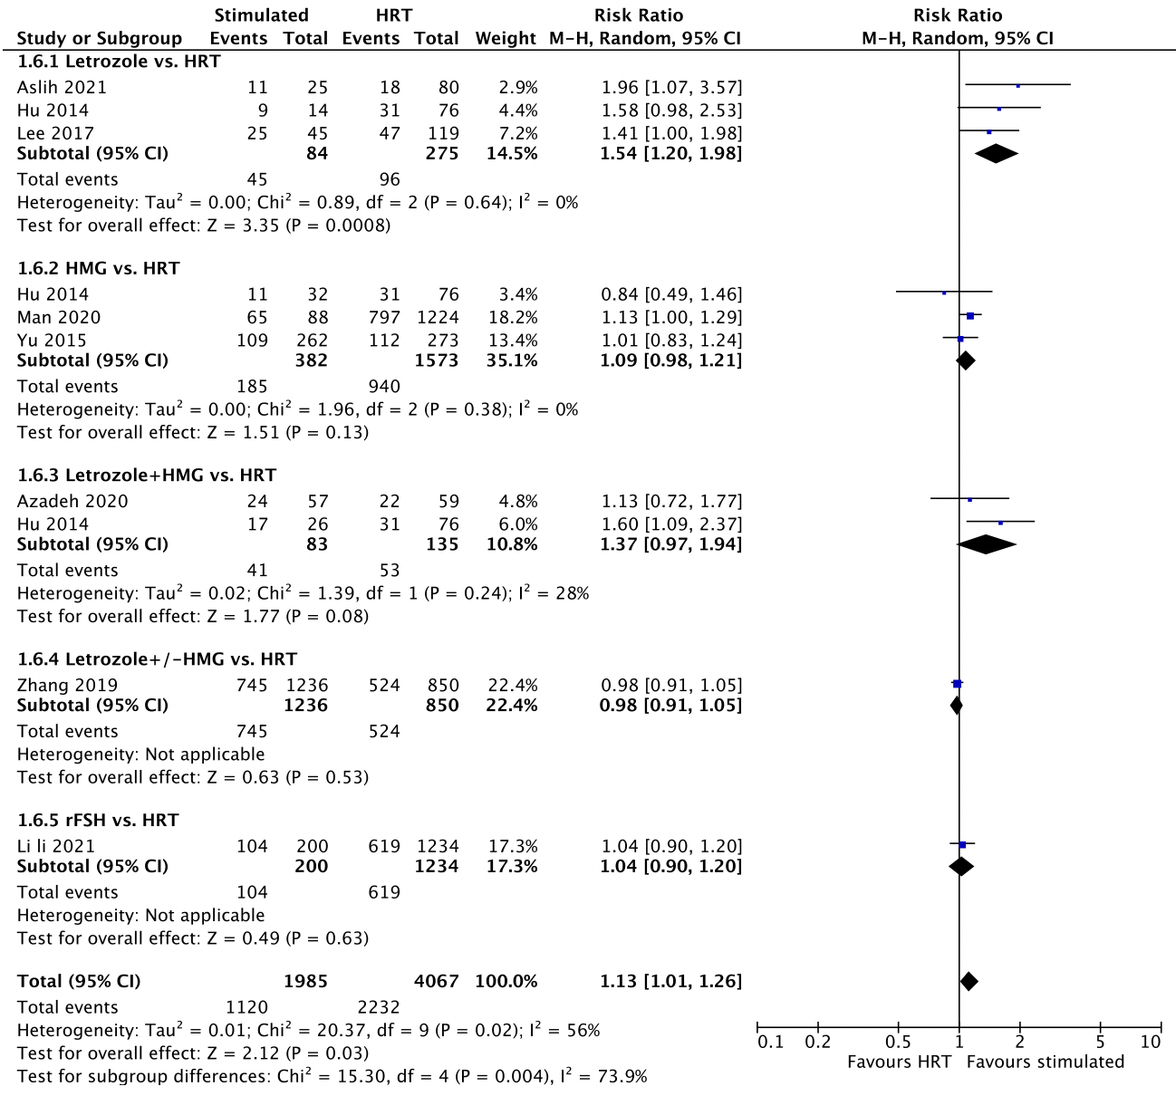
Supplementary figure 7. Subgroup analyses for clinical pregnancy rate between different stimulation drugs and HRT cycles.

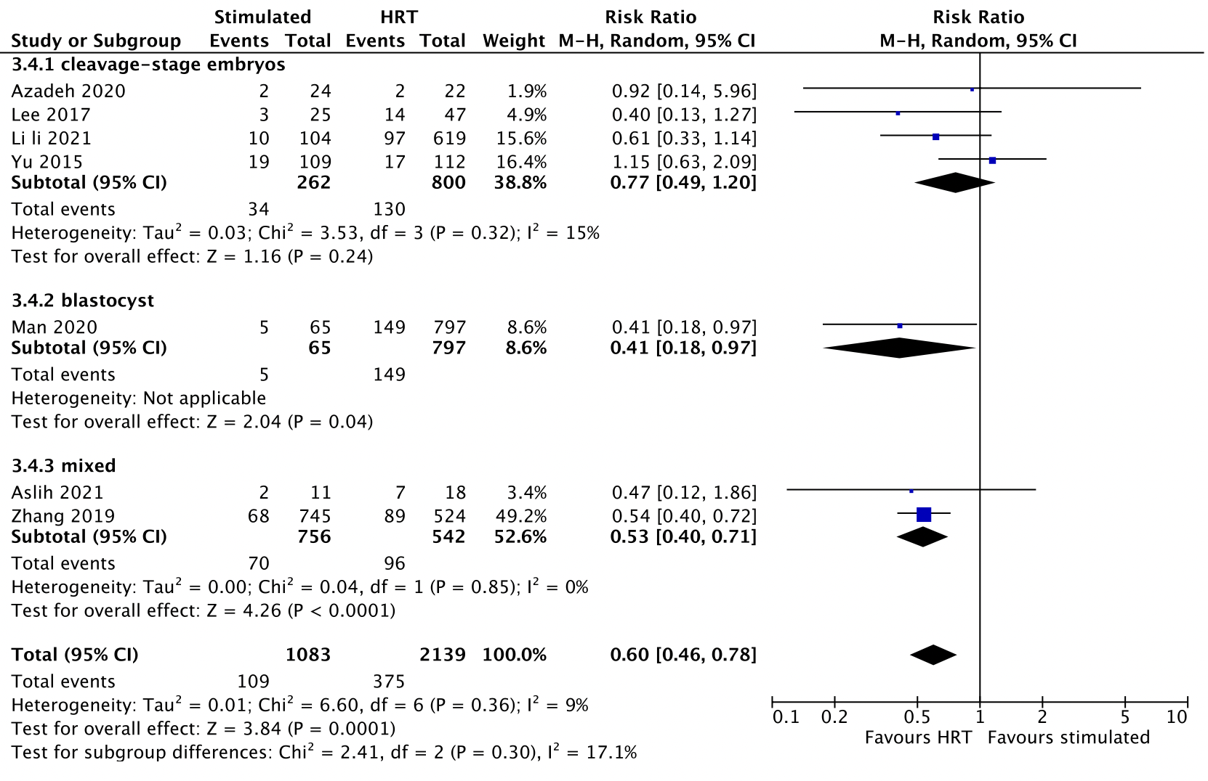
Supplementary figure 8. Subgroup analyses of different stages of embryo transferred for the outcome of miscarriage rate between the stimulated and HRT cycles.

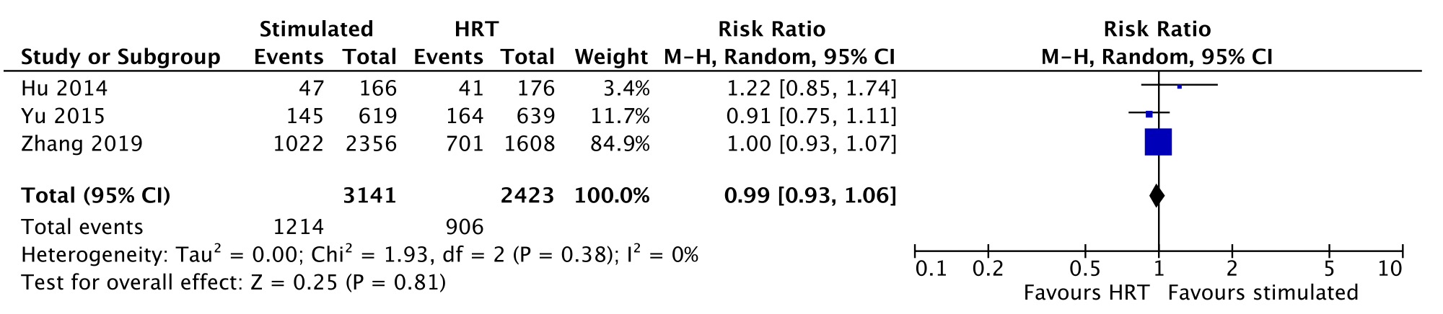Supplementary figure 9. Implantation rate between the stimulated and HRT cycles.
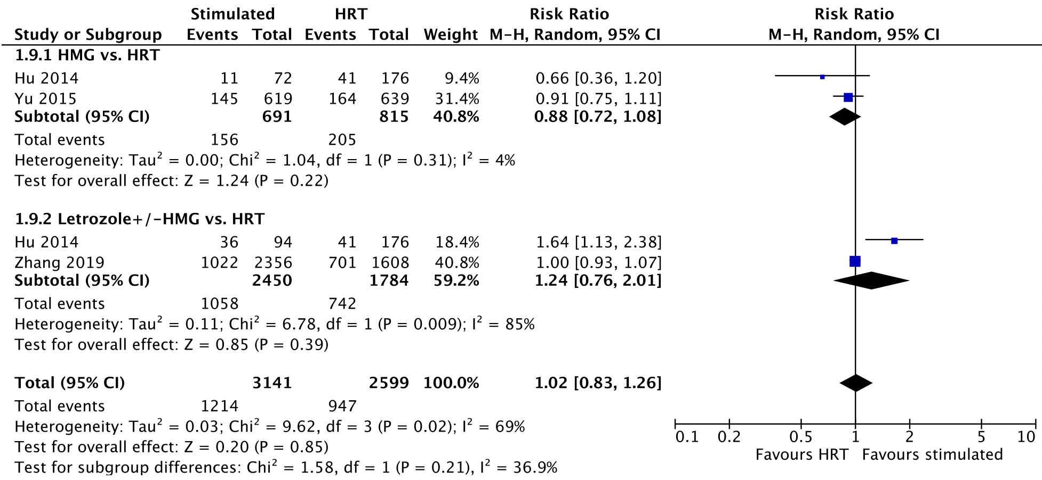
Supplementary figure 10. Subgroup analyses for implantation rate between different stimulation drugs and HRT cycles.

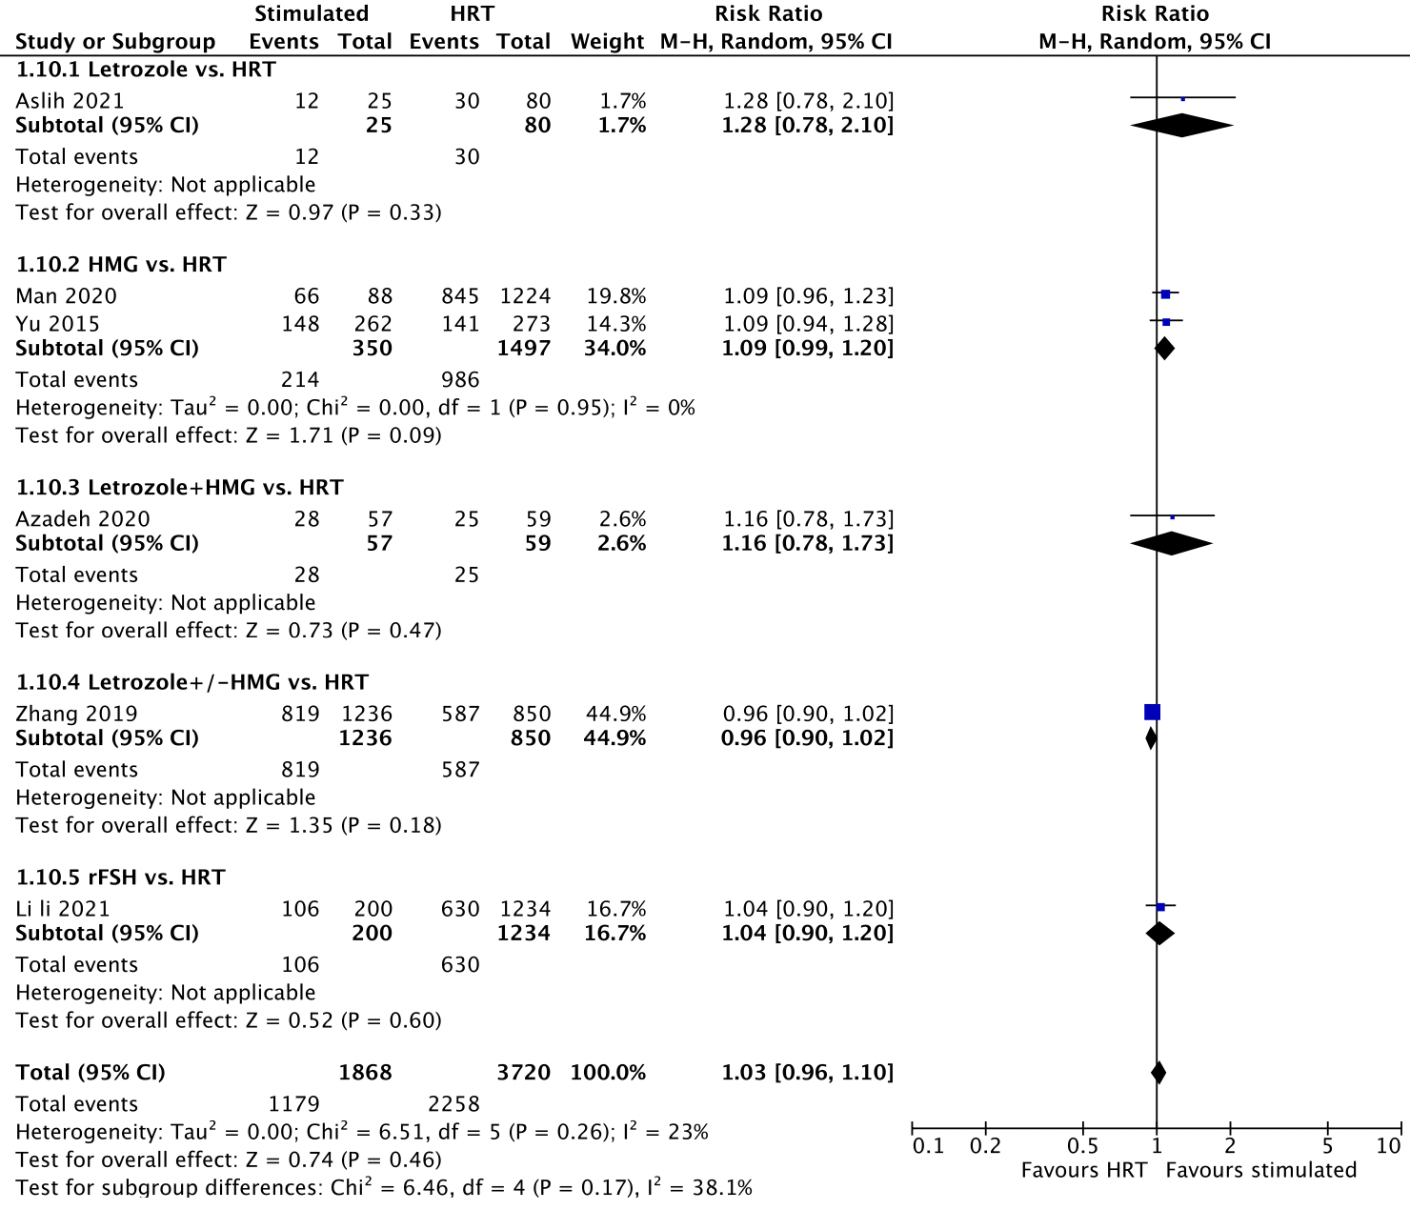Supplementary figure 11. hCG-positive rate between the stimulated and HRT cycles.
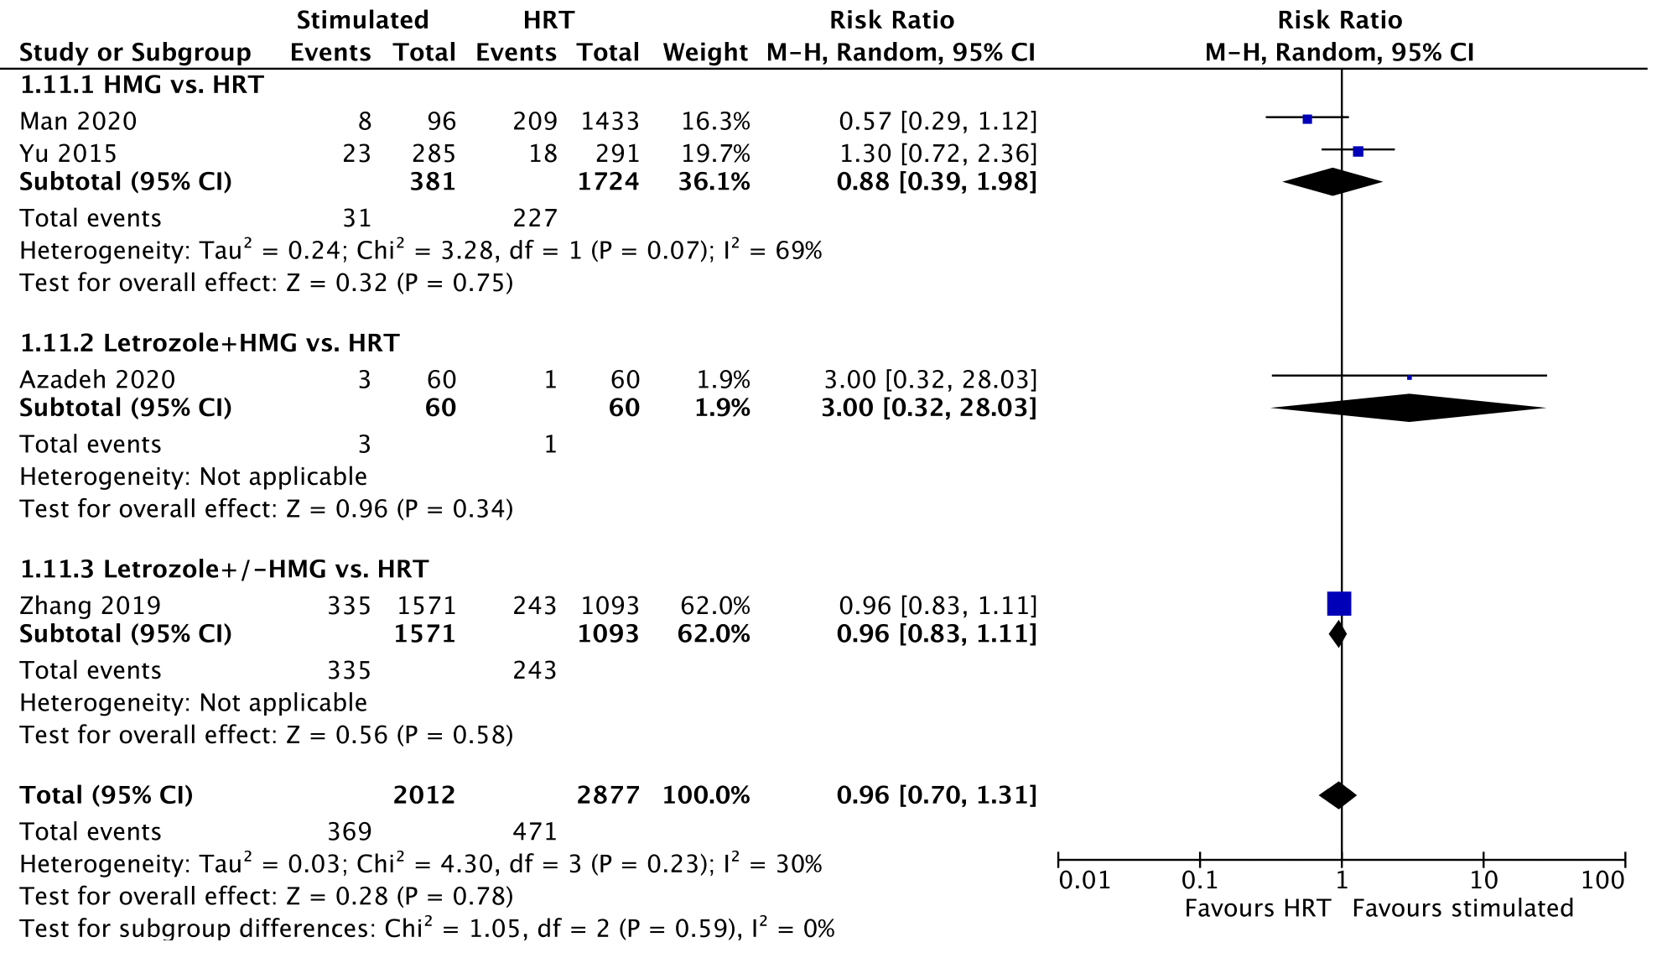
Supplementary figure 12. Cycle cancelation rate between the stimulated and HRT cycles.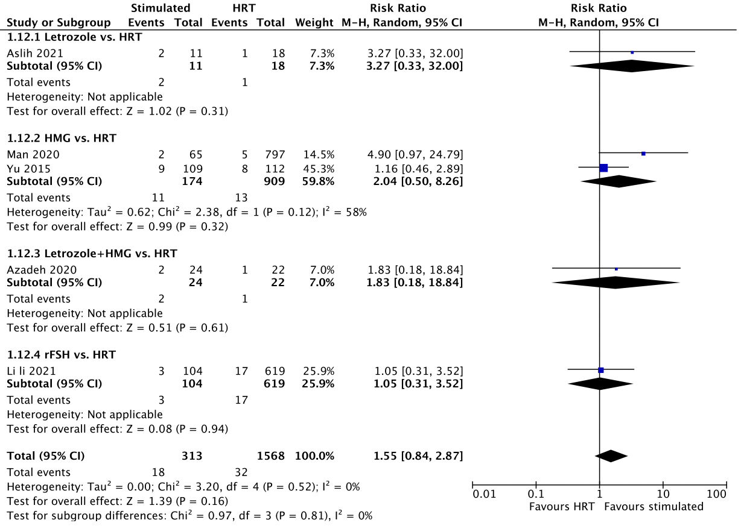Supplementary figure 13. Ectopic pregnancy rate between the stimulated and HRT cycles.
Supplementary Figure 14. Analysis of (A) preterm birth rate (per baby); (B) preeclampsia rate, (C) gestational hypertension rate, (D) gestational diabetes mellitus rate, (E) abnormal placentation rate (per women with live birth) between the stimulated and HRT cycles.

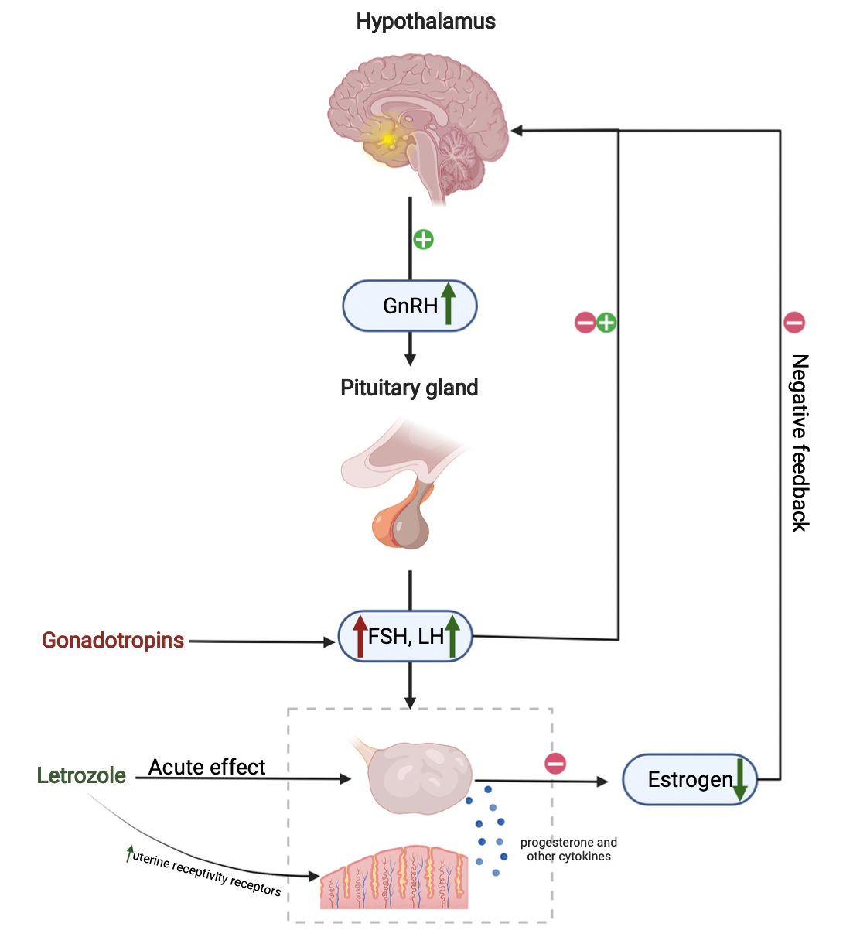
Supplementary figure 15. Mechanisms of the action of letrozole and gonadotropins in ovarian stimulation (Created with BioRender.com).

