Sacubitril/valsartan in real-life European patients with heart failure and reduced ejection fraction: a systematic review and meta-analysis

Giovinazzo S, Carmisciano L, Toma M, Benenati S, Tomasoni D, Sormani MP, Porto I, Canepa M, Senni M, Metra M, Ameri P.

Supplementary material

Corresponding author
Pietro Ameri, MD, PhD, FHFA
IRCCS Ospedale Policlinico San Martino – IRCCS Italian Cardiology Network
Department of Internal Medicine, University of Genova
Viale Benedetto XV, 6 – 16132 Genova, Italy
Phone: +390103538928; fax: +390105556513
Email: pietroameri@unige.it

Supplementary Table 1. PRISMA checklist.
Section/topic | # | Checklist item | Reported  on page #
TITLE
Title | 1 | Identify the report as a systematic review, meta-analysis, or both. | 1
ABSTRACT
Structured summary | 2 | Provide a structured summary including, as applicable: background; objectives; data sources; study eligibility criteria, participants, and interventions; study appraisal and synthesis methods; results; limitations; conclusions and implications of key findings; systematic review registration number. | 2
INTRODUCTION
Rationale | 3 | Describe the rationale for the review in the context of what is already known. | 3
Objectives | 4 | Provide an explicit statement of questions being addressed with reference to participants, interventions, comparisons, outcomes, and study design (PICOS). | 3
METHODS
Protocol and registration | 5 | Indicate if a review protocol exists, if and where it can be accessed (e.g., Web address), and, if available, provide registration information including registration number. | 4
Eligibility criteria | 6 | Specify study characteristics (e.g., PICOS, length of follow-up) and report characteristics (e.g., years considered, language, publication status) used as criteria for eligibility, giving rationale. | 4
Information sources | 7 | Describe all information sources (e.g., databases with dates of coverage, contact with study authors to identify additional studies) in the search and date last searched. | 4
Search | 8 | Present full electronic search strategy for at least one database, including any limits used, such that it could be repeated. | 4
Study selection | 9 | State the process for selecting studies (i.e., screening, eligibility, included in systematic review, and, if applicable, included in the meta-analysis). | 4
Data collection process | 10 | Describe method of data extraction from reports (e.g., piloted forms, independently, in duplicate) and any processes for obtaining and confirming data from investigators. | 4
Data items | 11 | List and define all variables for which data were sought (e.g., PICOS, funding sources) and any assumptions and simplifications made. | 4
Risk of bias in individual studies | 12 | Describe methods used for assessing risk of bias of individual studies (including specification of whether this was done at the study or outcome level), and how this information is to be used in any data synthesis. | 4
Summary measures | 13 | State the principal summary measures (e.g., risk ratio, difference in means). | 5
Synthesis of results | 14 | Describe the methods of handling data and combining results of studies, if done, including measures of consistency (e.g., I²) for each meta-analysis. | 5
Risk of bias across studies | 15 | Specify any assessment of risk of bias that may affect the cumulative evidence (e.g., publication bias, selective reporting within studies).
Additional analyses | 16 | Describe methods of additional analyses (e.g., sensitivity or subgroup analyses, meta-regression), if done, indicating which were pre-specified.
RESULTS
Study selection | 17 | Give numbers of studies screened, assessed for eligibility, and included in the review, with reasons for exclusions at each stage, ideally with a flow diagram. | 6
Study characteristics | 18 | For each study, present characteristics for which data were extracted (e.g., study size, PICOS, follow-up period) and provide the citations. | 6
Risk of bias within studies | 19 | Present data on risk of bias of each study and, if available, any outcome level assessment (see item 12).
Results of individual studies | 20 | For all outcomes considered (benefits or harms), present, for each study: (a) simple summary data for each intervention group (b) effect estimates and confidence intervals, ideally with a forest plot. | 6-7
Synthesis of results | 21 | Present results of each meta-analysis done, including confidence intervals and measures of consistency. | 6-7
Risk of bias across studies | 22 | Present results of any assessment of risk of bias across studies (see Item 15).
Additional analysis | 23 | Give results of additional analyses, if done (e.g., sensitivity or subgroup analyses, meta-regression [see Item 16]).
DISCUSSION
Summary of evidence | 24 | Summarize the main findings including the strength of evidence for each main outcome; consider their relevance to key groups (e.g., healthcare providers, users, and policy makers). | 7-11
Limitations | 25 | Discuss limitations at study and outcome level (e.g., risk of bias), and at review-level (e.g., incomplete retrieval of identified research, reporting bias). | 7-11
Conclusions | 26 | Provide a general interpretation of the results in the context of other evidence, and implications for future research. | 7-11
FUNDING
Funding | 27 | Describe sources of funding for the systematic review and other support (e.g., supply of data); role of funders for the systematic review.

Supplementary Table 2. Patient characteristics in the selected articles: demographic data and clinical presentation.
 | N. of pts | Age  (years) | Female sex | SBP  (mmHg) | HR  (bpm) | BMI (kg/m2) | NYHA III-IV | LVEF  (%) | Creatinine (mg/dL) | NT-proBNP (pg/mL)
Backelin 2020 | 95 | 65.4±12.2 | 11.1 | 116.6±18.7 | - | - | - | - | - | 2860,00
Correale 2020 | 60 | 66±9 | 12 | 123±20 | 70±14 | - | - | 34±9 | 1.16±0.42 | 3049,1±5775.1
Cosentino 2019 | 29 | 76±10 | 28 | 125±15 | 66±12 | - | 38 | 32±5 | 1.1±0.3 | 6538±2754
De Gregorio 2020 | 42 | 61.5±11 | 24 | - | - | - | 38 | - | - | -
De Vecchis 2017 | 44 | 76±5.5 | 29 | 115±26 | 90±19 | 28.2±6.87 | 2 | 38±6 | 1.46±0.55 | 800±123
Fu 2020 | 2037 | 67.9±11.3 | 19.8 | - | - | - | - | - | - | -
Ganesananthan 2020 | 80 | 64±12 | 27 | 122±18 | 71±11 | - | 26 | 26±7 | 1.1±0.31 | -
Kakuzna-Oleksy 2018 | 28 | 64±11 | 14.3 | 116±14 | 72±12 | - | 79 | 25,00 | 1.22±0.31 | 2900±1874
Lau 2019 | 201 | 67.7±10.7 | 18 | 122±18 | 69±13 | 27.6 | 32.2 | - | 1.27±0.4 | -
Lopez-Azor 2019 | 527 | 70  (62-78) | 26.9 | 120  (106-130) | 67  (60-75) | - | 35.5 | 30  (25-34) | 1.1  (0.9-1.4) | 2263  (1060-4764)
Mapelli 2020 | 201 | 67.2±20.9 | 20.9 | 117±12 | - | 26.1±4.1 | 35.3 | 30.1±6.9 | 1.27±0.41 | -
Marchitto 2019 | 11 | 77±8 | 18.2 | - | - | - | 100 | - | 1.58±0.72 | 1513±936
Martens 2019 | 401 | 68.4±11 | 22.9 | 124±19 | 69.5±13.2 | 27.4±10.4 | 38.6 | 30±8 | 1.3±0.4 | -
Moliner-Abos 2019 | 108 | 64±11 | 21 | 123±19 | - | - | 40 | 30±7 | 1.1±0.3 | 1164  (698-3678)
Parisi 2019 | 14 | 66±10.3 | 14.3 | 120±15 | 70.2±10.9 | 29.9±4.7 | - | 28.7±4.7 | 1.1±0.2 | -
Pharithi 2019 | 322 | 70  (61.9-76.2) | 24.9 | 123  (112-136) | 68  (60-76) | - | 11.3 | 28  (23.7-33) | 1.18  (0.94-1.43) | 1092  (514.5-2422.5)
Polito 2019 | 90 | 66.1±11.7 | 12.4 | 130  (120-140) | 70  (64-81) | 27.6 | 47.8 | 31  (27.2-37) | - | -
Spannella 2019 | 54 | 65.5±11.7 | 25.9 | 119±14.3 | 68  (60-80) | 27.1±4.9 | 63 | 29.7±4.9 | 1.28±0.34 | 1736  (1366-4323)
Vicent 2019 | 427 | 68.1±12.4 | 29.5 | 119±118 | 68±67 | - | 30.3 | 28.8±6.9 | - | 3,4±231
Vitale 2019 | 99 | 58.7±9.3 | 14 | 117±14 | 67±11 | 28.1±4.2 | 37 | 27±6 | - | 1200  (446-2120)
Wachter 2019 | 12082 | 71.3±12 | 46 | - | - | - | - | - | - | -

Data are presented as mean ± SD, median (interquartile range) or percentage.
SBP: systolic blood pressure; HR: heart rate; BMI: body mass index; NYHA: New York Heart Association; LVEF: left ventricular ejection fraction; NT-proBNP: N-terminal pro-brain natriuretic peptide.

Supplementary Table 3. Patient characteristics in the selected articles: comorbidities and treatments.
 | Ischemic etiology | Hyper-  tension | Diabetes | AF | Prior HF hospitalization | Prior ACEi | Prior ARB | Beta-blocker | MRA | Diuretic | Digoxin | ICD | CRT
Backelin 2020 | 28.4 | 32.6 | 27.4 | 47.4 | - | - | - | 100 | 100 | 58.9 | - | 35.7 | 23.1
Correale 2020 | 43 | 57 | 31 | - | - | 68 | 32 | 96 | 57 | 85 | 13 | - | -
Cosentino 2019 | 52 | 42 | 28 | 35 | - | 80 | 20 | 97 | 86 | 100 | 0 | - | -
De Gregorio 2020 | 67 | - | - | - | - | - | - | - | - | - | - | 52 | 7.1
De Vecchis 2017 | 45 | 57 | 23 | 50 | - | - | - | 100 | 100 | - | - | 9 | -
Fu 2020 | 52.9 | 54.1 | 27.6 | 44.3 | 38.8 | - | - | 98.9 | 90.9 | - | - | - | -
Ganesananthan 2020 | 48 | 33 | 21 | 35 | - | 76 | 24 | 95 | 91 | 53 | 21 | 44 | 39
Kakuzna-Oleksy 2018 | 64.3 | - | - | 21 | - | 67.9 | 21.4 | 96 | 100 | - | - | 46 | 21
Lau 2019 | 61 | 67 | 25 | 42 | - | - | - | 96 | 84 | 51 | - | 58 | 54
Lopez-Azor 2019 | 55.3 | 75.1 | 42.3 | - | 23.9 | 67.6 | 27.4 | 91 | 63.5 | - | - | 49.4 | 22.7
Mapelli 2020 | 54.2 | 45.3 | 21.9 | 36.8 | 22.4 | 68.2 | 23.9 | 95.5 | 76.6 | 87.6 | 6 | 41.8 | 28.4
Marchitto 2019 | - | 100 | 36.3 | - | - | - | - | - | - | - | - | - | -
Martens 2019 | 61.1 | 55.1 | 27.8 | 39 | - | - | - | 93.7 | 80.6 | 46.1 | - | 51 | 45.5
Moliner-Abos 2019 | - | - | - | 39 | 40 | - | - | 97 | 93 | - | - | 54 | 19
Parisi 2019 | 71.4 | 42.9 | 35.7 | - | - | - | - | - | - | - | - | - | -
Pharithi 2019 | 41.9 | 30.7 | 17.4 | 43.2 | - | 81.1 | 18.9 | 90.7 | 72.5 | 82.5 | - | 32.6 | 5.6
Polito 2019 | 63.3 | 91.1 | 32.2 | 33.3 | - | - | - | 92.2 | 51.1 | 93.3 | 10 | 34.4 | 37.8
Spannella 2019 | 59.3 | 72.2 | 20.4 | 44.4 | - | 55.6 | 44.4 | 90.7 | 74.1 | 90.7 | 25.9 | - | -
Vicent 2019 | 52.8 | 74.1 | 39.8 | - | - | 69.4 | 26.4 | 91.5 | 61.4 | - | - | 54.3 | 25.9
Vitale 2019 | 51 | 51 | 34 | 17 | - | 63 | 25 | 94 | 88 | 89 | 7 | 77 | 22
Wachter 2019 | - | - | 34.8 | - | - | 56.1 | 37 | 90 | 64 | 86.4 | - | - | -

Data are presented as percentage.
AF: atrial fibrillation; HF, heart failure; ACEi: angiotensin-converting enzyme inhibitor; ARB: angiotensin receptor blocker; MRA: mineralocorticoid receptor antagonist; ICD: implantable cardioverter defibrillator; CRT: cardiac resynchronization therapy.

Supplementary Table 4. Missing data and knowledge contribution in the articles describing the use of sacubitril-valsartan in European clinical practice according to the source of funding.
Sponsor | N. (%)  of studies | N (%)  of patients | Missing variables  (%) * | KC  (%) **
Novartis | 8 (38) | 14,497 (85.5) | 47.4 | 89.4
Others | 4 (19) | 1,137 (6.7) | 35.4 | 5.3
None | 9 (43) | 1,318 (7.8) | 31.0 | 5.2

* Proportion of missing variables among those describing the PARADIGM-HF population.
** Sum of the KC of all articles with the same source of funding.
KC: knowledge contribution.

Supplementary Figure 1. PRISMA flow diagram.
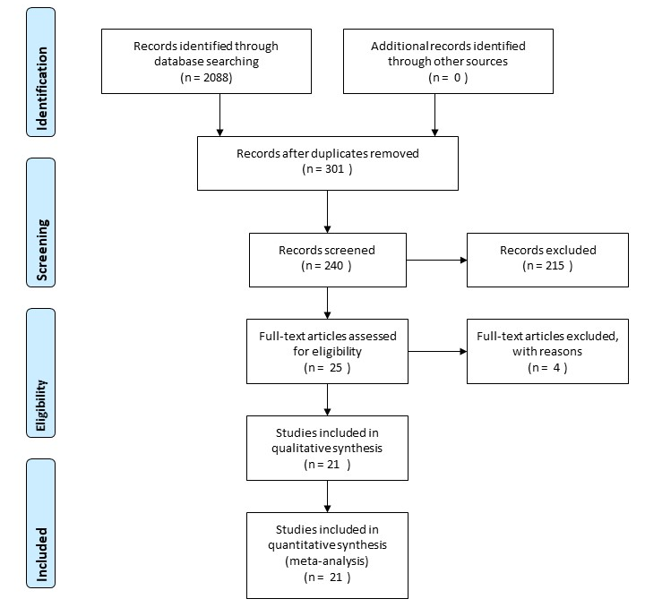
Supplementary Figure 2. Risk of bias in the selected articles.
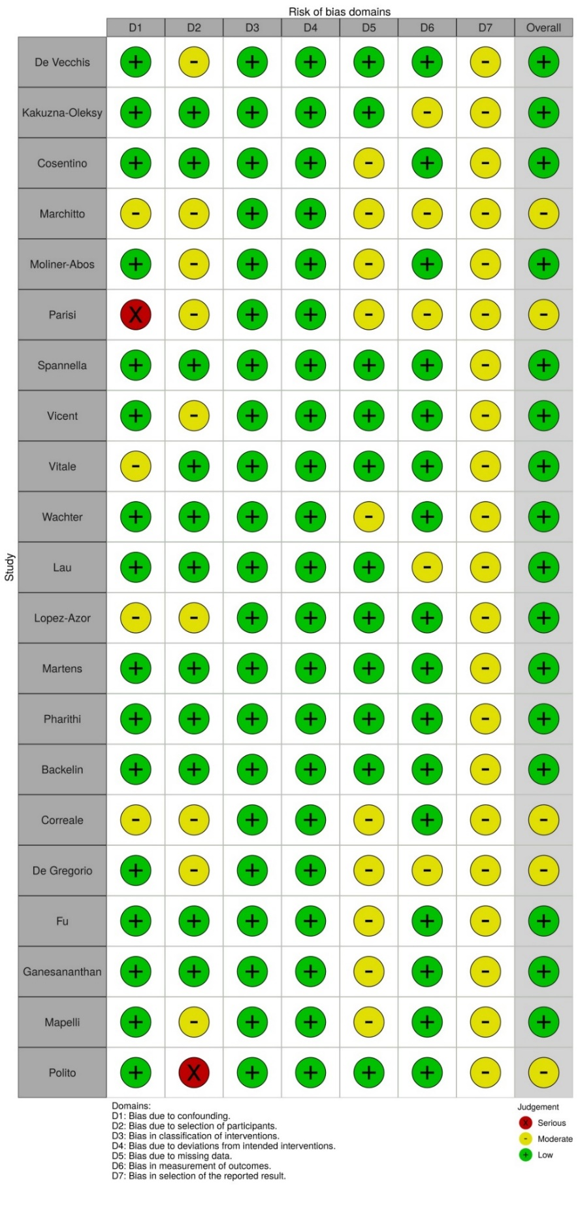
Supplementary Figure 3. Mean age in the selected articles as compared with the PARADIGM-HF cohort.
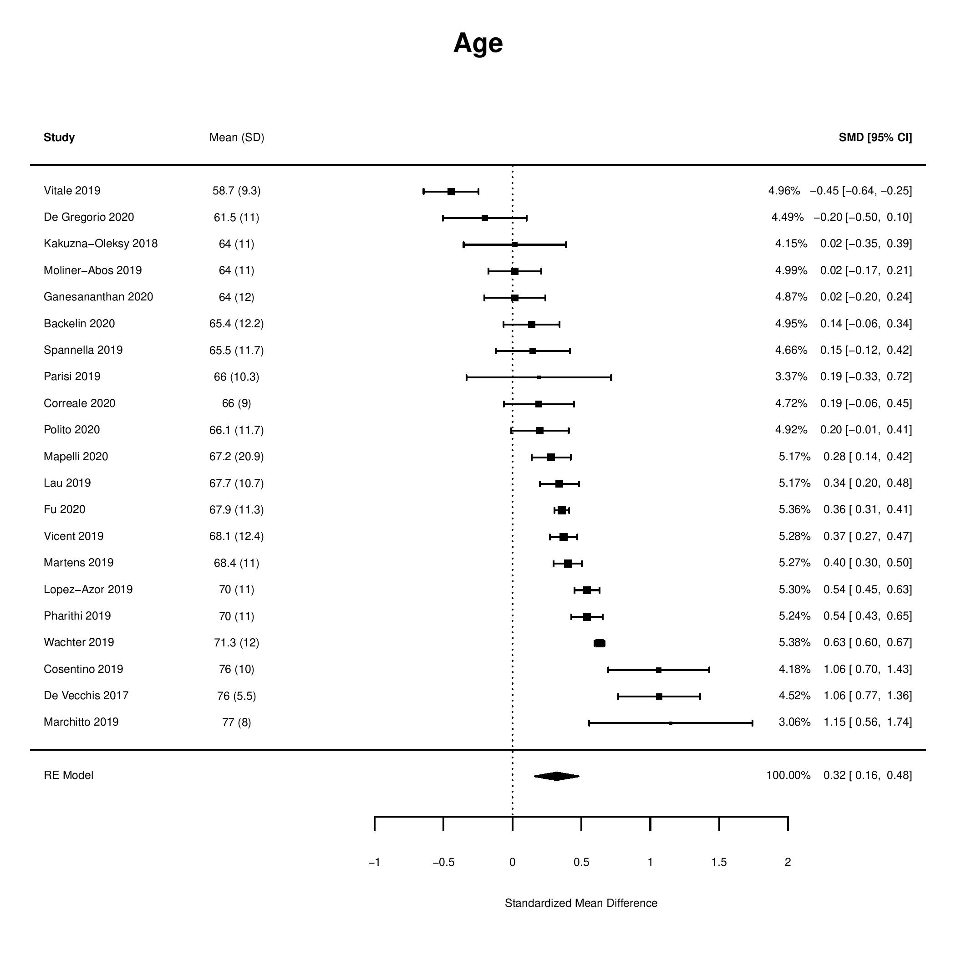

Supplementary Figure 4. Frequency of ischemic etiology in the selected articles as compared with the PARADIGM-HF cohort.
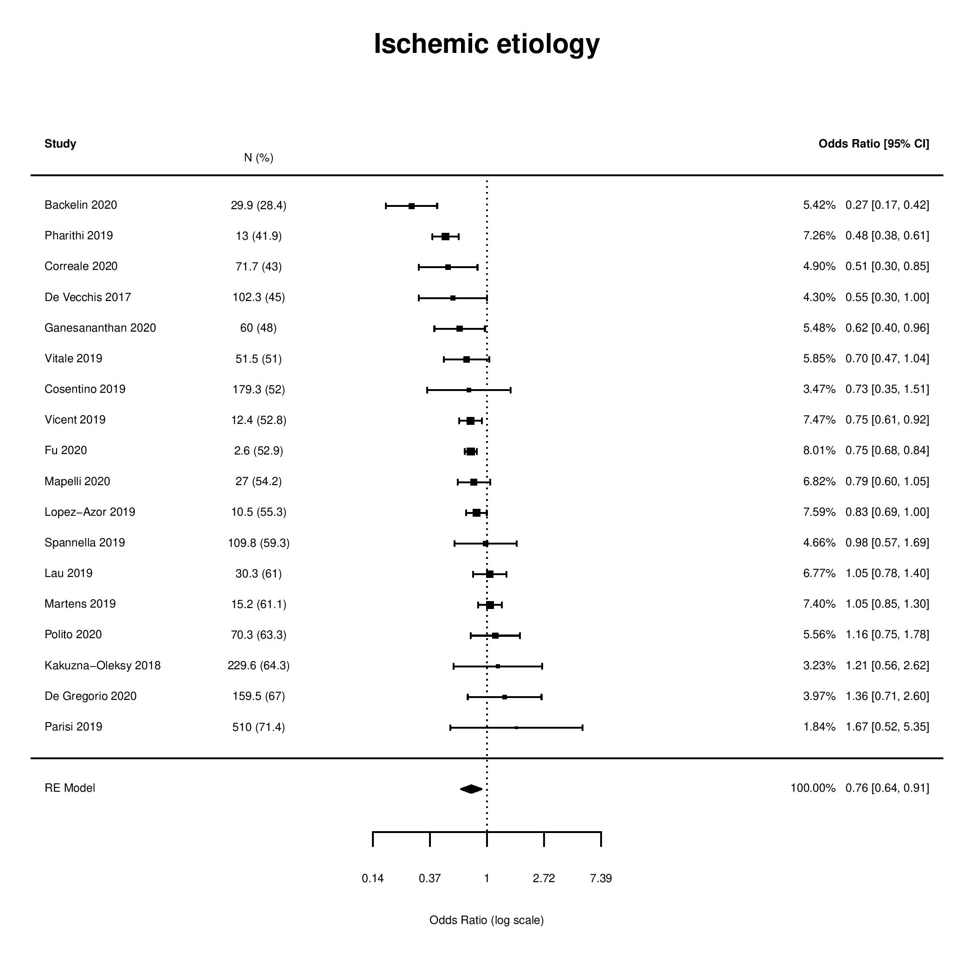
Supplementary Figure 5. Frequency of hypertension in the selected articles as compared with the PARADIGM-HF cohort.
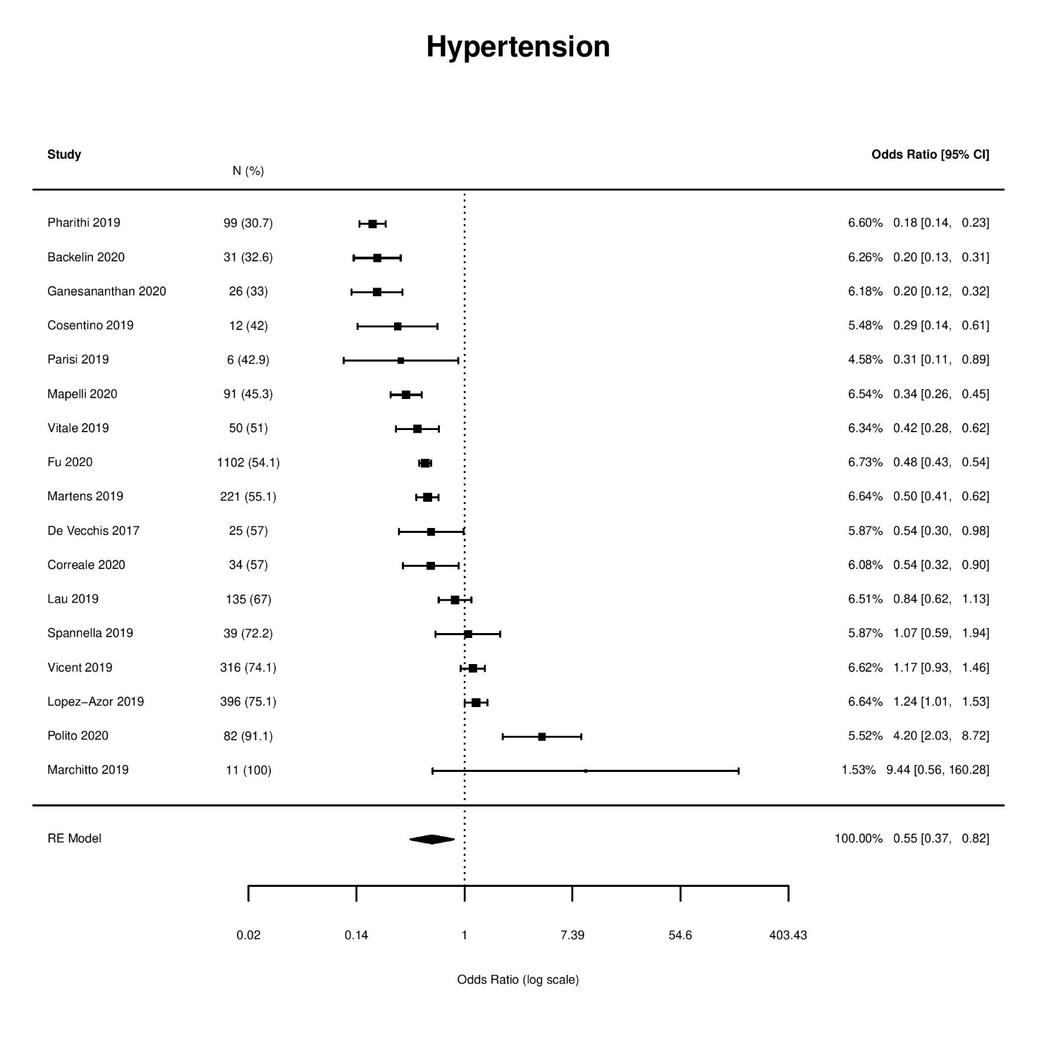
Supplementary Figure 6. Frequency of diabetes in the selected articles as compared with the PARADIGM-HF cohort.
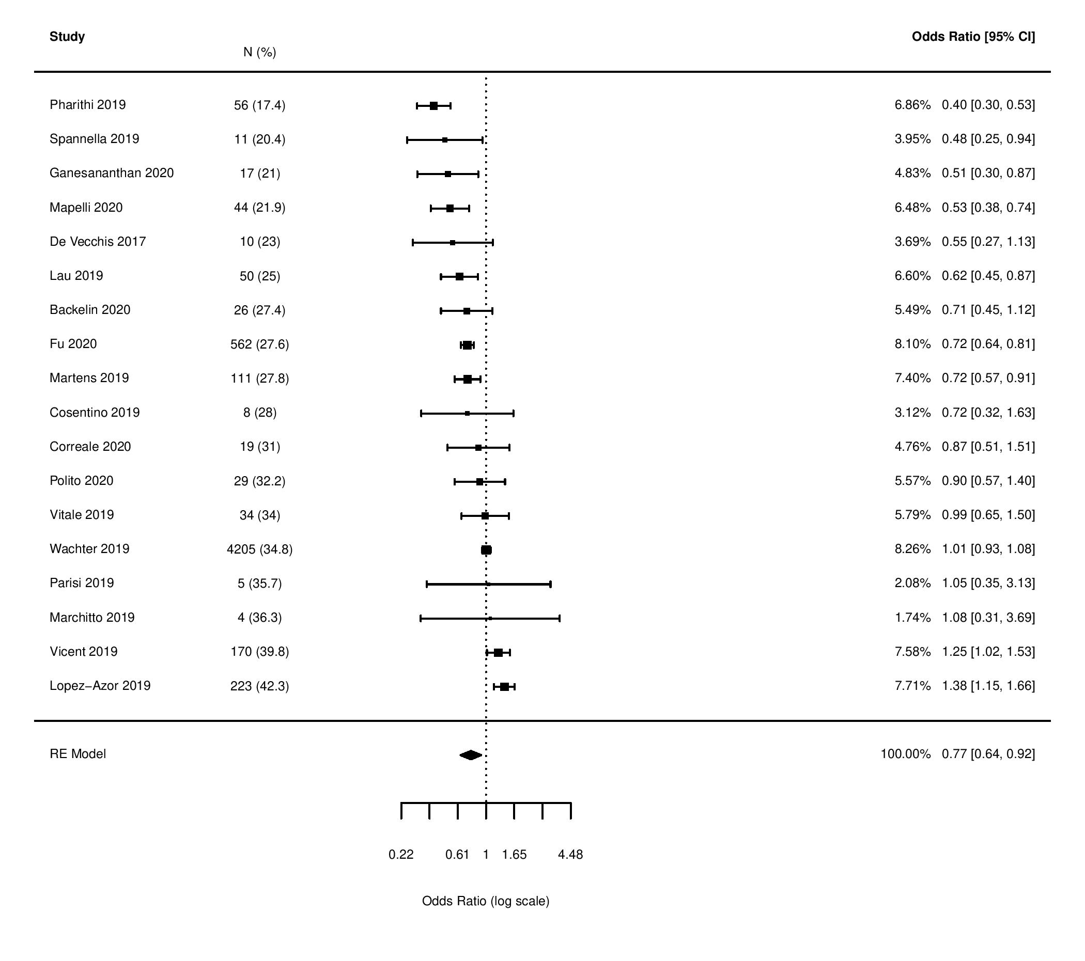
Supplementary Figure 7. Frequency of MRA use in the selected articles as compared with the PARADIGM-HF cohort.
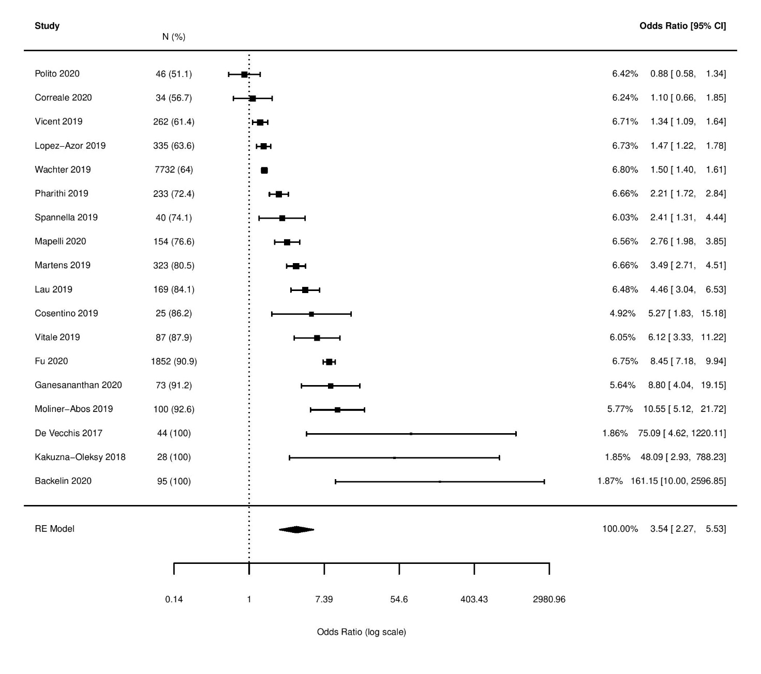
Supplementary Figure 8. Frequency of NYHA class I-II vs. III-IV in the selected articles as compared with the PARADIGM-HF cohort.
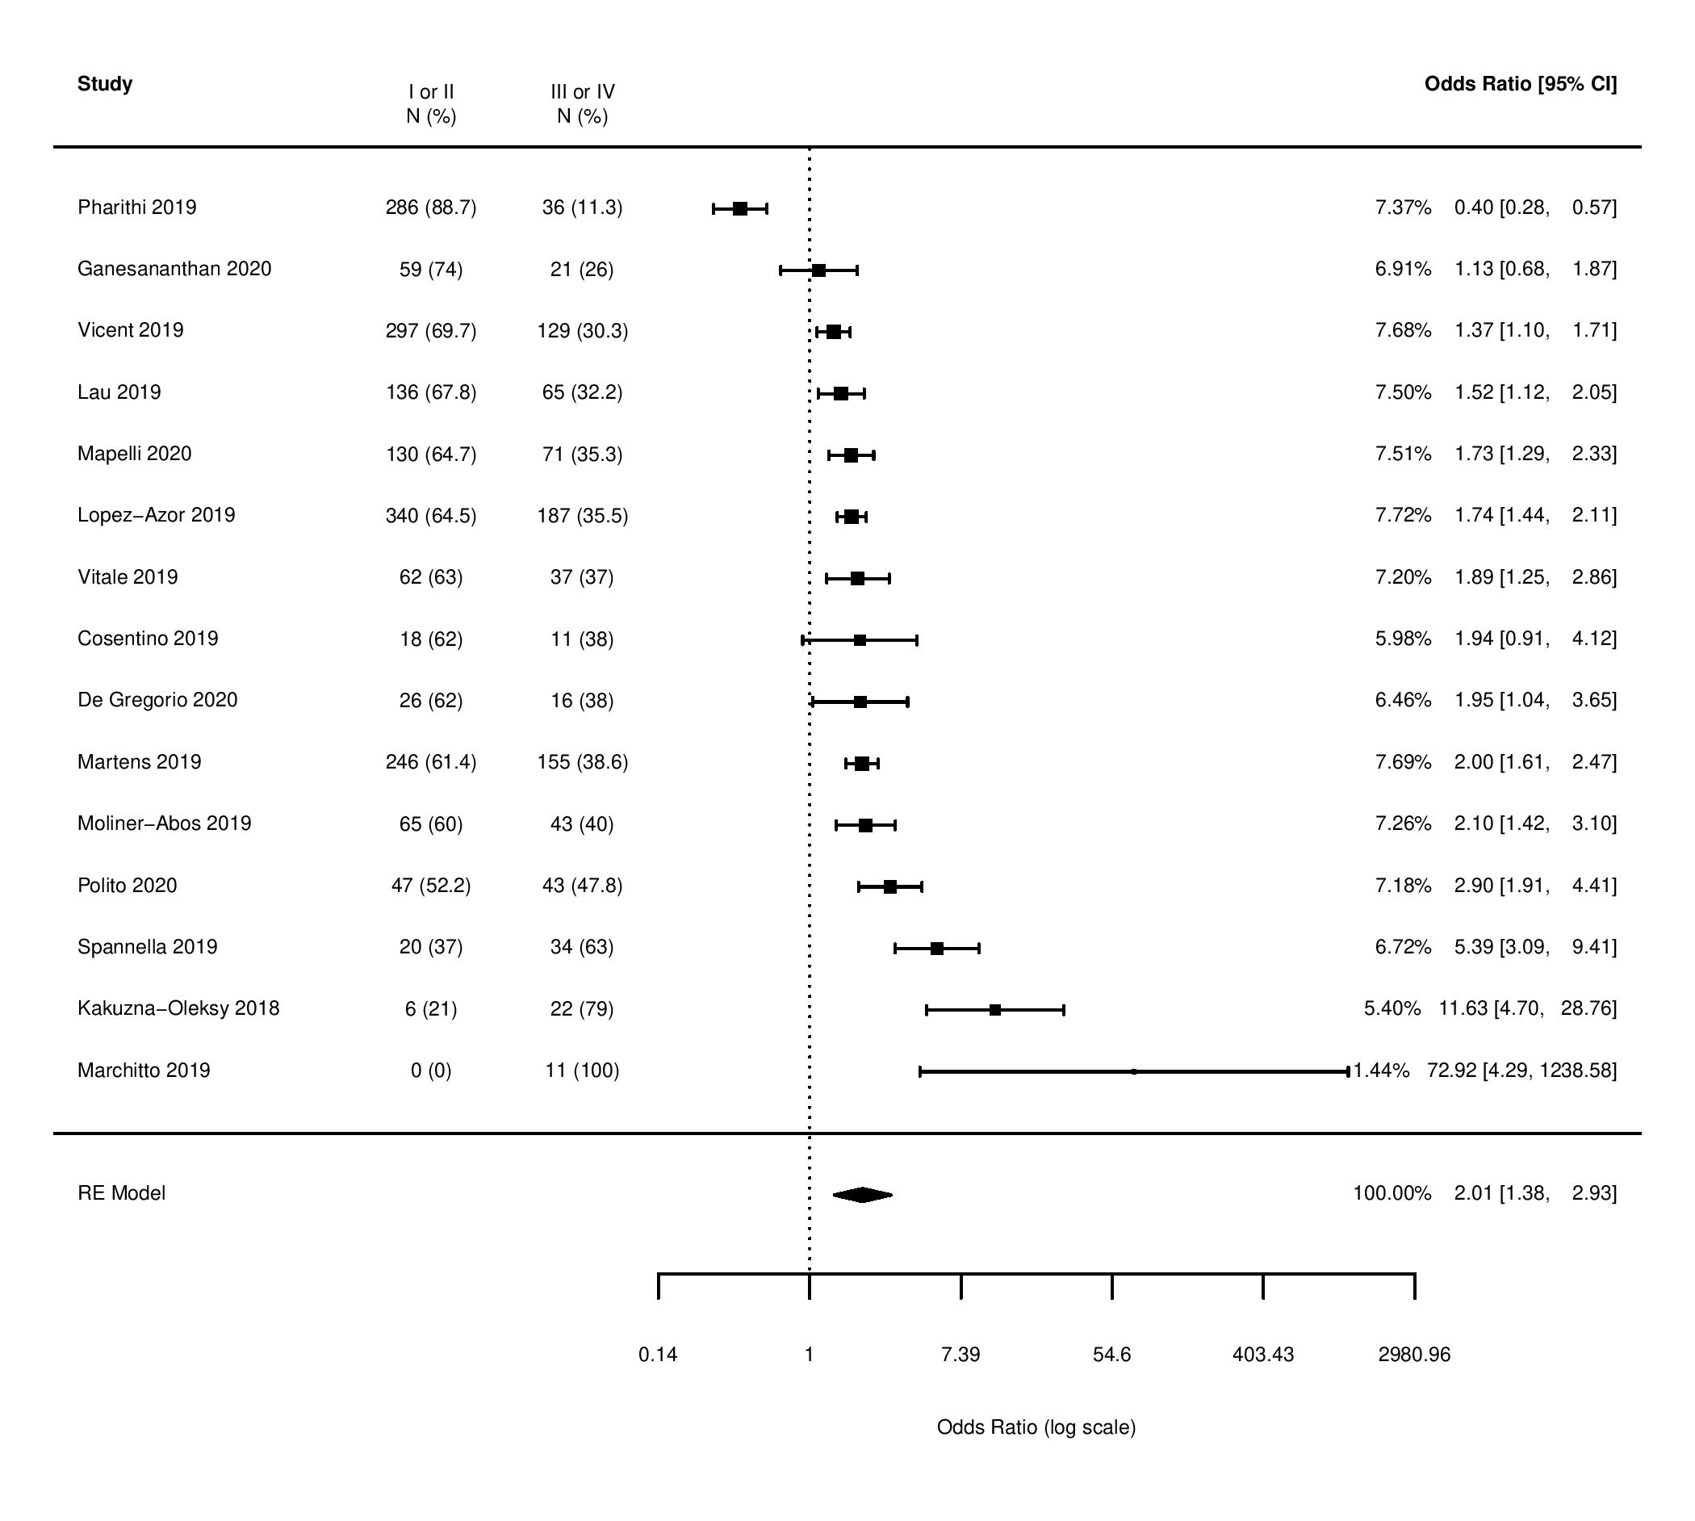
Supplementary Figure 9. Frequency of prior HF hospitalization in the selected articles as compared with the PARADIGM-HF cohort.
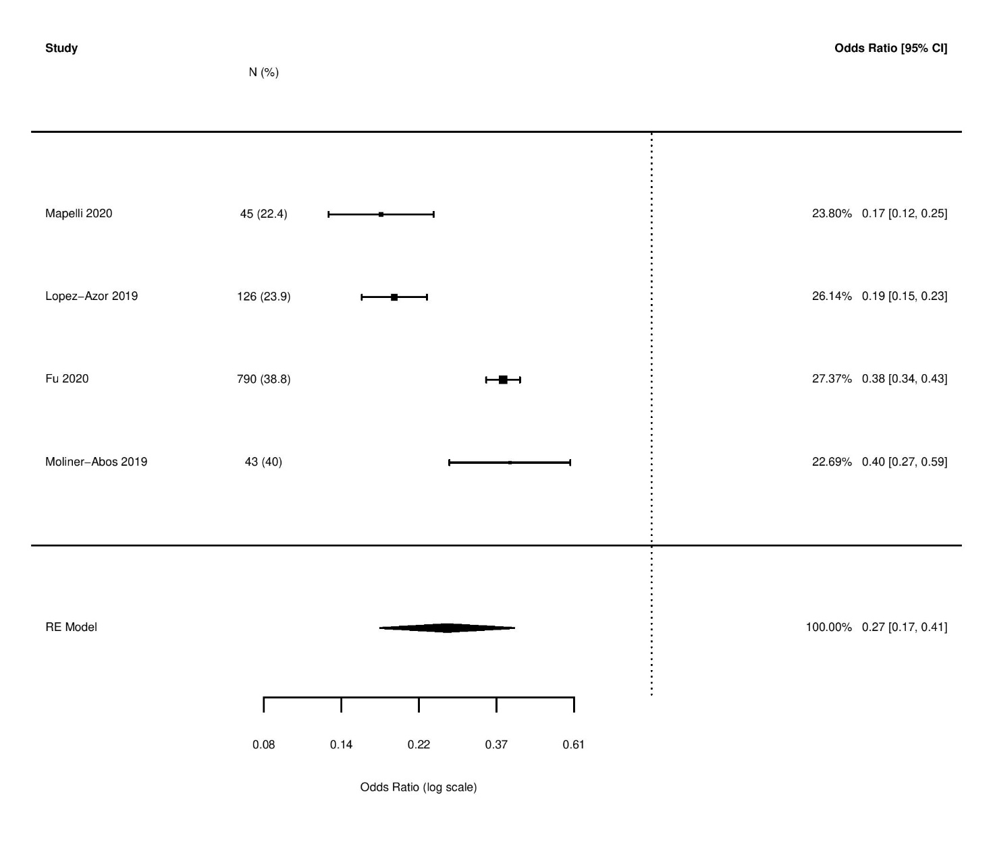
Supplementary Figure 10. Mean serum creatinine concentration in the selected articles as compared with the PARADIGM-HF cohort.
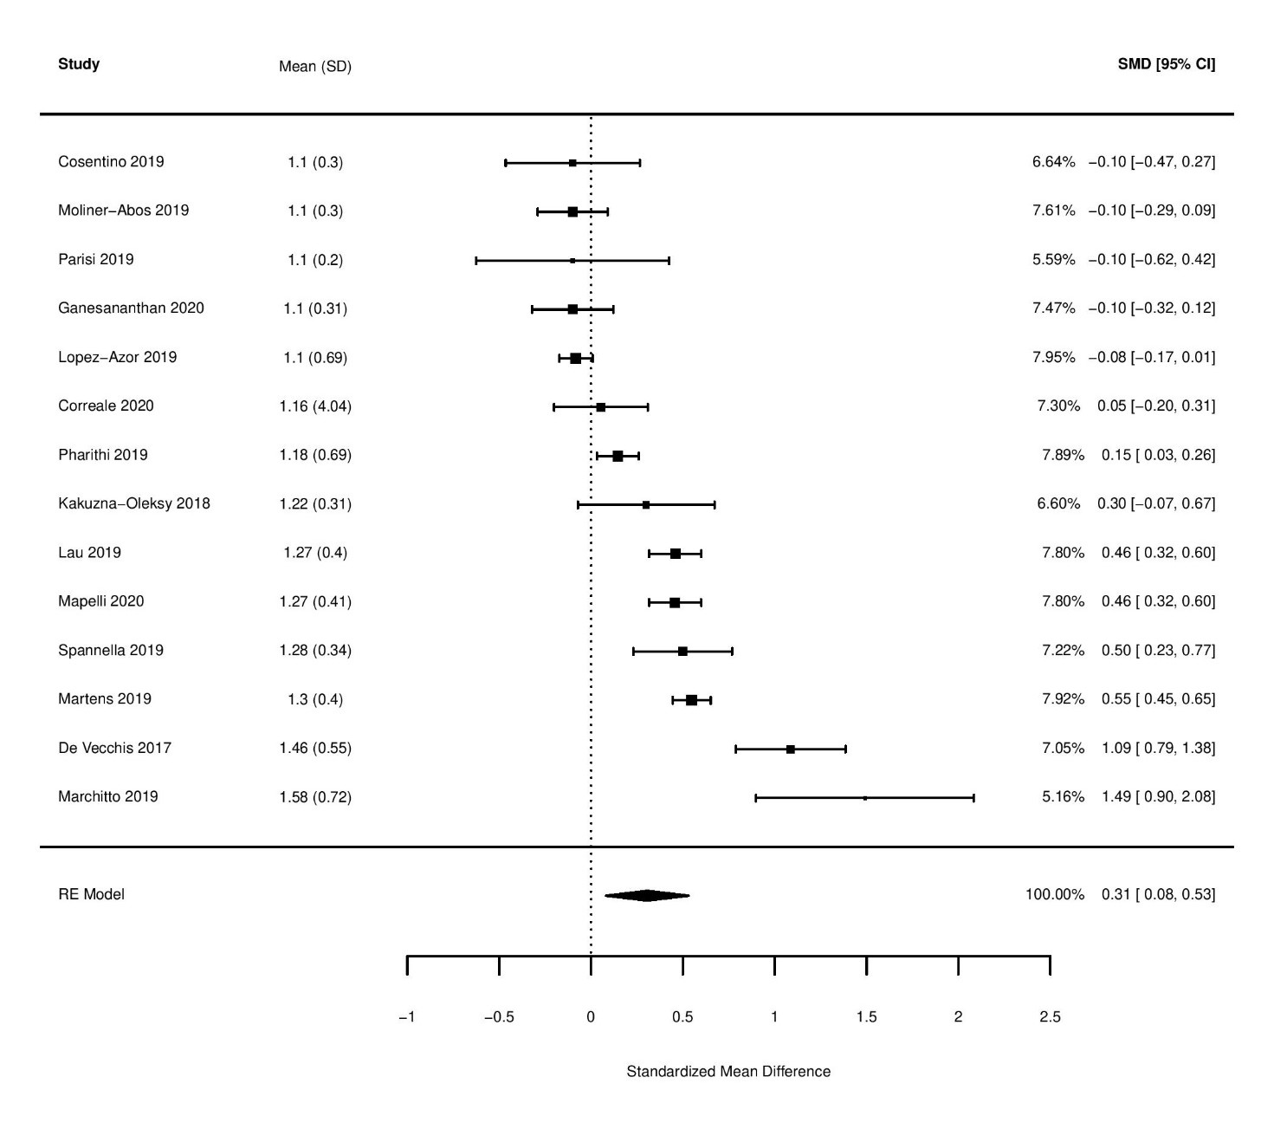
Supplementary Figure 11. Mean NT-proBNP concentration in the selected articles as compared with the PARADIGM-HF cohort.
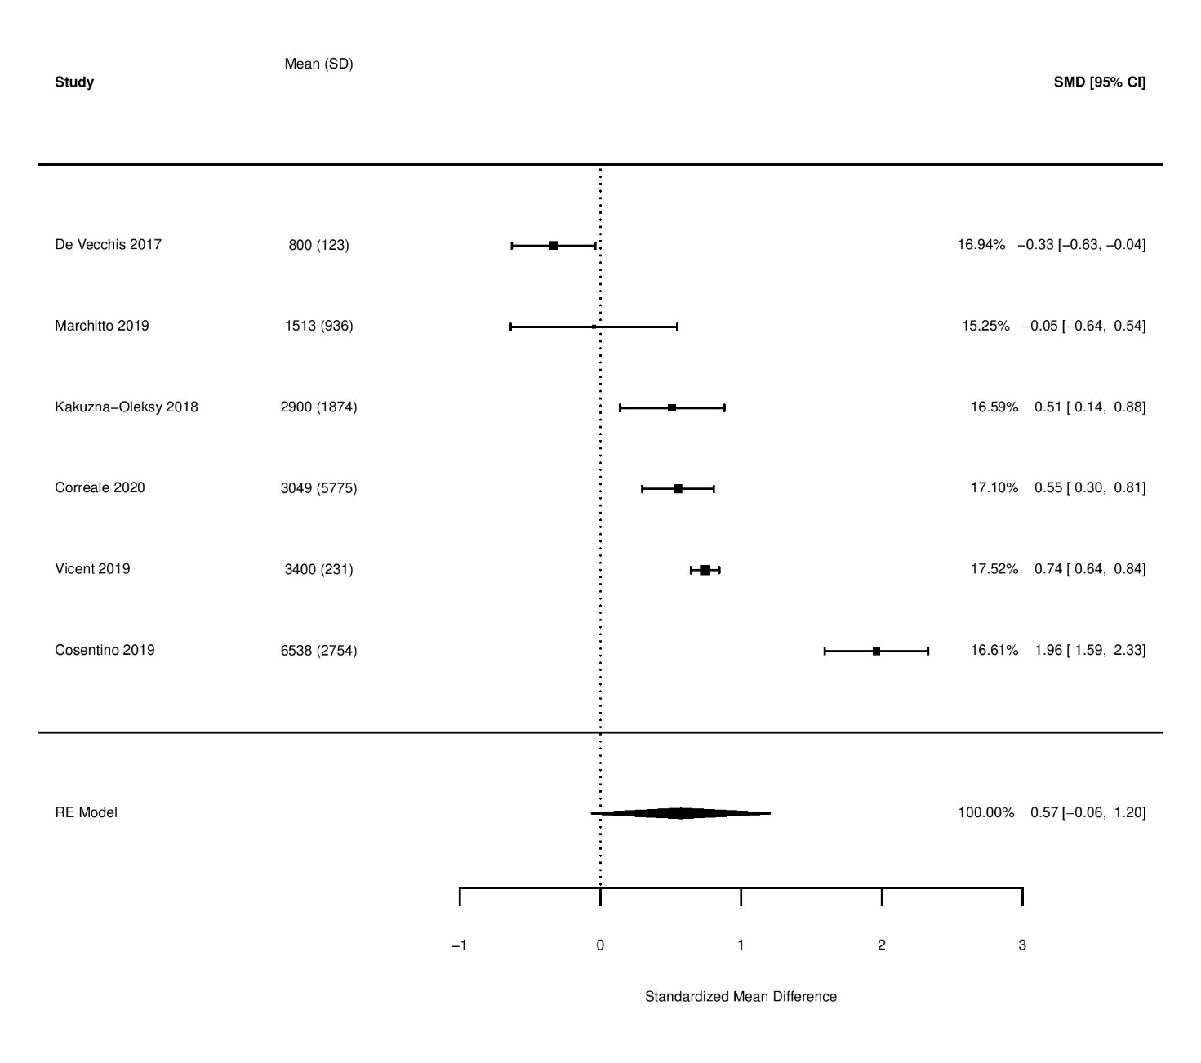
Supplementary Figure 12. Prior use of ACEi or ARB in the selected articles as compared with the PARADIGM-HF cohort.
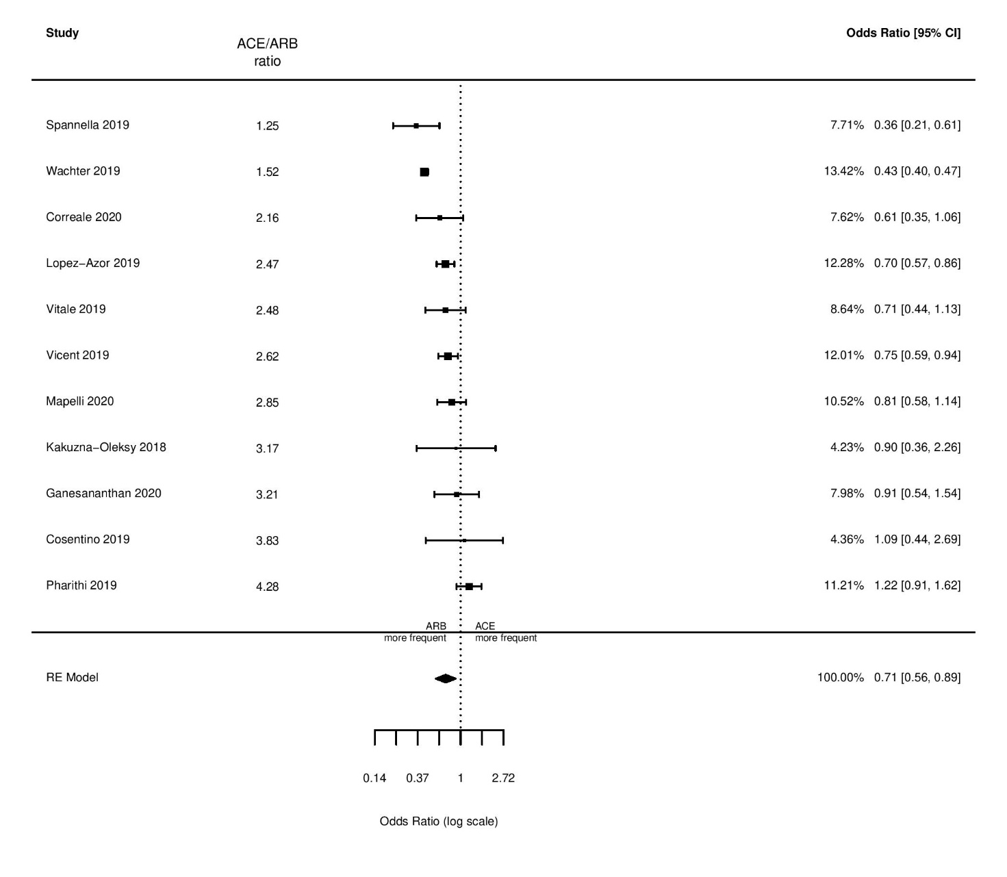
Supplementary Figure 13. Frequency of implantable cardioverter defibrillators in the selected articles as compared with the PARADIGM-HF cohort.
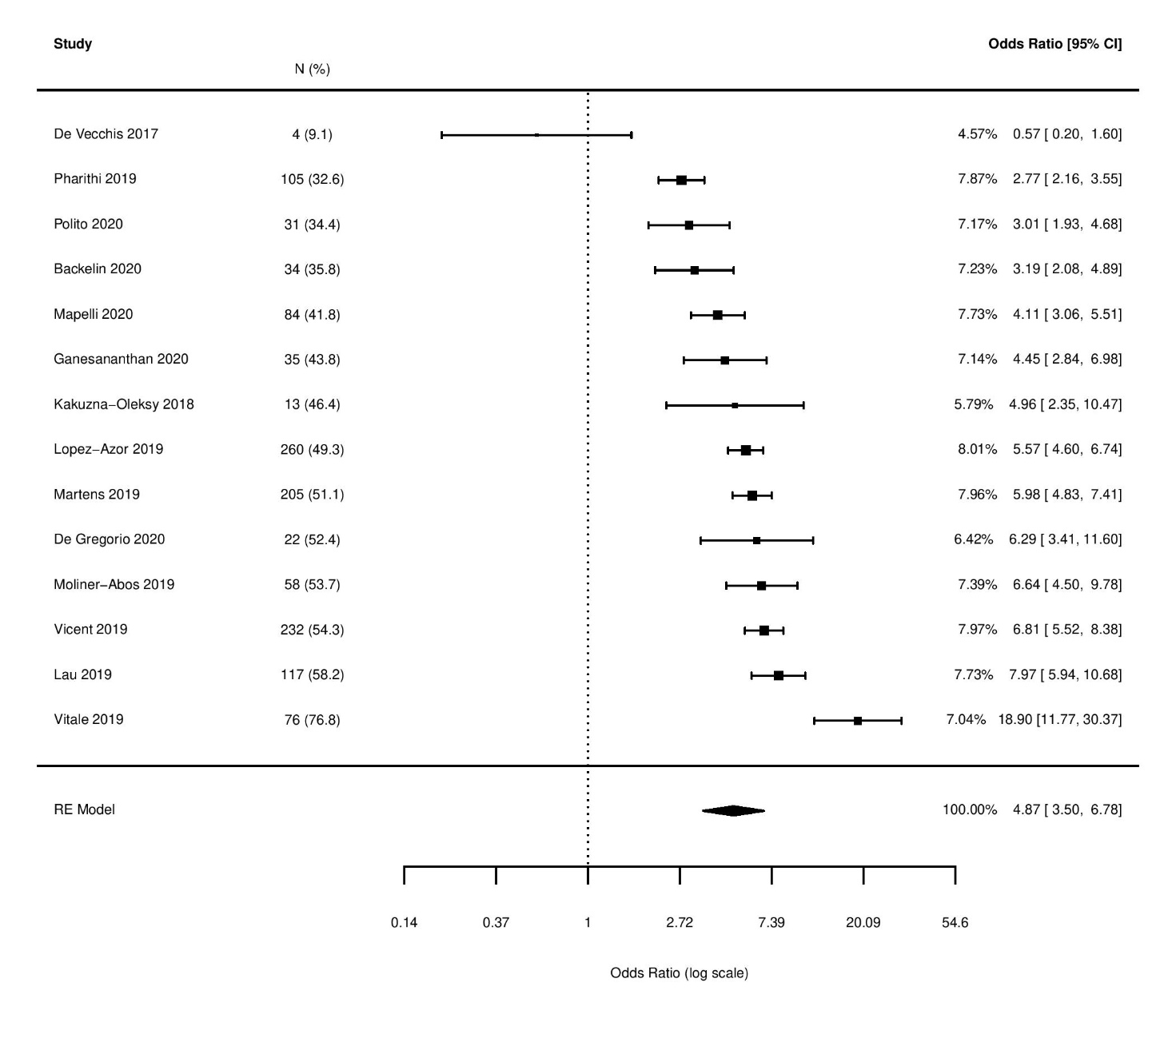
Supplementary Figure 14. Frequency of cardiac resynchronization therapy in the selected articles as compared with the PARADIGM-HF cohort.
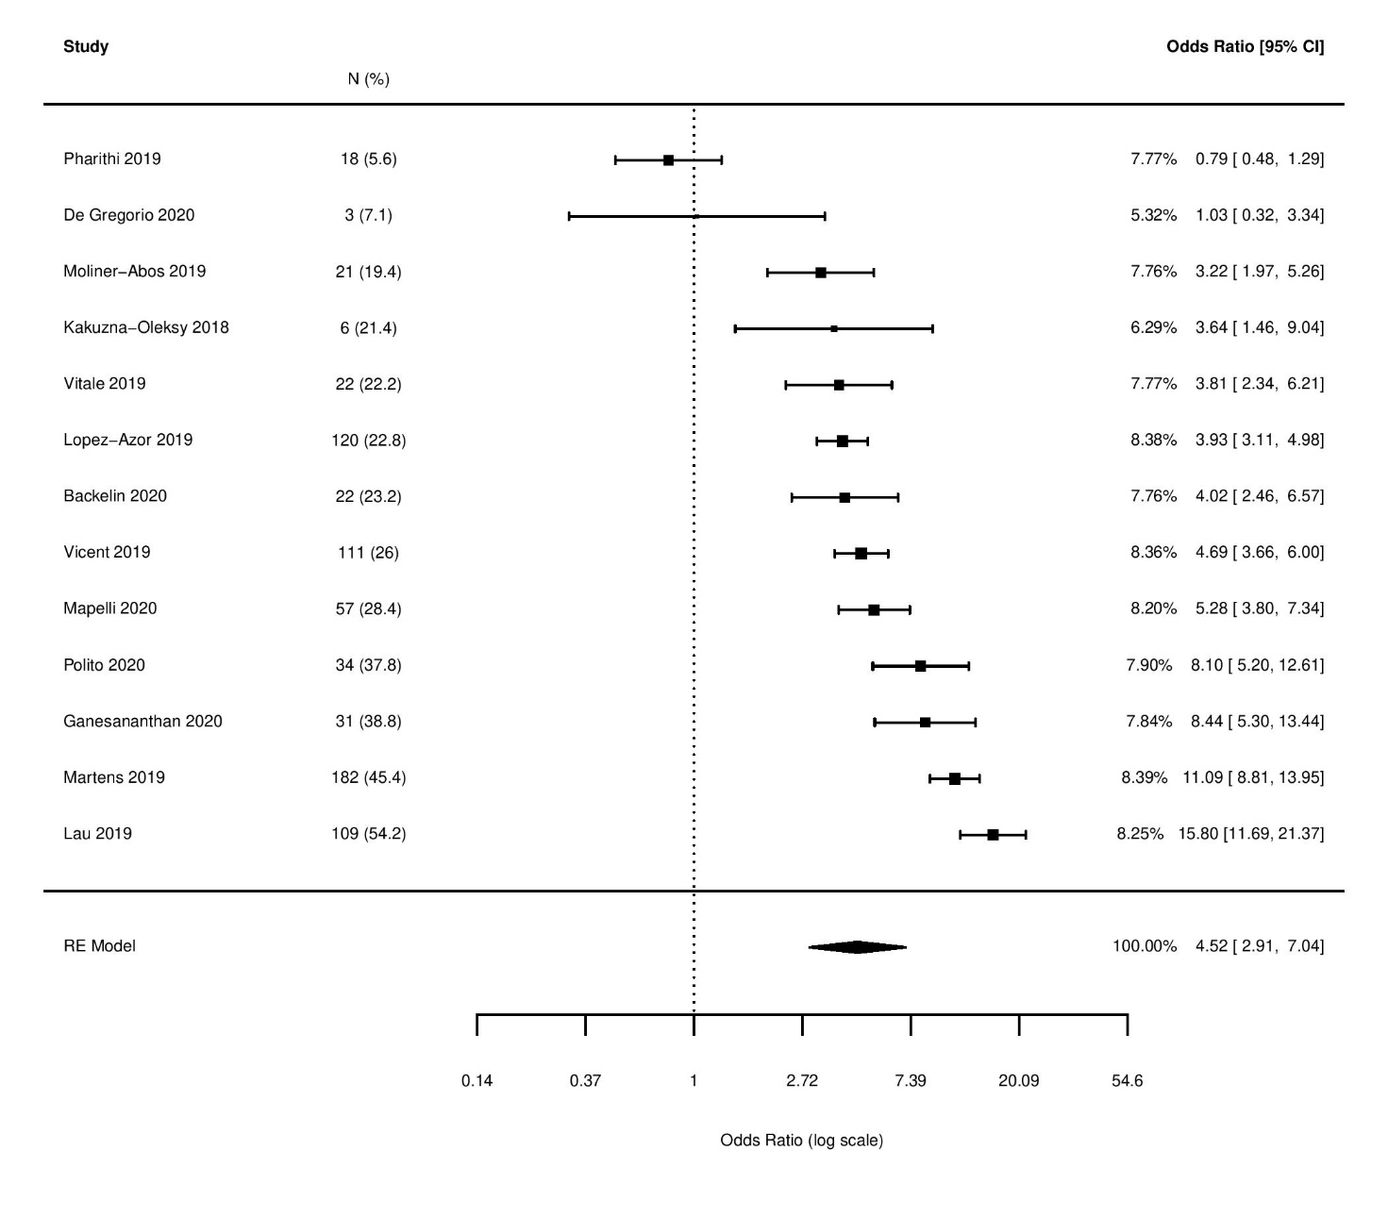
Supplementary Figure 15. Frequency of digoxin use in the selected articles as compared with the PARADIGM-HF cohort.
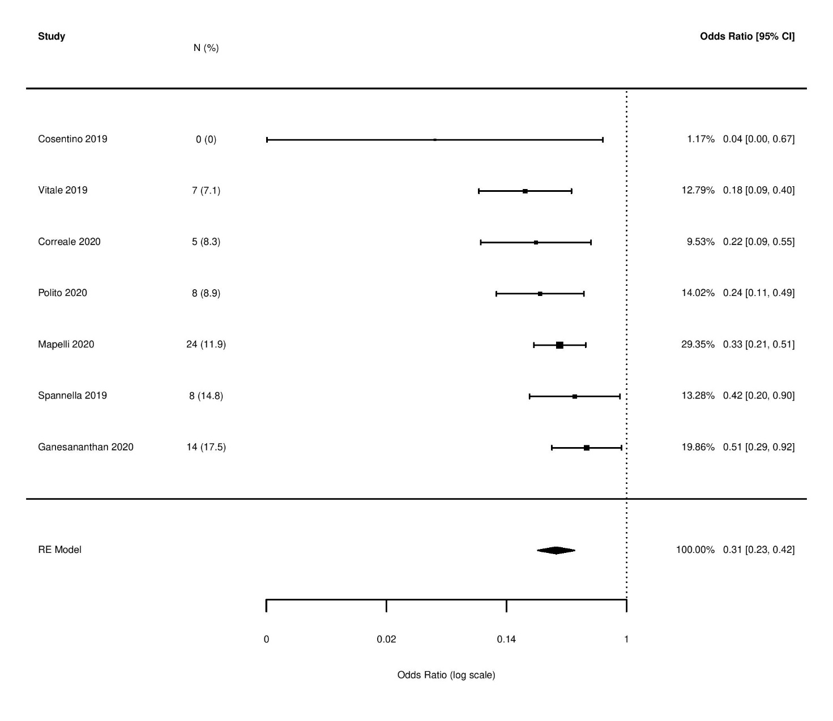
Supplementary Figure 16. Temporal distribution of underreporting of the baseline characteristics of patients receiving sacubitril-valsartan in Europe.

