Non-invasive home telemonitoring for acutely decompensated heart failure

Figures
Figure 1
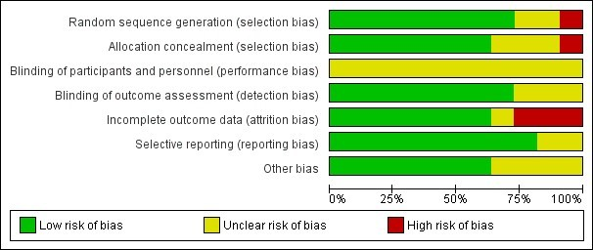
Risk of bias graph: review authors' judgements about each risk of bias item presented as percentages across all included studies.
Review Manager 5.3 1

