S1 Fig – Meta-analysis without previous conization
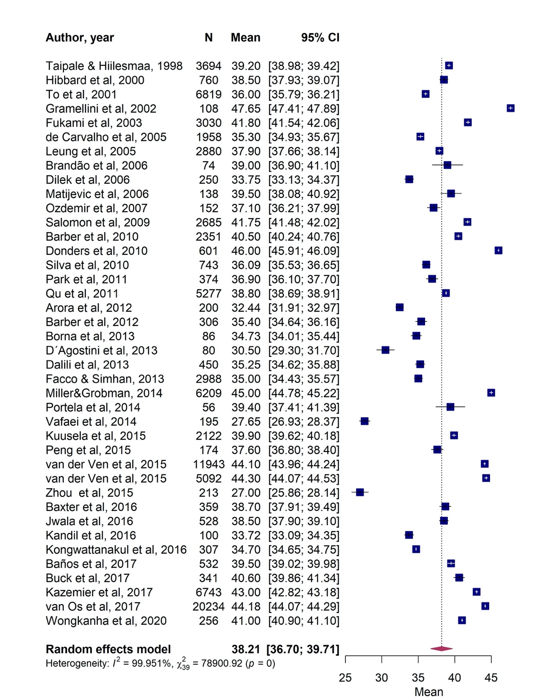
Forest plot for cervical length measurement in patients without previous conization

